[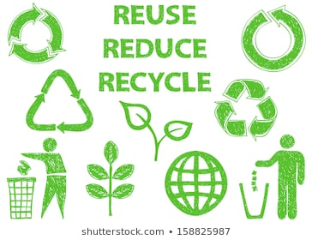](https://www.shutterstock.com/search/reduce+reuse+recycle)Christmas Holiday Challenge…

Our theme next term is ‘M is for Making’.

[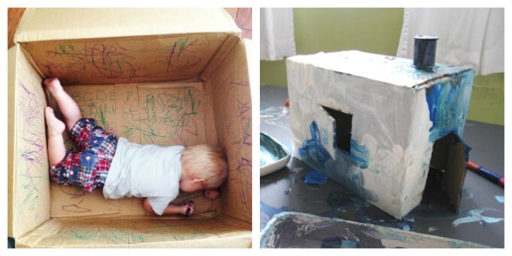](https://artfulparent.com/cardboard-art-ideas/)[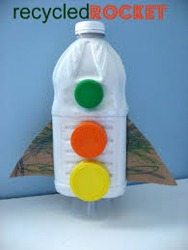](https://www.google.co.uk/url?sa=i&rct=j&q=&esrc=s&source=images&cd=&ved=2ahUKEwiQ96uCrrDmAhUMmRoKHU9qCX8QjRx6BAgBEAQ&url=https%3A%2F%2Fwww.notimeforflashcards.com%2F2014%2F04%2Frecycled-art-project-for-kids-2.html&psig=AOvVaw3ncPhj97__iNlZVsKd-1Md&ust=1576248621685206)[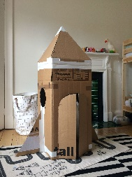](https://www.google.co.uk/url?sa=i&rct=j&q=&esrc=s&source=images&cd=&cad=rja&uact=8&ved=2ahUKEwio3o2crbDmAhWnxYUKHRjeB8sQjRx6BAgBEAQ&url=https%3A%2F%2Fwww.thebearandthefox.com%2F2019%2F01%2Frecycled-cardboard-box-rocket-ship%2F&psig=AOvVaw3TrgN5e-cJQQinBh1X3Uj8&ust=1576248336058260)[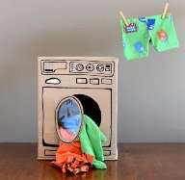](https://www.musely.com/tips/Cardboard-Box-Creations-Your-Kids-Will-Love/18209608)What building/structure can you create with your child reusing some of the Christmas boxes/tubes/paper???

[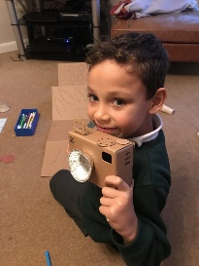](https://www.google.co.uk/url?sa=i&rct=j&q=&esrc=s&source=images&cd=&ved=2ahUKEwiOj6TIrLDmAhUD4BoKHfaYCfAQjRx6BAgBEAQ&url=https%3A%2F%2Ftheharrisonhousehold.com%2Freview-lonely-planet-kids-cardboard-box-creations%2F&psig=AOvVaw3olGUGsyRRykTbqsgZGBhl&ust=1576248179034058)[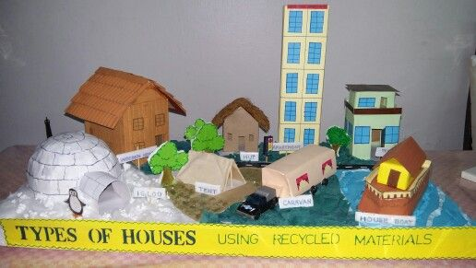](https://www.pinterest.com/pin/538391330434099708/)[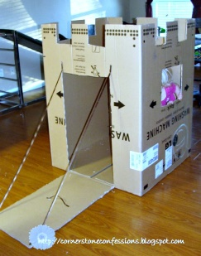](https://www.google.co.uk/url?sa=i&rct=j&q=&esrc=s&source=images&cd=&cad=rja&uact=8&ved=2ahUKEwix58HqrLDmAhVGOBoKHXUWA0kQjRx6BAgBEAQ&url=https%3A%2F%2Fwww.pinterest.com%2Fpin%2F115334440433315267%2F&psig=AOvVaw3TrgN5e-cJQQinBh1X3Uj8&ust=1576248336058260)

[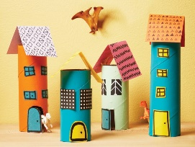](https://www.todaysparent.com/family/crafts/13-kid-friendly-crafts-using-recyclables/)

Please bring in your structures or send us a photo ☺

[](https://www.shutterstock.com/search/reduce+reuse+recycle)Christmas Holiday Challenge…

Our theme next term is ‘M is for Making’.

[](https://artfulparent.com/cardboard-art-ideas/)[](https://www.google.co.uk/url?sa=i&rct=j&q=&esrc=s&source=images&cd=&ved=2ahUKEwiQ96uCrrDmAhUMmRoKHU9qCX8QjRx6BAgBEAQ&url=https%3A%2F%2Fwww.notimeforflashcards.com%2F2014%2F04%2Frecycled-art-project-for-kids-2.html&psig=AOvVaw3ncPhj97__iNlZVsKd-1Md&ust=1576248621685206)[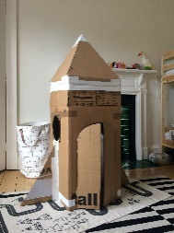](https://www.google.co.uk/url?sa=i&rct=j&q=&esrc=s&source=images&cd=&cad=rja&uact=8&ved=2ahUKEwio3o2crbDmAhWnxYUKHRjeB8sQjRx6BAgBEAQ&url=https%3A%2F%2Fwww.thebearandthefox.com%2F2019%2F01%2Frecycled-cardboard-box-rocket-ship%2F&psig=AOvVaw3TrgN5e-cJQQinBh1X3Uj8&ust=1576248336058260)[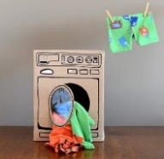](https://www.musely.com/tips/Cardboard-Box-Creations-Your-Kids-Will-Love/18209608)What building/structure can you create with your child reusing some of the Christmas boxes/tubes/paper???

[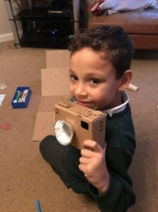](https://www.google.co.uk/url?sa=i&rct=j&q=&esrc=s&source=images&cd=&ved=2ahUKEwiOj6TIrLDmAhUD4BoKHfaYCfAQjRx6BAgBEAQ&url=https%3A%2F%2Ftheharrisonhousehold.com%2Freview-lonely-planet-kids-cardboard-box-creations%2F&psig=AOvVaw3olGUGsyRRykTbqsgZGBhl&ust=1576248179034058)[](https://www.pinterest.com/pin/538391330434099708/)[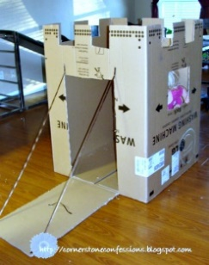](https://www.google.co.uk/url?sa=i&rct=j&q=&esrc=s&source=images&cd=&cad=rja&uact=8&ved=2ahUKEwix58HqrLDmAhVGOBoKHXUWA0kQjRx6BAgBEAQ&url=https%3A%2F%2Fwww.pinterest.com%2Fpin%2F115334440433315267%2F&psig=AOvVaw3TrgN5e-cJQQinBh1X3Uj8&ust=1576248336058260)

[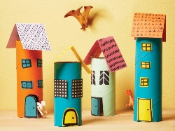](https://www.todaysparent.com/family/crafts/13-kid-friendly-crafts-using-recyclables/)

Please bring in your structures or send us a photo ☺