

PRIME AREAS
Daily opportunities for children to:
Play co-operatively. ‘Team Ant’.
Respect adults and children.
Understand the rules and boundaries of the setting and adhere to these.
Use the environment and resources appropriately and purposefully.
Make choices about their play.
Participate in circle-time sessions.
Explore moral and social dilemmas through small-world play and role-play.
Be independent.
Focus teach:
Helicopter stories – chn telling their own.
Positive attitudes to learning.
Morals in fairy tales.

PSED
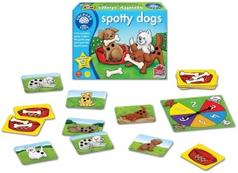

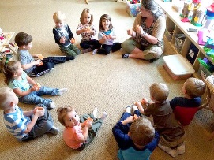
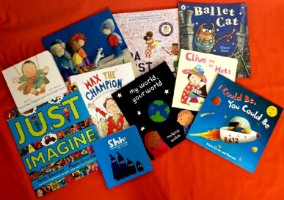

Daily opportunities for children to:
Communicate with others in a range of ways and in a range of scenarios.
Ask and answer questions.
Play in a language rich environment.
Participate in role-play and small-world play.
Use their imagination.
Access books and activities focussed around stories.
Participate in speaking and listening activities.
Helicopter stories.
Focus teach:
Recalling experiences during mark-making and writing in their forest school diaries. Nursery rhymes and fairy tales. Circle-time.
To orally plan for their learning in open door sessions.
Promote ‘learning without limits’.



CL

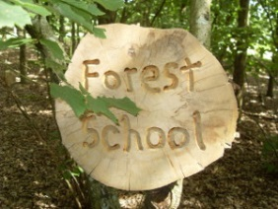

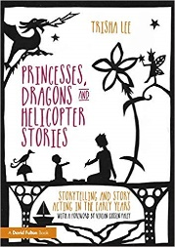
Daily opportunities for children to:
Take manageable risks with both gross and fine motor movements.
Use a variety of tools to create effects.
Take responsibility for their self-care through toileting, snack time, lunch time.
Play outdoors using large scale equipment. Develop control and co-ordination in large and small movements.
Make marks and write using a variety of materials.
Cook - show an understanding of safety and rules.
Explore schemas of filling and tipping in the sand pit, water tray and mud kitchen.
Engage in malleable play.
Focus teach:
Stickman – safety at forest school/off site – lollipop woods/nature walks
P.E sessions focussing on spatial awareness/control and coordination.


PD



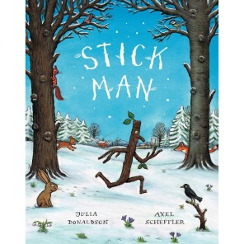



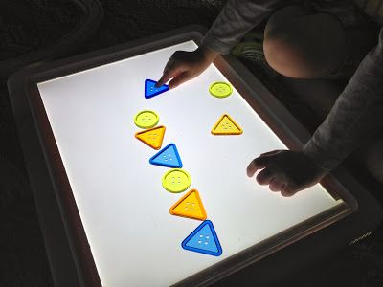
SPECIFIC AREAS
Daily opportunities for children to:
Use and apply their knowledge of number. Count. Subitise.
Explore Numicon in a range of scenarios. Play board games.
Explore 2D and 3D shapes through varied construction activities – making structures.
Investigate measures through sand, water, mud play and cookery.
Recognise patterns in the environment and in number.
Focus teach:
Discrete Numbers and Patterns sessions differentiated according to children’s needs. Length – Jack’s beanstalk.
Shapes needed to construct buildings.


Mathematics
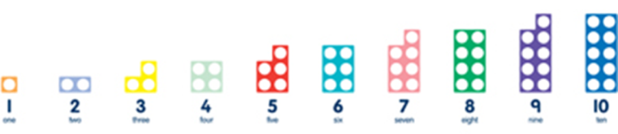

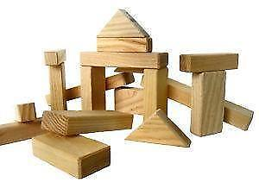
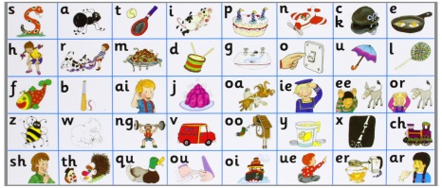
Daily opportunities for children to:
Participate in open-ended role-play and small world play.
Write purposefully using a range of genres.
Listen to stories told and read by adults.
Apply their phonetic knowledge to reading and writing in their play.
5th March WORLD BOOK DAY
Focus teach:
Promote reading morning
Discrete daily phonics sessions supported by Letters and Sounds.
Mark-making and writing in Forest School Diaries on a
weekly basis.


Literacy

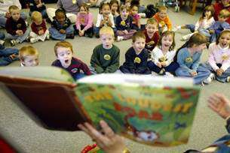

Daily opportunities for children to:
Explore different people and places through small world and role-play.
Use technology to enhance their learning – green screen/cubetto using IPADs and age appropriate software e.g. numbots, scratch junior.
Talk about their home-life and consider the lives of others.
Construction – suitable materials for buildings/furniture…
Discuss similarities and differences of family customs and routines.
Focus teach:
Forest School.
Explore seasons - Winter.
Chinese New Year 25th January.
Holi 9th March – Festival of colours - Hinduism
Easter celebrations; Christianity.
Special buildings from different faiths.


Understanding
the World

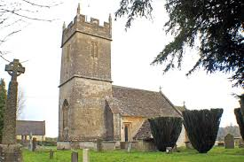

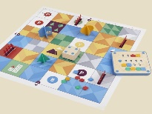
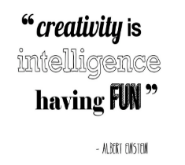
Daily opportunities for children to:
What can you make? Songs, books, instruments, sounds…
Explore and use a variety of materials in the Art Studio.
Puppet making (Peter and the Wolf’) plus constructing a theatre.
Recreate their experiences and make representations through
acting, songs and dancing, using the outdoor theatre.
Focus teach:
Puppet making
Michael Brennand-Wood – selecting tools and techniques needed to shape, assemble and join materials - weaving

Expressive Art and Design





