Lesson 1 Themed Learning: No Poverty
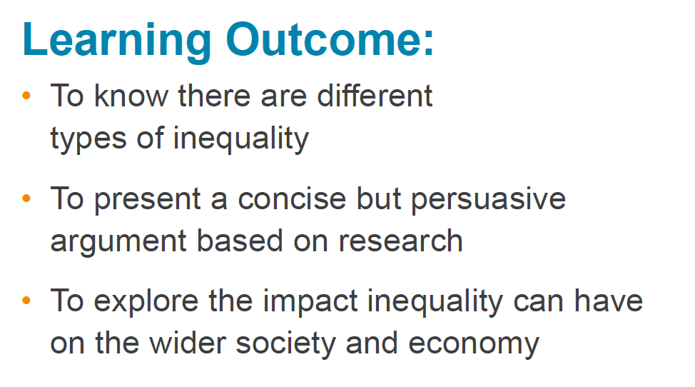
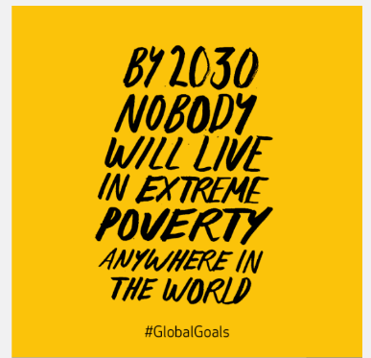
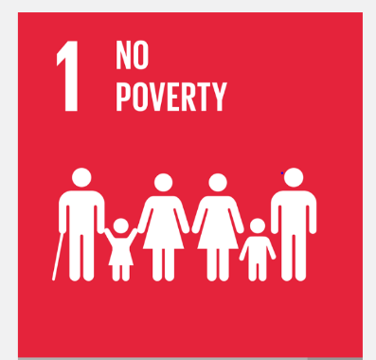
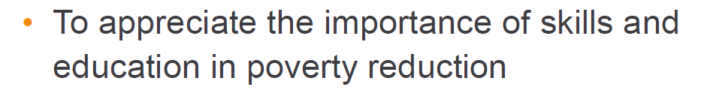

Task One: Answer the questions below in one of the following ways: a fact sheet, a PowerPoint presentation or, a produce a poster.

What is poverty?
Why do we have world poverty?
Which 5 countries have the highest poverty rate?
Why do people live in poverty?
What do you think every person has a right to have or expect?
Half the world’s population live in poverty. What do you think about this statement?
What is a food bank? Are there any near where you live?
What organisations and charities work to help people who live in poverty?
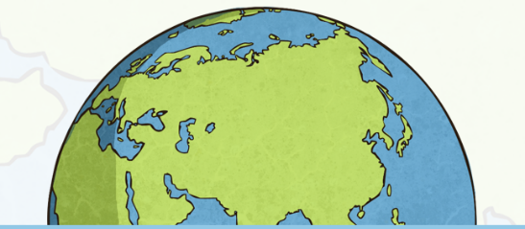
What are you guilty of wasting?
How can we make a difference?
How could you affect the world?
Task Two: Pretend you are a world leader for the day. What would you change? Would you make any new laws?
Display this task in paragraphs.

Task Three: Design a change. As you know superheroes don’t just exist in books, they are in real-life too. You can become a superhero!

Think of three things you can change to benefit others. One in your own life e.g. teaching someone something new; one in school e.g. stop food waste in school; one in the community e.g. adding cycle paths.
Remember you are trying to persuade your family, Mrs Tomlinson and Boris Johnson’s Government - think about the best way to display this e.g. a letter, a poster, etc

