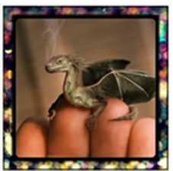

Look at this photo of a tiny dragon…

Answer these questions in your red book, answer in full sentences and be as imaginative as you can.

1. Where has this dragon come from?

2. Why is the dragon so small?

3. Are there any other dragons like him?

4. Where does this dragon live? Describe the setting.

5. How would you look after this tiny dragon?

6. Is it magic? What magic can it do?