Year 3 Home learning activities
We hope you had an enjoyable family Easter.
Please find below, a selection of activities to keep your child busy!
- Operation gratitude: Make a list or brainstorm of all the people that work hard to help us daily. Pick one of these people and write them a thank you note/card to show how grateful you are of the work they do. You can write and draw lovely pictures. Please upload any finished notes/cards to seesaw! We would love to see them!
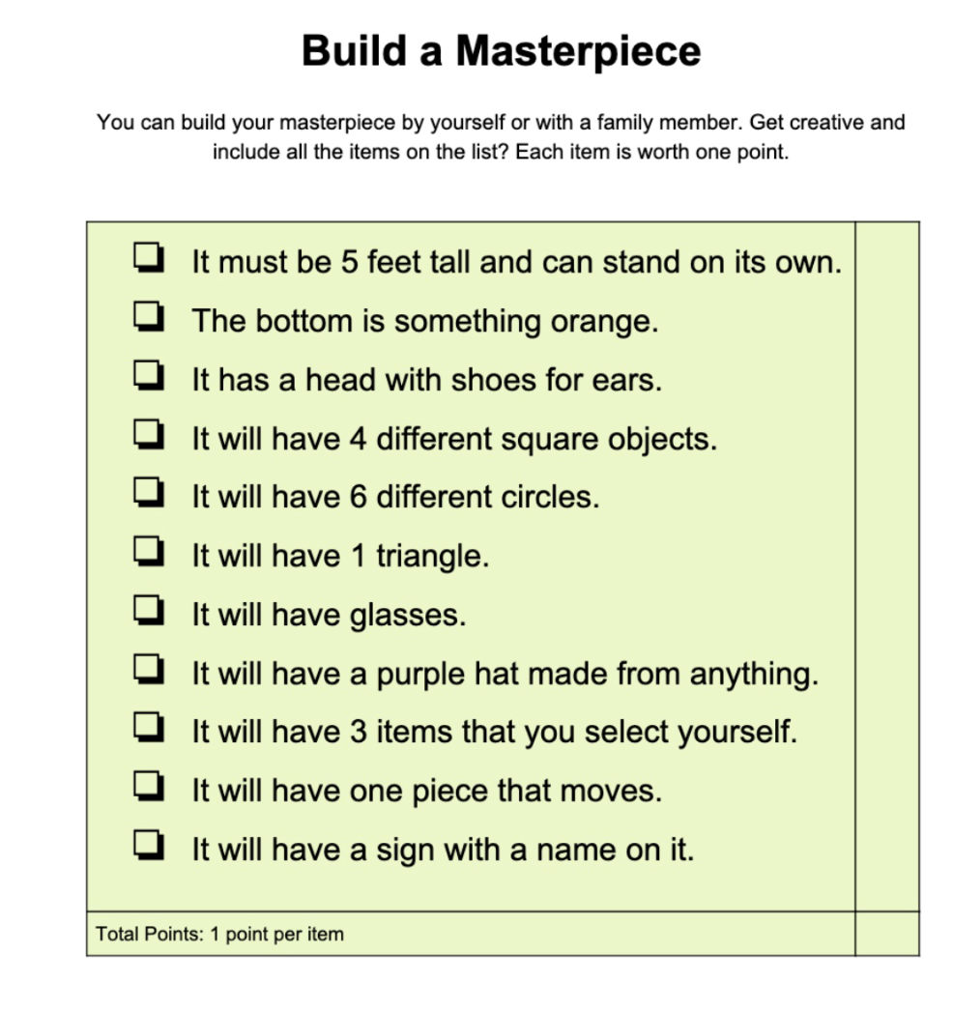
- Build a masterpiece: Here is a list of things to include in your masterpiece. You get a point for every one you include! Don’t forget to share them with us!

- Build a reading fort: Pick a spot in your house or garden (if the weather is nice) and build a reading fort with your family. You can use it for lots of things like: drawing, playing quiet games, listening to music or just talking to each other.

EARTH DAY WEDNESDAY 22ND APRIL: On Wednesday it is Earth day! This is a day where lots of people think about looking after our planet. Can you find out some things about Earth Day and write an acrostic poem about it. The template is below if you wish to use it or make your own!!

- You could also make a poster about the things you could do to help change the world. Here is a picture to give you some inspiration!

Maths- Whiterose
Follow this link to Whiterose resources
https://whiterosemaths.com/homelearning/year-3/

Ensure you click on the summer term heading. There are videos for each day’s activity, then some questions- you can print these off or have them up on your screen for your child to use.

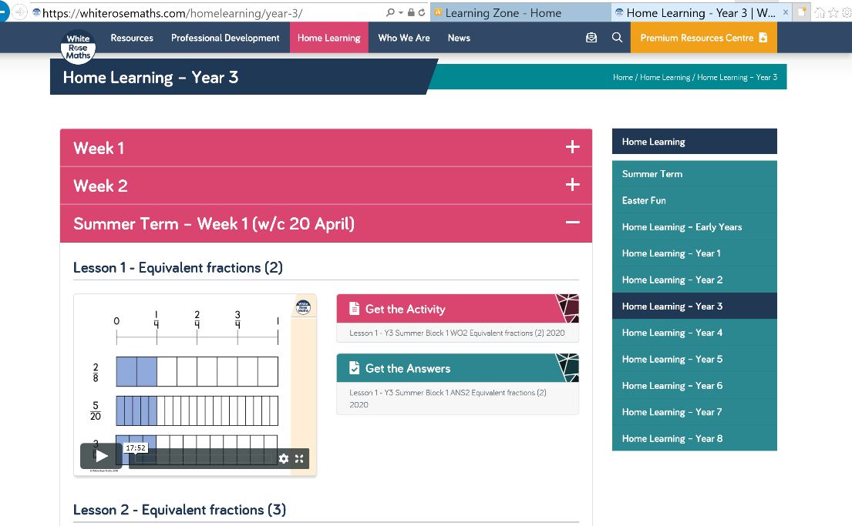
There is also an answer page, to check your child understands what the question is asking.

Please feel free to take pictures of your child’s work and upload to Seesaw or email your child’s teacher.

Computing
https://www.barefootcomputing.org/homelearning
Follow this link to play a variety of online, computing games

The BBC are also providing a vast range of activities for children- they are broken up, into year groups.
If you have any questions about what the activity is asking of your child, please ask us.
https://www.bbc.co.uk/bitesize/levels/zbr9wmn

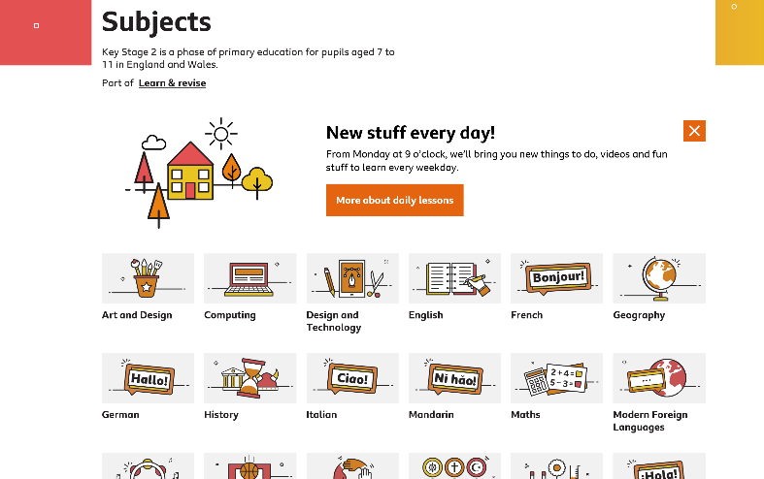

If you have any questions about any of the work set, or to simply allow your child to keep in touch with us- please ensure you have access to your child’s Seesaw account.
You can gain access by emailing us on
sarah.vickers@taw.org.uk
hannah.kibblewhite1@taw.org.uk

