Year 3 Home learning activities
Week commencing 27th April

English- Rainforests!
Our topic this term is Rainforests. We would like you to make a fact file about a rainforest animal. Here is an example of how you could break this activity up across the week.
Monday- Choose an animal and brainstorm some fact about that animal into headings: e.g. Where do they live? What do they eat? What do they look like? Other interesting facts. Research using the children’s search engine: https://www.kiddle.co/
Tuesday- Complete the front cover of your fact file and write a short introduction telling your reader what the fact file is about.
Wednesday- Write a short paragraph about each heading using your research to help you.
Thursday- Complete your fact file with a detailed diagram of the animal and label it.
Friday- Read through your fact file and edit for spelling mistakes, capital letters, full stops and check it makes sense.
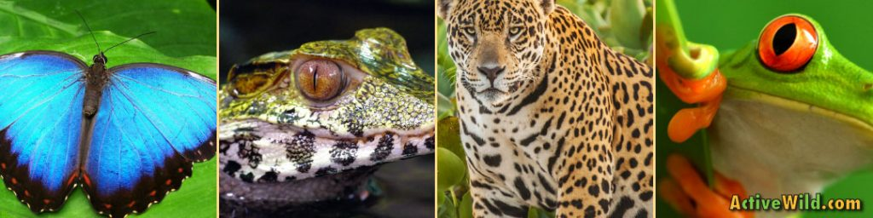

Take pictures of your fact file and share with us on Seesaw or e mail it to us at:
sarah.vickers@taw.org.uk
hannah.kibblewhite1@taw.org.uk

Reading- comprehension
As well as reading your books. This week we would like you to watch this video clip and answer these questions in your book. Don’t forget to share your answers on seesaw!
https://www.youtube.com/watch?v=oIlIVFBBbNw&safe=active

Spellings-
Red and Green | Blue and Yellow
teacher | her
catcher | term
richer | verb
stretcher | person
pitcher | number
fetcher | other
preacher | after
 | dinner
 | finger
 | herd

Maths- Whiterose
Follow this link to Whiterose resources
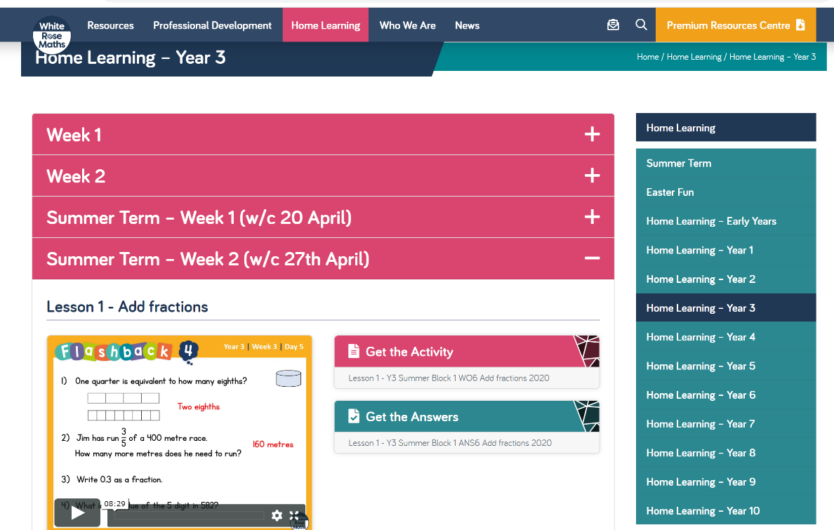
https://whiterosemaths.com/homelearning/year-3/

Ensure you click on the summer term heading. Week 2 (w/c 27th April) There are videos for each day’s activity, then some questions- you can print these off or have them up on your screen for your child to use.

There is also an answer page, to check your child understands what the question is asking.
Please take pictures of your child’s work and upload to Seesaw or email your child’s teacher.

Also your child has access to Timetable rock stars at https://play.ttrockstars.com/auth/school/student/16409
If you do not have your child’s log in details- please ask us for them.

Science- Why not try one of these great activities at home with your family! Upload the results onto seesaw!

Computing
https://www.barefootcomputing.org/homelearning
Follow this link to play a variety of online, computing games

The BBC are also providing a vast range of activities for children- they are broken up, into year groups.
If you have any questions about what the activity is asking of your child, please ask us.
https://www.bbc.co.uk/bitesize/levels/zbr9wmn

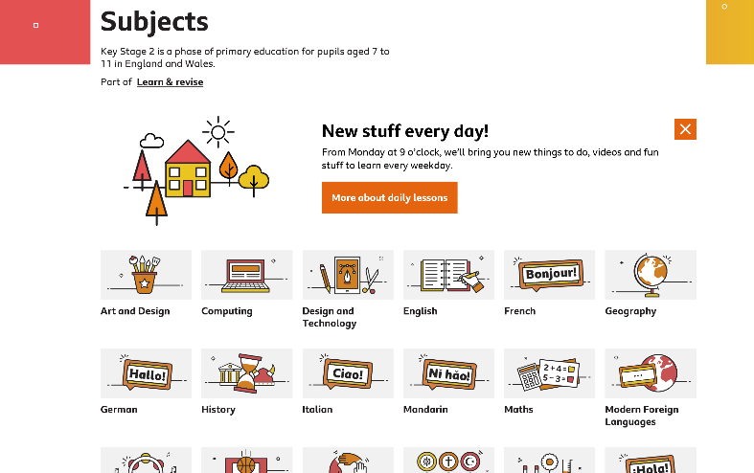

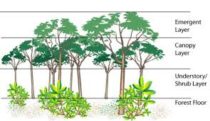
Geography

Research the different layers of the rainforest.

If you have any questions about any of the work set, or to simply allow your child to keep in touch with us- please ensure you have access to your child’s Seesaw account.
You can gain access by emailing us on
sarah.vickers@taw.org.uk
hannah.kibblewhite1@taw.org.uk

