Lesson 2 Themed Learning: Zero Hunger

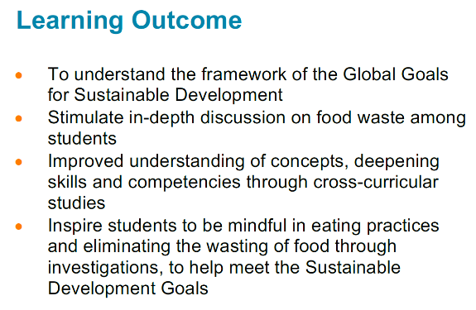
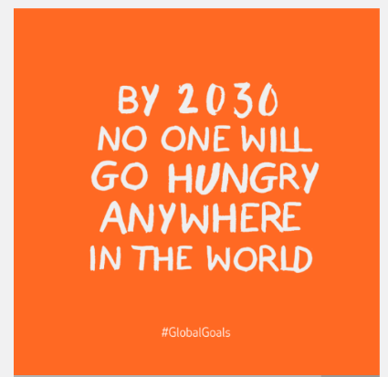
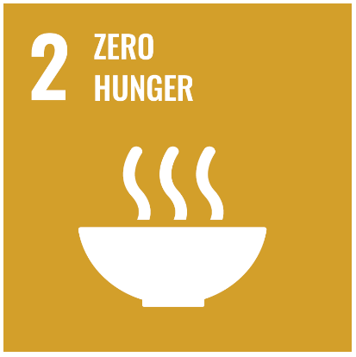

Every Plate Tells a Story
Activity 1: Choose your favourite meal or the meal you have had prepared for you today. Draw it. Answer the questions below:

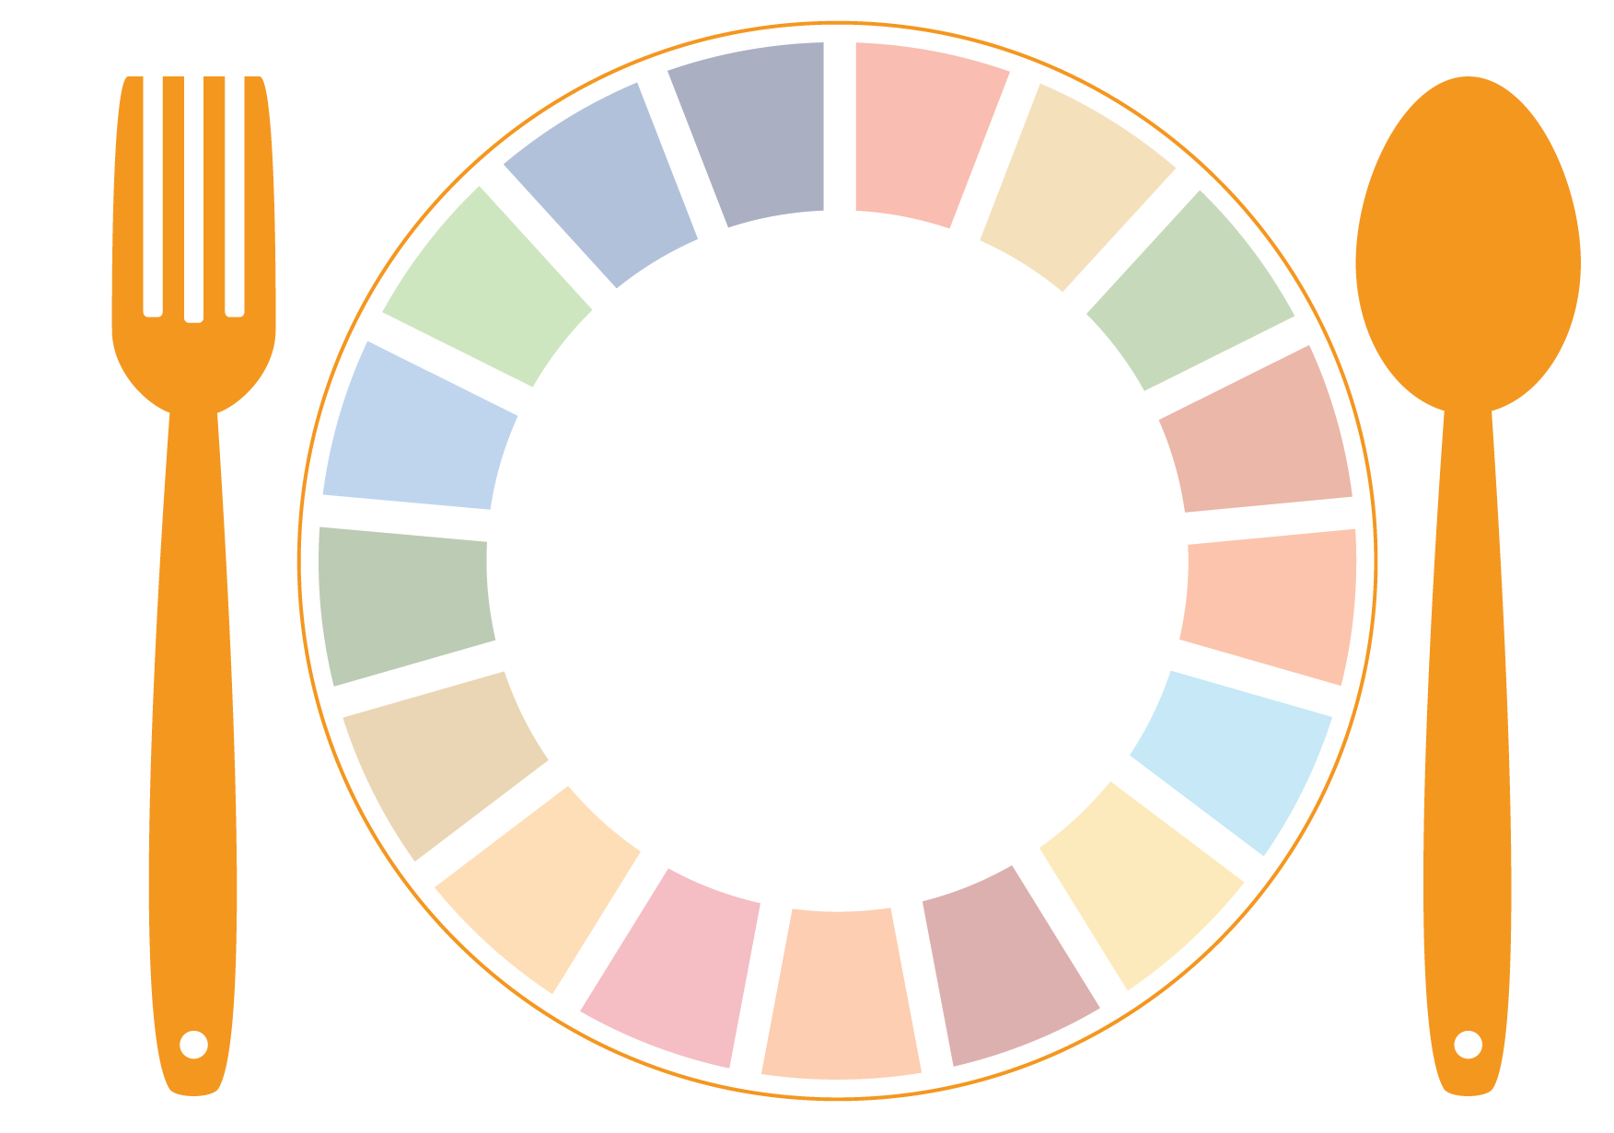
How many items on your plate contain processed sugar?
How many items of plastic packaging were the ingredients of your meal wrapped in?
How much food was thrown away from your plate?

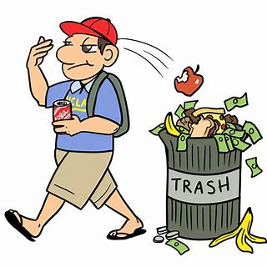
Activity 2: Investigate the journey of your favourite foods.
Activity 3:
- Keep a tally of the food your family throw away each day.
- Use this tally chat to produce a pie chart bar graph
- Work out the percentages of the food you waste the most of?

Activity 4: Make a pledge about wasting food and see if you and your family can stick to it.

