Expanded noun phrases.
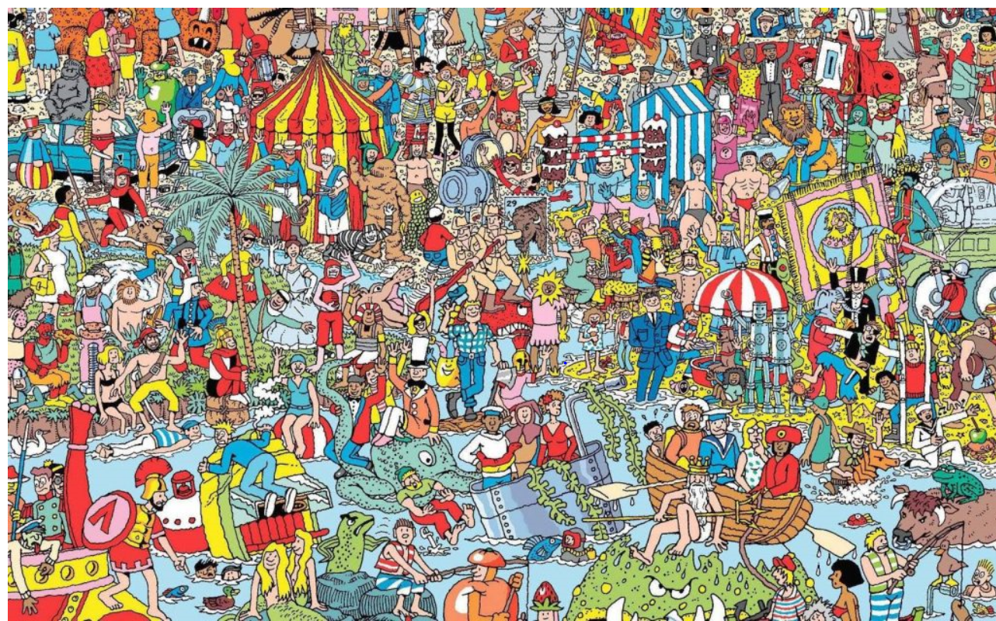

Can you find the man in this picture?
Oh I’m sorry, I’m not being specific enough.
The man is a noun phrase, can you use adjectives (describing words) to describe the noun and create expanded noun phrases.
Can you find the smiling, strong man?
Still too hard?
Okay, can you find the tall, strong, smiling man with a blue hat and an axe?
Oh wonderful, you can!

Your challenge today is to write your own expanded noun phrases to describe things in the picture.
Will your expanded noun phrases be good enough for me to identify what/who you are describing?

