Year 4 – Weekly activities – home learning - week commencing 20th April 2020

Some ideas of activities for learning at home.

Maths – Summer Term – Week 1 - Decimals.

There are 4 lessons this week on decimals. Each lesson has a video for your child to watch to explain each day’s activity, followed by some questions, which you can either print off or keep on screen for your child to use.

There is also an answer page, to check your child understands what the question is asking.

Add to your seesaw journal how you have found each lesson.

https://whiterosemaths.com/homelearning/year-4/
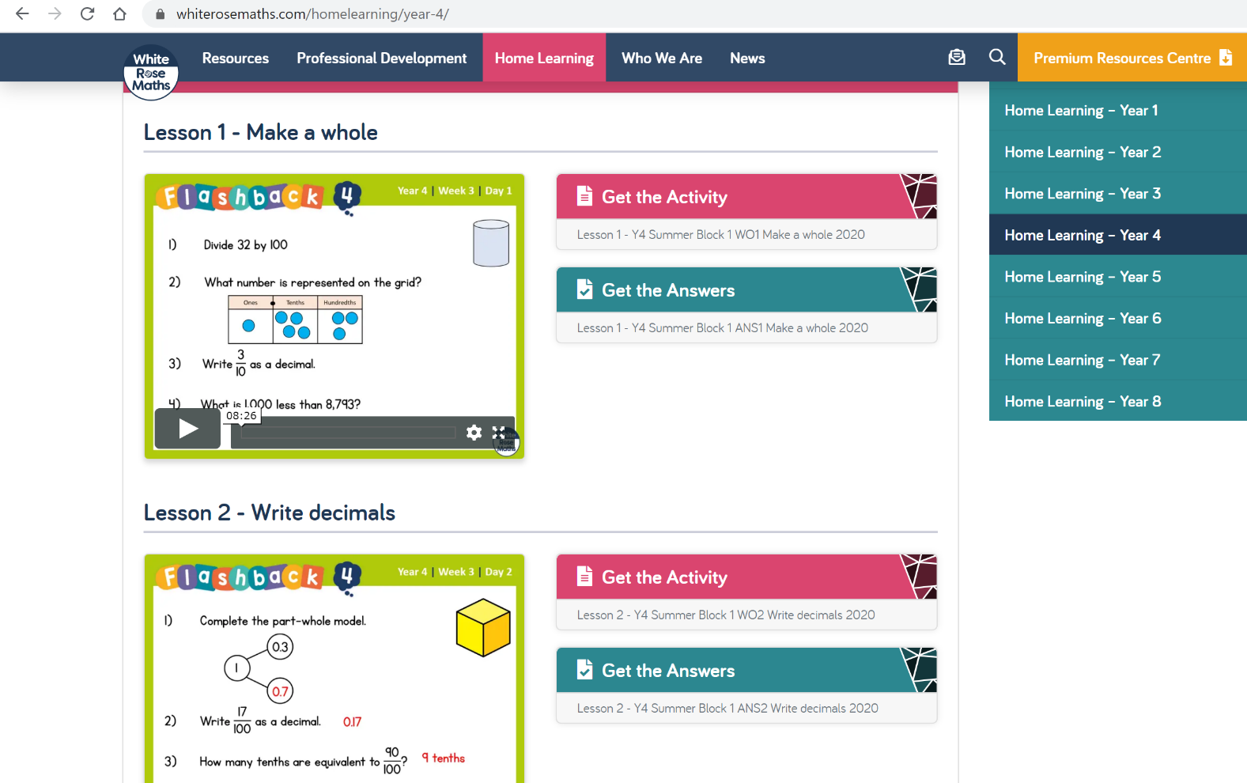

Test your new knowledge by completing a game linked to decimals on Topmarks. https://www.topmarks.co.uk/maths-games/7-11-years/fractions-and-decimals
Keep up the good work on times table rock stars.

English

Can you begin keeping a diary of your time at home? It is something that you may want to look back on in many years to come and share with friends and family members.

Remember to include the features of writing a diary entry:

- Dear Diary,
- First person (I, me, we)
- Describe your thoughts and feelings
- Write informally, as if you are chatting to a friend
- Use fronted adverbials (Earlier today, this morning, after lunch, etc.)

OR

Use Hamilton Trust free home learning resources
https://www.hamilton-trust.org.uk/blog/learning-home-packs/

Click on Year 4 English – week 3.

There are 5 lessons to follow including PowerPoints to assist with completing the tasks. Complete the tasks at your own pace.

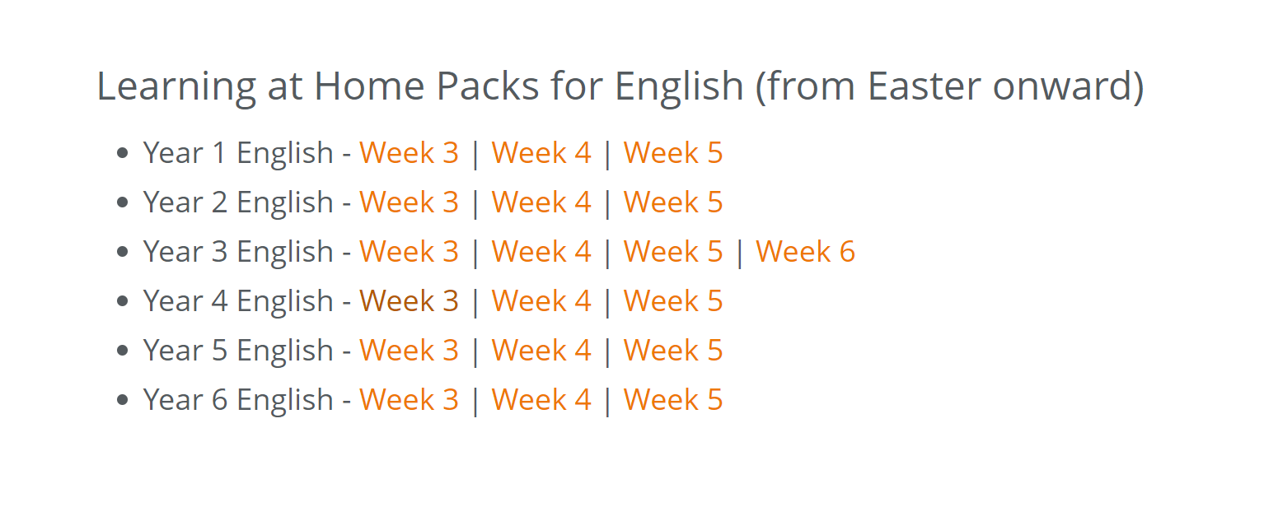
Reading

Before you start today's reading, I have a fun challenge for you!
Can you build your own reading den? This could be indoors or outdoors, depending on the weather!

Click on the link below to see some examples!

https://www.google.com/search?q=homemade+den+children&tbm=isch&rlz=1C1CHBF_en-GBGB811GB811&hl=en&ved=2ahUKEwjuhOj9-cPoAhVedRQKHWO0ArgQBXoECAEQJQ&biw=1349&bih=608

Please take photos of your completed reading den and share through seesaw or email us.

Read for 20 minutes a day. When you have completed a book, write a book review about what you have read.

Optional ideas - Write a character description from your favourite book.

Draw your characters from your book; use these to decorate your new reading den.

Computing

Barefoot Computing have put together some free home learning resources to help. With fun lesson-based activities and interactive games, children can work together with their families to develop their computational thinking skills. Choose one to try through https://www.barefootcomputing.org/homelearning

Create a game on scratch https://scratch.mit.edu/

Have a go at one of the free scratch code club modules; there are free guides to complete each module.
https://projects.raspberrypi.org/en/codeclub/scratch-module-1

PE
Daily exercise is an essential part of healthy living. Many of you have been following Jo Wicks, keep up the hard work with these daily sessions https://www.youtube.com/user/thebodycoach1/video or if you fancy a change try one of the super mover videos https://www.bbc.co.uk/teach/supermovers .

RE

Try one of the free home learning activities from NATRE
https://www.natre.org.uk/uploads/Free%20Resources/2%207-11%20RE%20Today%20and%20NATRE%20home%20learning%20Spirited%20Arts.pdf

Spellings

This week’s spellings are
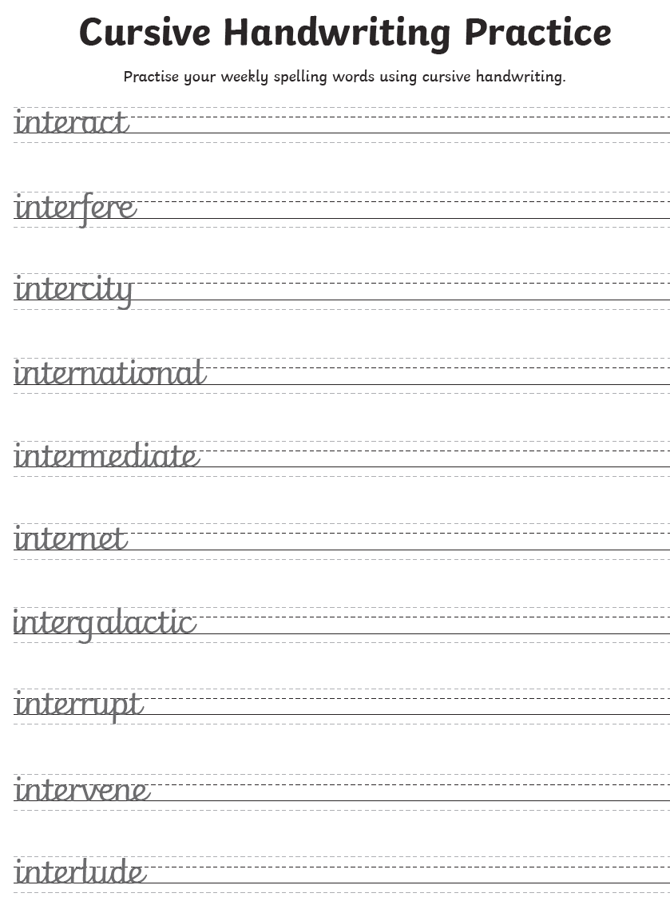
Practise them daily in your neatest cursive handwriting and get a grown up to test you on Friday.

Science

Choose one task to explore.
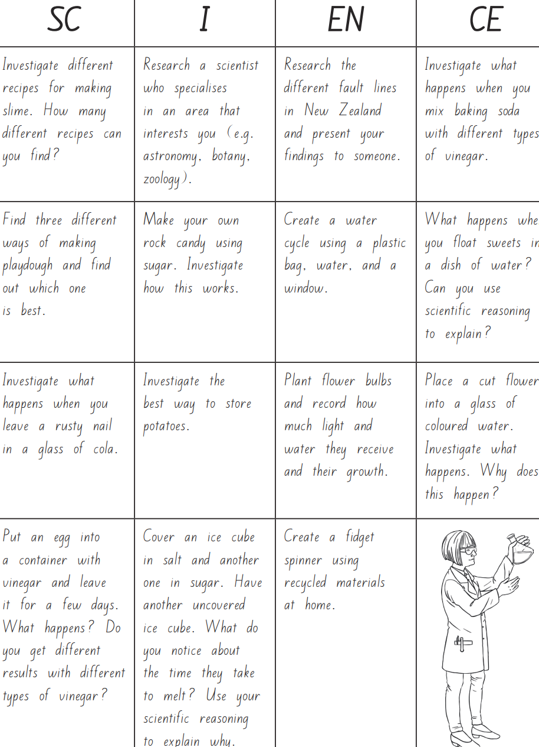

History

For the summer, we will be looking at the Romans. This week research the Romans and create a fact file about one of the following areas:-

(a) Roman religions (gods and myths)
(b) Roman sports and leisure (Gladiators, competitions)
(c) Roman army (soldiers and road building)

Geography

Find Rome on a map. Research tourist attractions in Rome, particularly those dating back to ancient Rome. Write a description of each attraction and then draw your favourite one. Share on seesaw.

Music

Create your own times table song.
Alternatively, complete one of the modules on charanga.

French
Try to have a small conversation in French each day. Use these phrases to help you.
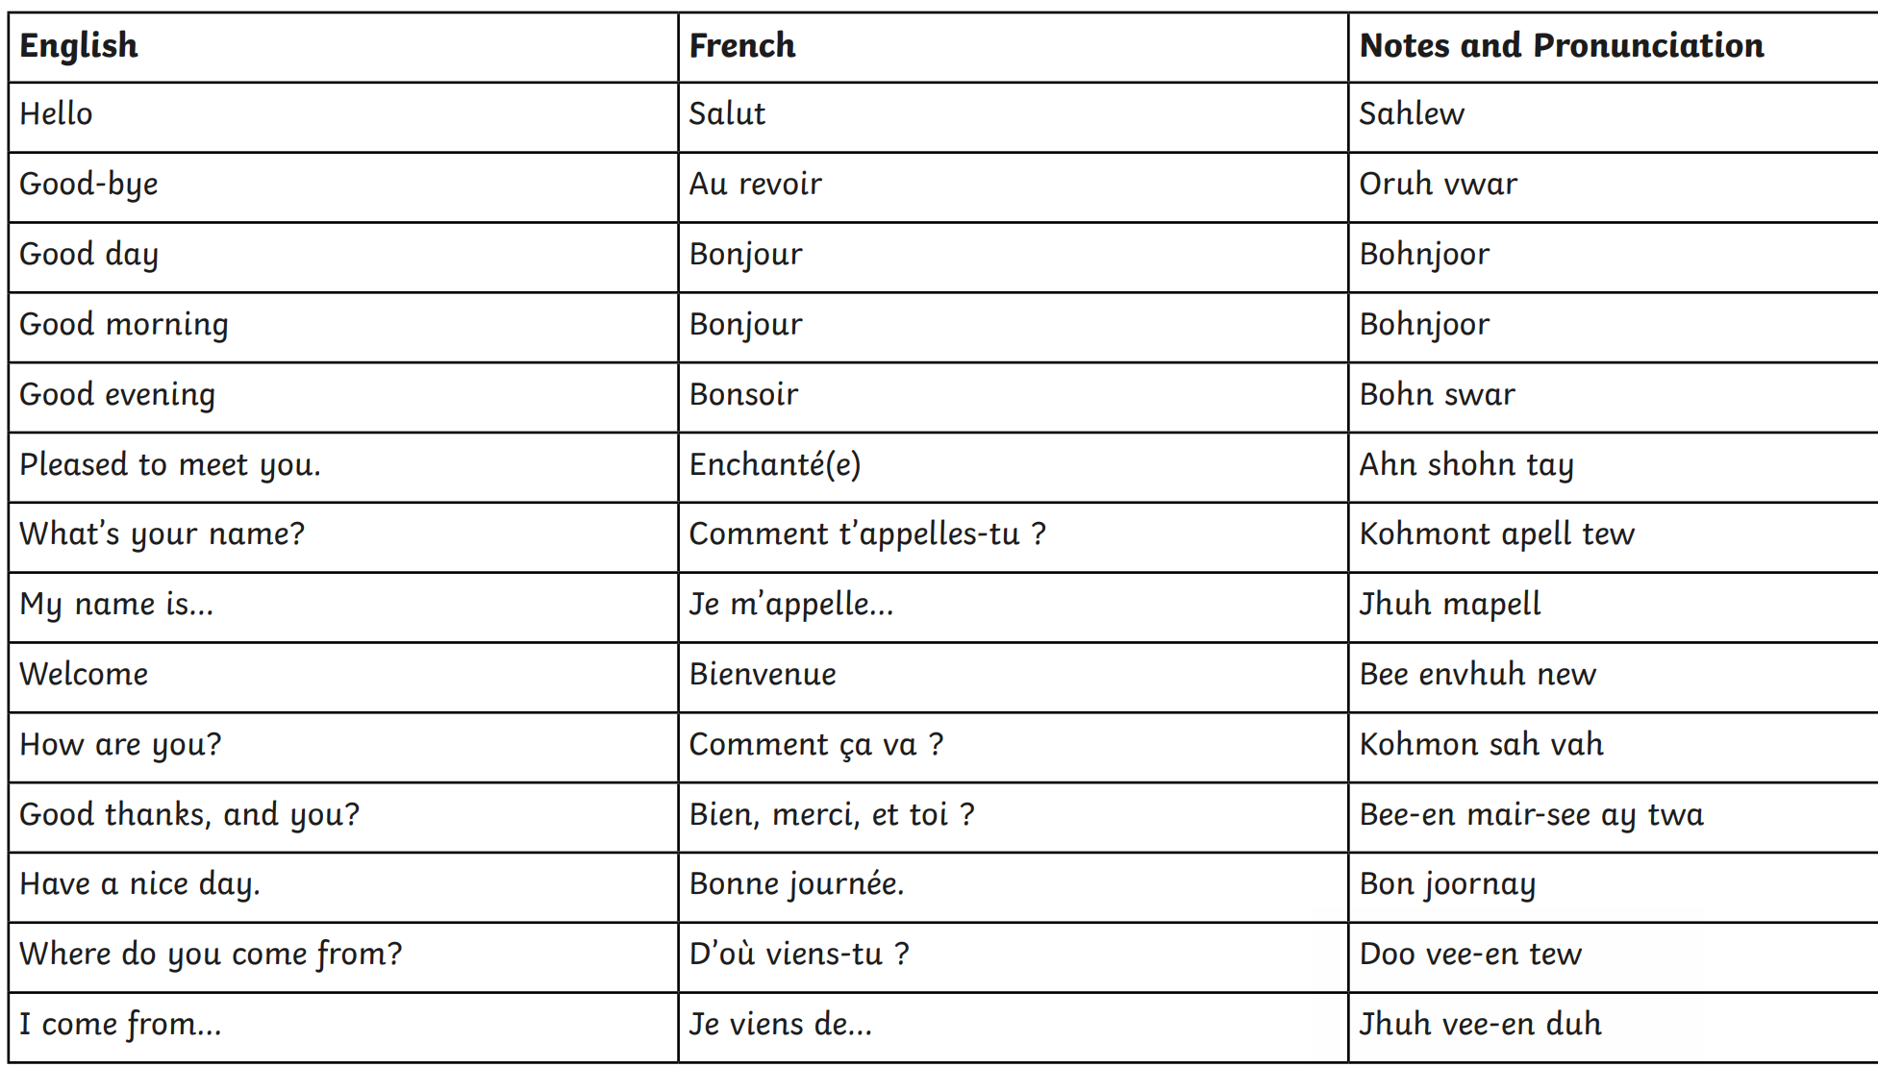
Record one and share it on seesaw.

Other available lessons
The BBC are also providing a vast range of activities for children. This link will give you three appropriate lessons a day to complete.
https://www.bbc.co.uk/bitesize/tags/z63tt39/year-4-lessons/1

Warm wishes

Mrs Lane and Mr Warren

