Year 4 – Weekly activities – home learning - week commencing 27th April 2020

Some ideas of activities for learning at home.

Maths – Summer Term – Week 2.

There are five lessons this week looking at tenths and hundredths. Each lesson has a video for your child to watch to explain each day’s activity, followed by some questions, which you can either print off or keep on screen for your child to use.

There is also an answer page, to check your child understands what the question is asking.

Add to your seesaw journal how you have found each lesson.

https://whiterosemaths.com/homelearning/year-4/

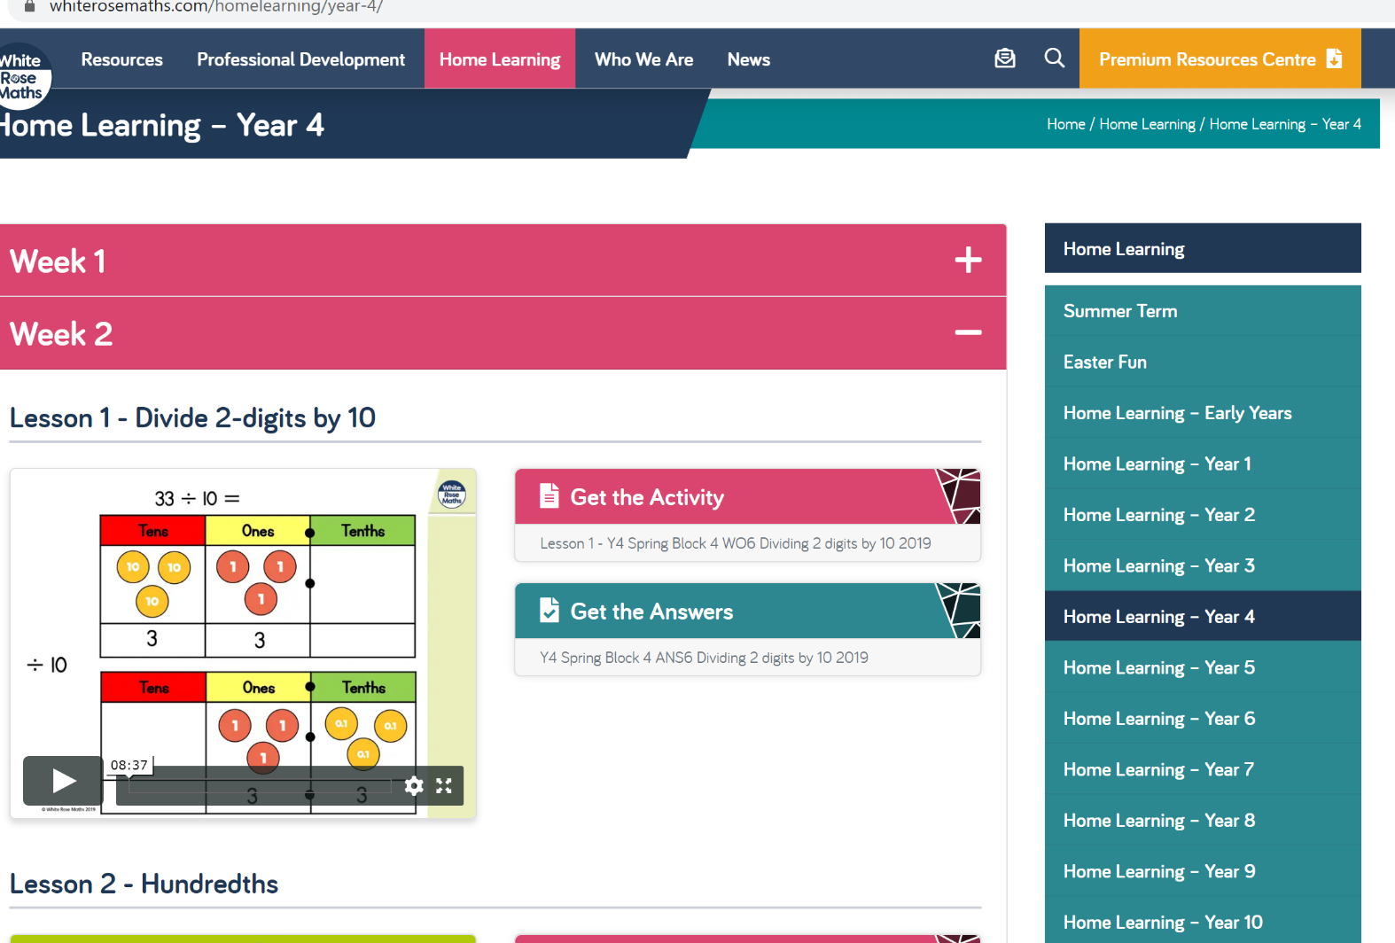
Keep up the good work on times table rock stars.

English

Write a character description of all the people in your household.
Is there something unique about your character’s appearance?
What is their eye, skin and hair colour?
Tall or short.?
Big or small nose?
What types of things does your character enjoy doing or eating?
Why do they like those things?
What types of things do they dislike and why?
What is their personality like?

OR

Use Hamilton Trust free home learning resources
https://www.hamilton-trust.org.uk/blog/learning-home-packs/
Please do not worry if you are still completing last week’s work, just work at your child’s own pace.
Click on Year 4 English – week 4.

There are five lessons to follow including PowerPoints to assist with completing the tasks. Complete the tasks at your own pace.

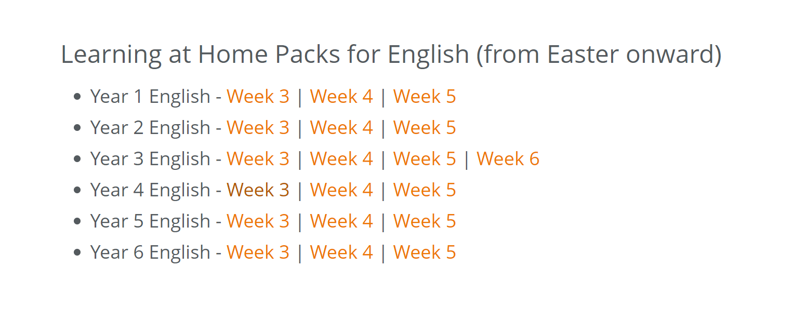
Reading

Well done if you managed to make a reading den. We have loved seeing many of your photos. If not why not try this week. This could be indoors or outdoors, depending on the weather!

Click on the link below to see some examples!

https://www.google.com/search?q=homemade+den+children&tbm=isch&rlz=1C1CHBF_en-GBGB811GB811&hl=en&ved=2ahUKEwjuhOj9-cPoAhVedRQKHWO0ArgQBXoECAEQJQ&biw=1349&bih=608

Read for 20 minutes a day. When you have completed a book, write a book review about what you have read.

Try reading a non-fiction book and write down three new facts that you have learnt.

Optional ideas after reading – Find the meanings of any words you have not heard of before. Now write a few sentences using these words.

Computing
Each week try one different computing activity.
Barefoot Computing have put together some free home learning resources to help. With fun lesson-based activities and interactive games, children can work together with their families to develop their computational thinking skills. Choose one to try through https://www.barefootcomputing.org/homelearning.

Create a game on scratch https://scratch.mit.edu/

Have a go at one of the free scratch code club modules; there are free guides to complete each module.
https://projects.raspberrypi.org/en/codeclub/scratch-module-1

PE
Daily exercise is an essential part of healthy living. Many of you have been following Jo Wicks, keep up the hard work with these daily sessions https://www.youtube.com/user/thebodycoach1/video or if you fancy a change try one of the super mover videos https://www.bbc.co.uk/teach/supermovers .
Alternatively, why not try PE with our very own Mr Stevens – use the link from the school website.

RE

Try a different one each week - free home learning activities from NATRE
https://www.natre.org.uk/uploads/Free%20Resources/2%207-11%20RE%20Today%20and%20NATRE%20home%20learning%20Spirited%20Arts.pdf

Spellings

This week’s spellings are
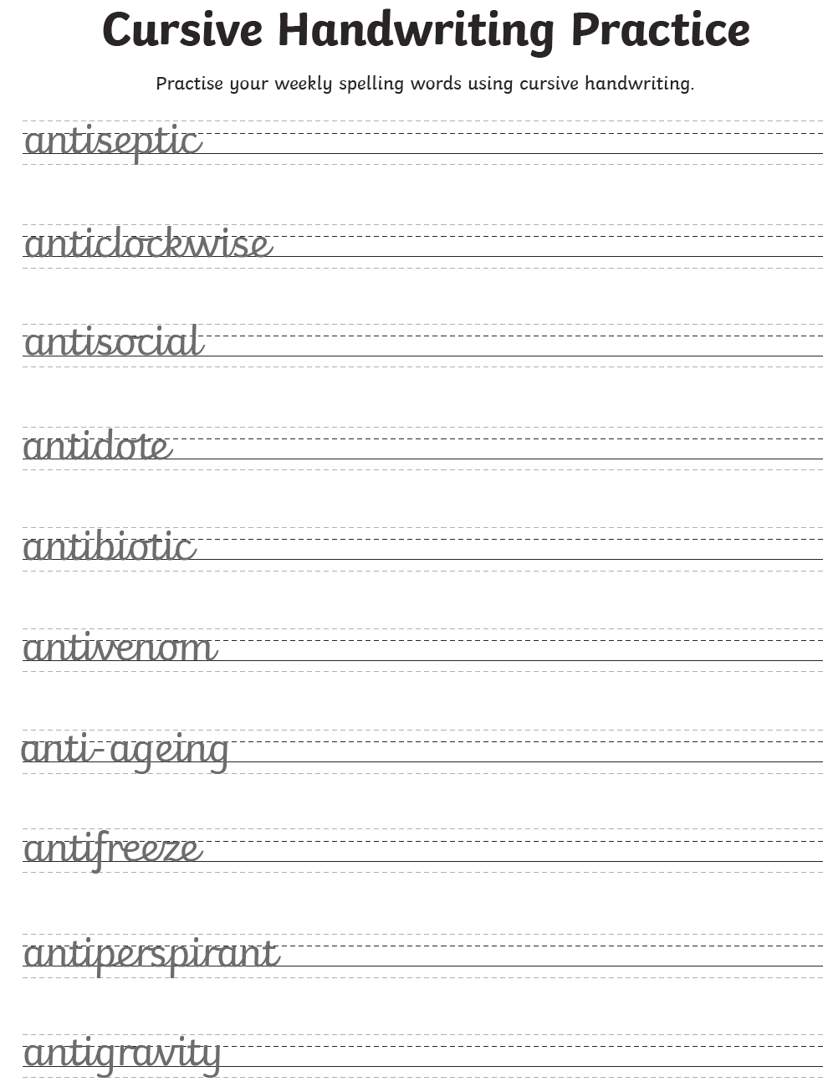
Practise them daily in your neatest cursive handwriting and get a grown up to test you on Friday.

Science

Choose a different task to explore.
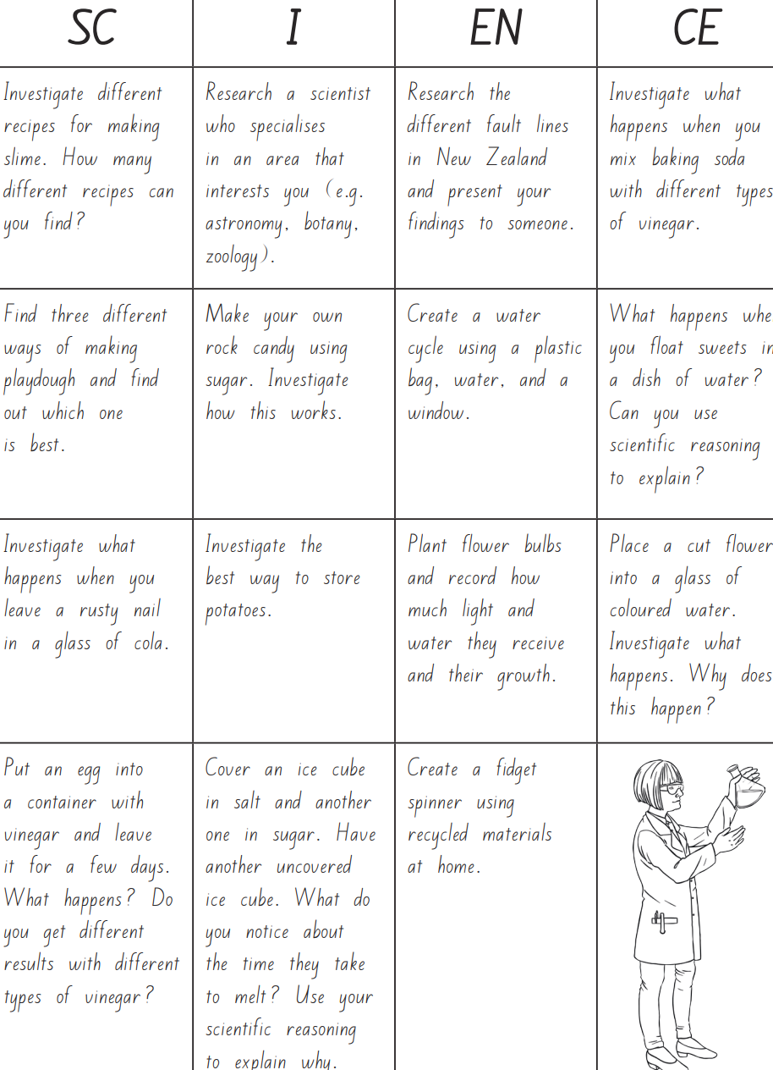

History

For the summer, we will be looking at the Romans. Last week some of you may have started to research the Romans and create a fact file about one of the following areas:-

(a) Roman religions (gods and myths)
(b) Roman sports and leisure (Gladiators, competitions)
(c) Roman army (soldiers and road building)

Next activity – continue with your fact file by researching one of the other areas above.

Alternatively, research how the Roman Empire expanded. Present your findings in your preferred way.

Geography

Find Rome on a map. Research tourist attractions in Rome, particularly those dating back to ancient Rome. Write a description of each attraction and then draw your favourite one. Share on seesaw.
Follow on activity – Britain vs Italy - Research and compare the weather, culture, landscape and climate in both countries. Write a list of similarities and differences. Be as creative as you want in displaying your work.

Art
The floors of Roman people were often richly decorated with mosaics. Mosaics were made from tiny coloured stones, which they called tesserae. Mosaic floors were a statement of how wealthy and important you were.
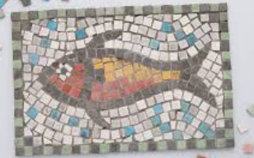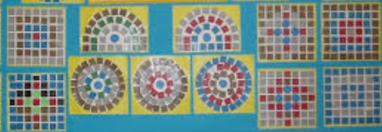
Design and draw your own mosaic picture. You could even cut out some collage materials for your own tesserae.

Music

Create your own times table song.
Alternatively, complete one of the modules on charanga.

French

This week – Follow this link for key vocabulary on pets.
https://view.officeapps.live.com/op/view.aspx?src=https%3A%2F%2Fpln.myvle.co.uk%2Ffiles%2Fsc3490%2Fsc3490%2F76%2F%5B27474%5DFre_Y3_Spr_1_Animals_Work_Organisers_Template.pptx?dt=1587896382

Have a conversation in French about which pets you like. Record and share on seesaw.

Other available lessons
The BBC are also providing a vast range of activities for children. This link will give you three appropriate lessons a day to complete.
https://www.bbc.co.uk/bitesize/tags/z63tt39/year-4-lessons/1

Oak National Academy is a new collection of high-quality lessons and online resources. Backed by the government, you can find a range of lessons with PowerPoints/ videos free at https://www.thenational.academy/

If you have any queries about the work then please contact us via Seesaw or email us at Julie.lane1@taw.org.uk.

Thank you for your continued support.

Warm wishes

Mrs Lane and Mr Warren

