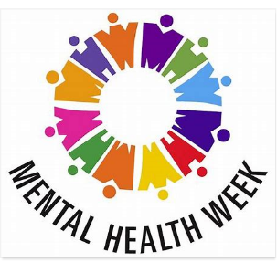
Monday 18th – Friday 22nd May
Mental Health Awareness Week
Year 6

As this week marks mental health week, we though we would give you a series of activities this week that reflect that.
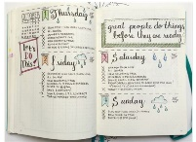
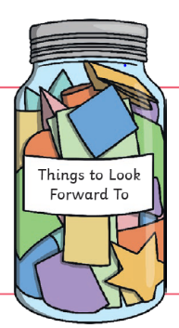
- Complete the attached Wellbeing Daily Diary

- Create a ‘Thigs to Look Forward to Jar’
- Decorate it
- Write things that you are looking forward to on pieces of paper and place them in your jar.
Extension: you could create one for you whole family.

- If you can, go for a walk with your family.
- take photographs
- collect things from nature
- have fun!
- Create memories

- Create a time capsule that captures your life as it is now.

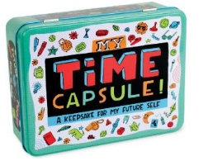
- Add pictures/photographs
- Fill it with things that symbolise this time e.g. face masks, toilet paper
- Add a news article
- Add a list of things you have been doing e.g. films you’ve watched
- Add a letter to your future self
Extension: Ask your whole family to get involved and add things

- Show yourself gratitude by doing the one or some following things:
- Treat yourself with something you like e.g. chocolate
- Have a relaxing bath
- Plan a day of doing no work and fill it what you love
- Ask people in your family to write down something positive about you

- Do some five-minute boredom busters:
- Can you think of a name for each letter of the alphabet e.g. Alice, Ben, Charlie…?
- How many different animal noises can you make in five-minutes?
- Write a new nursery rhyme
- Make three wishes
- Write some jokes
- Send a message to a friend or relative
- Write a quiz
- Create a menu to for perfect meal
- Find each digit from 0-9 in your house and garden
- Do an exercise circuit
- Think of a word, how many other words can you think of to rhyme with it.

**In addition to these activities this week you are still encourage to read daily, go on TT Rockstars and get exercise **

