Year 3 Home learning activities
Week commencing 11th May
English- VE Day!

This week we would like you to write a recount of your VE day. Start from you waking up and recount your whole day. Your last sentence should be about you going to bed. Your title for your recount should be A recount of VE Day.
When you have written please share it with us via seesaw!
This is how you could break this activity up across the week:
Monday- Brainstorm your VE day. What did you do? What did you have to eat? What did you wear? The more ideas the easier you will find it to plan your recount.
Tuesday- Plan your recount. Use your brainstorm to make notes and put them in chronological order (time order). Don’t forget to use Time adverbials e.g. First I woke up and rubbed my sleepy eyes. After that, I jumped out of bed and raced downstairs for breakfast.
Wednesday- Write your Introduction telling us what your recount is about and when it happened. Also write your first paragraph telling us about your morning up until lunchtime.
Thursday- Write your second paragraph telling us about what you did after lunchtime up until tea time.
Friday- Write your final paragraph explaining what you did before you went to bed finishing with you going to bed. Then read back through your whole recount and make sure you edit your work for spellings and punctuation.
Reading- comprehension
As well as reading your books, we would like you to have a go at this comprehension activity.
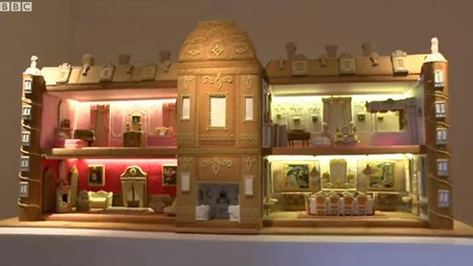
http://www.bbc.co.uk/news/uk-england-beds-bucks-herts-37948540
Gingerbread house of Waddesdon Manor unveiled

Spellings-
Red and Green | Blue and Yellow
Musician | see
Electrician | tree
Magician | green
Politician | meet
Mathematician | week
Optician | seed
Technician | sheep
Beautician | creep
Dietician | weep
Musician | deep

Maths
This week we are going to start using the BBC bitesize resources.
These week the children are learning to multiply and divide by 4 and 8.
Follow this link to the daily lessons- which include a presentation and activity sheets.
https://www.bbc.co.uk/bitesize/tags/zmyxxyc/year-3-and-p4-lessons/1

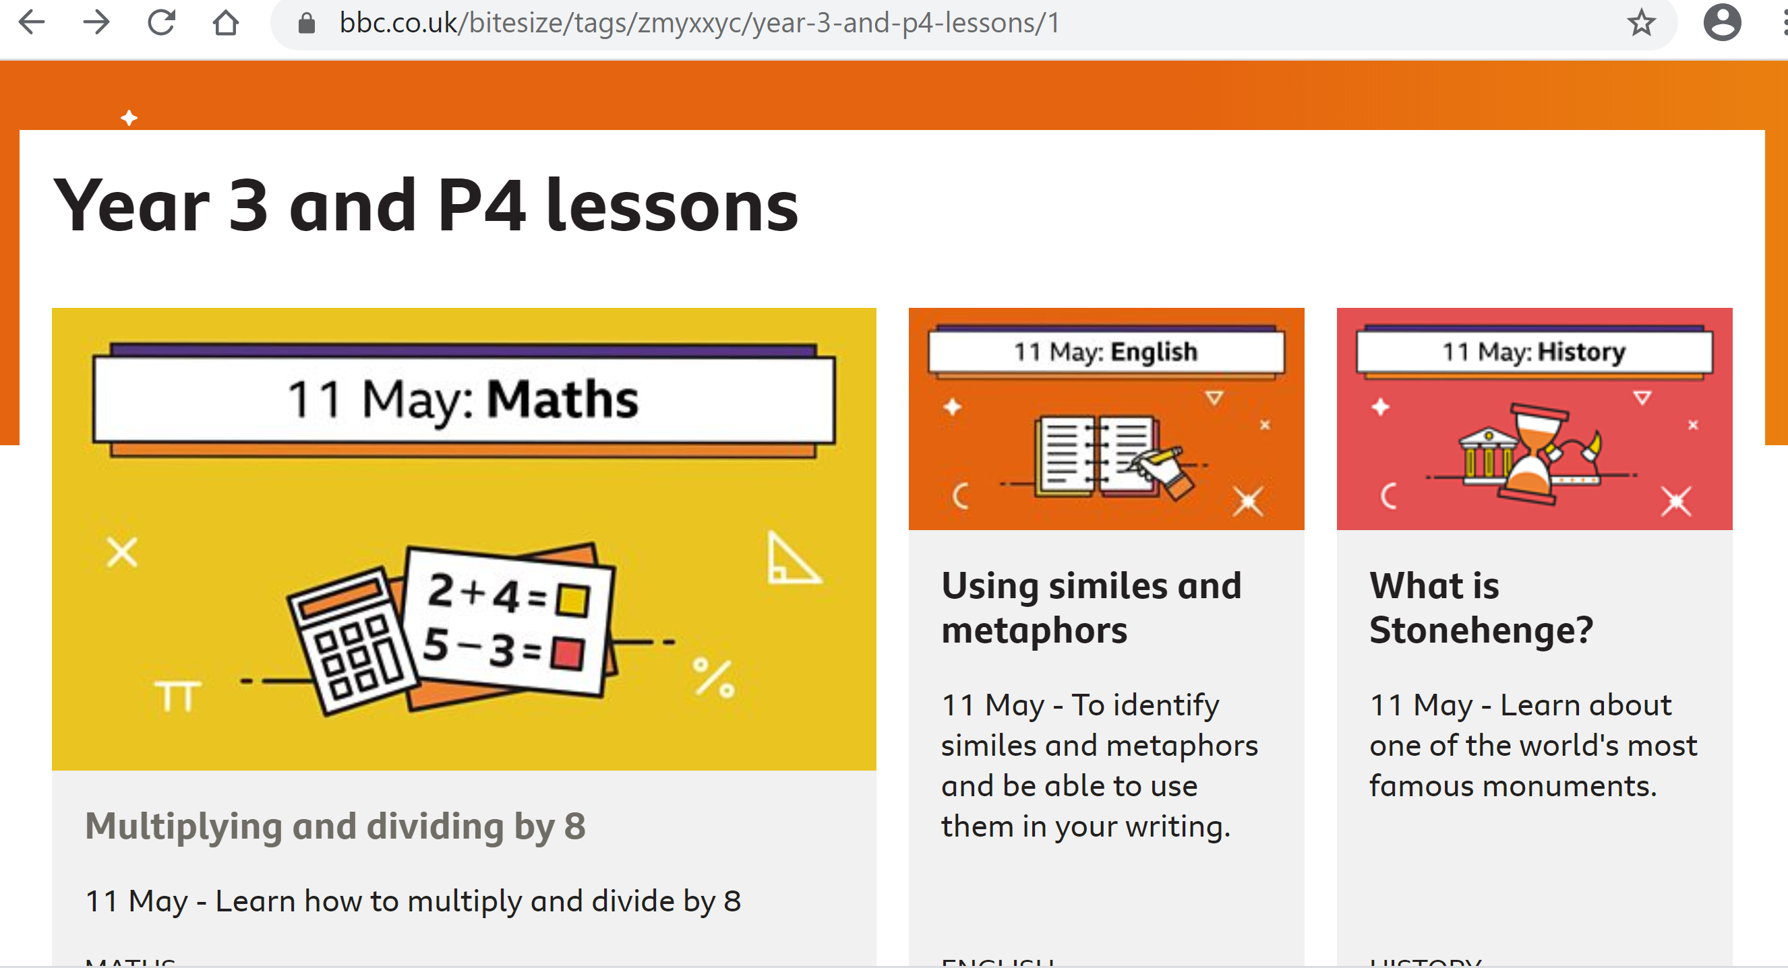

Please take pictures of your child’s work and upload to Seesaw or email your child’s teacher.

Also your child has access to Timetable rock stars at https://play.ttrockstars.com/auth/school/student/16409
If you do not have your child’s log in details- please ask us for them.

Art
This week we would like you to use junk around your house to make something to do with our heroes! For example:
- Emergency service vehicle: ambulance, police car, fire engine, tank, aeroplane.
- A building: hospital, fire station, police station, supermarket.
- A person: nurse, doctor, firefighter. police officer.
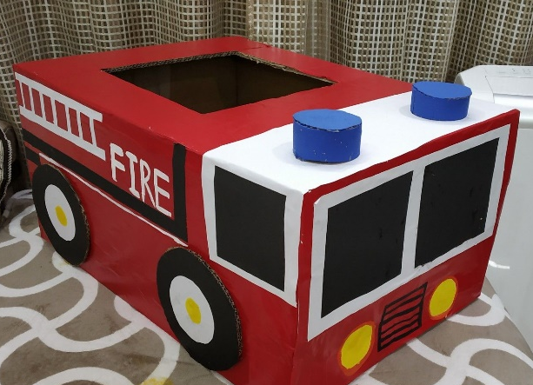
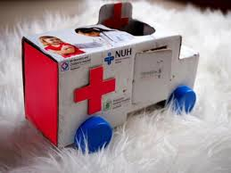
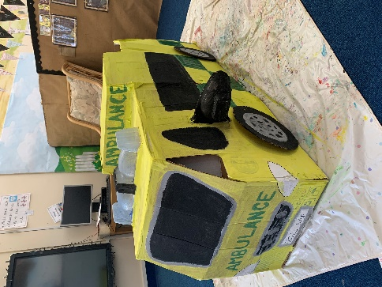

Computing
https://www.barefootcomputing.org/homelearning
Follow this link to play a variety of online, computing games

The BBC are also providing a vast range of activities for children- they are broken up, into year groups.
If you have any questions about what the activity is asking of your child, please ask us.
https://www.bbc.co.uk/bitesize/levels/zbr9wmn

Geography
This week we would like for you to research where rainforests are located. Then label the map of the world with the names of countries that have rainforests in them.

If you have any questions about any of the work set, or to simply allow your child to keep in touch with us- please ensure you have access to your child’s Seesaw account.
You can gain access by emailing us on
sarah.vickers@taw.org.uk
hannah.kibblewhite1@taw.org.uk

