Year 3 Home learning activities
Week commencing 18th May
English-
This week we would like you to write a newspaper article explaining why deforestation is bad for our environment. We have put some videos at the bottom to help you understand what deforestation is and what impact it has on the world, as well as what people can do to help stop it.
When you have written please share it with us via seesaw!
This is how you could break this activity up across the week:
Monday- Watch the videos and make notes (like a news reporter) about what deforestation is and why it is bad for the environment.
Tuesday- Decide on a heading for your article. Remember it needs to be eye catching! Look at other articles in newspapers to give you some inspiration.
Wednesday- Write your first paragraph explaining what deforestation is. Don’t forget to check your punctuation and read your writing back to check it makes sense.
Thursday- Write your second paragraph explaining why it is bad for our environment and the impact it has on the world. Try to use language that will make your reader believe how bad deforestation is for our planet.
Friday- Finally write about what people can do to help with deforestation and help the environment. Make sure you read and edit your work. If you want to you can record yourself reading your article like a news reporter does on the television and share it on seesaw.
https://www.youtube.com/watch?v=yvdfqrnvu6Q
https://www.youtube.com/watch?v=Nc7f5563azs

Reading- comprehension
As well as reading your books, we would like you to have a go at this comprehension activity.
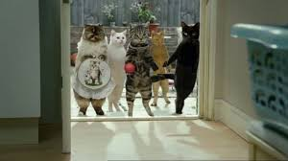
Cravendale ‘opposable thumbs’ advert
https://www.youtube.com/watch?v=EmJhv6W_URY
Spellings-
Red and Green | Blue and Yellow
vein | blue
weigh | new
eight | clue
neighbour | few
they | true
obey | grew
beige | rescue
veil | flew
sleigh | Tuesday
reign | threw

Maths-
This week we are going to begin working on Time.

This is a breakdown of the activity suggestions for each day.

Monday- Use your creative side to make your own analogue clock face. Ensure you place the numbers in the correct place, on the face.
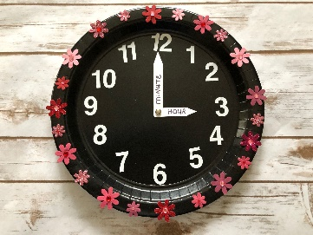
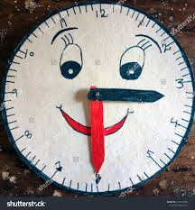
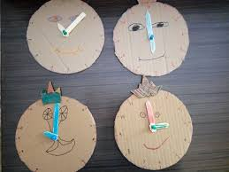

Extra challenge- could you include Roman numerals on your clock face.

Tuesday- Reading time on an analogue clock and a digital clock.
Watch this video first:
https://www.youtube.com/watch?v=sAYiUZSRmk0
Throughout the day record the times of these events on your analogue clock (take a picture) and in a digital format.
- Time you got up.
- Time you had a morning snack.
- Time you ate your lunch.
- Time you went out for some exercise- the time you returned from your exercise.
- Time you ate your tea.
- Time you went to bed.

Wednesday- Converting time between analogue and digital time

Thursday- Explore- how long a minute is.

Watch this video
https://www.youtube.com/watch?v=gEStq1e1Qrc
Now use a one minute timer (you will find one on youtube or a tablet)
And find out how many different things you can do in a minute- for example:
- How many hops can you do in 1 minute?
- How many times can you walk up and down your stairs in a minute?

Share your minute challenges using photos or videos on Seesaw.

Friday- Time word problems

Also your child has access to Timetable rock stars at https://play.ttrockstars.com/auth/school/student/16409
If you do not have your child’s log in details- please ask us for them.

Science
This week we would like you label the parts of the body. You could do this by: drawing around yourself with chalk, drawing a skeleton in your book or printing one. See if you can use these scientific names to label the parts.

Computing
https://www.barefootcomputing.org/homelearning
Follow this link to play a variety of online, computing games

PSHE
This week marks mental health awareness week.
With this is in mind, here are some suggestions of activities that you can complete.
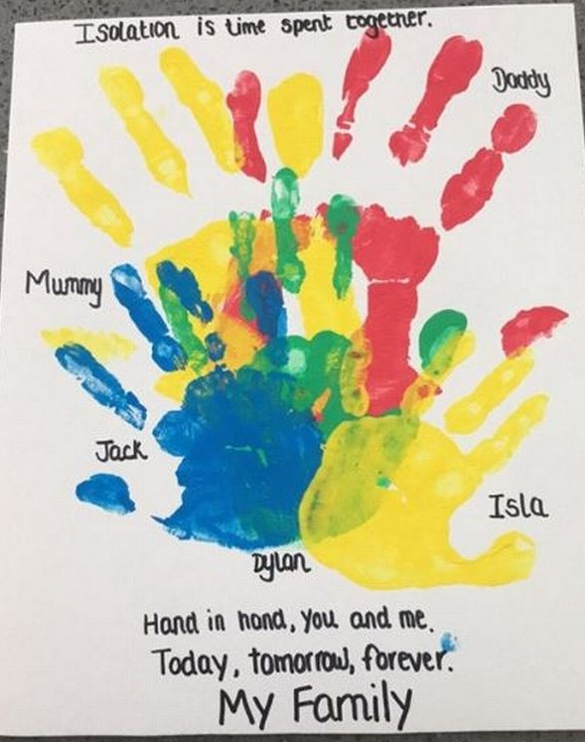
Create a family piece of art, to remember you spent isolation with loved ones.

Make a wish jar.

Reflect on your week.

If you have any questions about any of the work set, or to simply allow your child to keep in touch with us- please ensure you have access to your child’s Seesaw account.
You can gain access by emailing us on
sarah.vickers@taw.org.uk
hannah.kibblewhite1@taw.org.uk

Have a wonderful week.
We miss you all very much.
Mrs Vickers and Mrs Kibblewhite.

