Year 3 Home learning activities
Week commencing 4th May
English- Rainforests!
Our topic this term would have been rainforests.
This week we would like you to write either a haiku poem or an acrostic poem about your rainforest animal!
When you have written it record yourself performing it and upload it to seesaw. Watch the video below of Michael Rosen performing a poem so you can see the expression they use. Also watch Michael Rosen’s top tips for performing poems and stories.
This is how you could break this activity up across the week:
Monday- look back at the research you did about your animal. Choose which poem you would like to write. Start to plan out your ideas for each line.
Tuesday- Write up your poem in best and draw pictures or make props to make your performance more interesting.
Wednesday- Practise your performance in front of a mirror or family member.
Thursday- Record your final performance. Then evaluate your performance. What went well? What would you change if you did it again?
https://www.youtube.com/watch?v=Akwm2UZJ34o

https://www.youtube.com/watch?v=RvV23xoZRkI

Reading- comprehension
As well as reading your books, we would like you to have a go at this comprehension activity.
Frisbee by Brian Bilston
Frisbee whizzing
Through the air
Above our heads,
Over the sand,
Into the water,
Onto the waves,
Out to sea.

You cried a lot that day.
Frisbee was a lovely dog.

Spellings-
Red and Green | Blue and Yellow
division | better
invasion | under
confusion | summer
decision | winter
collision | sister
television | dinner
occasion | driver
conclusion | sweeter
explosion | camper
erosion | flower

Create a word search using your spellings- ask a family member to complete the word search.

Maths- Whiterose
Follow this link to Whiterose resources
https://whiterosemaths.com/homelearning/year-3/
This week is Money.

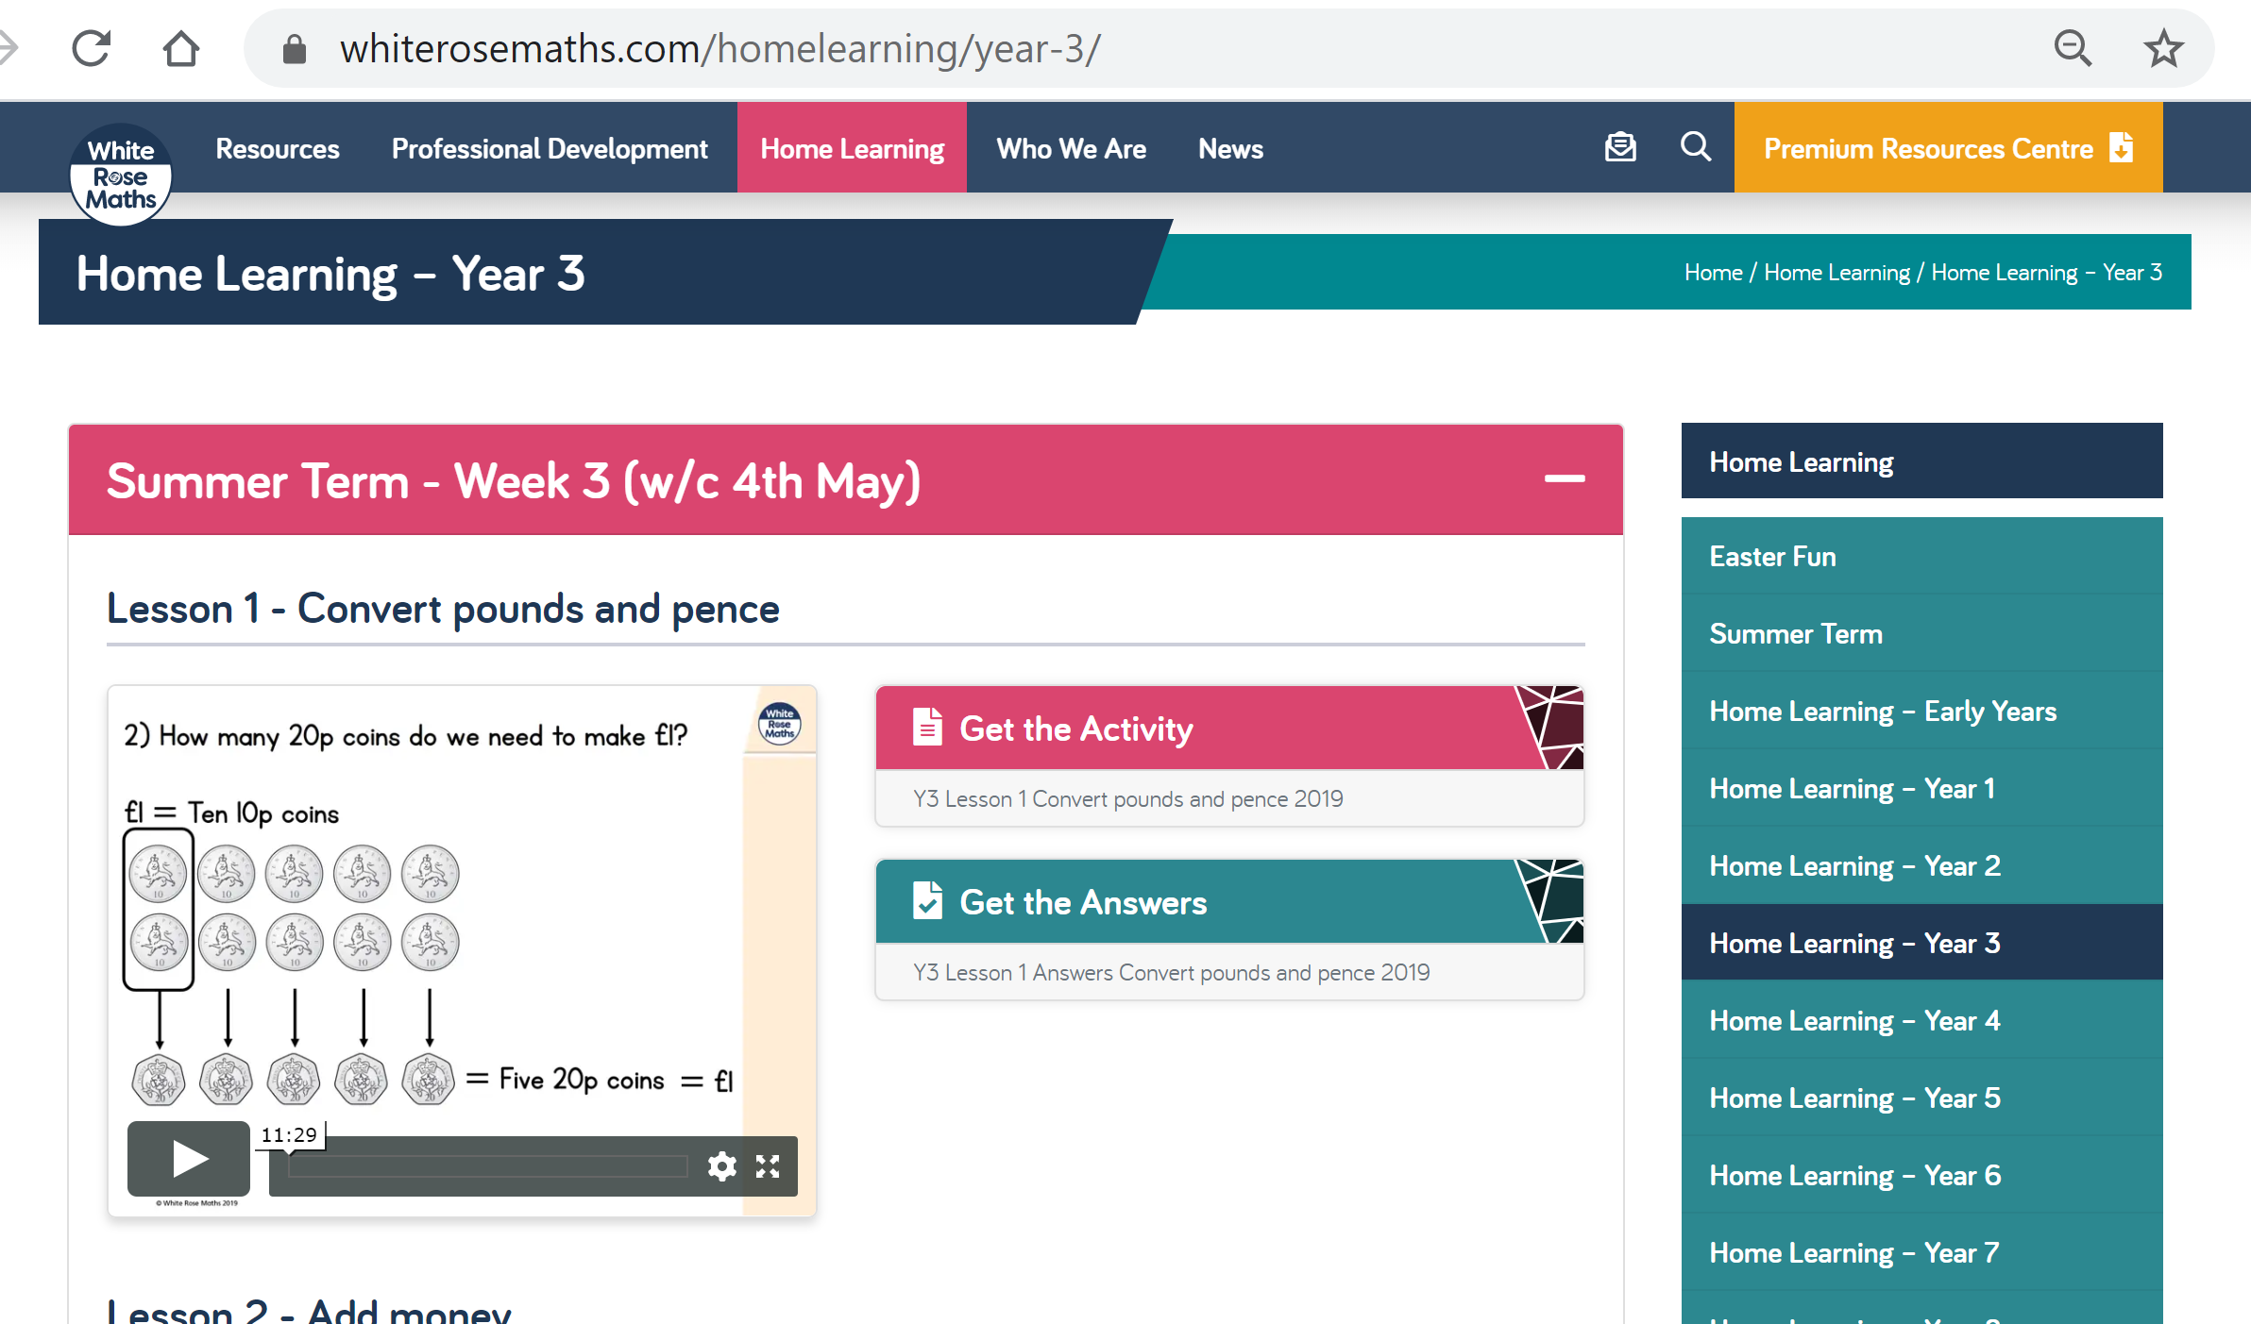

Ensure you click on the summer term heading. Week commencing 4.05.2020. There are videos for each day’s activity, then some questions- you can print these off or have them up on your screen for your child to use.

There is also an answer page, to check your child understands what the question is asking.
Please take pictures of your child’s work and upload to Seesaw or email your child’s teacher.

Also your child has access to Timetable rock stars at https://play.ttrockstars.com/auth/school/student/16409
If you do not have your child’s log in details- please ask us for them.

Science- This week we would like you to be weather reporters. Keep a weather diary and see if you can spot any signs of spring. You can draw a weather map using symbols or even record yourself reporting the weather like they do on the television! We would love to see what you do so please upload it onto seesaw!
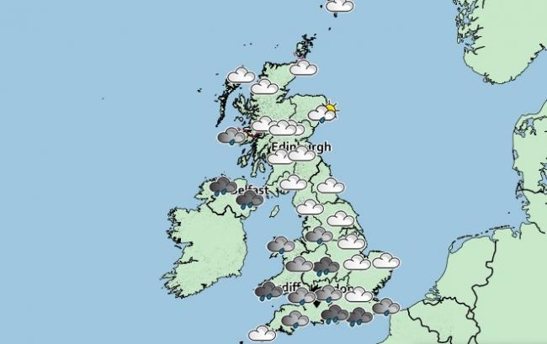
Computing
https://www.barefootcomputing.org/homelearning
Follow this link to play a variety of online, computing games

The BBC are also providing a vast range of activities for children- they are broken up, into year groups.
If you have any questions about what the activity is asking of your child, please ask us.
https://www.bbc.co.uk/bitesize/levels/zbr9wmn

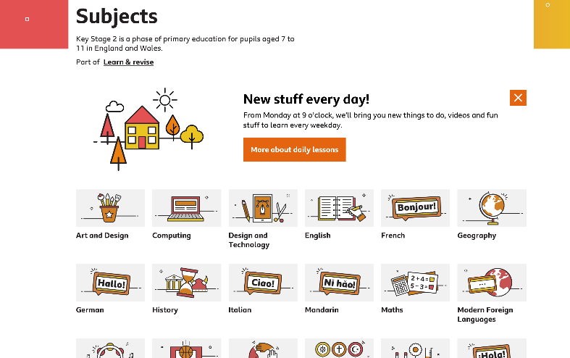

Geography

Last week you researched the different layers of the rainforest. You will have discovered that animals live in the different layers and have different features to allow them to survive their surroundings. This week we would like you to create your own animal that could survive in all of the layers. Draw your animal and the label the features. Get creative.
If you have any questions about any of the work set, or to simply allow your child to keep in touch with us- please ensure you have access to your child’s Seesaw account.
You can gain access by emailing us on
sarah.vickers@taw.org.uk
hannah.kibblewhite1@taw.org.uk

