Year 4 – Weekly activities – home learning - week commencing 4th May 2020

Some ideas of activities for learning at home.

This Friday will be 75 years since the end of the Second World War in Europe so we have based some of this week’s activities linked to World War 2. Children can choose how they wish to present their work for example – through PowerPoint, poster, written etc.

Maths – Summer Term

There are four weeks of different lessons, many of you have been doing these while we have been off so may have completed all four. If not why not choose the areas you have not covered yet. Each lesson has a video for your child to watch to explain each day’s activity, followed by some questions, which you can either print off or keep on screen for your child to use.

There is also an answer page, to check your child understands what the question is asking.
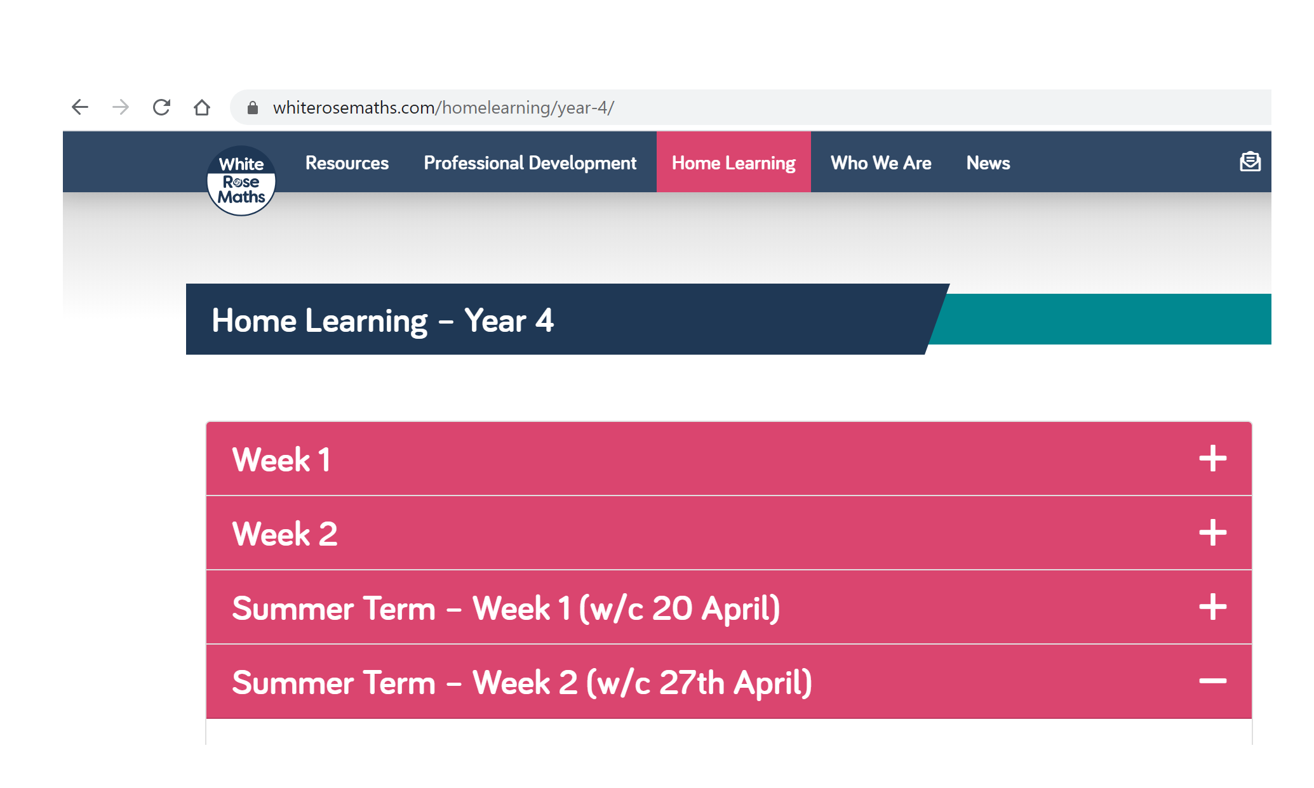
Add to your seesaw journal how you have found each lesson.

https://whiterosemaths.com/homelearning/year-4/
White rose are continuing to offer free PowerPoints to watch linked to year 4 themes (this next set is multiplication and division). However, they are not offering free worksheets. If you have enjoyed watching these PowerPoints please email us for worksheets to complement their PowerPoints.

Alternatively, if you have finished all of these, then why not try one of the following https://www.thenational.academy/online-classroom/year-4/maths#subjects, which has 10 lessons on area and perimeter. This site is backed by the government and has PowerPoints of teachers running the lesson.
Alternatively, Hamilton home learning packs - 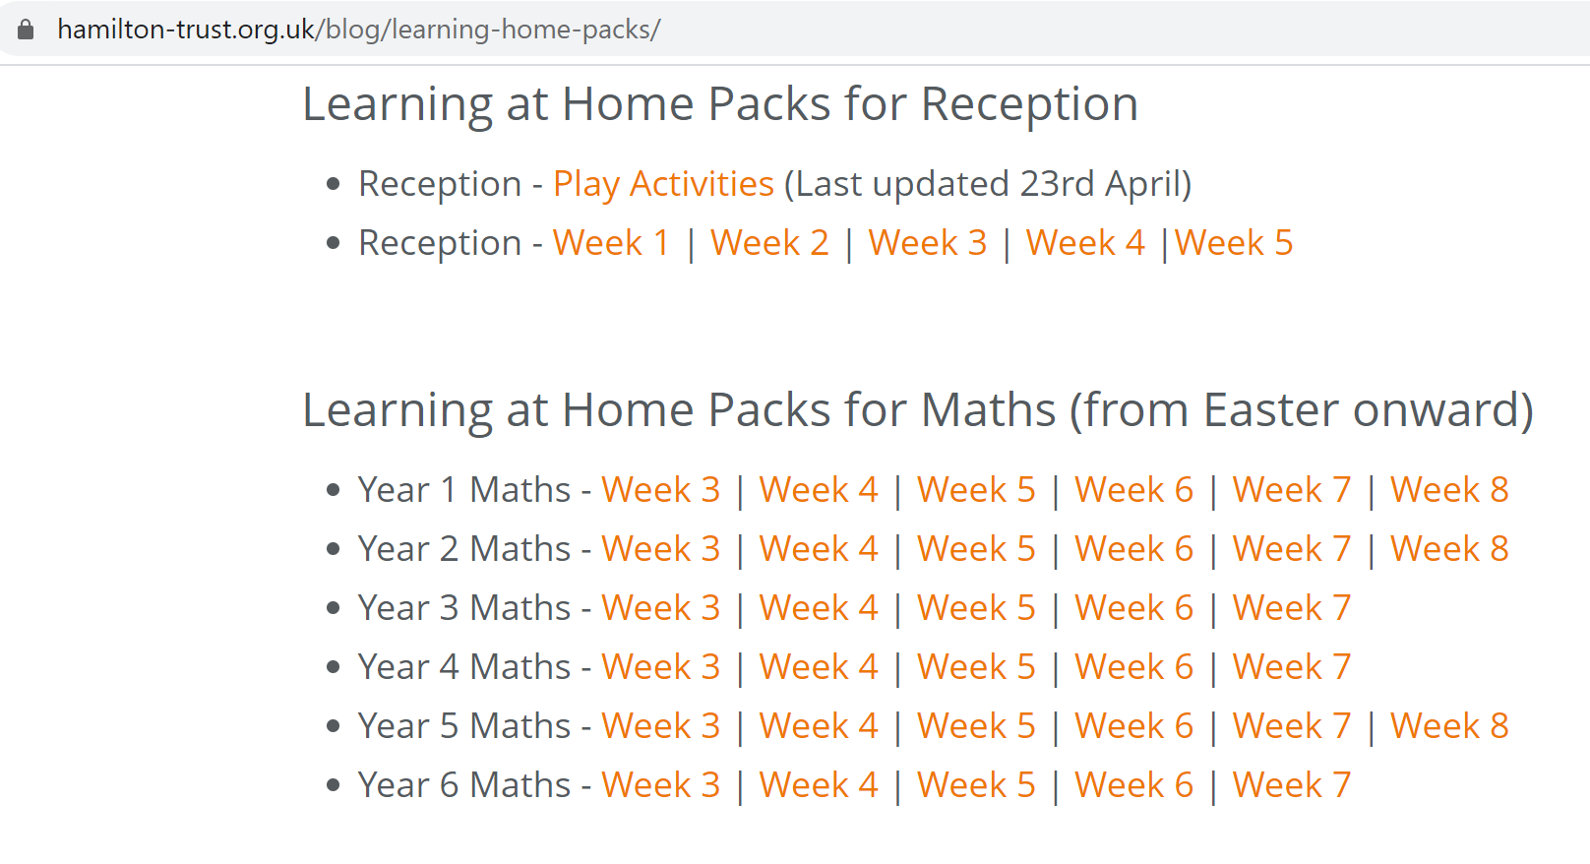

Keep up the good work on times table rock stars.

OTHER FUN MATHS ACTIVIES

Roll three dice – What is the biggest number you can make using these three numbers?
What is the smallest number you can make using these three numbers?
What is the difference between the two numbers?

English

Fancy some creative writing? Try one of the following activities:

Option 1 - Pie Corbett’s English talk for writing resources - https://www.talk4writing.co.uk/wp-content/uploads/2020/04/Y4-Maria-Aliens.pdf

Option 2 - https://www.pobble365.com/ every day, you will find an interesting picture, writing prompts and philosophical questions to spark creative writing.

OR

Use Hamilton Trust free home learning resources
https://www.hamilton-trust.org.uk/blog/learning-home-packs/
Please do not worry if you are still completing last week’s work, just work at your child’s own pace through the different weeks.

Click on Year 4 English – week 6

There are a series of lessons to follow including PowerPoints to assist with completing the tasks. Complete the tasks at your own pace.

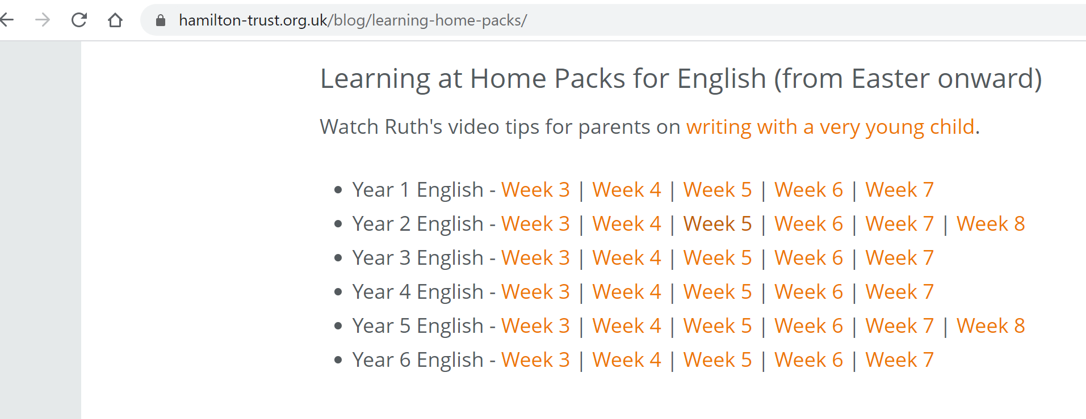

Reading

Well done if you managed to make a reading den. We have loved seeing many of your photos. If not why not try this week. This could be indoors or outdoors, depending on the weather!

Click on the link below to see some examples!

https://www.google.com/search?q=homemade+den+children&tbm=isch&rlz=1C1CHBF_en-GBGB811GB811&hl=en&ved=2ahUKEwjuhOj9-cPoAhVedRQKHWO0ArgQBXoECAEQJQ&biw=1349&bih=608

Read for 20 minutes a day. When you have completed a book, write a book review about what you have read. How does the story make you want to keep reading? Write down the phrases and words that you find effective in gripping the reader.

Try reading a non-fiction book this week. If possible, read some literature linked to World War 2.

Optional ideas after reading – Find the meanings of any words you have not heard of before. Now write a few sentences using these words.

Computing
Each week try one different computing activity.
Barefoot Computing have put together some free home learning resources to help. With fun lesson-based activities and interactive games, children can work together with their families to develop their computational thinking skills. Choose one to try through https://www.barefootcomputing.org/homelearning.

Create a game on scratch https://scratch.mit.edu/

Have a go at one of the free scratch code club modules; there are free guides to complete each module.
https://projects.raspberrypi.org/en/codeclub/scratch-module-1

PE
Daily exercise is an essential part of healthy living. Many of you have been following Jo Wicks, keep up the hard work with these daily sessions https://www.youtube.com/user/thebodycoach1/video or if you fancy a change try one of the super mover videos https://www.bbc.co.uk/teach/supermovers .
Alternatively, why not try PE with our very own Mr Stevens – use the link from the school website.

RE

Try a different one each week - free home learning activities from NATRE
https://www.natre.org.uk/uploads/Free%20Resources/2%207-11%20RE%20Today%20and%20NATRE%20home%20learning%20Spirited%20Arts.pdf

Spellings

This week’s spellings are
Practise them daily in your neatest cursive handwriting and get a grown up to test you on Friday.
EXTRA SPELLING FUN – visit https://spellingframe.co.uk/ - click on year 3 and 4 – choose the spelling rule you want to explore and click on free spelling tiles game.

Science

Choose a different task to explore each week.
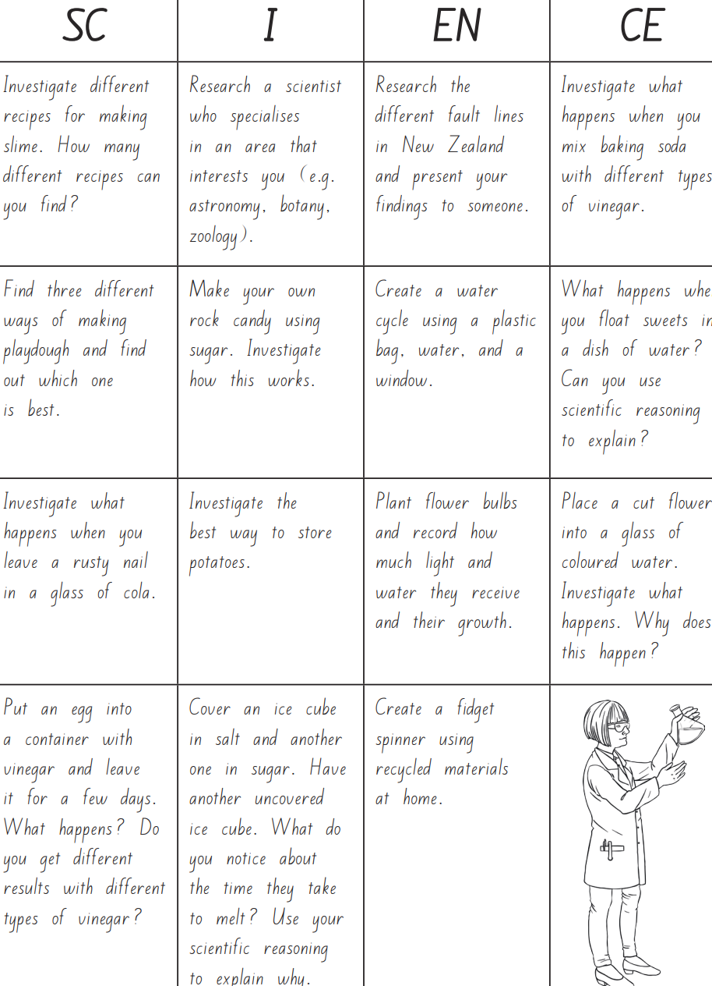

History

For this week, we have a special focus on VE day.

Activity 1

Research the history behind this day. What makes it so special?

Or

Activity 2

Read the following 2 accounts, then answer the questions below.

Account 1

This is an account of VE day from a child at the time.
“For the party, everyone on the street had to give up 2 shillings to help pay for it. In addition, everyone gave two teaspoons of tea and two teaspoons of sugar too so that everyone could have tea to drink. When the party was about to start, everyone had to take out a chair, and sheet to make a tablecloth. A poor family did not have any but neighbours brought out spares for them. They also let them join in even though they could not afford to pay the 2 shillings people had contributed because everyone was rallying together. There was a piano, singing, dancing and an accordion. People that could bake made buns. There was sandwiches with either fish or meat paste in them as there still was not much food about. It was the first real jollity we grew up with because I was a toddler when the war started – there were never any celebrations because of the blackout conditions.”

Account 2

This is another account of VE day from a child at the time.
“I remember my mother made some bunting as she was a dressmaker and was good with a sewing machine. They were red, blue and white. Rectangles of paper sewn onto a string. She did lots of them, I think she collected material and held on to it and kept it for all sorts of reasons. We found loads when she died.
There was dancing going on in the street but I did not understand it, as I was a little lad. Some sort of music was playing but it was not in our street. I did not fully understand why they were doing it. It was a radio playing on the street from one of the houses. The street was two rows of houses facing each other and people were dancing in the middle of it. I don’t remember a party or food as such.”

Questions

(1) What is the difference between account 1 and account 2?
(2) Using the text, what can you tell me about the VE day celebrations?
(3) Is there anything that surprises you? Why?
(4) Would this happen now? Explain your answer.
(5) What questions would you ask to someone who was there?

Geography

Continuing with the VE day theme for this week, choose one of the following activities –
Activity 1 – Research the countries involved in World War 2

Activity 2 – Research the impact that World War 2 had on our country. What impact did it have on the environment?

Art
Activity 1 – Make some bunting ready for your VE day picnic. See ideas attached to website.

Activity 2 - Design a medal ready to wear at your VE day picnic on Friday 8th May 2020.
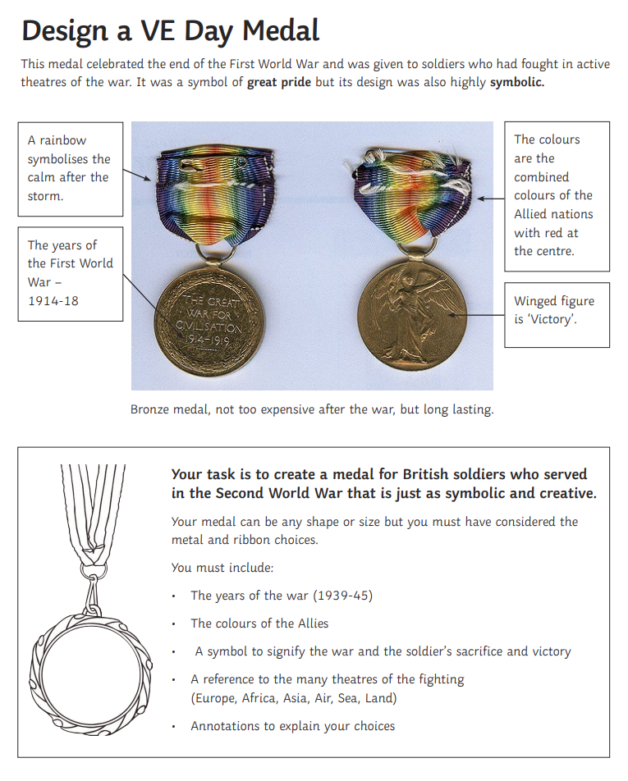

Music

During the war, many people liked to listen to music and songs, just as we do today, but they could only listen to music on the radio or play songs using their own instruments. Here are some of the songs that they might have listened to during that time. You might like to learn some of these songs with your family.

Pack up your trouble/ Long way to Tipperary: https://www.youtube.com/watch?v=FsynSgeo_Uo

Think about the following questions –
(1) How would the soldiers have felt about these songs?
(2) Would the songs have helped them during the war? Explain your answer.

Alternatively, complete one of the modules on charanga.

DT
Can you make some of the wartime recipes attached?
Help prepare your VE day picnic for Friday.

PSHE
Should we continue to remember VE day? Is VE day more important or less important than it was 50 years ago?

French
Try some French fun - Dragons and unicorns
https://view.officeapps.live.com/op/view.aspx?src=http://pln.myvle.co.uk/files/sc3490/websites/lspace_42/resources/__78aace1cf9e7cdbac0efec7834edaaba.pptx%3frd=1

Other available lessons
The BBC are also providing a vast range of activities for children. This link will give you three appropriate lessons a day to complete.
https://www.bbc.co.uk/bitesize/tags/z63tt39/year-4-lessons/1

Oak National Academy is a new collection of high-quality lessons and online resources. Backed by the government, you can find a range of lessons with PowerPoints/ videos free at https://www.thenational.academy/

If you have any queries about the work then please contact us via Seesaw or email us at Julie.lane1@taw.org.uk.

Thank you for your continued support.

Warm wishes

Mrs Lane and Mr Warren

