Year 4 – Weekly activities – home learning - week commencing 11th May

Some ideas of activities for learning at home.

Maths – Summer Term

There are four weeks of different lessons, many of you have been doing these while we have been off so may have completed all four. If not why not choose the areas you have not covered yet. Each lesson has a video for your child to watch to explain each day’s activity, followed by some questions, which you can either print off or keep on screen for your child to use.

There is also an answer page, to check your child understands what the question is asking.
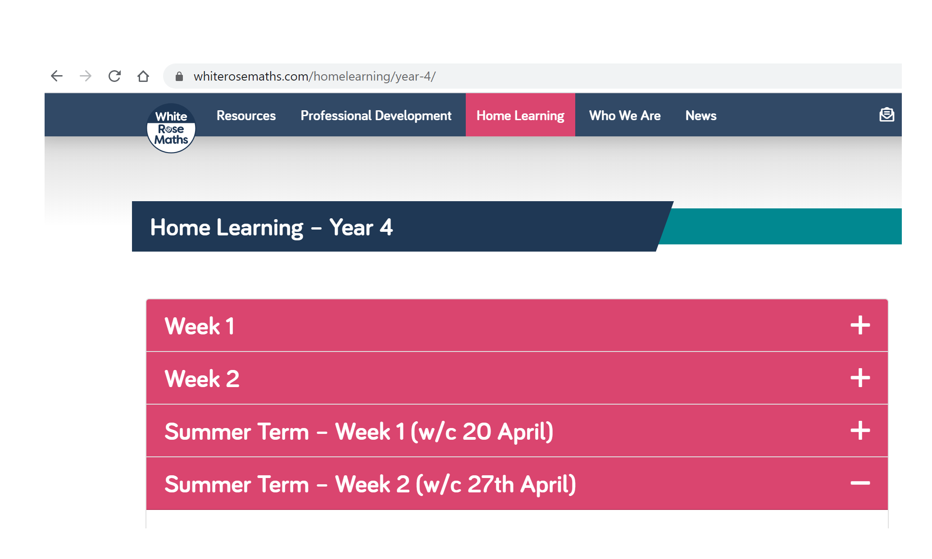
Add to your seesaw journal how you have found each lesson.

https://whiterosemaths.com/homelearning/year-4/
White rose are continuing to offer free PowerPoints to watch linked to year 4 themes (this next set is multiplication and division). However, they are not offering free worksheets. If you have enjoyed watching these PowerPoints please email us for worksheets to compliment these PowerPoints.
Alternatively, if you have finished all of these, then why not try one of the following https://www.thenational.academy/online-classroom/year-4/maths#subjects, which has 10 lessons on area and perimeter or 5 lessons on measurement. This site is backed by the government and has PowerPoints of teachers running the lesson.
Alternatively, Hamilton home learning packs - 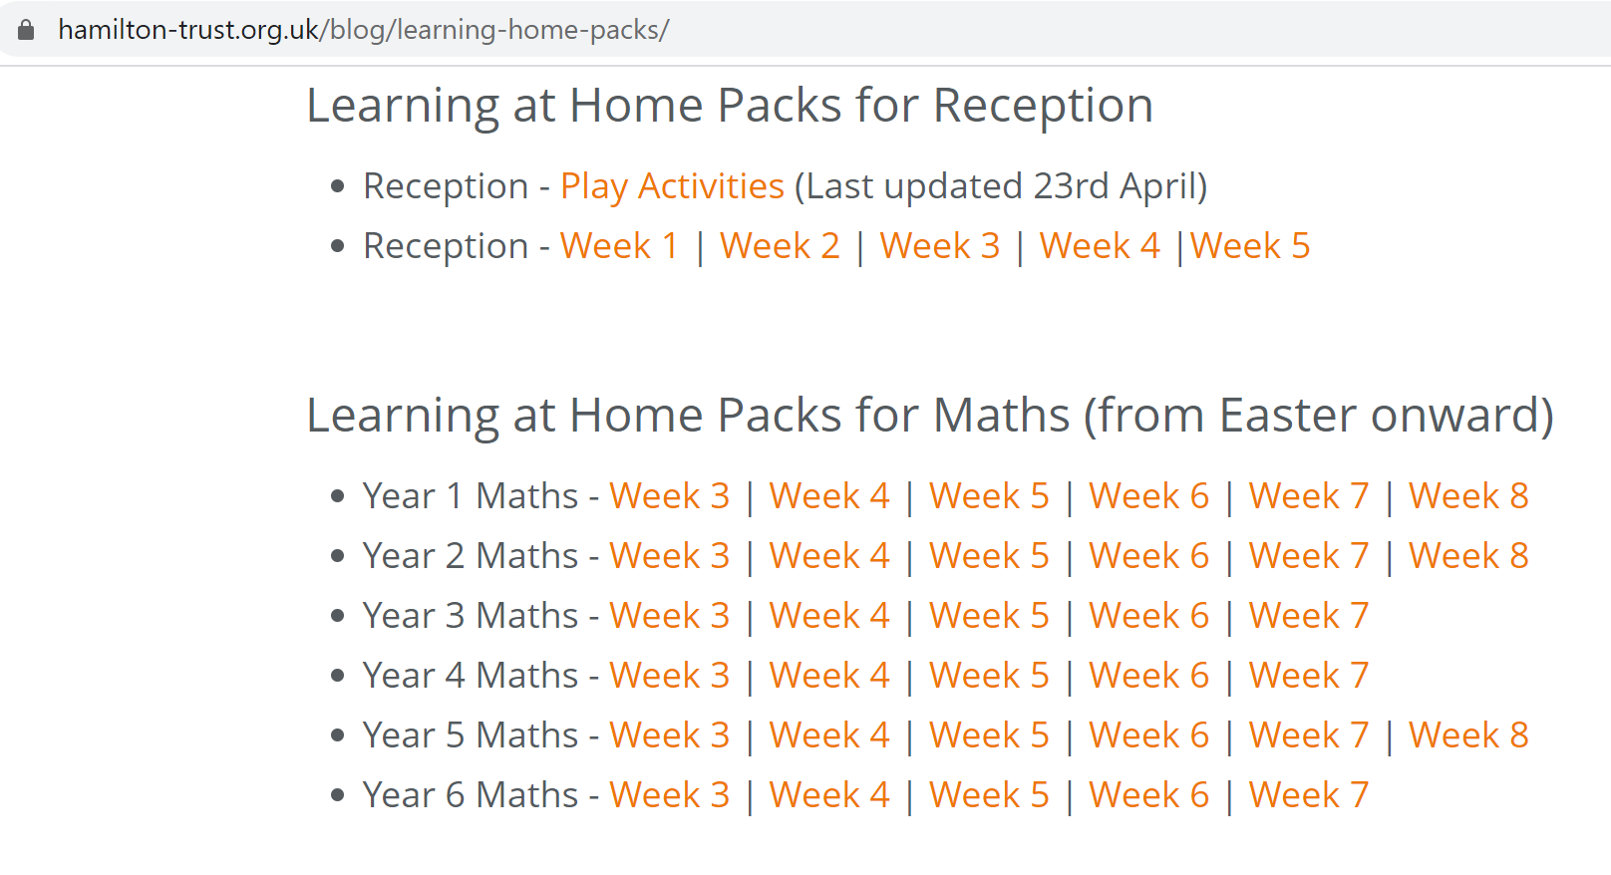

Keep up the good work on times table rock stars.

OTHER FUN MATHS ACTIVIES

Roll three dice – What is the biggest number you can make using these three numbers?
What is the smallest number you can make using these three numbers?
What is the difference between the two numbers?

English

Fancy some creative writing? Try one of the following activities:

Option 1 - Pie Corbett’s English talk for writing resources - https://www.talk4writing.co.uk/wp-content/uploads/2020/04/Y4-Maria-Aliens.pdf

Option 2 - https://www.pobble365.com/ every day, you will find an interesting picture, writing prompts and philosophical questions to spark creative writing.

OR

Use Hamilton Trust free home learning resources
https://www.hamilton-trust.org.uk/blog/learning-home-packs/
Please do not worry if you are still completing last week’s work, just work at your child’s own pace through the different weeks.

Click on Year 4 English – week 7

There are a series of lessons to follow including PowerPoints to assist with completing the tasks. Complete the tasks at your own pace.

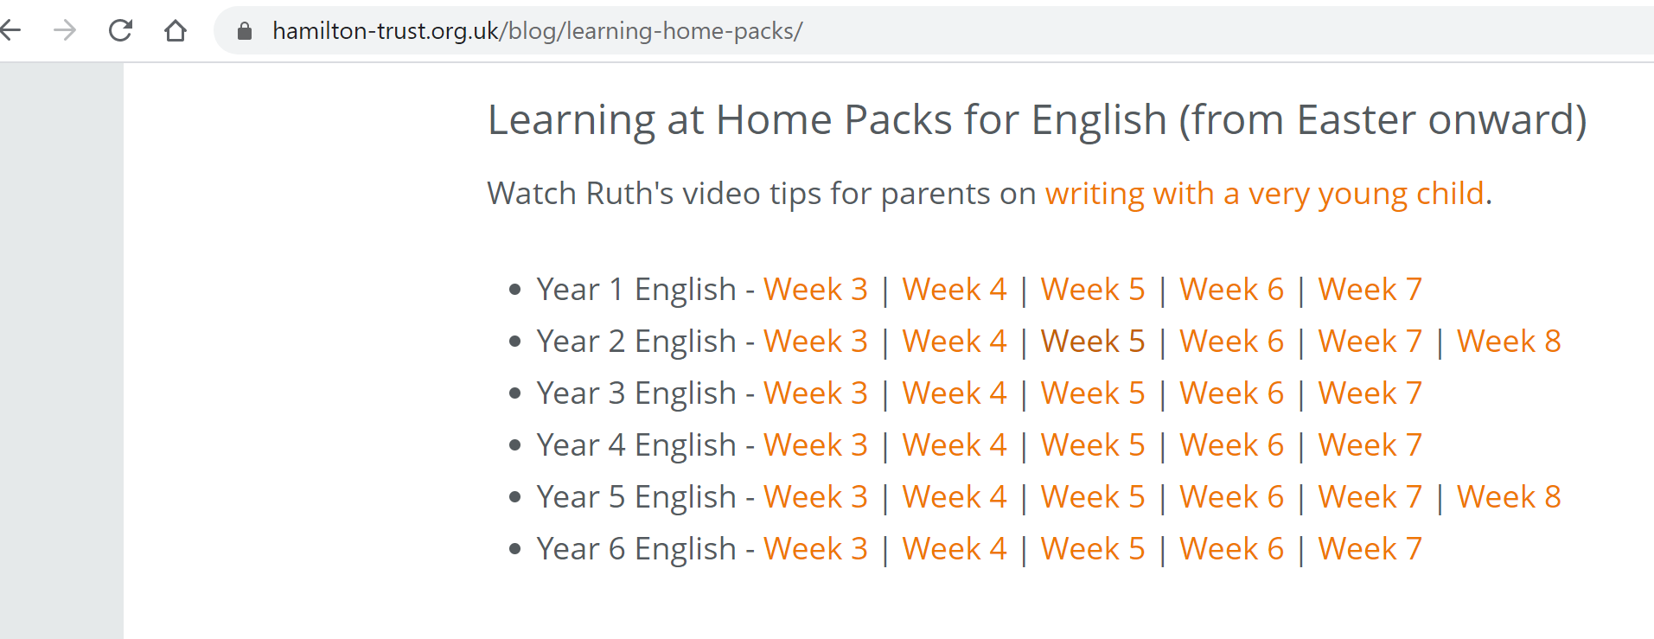

Reading

Read for 20 minutes a day. When you have completed a book, write a book review about what you have read. How does the story make you want to keep reading? Write down the phrases and words that you find effective in gripping the reader.

Optional ideas after reading –

Choose a descriptive passage and make a list of examples of vivid imagery – similes, metaphors, alliteration, powerful verbs, adjectives and adverbs etc

Choose a key moment in the book and change the event. Re-write the following chapter.

Re-write a chapter as a play-script.

Computing
Each week try one different computing activity.
Barefoot Computing have put together some free home learning resources to help. With fun lesson-based activities and interactive games, children can work together with their families to develop their computational thinking skills. Choose one to try through https://www.barefootcomputing.org/homelearning.

Create a game on scratch https://scratch.mit.edu/

Have a go at one of the free scratch code club modules; there are free guides to complete each module.
https://projects.raspberrypi.org/en/codeclub/scratch-module-1

PE
Daily exercise is an essential part of healthy living. Many of you have been following Jo Wicks, keep up the hard work with these daily sessions https://www.youtube.com/user/thebodycoach1/video or if you fancy a change try one of the super mover videos https://www.bbc.co.uk/teach/supermovers .
Alternatively, why not try PE with our very own Mr Stevens – use the link from the school website.

RE

Try a different one each week - free home learning activities from NATRE
https://www.natre.org.uk/uploads/Free%20Resources/2%207-11%20RE%20Today%20and%20NATRE%20home%20learning%20Spirited%20Arts.pdf

Spellings
This week’s spellings are
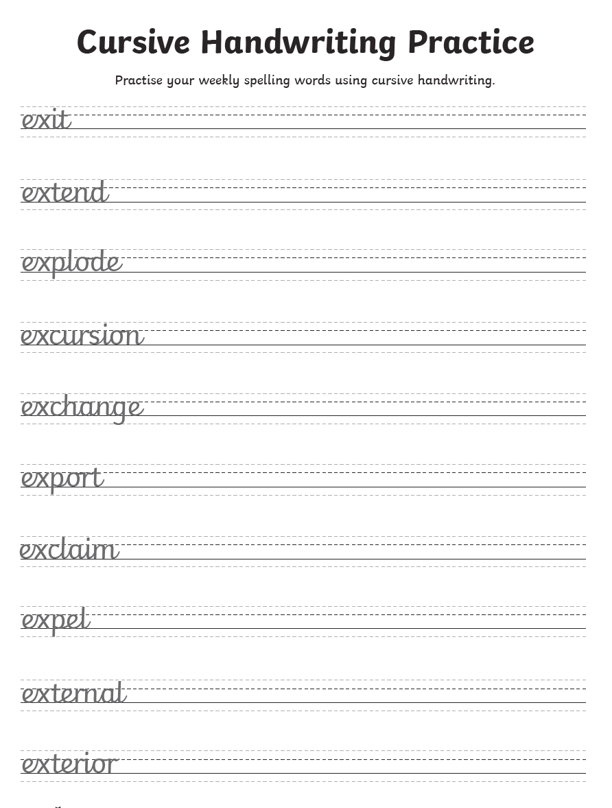
Practise them daily in your neatest cursive handwriting and get a grown up to test you on Friday.
EXTRA SPELLING FUN – visit https://spellingframe.co.uk/ - click on year 3 and 4 – choose the spelling rule you want to explore and click on free spelling tiles game.

Science

Choose a different task to explore each week.
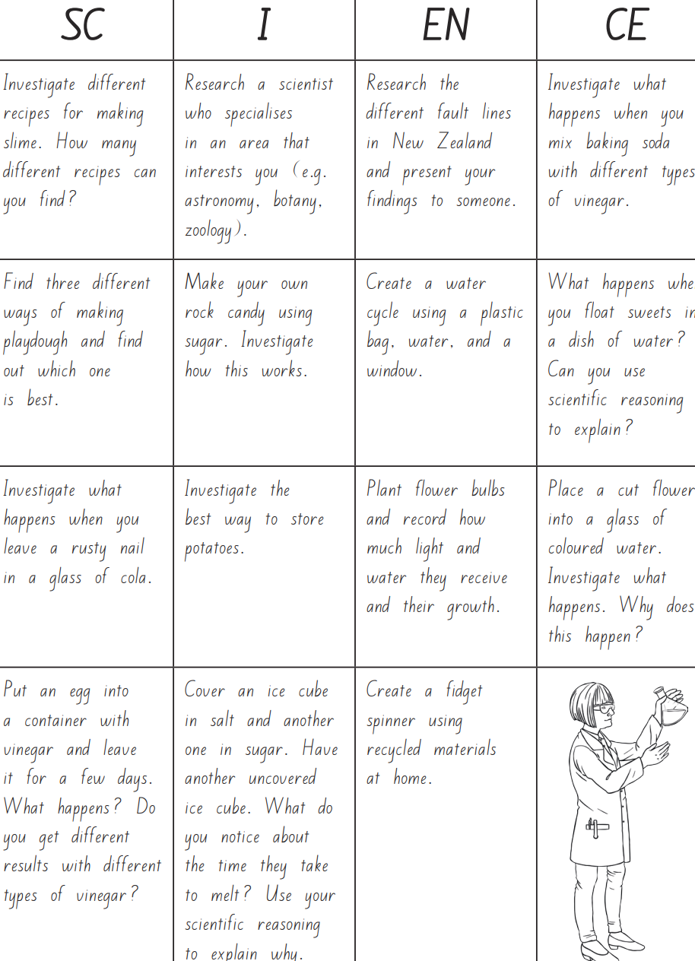
History

THE ROMAN EMPIRE AND ITS EFFECT ON BRITAIN

Watch this history clip at https://www.bbc.co.uk/teach/class-clips-video/history-ks2-the-roman-empire-and-its-effects-on-britain/zrvs382

Follow on activity:-

Write a diary as though you are Julius Caesar talking about the Celts, describing what they looked like, what you (as Julius Caesar) thought of them and what you think of Britain.
Then write a diary as though you are a Celt explaining your feelings about the Roman invasion, what you thought of the Romans and the differences between them.
OR

CHILDREN IN ROMAN BRITAIN

Watch this history clip - https://www.bbc.co.uk/teach/class-clips-video/history-ks2-children-in-roman-britain/zv7mrj6

Follow on activity:-

Compare the life of a Roman child to your own. Would you like to be a Roman child?
Write a diary as a Roman child, describing what their life was like and the differences between the lives of boys and girls.

Geography

A MAP OF ROMAN ROADS
Watch this short clip - https://www.bbc.co.uk/bitesize/clips/zdgrkqt
Create your own map of Roman roads. Use websites and an atlas to see if any Roman roads are still in use today. What would the characteristics of a Roman road be?

Art

Using the attached document draw your favourite Roman god or goddess.

Music

Which times table do you find the hardest to remember? Create your own times table song to help you.

Alternatively, complete one of the modules on charanga.

DT

Design and make a Roman shield
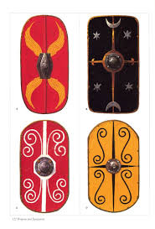

PSHE
People who help us - See attached worksheet.

French
Try some French fun - Dragons and unicorns
https://view.officeapps.live.com/op/view.aspx?src=http://pln.myvle.co.uk/files/sc3490/websites/lspace_42/resources/__78aace1cf9e7cdbac0efec7834edaaba.pptx%3frd=1

OR
Learn some basic ways to express your feelings in French https://www.youtube.com/watch?v=0CI1QKl6yEM&list=PLXMCXZunVHHcqhZxPnk0UINhhDjNVNJlZ&index=3&t=0s

Other available lessons
The BBC are also providing a vast range of activities for children. This link will give you three appropriate lessons a day to complete.
https://www.bbc.co.uk/bitesize/tags/z63tt39/year-4-lessons/1

Oak National Academy is a new collection of high-quality lessons and online resources. Backed by the government, you can find a range of lessons with PowerPoints/ videos free at https://www.thenational.academy/

If you have any queries about the work then please contact us via Seesaw or email us at Julie.lane1@taw.org.uk.

Thank you for your continued support.

Warm wishes

Mrs Lane and Mr Warren

