Year 4 – Weekly activities – home learning - week commencing 18th May

Some ideas of activities for learning at home. This week is mental health week so we have included activities to reflect this.

Create a self-praise jar.
The purpose of this jar is to store all your special qualities and talents in one place, so you can look at them regularly and remind yourself how special you are. See attached sheet on ideas for statements you might include.

Summer worry dolls
Be carefree and make a worry doll to take your worries away. See attached sheet on how to make these small dolls.

Maths – Summer Term

White Rose - https://whiterosemaths.com/homelearning/year-4/
There are four weeks of different lessons, many of you have been doing these while we have been off so may have completed all four. If not why not choose the areas you have not covered yet. Each lesson has a video for your child to watch to explain each day’s activity, followed by some questions, which you can either print off or keep on screen for your child to use.

White rose are continuing to offer free PowerPoints to watch linked to year 4 themes (this next set is fractions). However, they are not offering free worksheets. If you have enjoyed watching these PowerPoints please email us for worksheets to compliment these PowerPoints.
Alternatively, if you have finished all of these, then why not try one of the following https://www.thenational.academy/online-classroom/year-4/maths#subjects, which has lessons available on area and perimeter, measurement and money. This site is backed by the government and has PowerPoints of teachers running the lesson. Alternatively, Hamilton home learning packs –
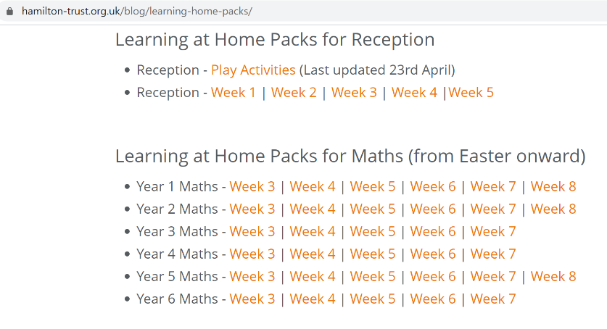

Keep up the good work on times table rock stars.

OTHER FUN MATHS ACTIVIES

This website has many fun maths game ideas – choose 1 a week to try - https://thirdspacelearning.com/blog/fun-maths-games-activities-for-kids/

English
Write a diary entry for each day. Include your thoughts and feelings.

Fancy some creative writing? Try one of the following activities:

Option 1 – Try one of Pie Corbett’s English talk for writing resources –
(1) https://www.talk4writing.co.uk/wp-content/uploads/2020/04/Y4-Maria-Aliens.pdf
(2) https://www.talk4writing.co.uk/wp-content/uploads/2020/05/Y4-Mission.pdf

Option 2 - https://www.pobble365.com/ every day, you will find an interesting picture, writing prompts and philosophical questions to spark creative writing.

OR

Use Hamilton Trust free home learning resources
https://www.hamilton-trust.org.uk/blog/learning-home-packs/
Please do not worry if you are still completing last week’s work, just work at your child’s own pace through the different weeks.

Click on Year 4 English – week 8

There are a series of lessons to follow including PowerPoints to assist with completing the tasks. Complete the tasks at your own pace.

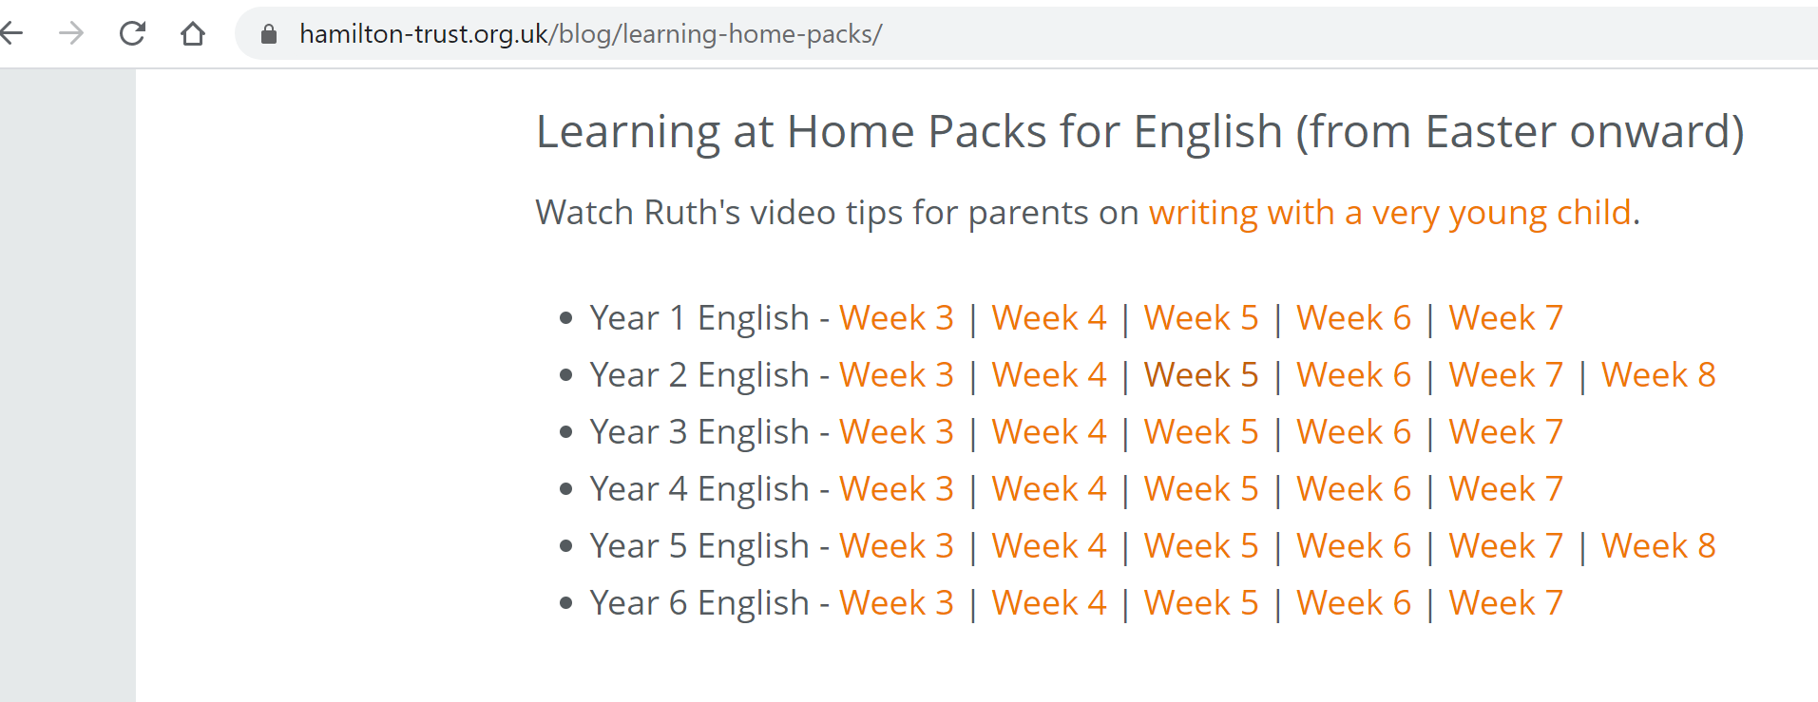

Reading

Read for 20 minutes a day. When you have completed a book, write a book review about what you have read. How does the story make you want to keep reading? Write down the phrases and words that you find effective in gripping the reader.

Optional ideas after reading –

How did you feel why you were reading your current book? Explain and be descriptive about your answer.

Design the clothes that your character would wear. Why have you chosen those particular clothes? What design would their t-shirt have?

What words have been used to create atmosphere? Write them down.

Computing
Each week try one different computing activity.
Barefoot Computing have put together some free home learning resources to help. With fun lesson-based activities and interactive games, children can work together with their families to develop their computational thinking skills. Choose one to try through https://www.barefootcomputing.org/homelearning.

Create a game on scratch https://scratch.mit.edu/

Have a go at one of the free scratch code club modules; there are free guides to complete each module.
https://projects.raspberrypi.org/en/codeclub/scratch-module-1

PE
Daily exercise is an essential part of healthy living. Many of you have been following Jo Wicks, keep up the hard work with these daily sessions https://www.youtube.com/user/thebodycoach1/video or if you fancy a change try one of the super mover videos https://www.bbc.co.uk/teach/supermovers .
Alternatively, why not try PE with our very own Mr Stevens – use the link from the school website.
Take a walk in a local forest with your family. Notice the sounds of the birds and enjoy the peaceful feeling that we gain from nature.

RE

Try a different one each week - free home learning activities from NATRE
https://www.natre.org.uk/uploads/Free%20Resources/2%207-11%20RE%20Today%20and%20NATRE%20home%20learning%20Spirited%20Arts.pdf

Spellings
This week’s spellings are
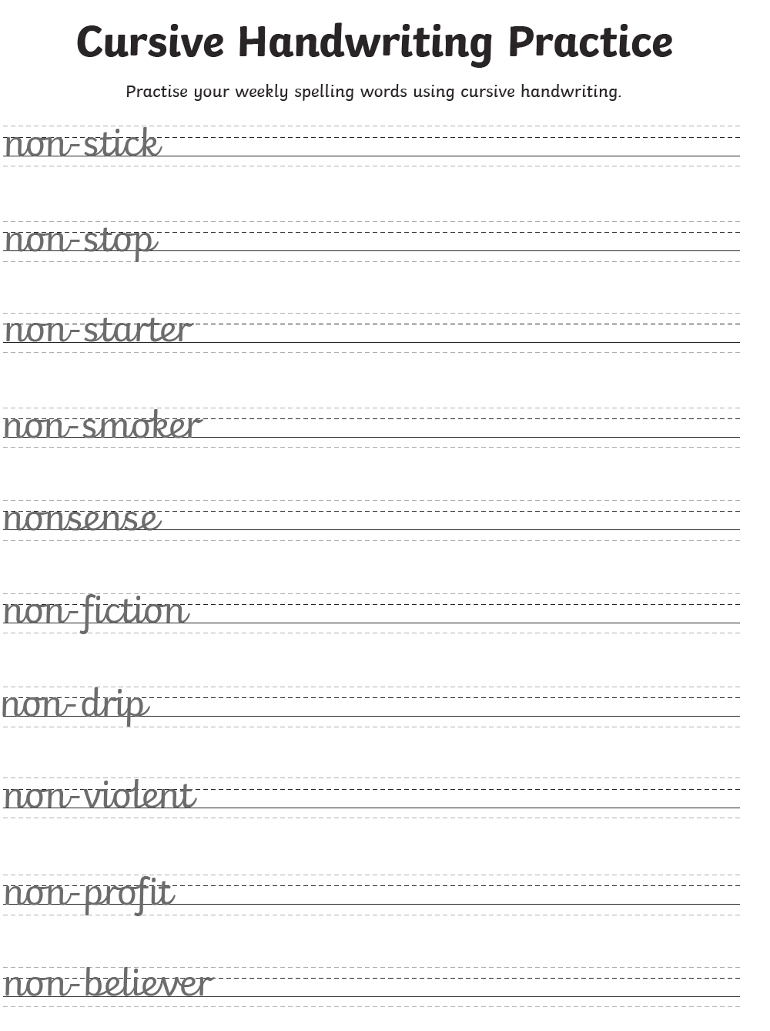
Practise them daily in your neatest cursive handwriting and get a grown up to test you on Friday.
EXTRA SPELLING FUN – visit https://spellingframe.co.uk/ - click on year 3 and 4 – choose the spelling rule you want to explore and click on free spelling tiles game.

Science

Choose a different task to explore each week.
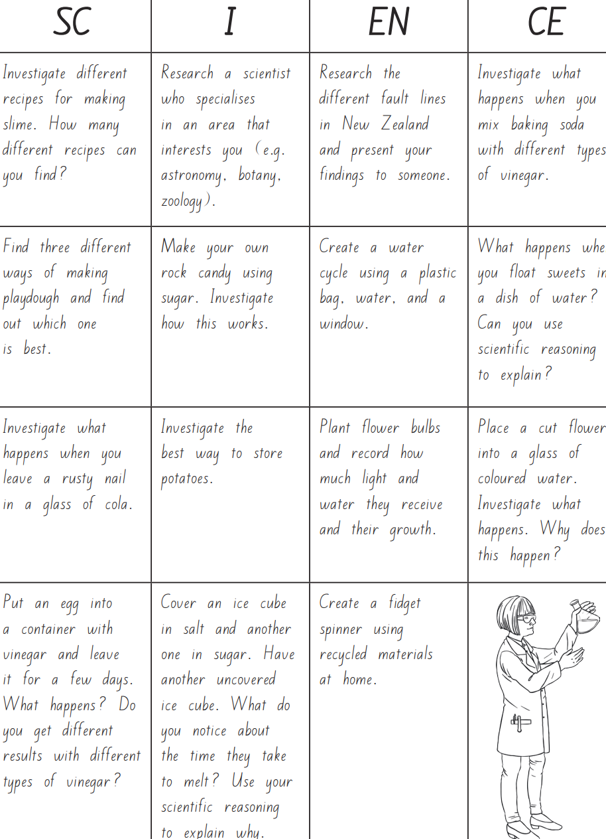
History & Geography

HADRIAN’S WALL

Watch this history clip at https://www.bbc.co.uk/bitesize/clips/zhq76sg

Follow on activity:-

Can you recall five facts from the video? Replay the video, what else can you recall? Continue to research on Hadrian’s Wall. How much of Hadrian’s Wall remains? Can you find images of it in books and online? What was the Antonine Wall built from? Is anything left on the Antonine Wall? What do pupils think happened to all the stone blocks now missing from Hadrian’s Wall?

Art
As part of mental health week, create a BE KIND TO YOUR MIND POSTER.
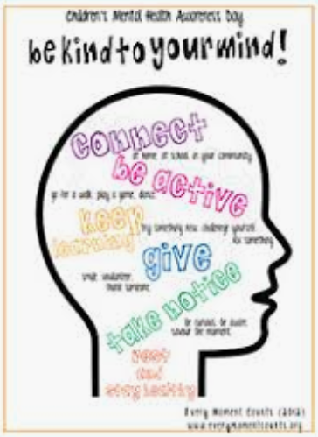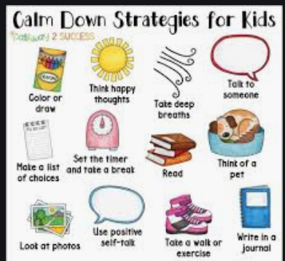
ALTERNATIVELY, take some time to relax and sit/ look outside and draw what nature you can see.

Music

Choose a times table that you find challenging to create a song/ rap to.

Alternatively, complete one of the modules on charanga.

DT

Last week you designed and made a Roman shield. Design and make a Roman helmet to go with it.
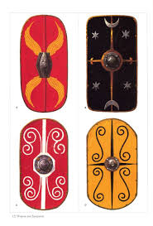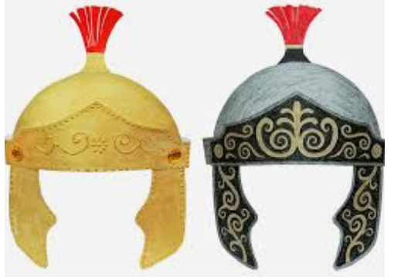

PSHE
Think about how we can still be a good friend to others that we maybe cannot see now. This maybe through writing a letter to a friend that you miss or drawing them a picture of a happy memory you have with them.

French
Try some French mindfulness.
https://www.youtube.com/watch?v=mkQsUmlcrng&list=PLXMCXZunVHHcqhZxPnk0UINhhDjNVNJlZ&index=1
Alternatively, recap on French numbers and colours
https://www.youtube.com/watch?v=urPJ9QTwqxk&list=PLXMCXZunVHHcqhZxPnk0UINhhDjNVNJlZ&index=5

Other available lessons
The BBC are also providing a vast range of activities for children. This link will give you three appropriate lessons a day to complete.
https://www.bbc.co.uk/bitesize/tags/z63tt39/year-4-lessons/1

Oak National Academy is a new collection of high-quality lessons and online resources. Backed by the government, you can find a range of lessons with PowerPoints/ videos free at https://www.thenational.academy/

If you have any queries about the work then please contact us via Seesaw or email us at Julie.lane1@taw.org.uk.

Thank you for your continued support.

Warm wishes

Mrs Lane and Mr Warren

