Reception Home Learning Activities Week beginning 15th June
Monday | Tuesday | Wednesday | Thursday | Friday
Numbers and Patterns  Counting to 20 | Numbers & Patterns  Missing number | Numbers & Patterns  One more | Numbers & Patterns  One less | Numbers & Patterns
Phonics/English  DfE lesson review ‘ai ee igh’  https://www.youtube.com/watch?v=Gyjd2gqw_bU | Phonics/English  DfE lesson review ‘oa oo ar’  https://www.youtube.com/watch?v=4KnggnLIy00 | Phonics/English  Sing tricky word song then colour the balloons.  https://www.youtube.com/watch?v=R087lYrRpgY  PHASE 3 | Phonics/English  DfE lesson review ‘or ar oo’  https://www.youtube.com/watch?v=8DEZnGT9I-U | Phonics/English  DfE lesson review ‘ow oi ear’  https://www.youtube.com/watch?v=9W4WiN3NeE4

Monday- Practice counting out loud. Try this super counting song: https://www.youtube.com/watch?v=D0Ajq682yrA
Challenge
What can you count up to? We’d love to see your videos. Can you count beyond 20? How about to 50!

Tuesday-Let’s count along to 30 first. Can you do it? https://www.youtube.com/watch?v=_SHlY9fzQd8
Can you make your own set of numbers?

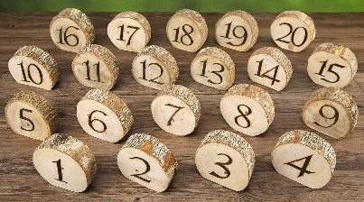
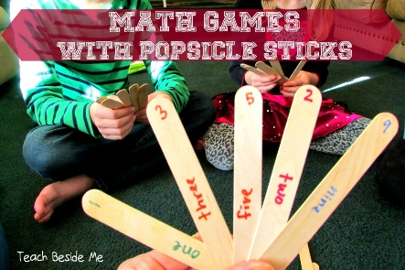
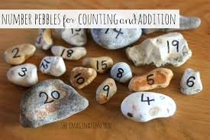
Wednesday – Try these great counting games.
Which is your favourite?
https://www.topmarks.co.uk/maths-games/3-5-years/counting

Thursday - Can you count backwards from 20? https://www.youtube.com/watch?v=srPktd4k_O8

