Home Learning Week Commencing 29th June 2020

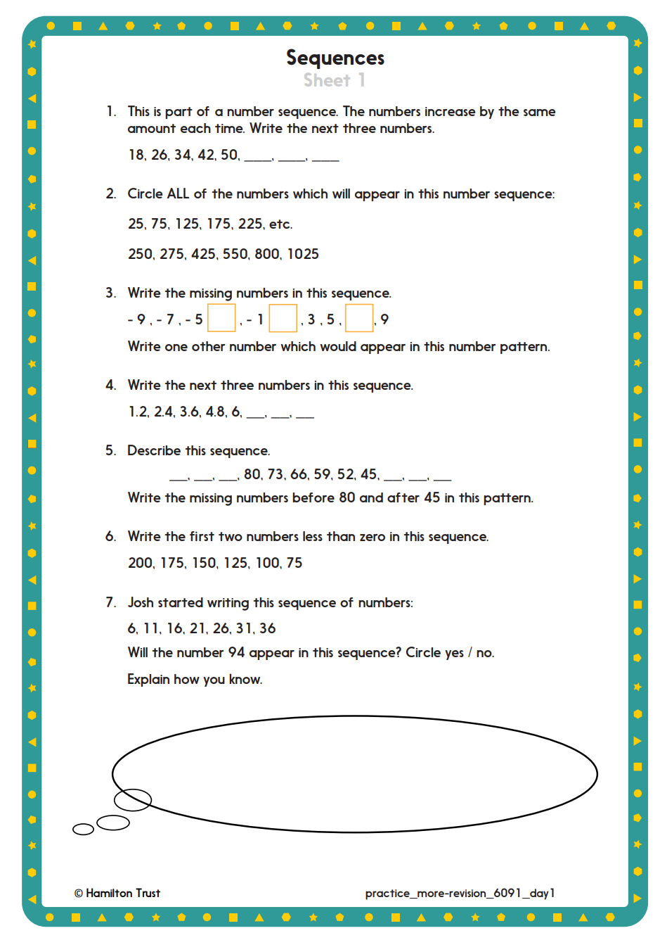
Maths – Algebra
Day 1)

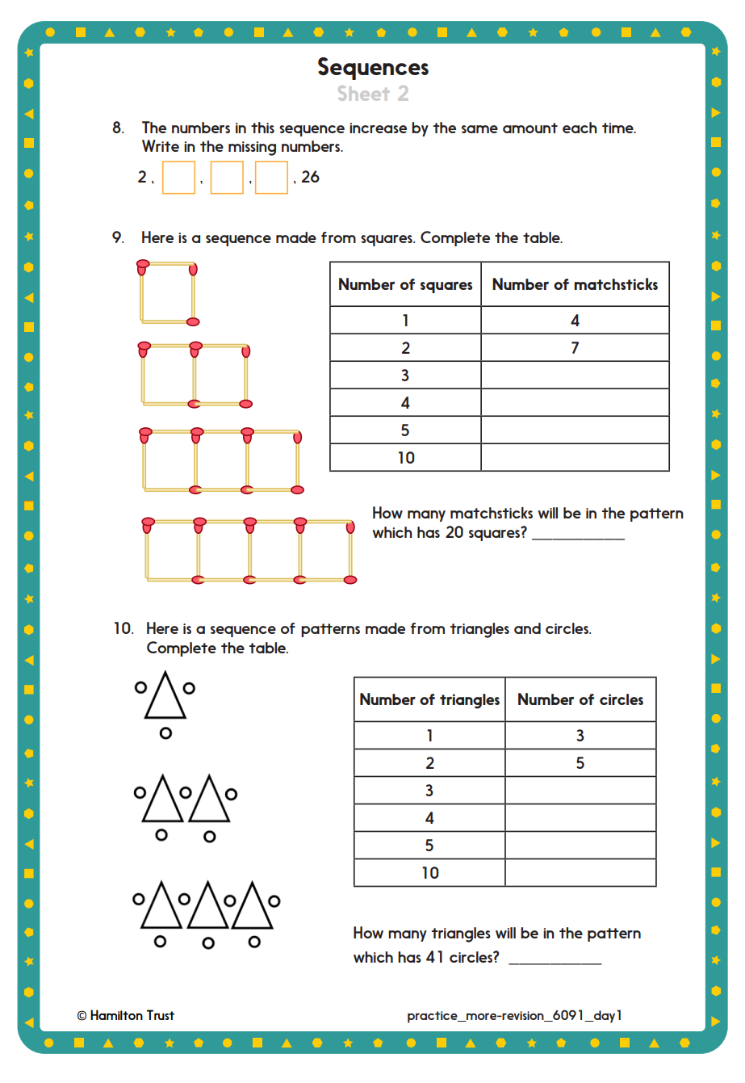
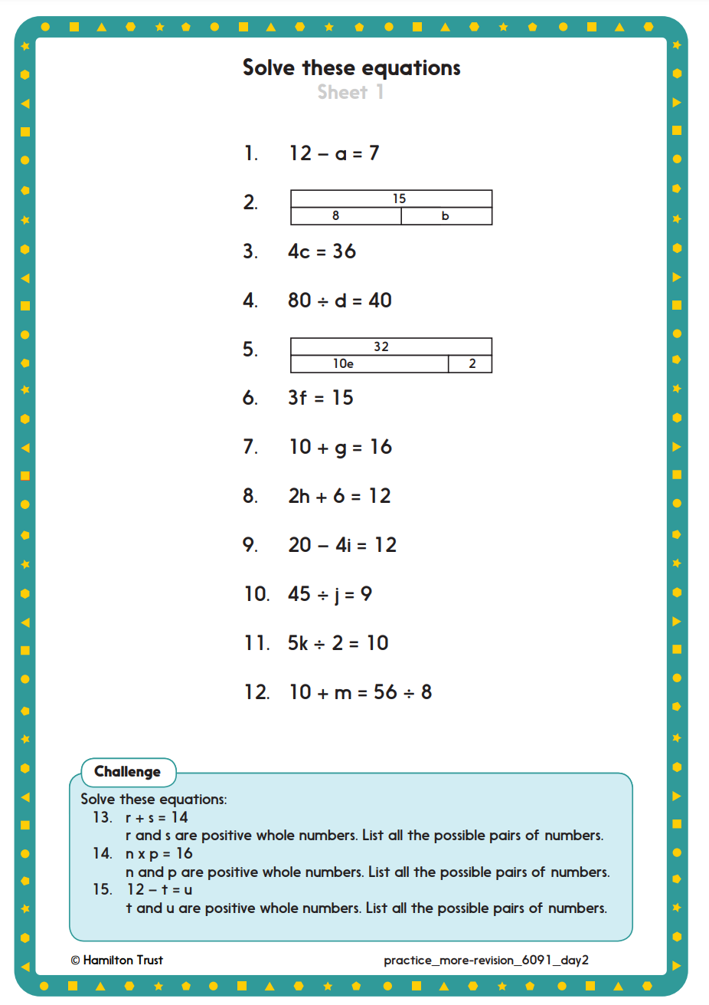
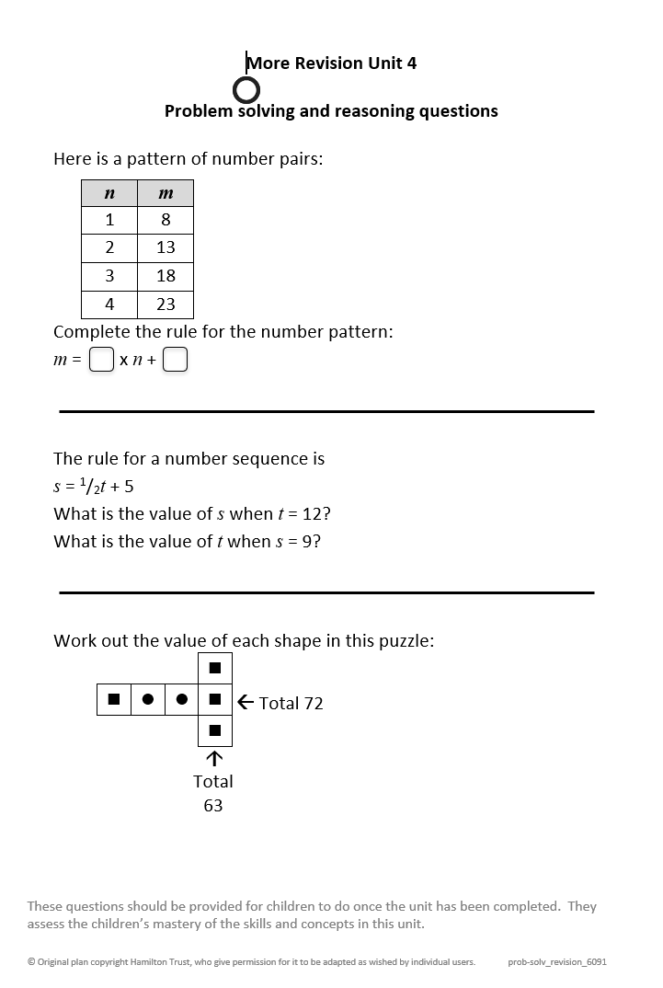
Day 2:

Day 3:
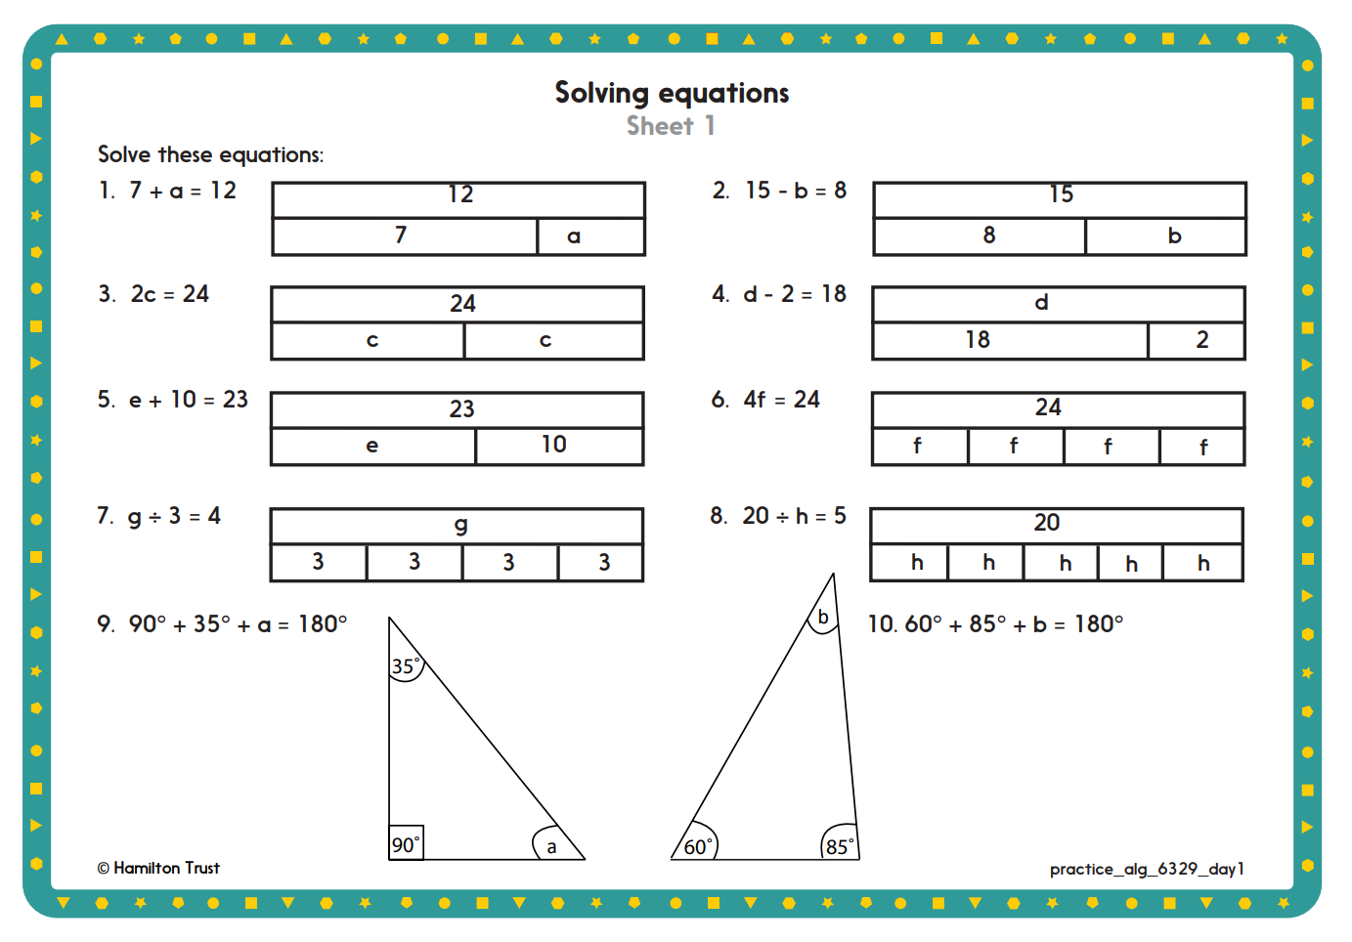
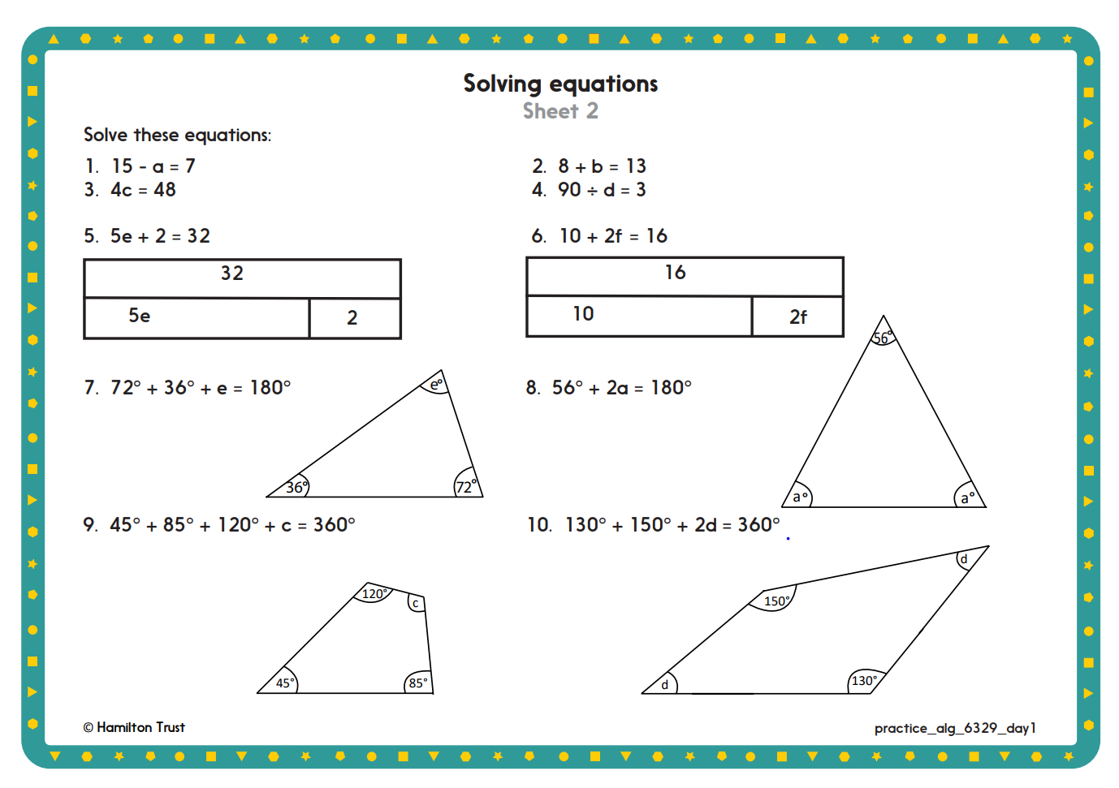

Day 4:

Have a go at these games:

https://www.topmarks.co.uk/maths-games/11-14-years/algebra

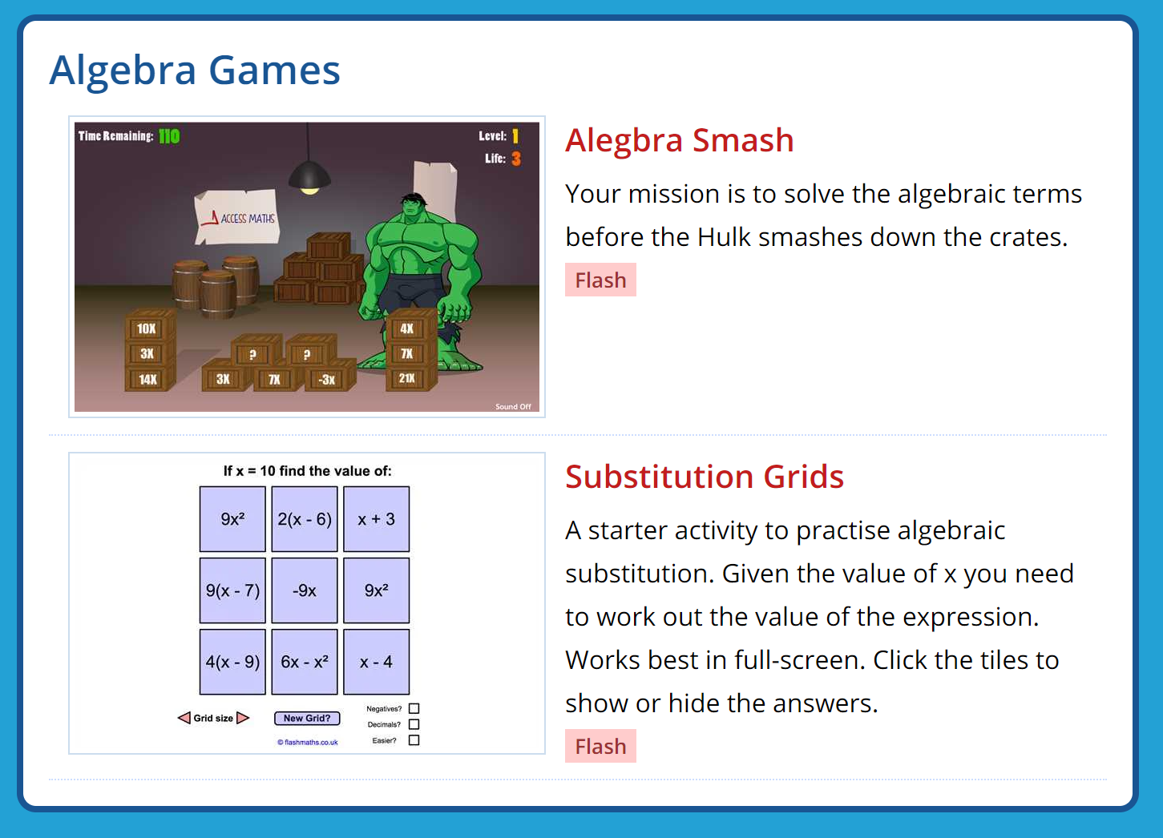

Day 5)

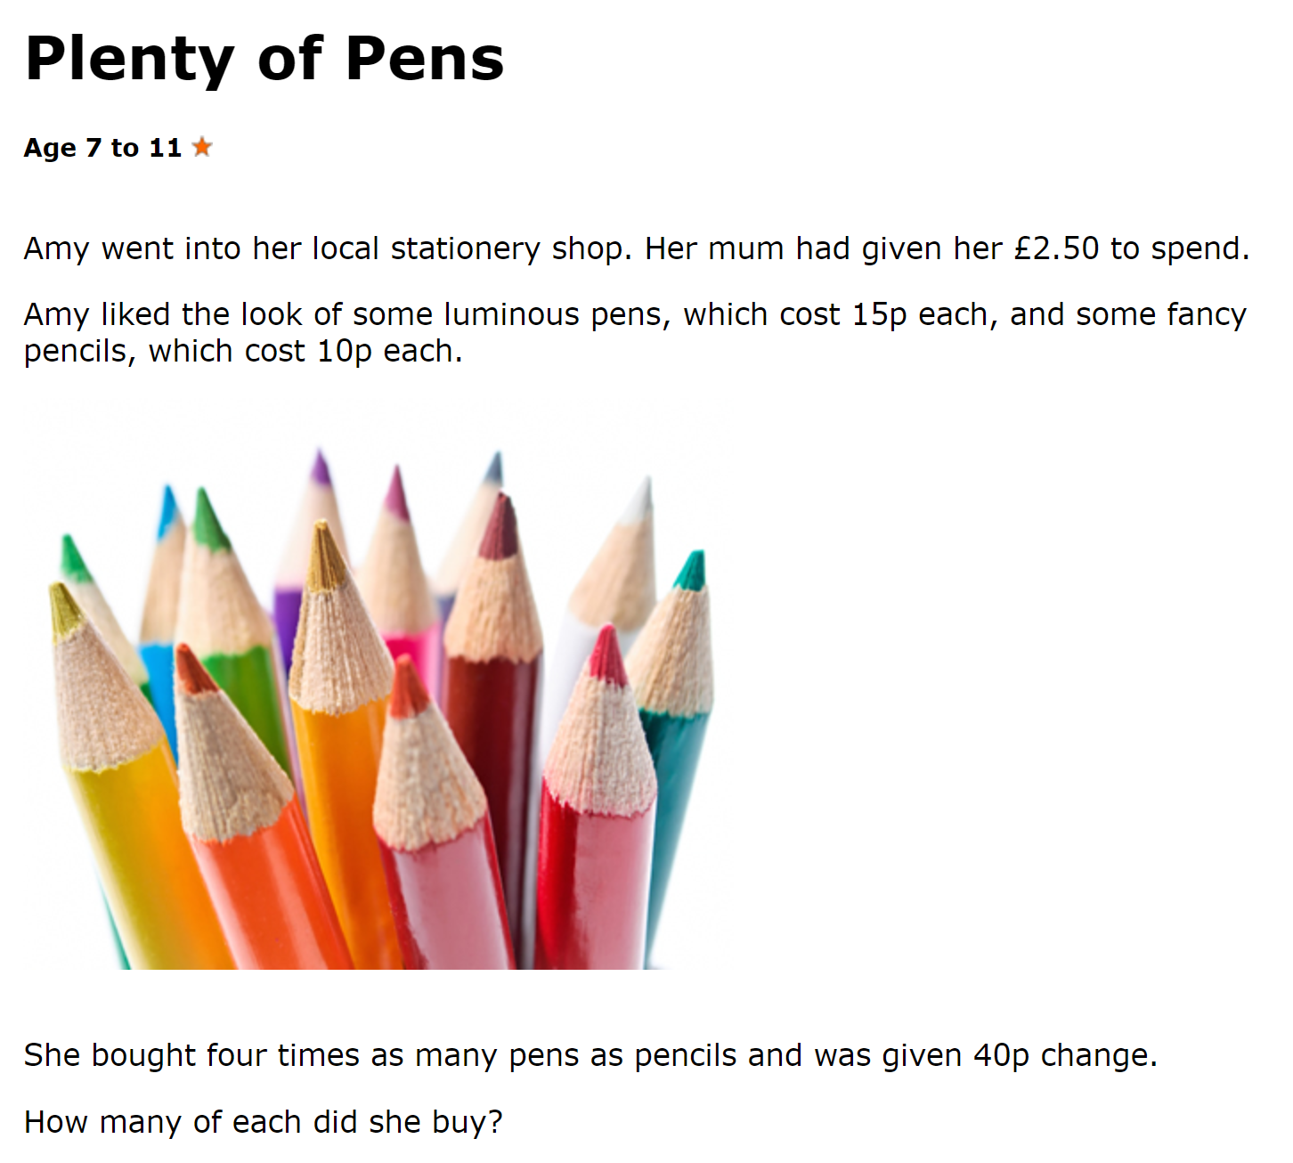

English
Day 1)
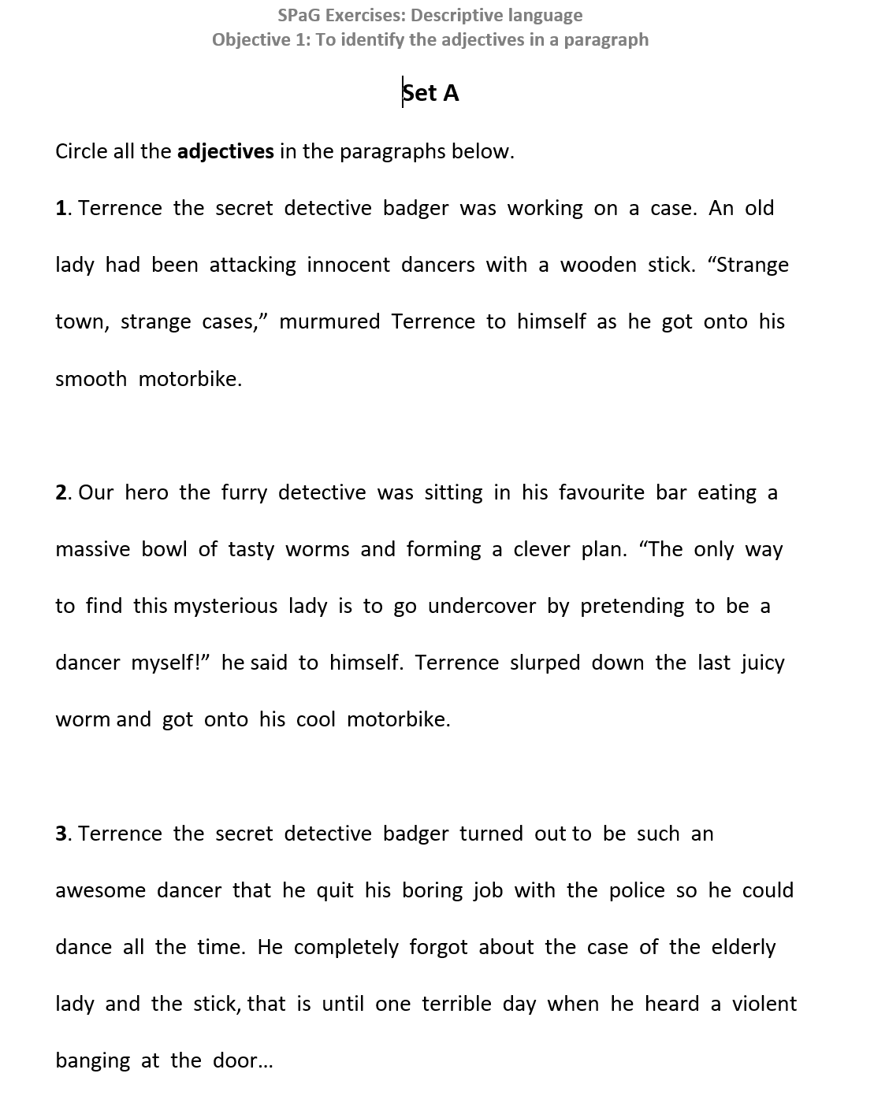

Day 2:
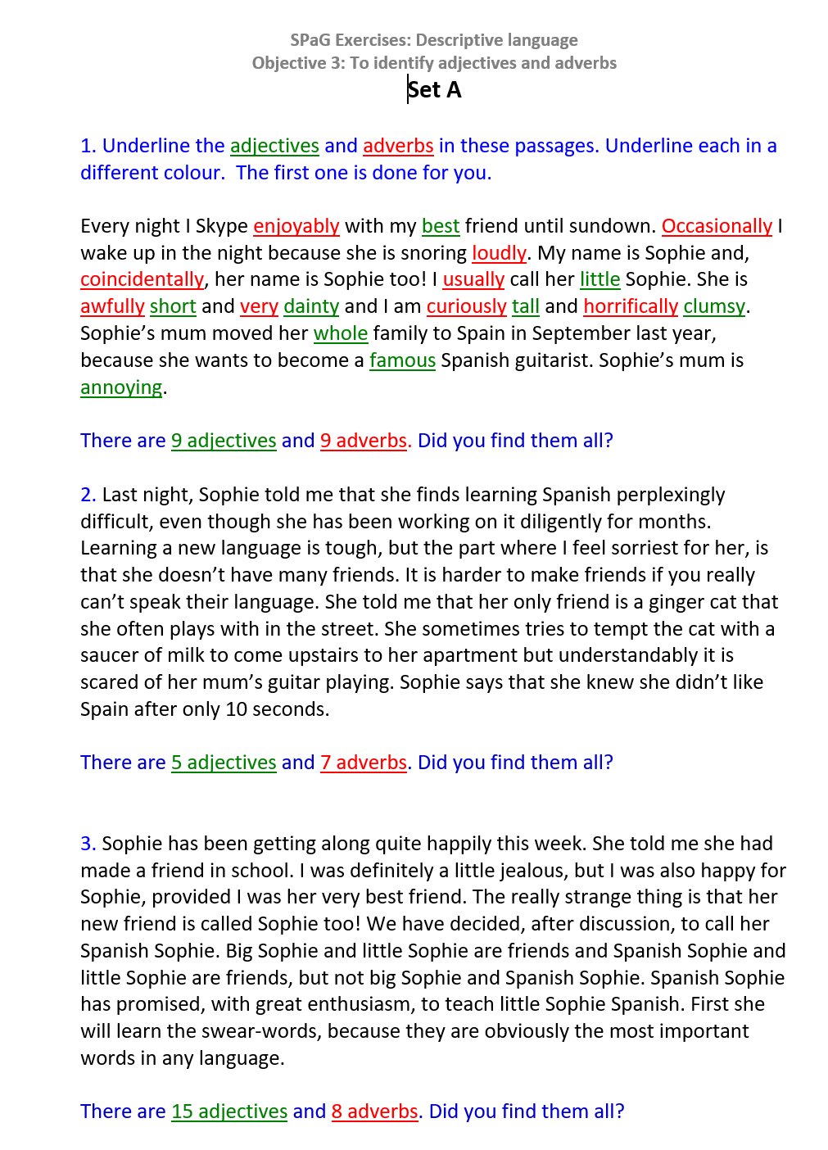
Day 3:
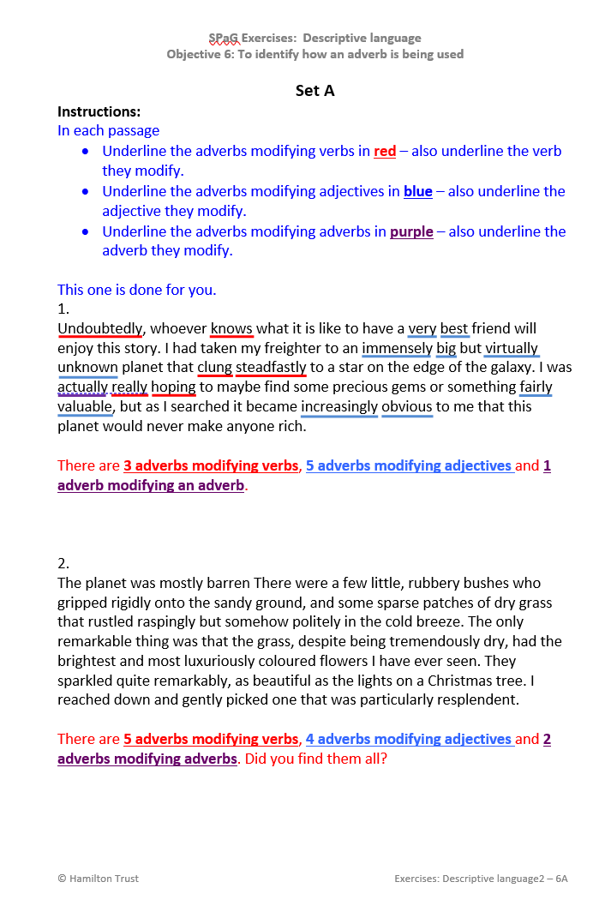

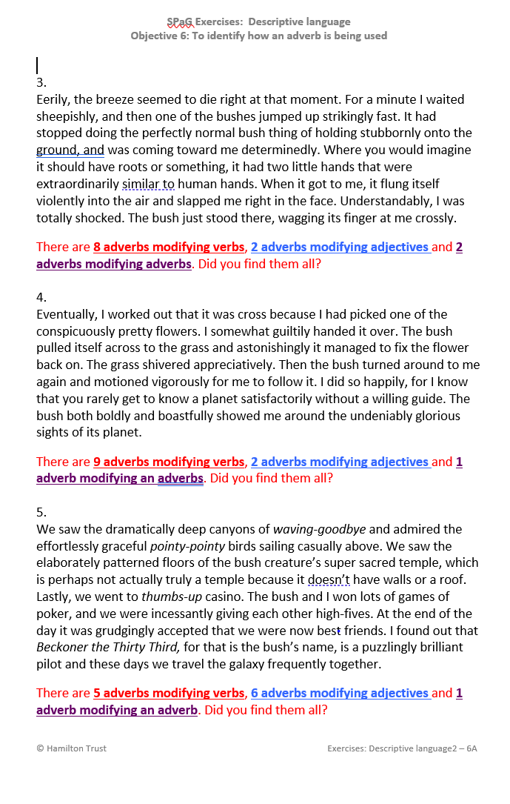

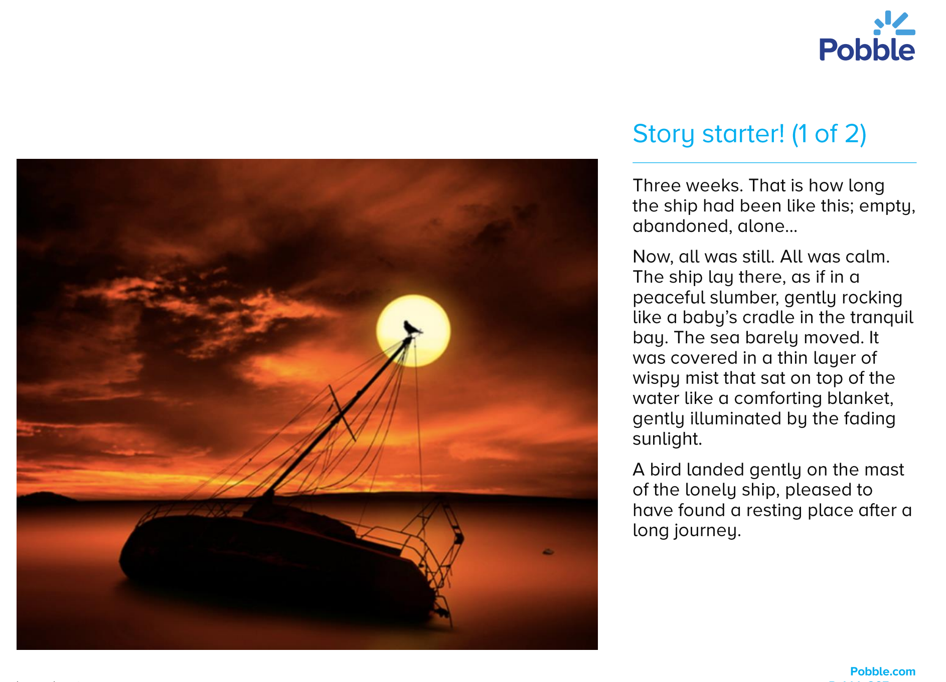

Day 4:

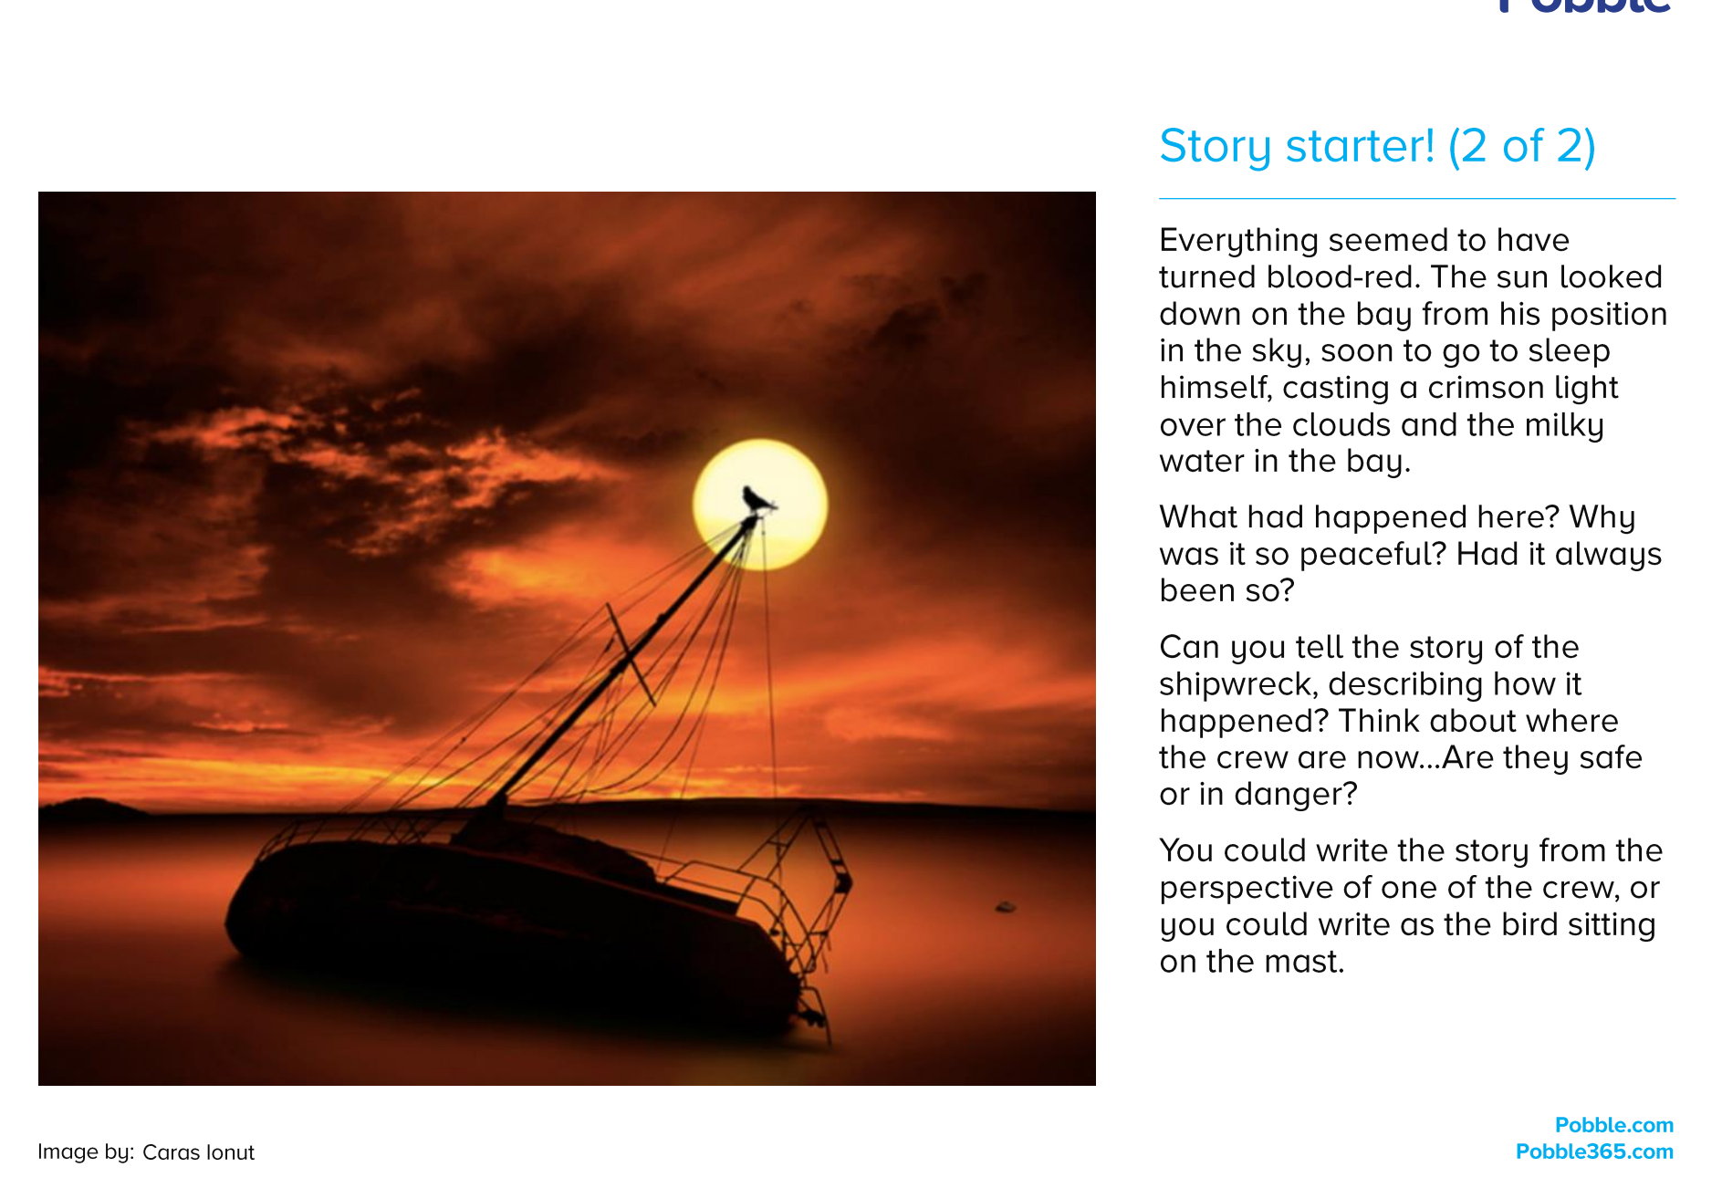
Day 5: Read this text and answer the questions:

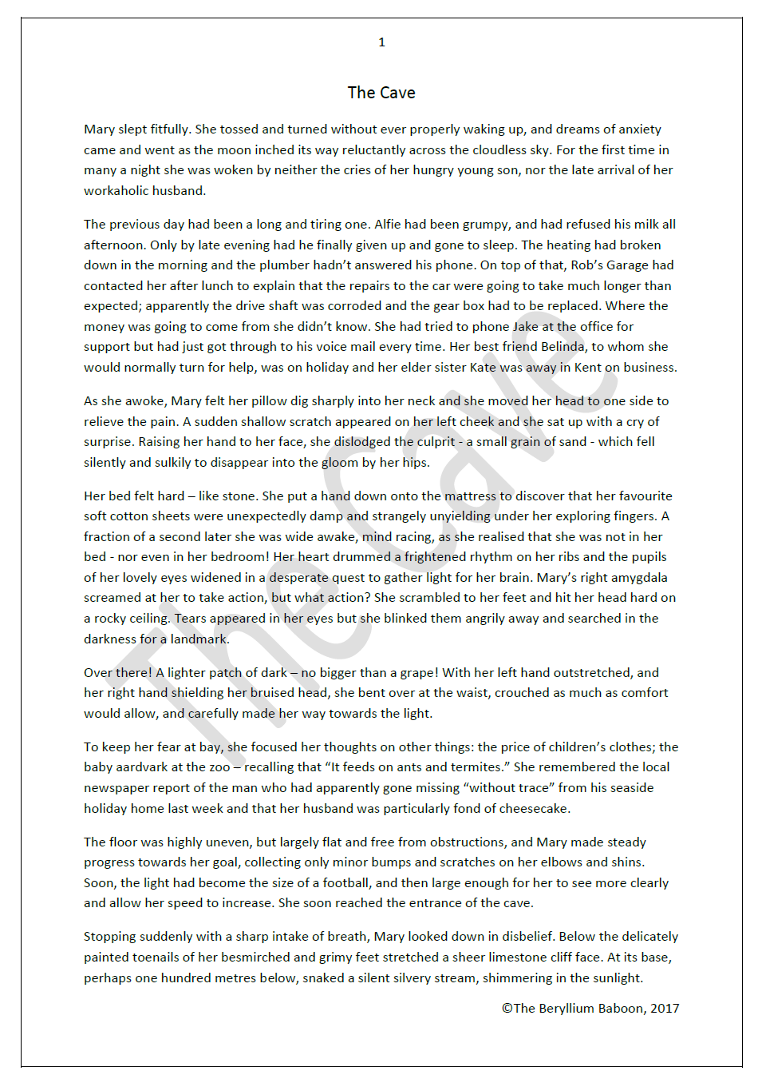

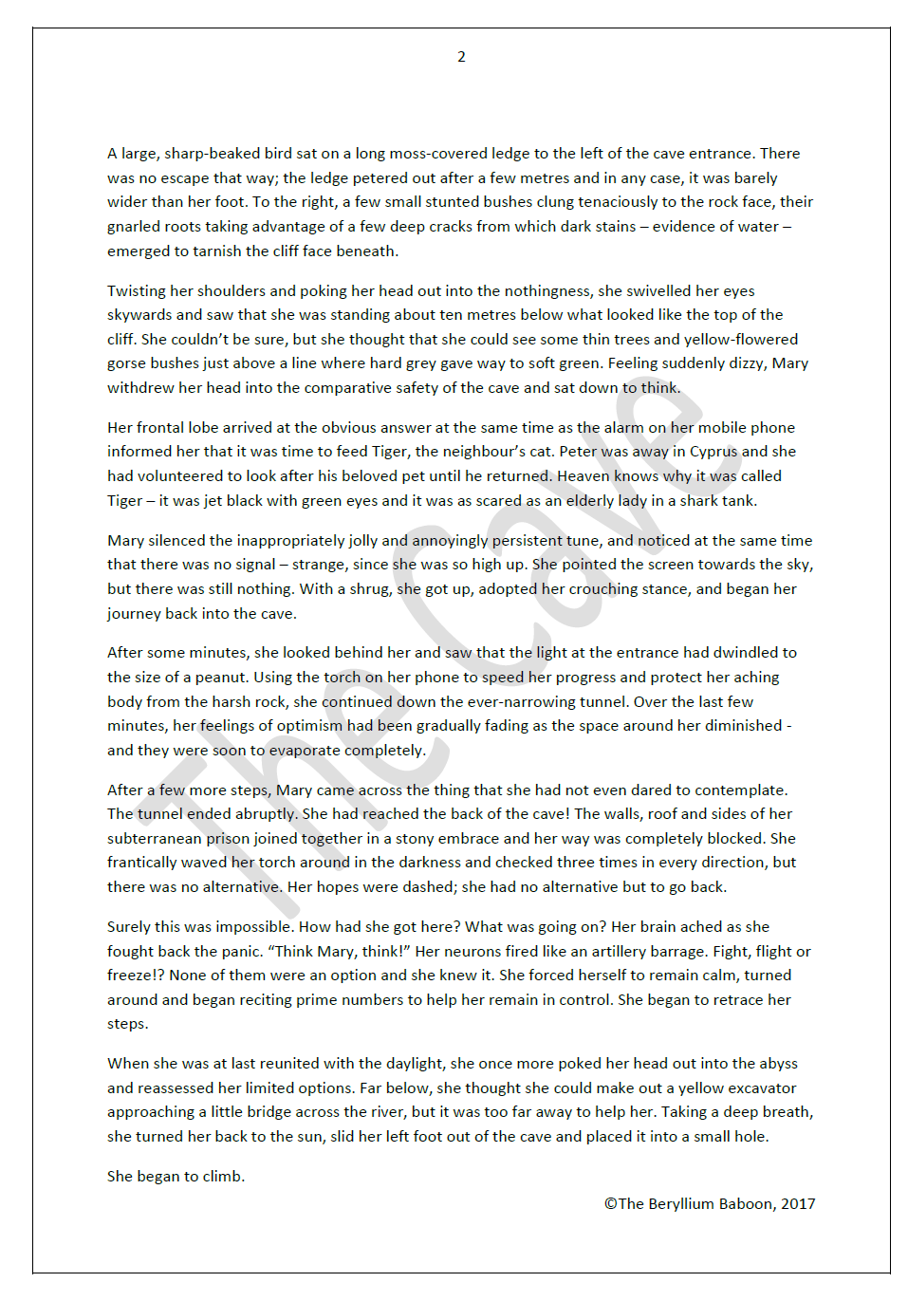
The Cave – Page 1: Questions

- Look at paragraph 1. (1 mark)
What two things have been waking Mary recently?

- The moon inched its way reluctantly across the cloudless sky. (2 marks)
What does the word reluctantly suggest about how time seems to be passing?
Explain your answer.

- In question 2, the moon is described as reluctant. (1 mark)
This is an example of: (Tick one)
- Exaggeration
- Personification
- Antonym
- Simile
- Understatement

- Find and copy one word which suggests that Mary’s husband works a lot. (1 mark)

- What do you think is the name of Mary’s husband? (2 marks)
Why do you think this?

- Why had the previous day been long and tiring? (2 marks)
Give three reasons.

- How do you know that Mary is worrying about her finances? (1 mark)

- From whom does Mary usually ask for advice when things go wrong? (1 mark)

- Why was Mary’s sister away from home? (Tick one)
- She was on holiday.
- She was looking to purchase some French wine from a dealer.
- She had taken a wrong turning off the M25.
- She was seeing a heart specialist in a hospital.
- She was looking for a new puppy from a rescue centre.
- She was on a lecture tour of the south east of England.

- Look at the third paragraph which begins: As she awoke... (1 mark)
What scratched Mary’s cheek?

- Mary realised she was not in her bedroom and became wide awake. (1 mark)
How do you know that she could not see very well at this moment?

- After she hit her head, Mary looked for a landmark in the darkness. (1 mark)
In what direction did she move?

- Choose the word which best describes how Mary moved through the cave. (1 mark)
Tick one:
  - Enthusiastically
  - Eagerly
  - Warily
  - Sulkily
  - Excitedly

- As she moved, what did Mary choose to do to stay in control and not panic? (2 marks)
Give a specific example from the text.

- What injuries did Mary collect on her journey along the cave? (1 mark)

- Why were Mary’s feet besmirched and grimy? (1 mark)

- How did Mary feel when she reached the entrance to the cave? (3 marks)
Find evidence from the text to support your view.
Explain why your evidence supports your view.

- Find the text: snaked a silent silvery stream, shimmering in the sunlight. (1 mark)
This is an example of: (Tick one)
- Hyperbole
- Personification
- Synonym
- Onomatopoeia
- Alliteration

- Identify one feature of Mary’s personality. (Point) (3 marks)
Find evidence from the text to support your view. (Evidence)
Explain why your evidence supports your view. (Explain)

The Cave – Page 2: Questions

- Look at paragraph 1. (2 marks)
Why was there no escape to the left of the cave entrance?

- What caused the dark stains on the cliff face to Mary’s right? (1 mark)

- Find and copy one word which tells you that the bushes on the cliff face had (1 mark)
not grown as tall as they normally would.

- When Mary looked up the cliff, she saw a line where hard grey gave way to (1 mark)
soft green. What does this mean?

- Mary popped her head back into the cave and sat down to think. (2 marks)
In your opinion, what was she trying to understand?
Give a reason for your answer.

- When Mary figured out the obvious answer to her puzzle, she immediately (2 marks)
set off back into the cave.
Why did she set off back into the cave? Explain your reasoning.

- Read paragraph 5. Why had the light dwindled to the size of a peanut? (1 mark)

- Mary’s feelings of optimism…were soon to evaporate completely. (1 mark)
This is an example of: (Tick one)
- Hyperbole
- Metaphor
- Synonym
- Simile
- Alliteration

- Find and copy one word from paragraph 6 which means to think about. (1 mark)

- What were Mary’s feelings when she reached the back of the cave? (2 marks)
How do you know this?

- Find the text: The walls, roof and sides of her subterranean prison joined (1 mark)
together in a stony embrace. What does this mean?

- Why were Mary’s hopes dashed? (Tick one) (1 mark)
- The roof had collapsed and blocked the way.
- She was exhausted and could not carry on.
- She did not know which tunnel to choose to escape from the cave.
- She could see no way out.
- Her torch batteries had run out and she could not see where to go.
- She had forgotten to set her TV to record Strictly.

- Choose the word which describes least well how Mary was feeling when she (1 mark)
turned around and retraced her steps. Tick one:
  - Concerned
  - Panicked
  - Agitated
  - Relaxed
  - Worried
  - Nervous

- Find and copy an example of a simile from paragraph 7. (1 mark)

- Find the text: Surely this was impossible. (1 mark)
Explain what was impossible.

- What three things were not an option for Mary? (3 marks)
Explain why each one was not an option.

- Where was Mary when she was reunited with the daylight? (1 mark)

- When Mary poked her head out into the abyss, she (Tick one): (1 mark)
  - wondered how high up she was;
  - tried to think of a new plan to get home;
  - thought about which of the many choices for escape she would pick;
  - once more thought about her small number of possible option;
  - day-dreamed about who had won Strictly this week.

- Why did Mary take a deep breath before leaving the cave (1 mark)

- How did Mary leave the cave? (1 mark)

- Do you think Mary reached safety after leaving the cave? (3 marks)
Find evidence from the text to support your answer.
Explain how this evidence backs up your opinion.

Science
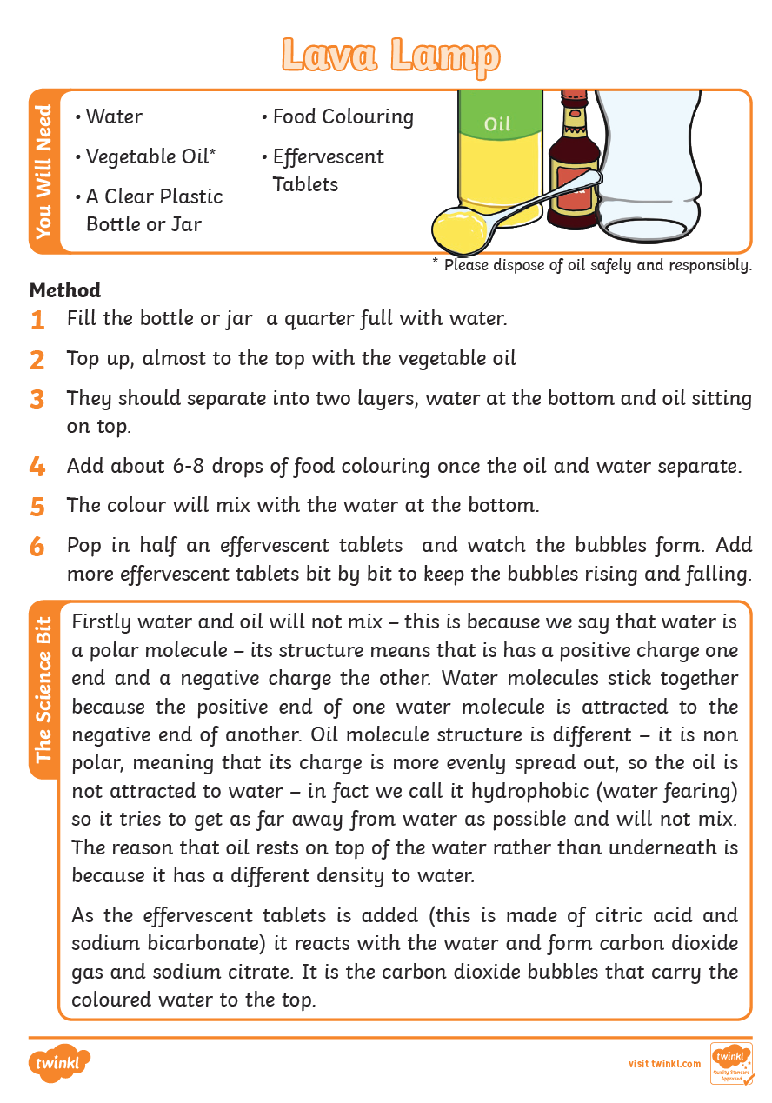

Topic Activity 1:
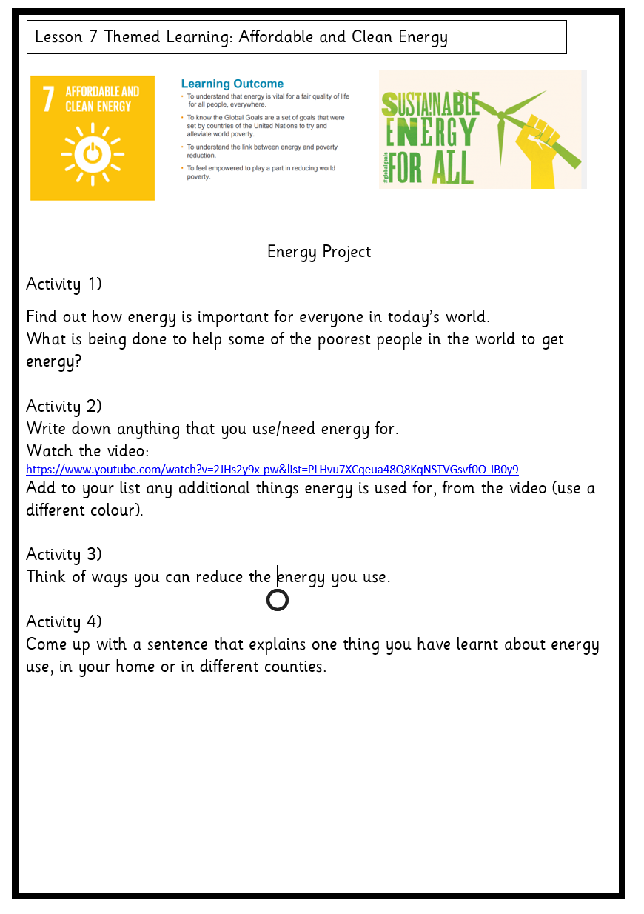

Topic 2: - History

Step 1) Find out about the Magna Carta
Step 2) Watch this video:https://learning.parliament.uk/resources/magna-carta-for-the-21st-century/
Step 3) How does it affect our rights and responsibilities today?
Step 4) Which rights and freedoms do you think are important enough to be enshrined in your own ‘Magna Carta for the 12st century’?
Step 5) Design your own shield
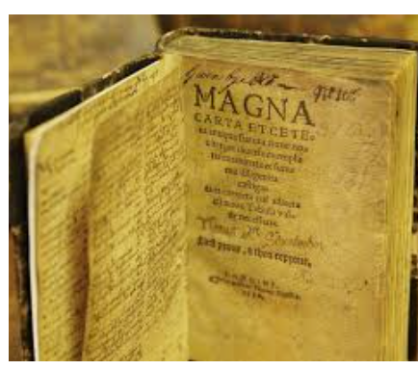
Step 6) Find a way to display this work so that you can teach others – you may choose an exploding book, a fact sheet (it must be attractive!), or you might have your own fantastic idea.

