Home Learning Week Commencing 2nd June 2020
The format of our home learning has changed slightly. It is split into days and subjects so please scroll down for Maths, English, Science and Topic activities per day. Enjoy!
Maths
Day 1) Identify patterns in Multiples – The eights have it! (see attached challenge)
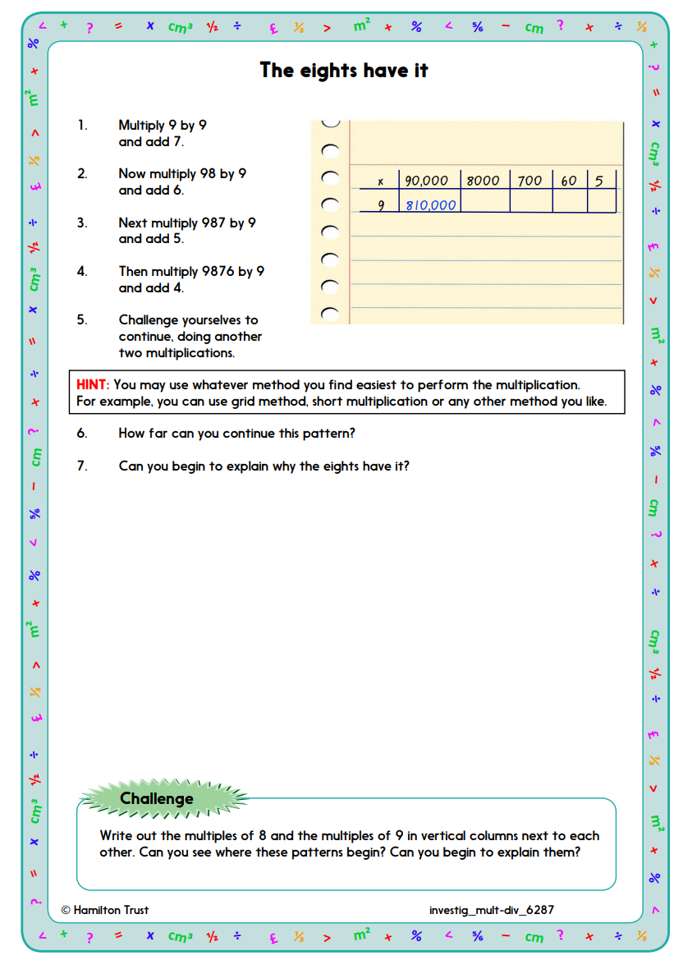

Day 2:
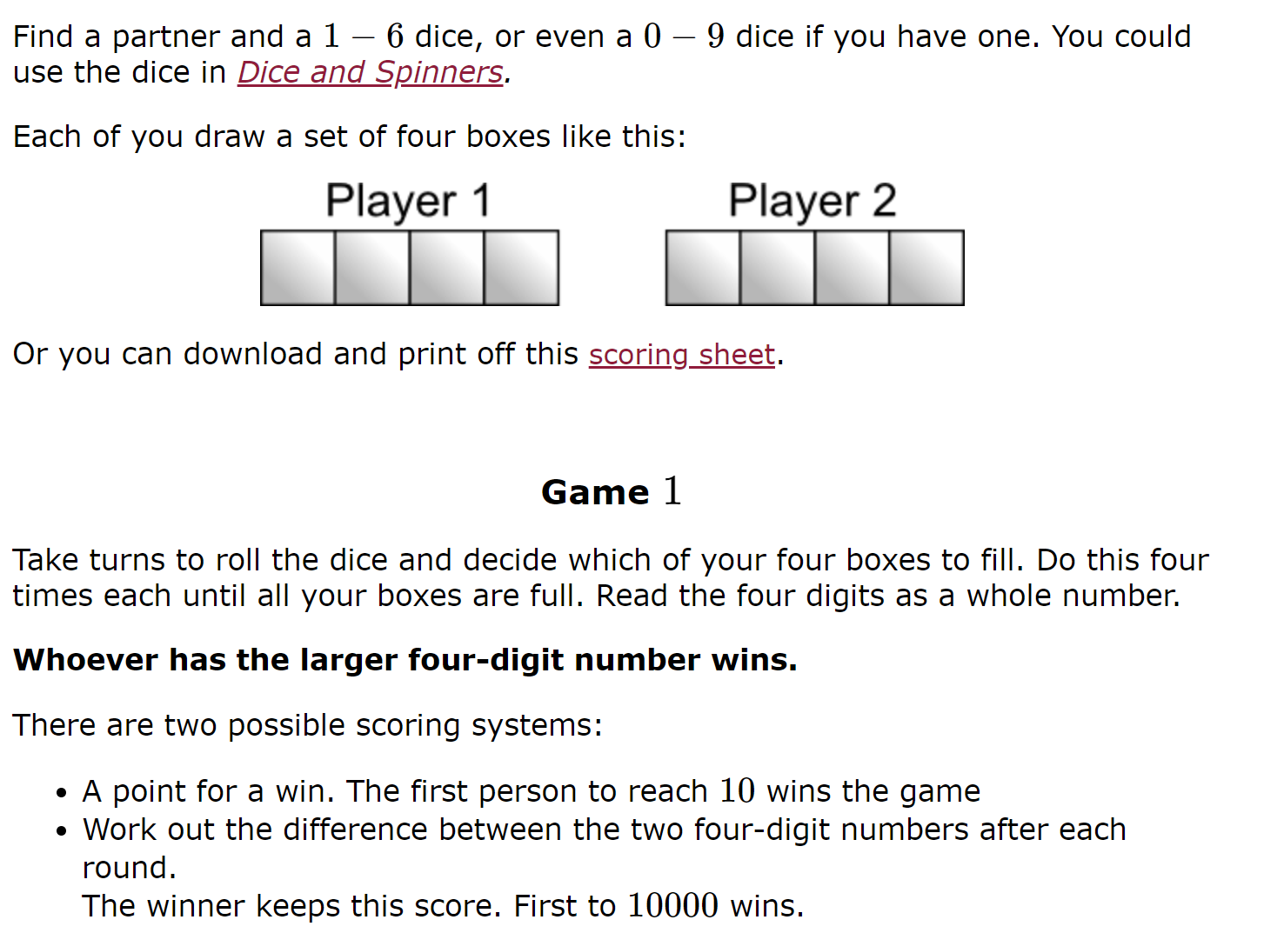
Extension:
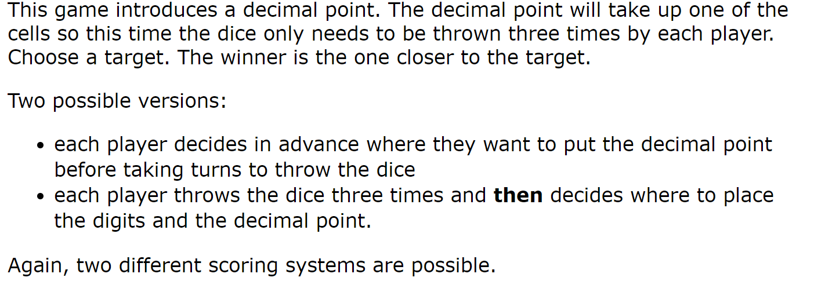

Day 3:

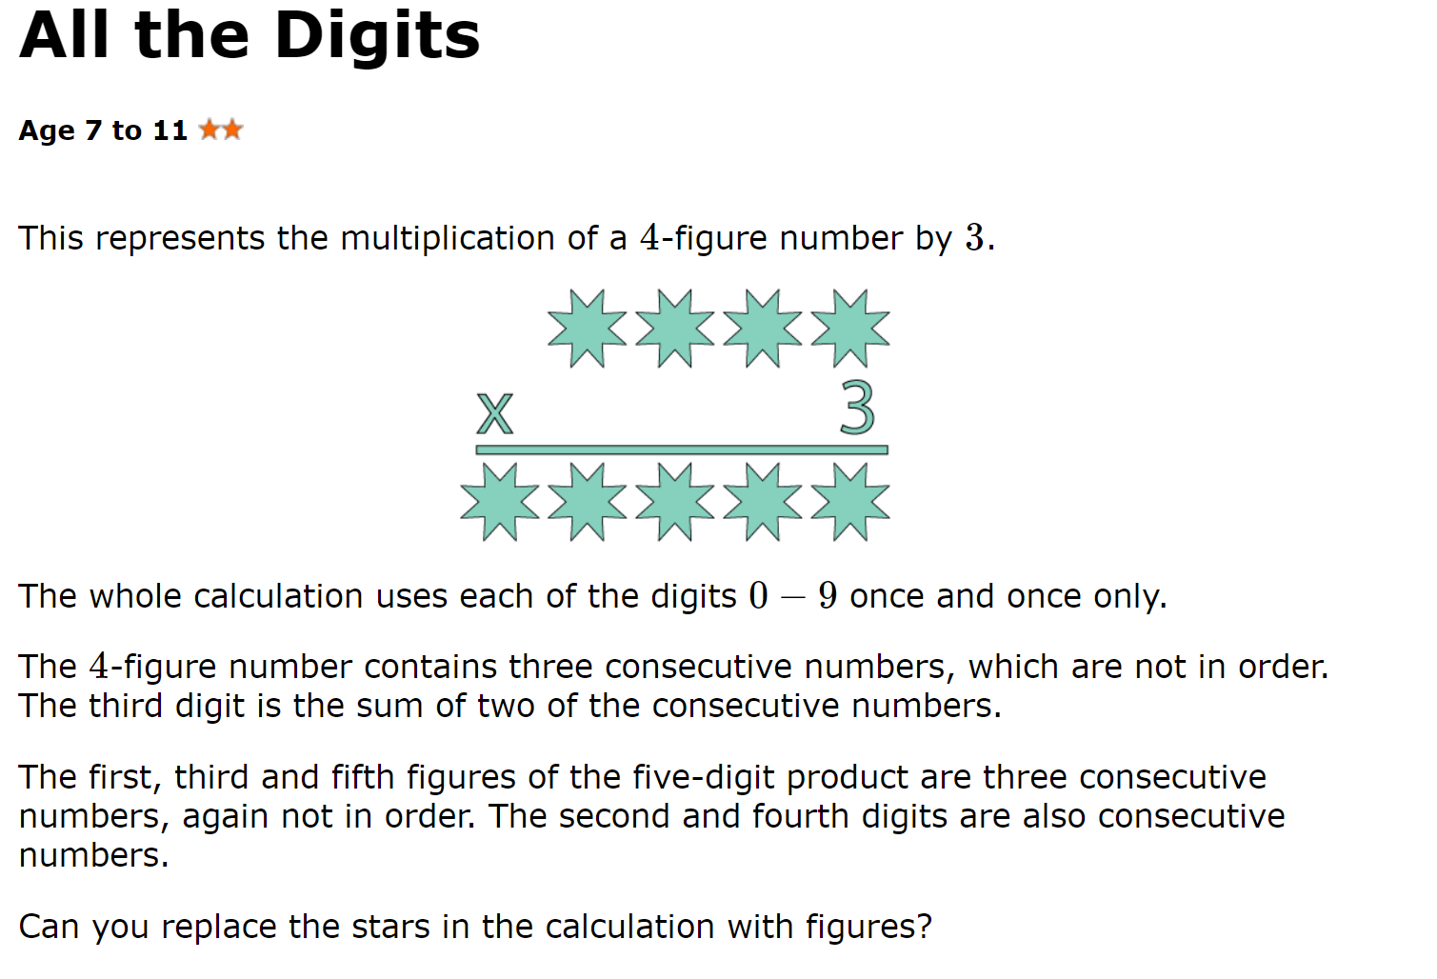

Day 4:
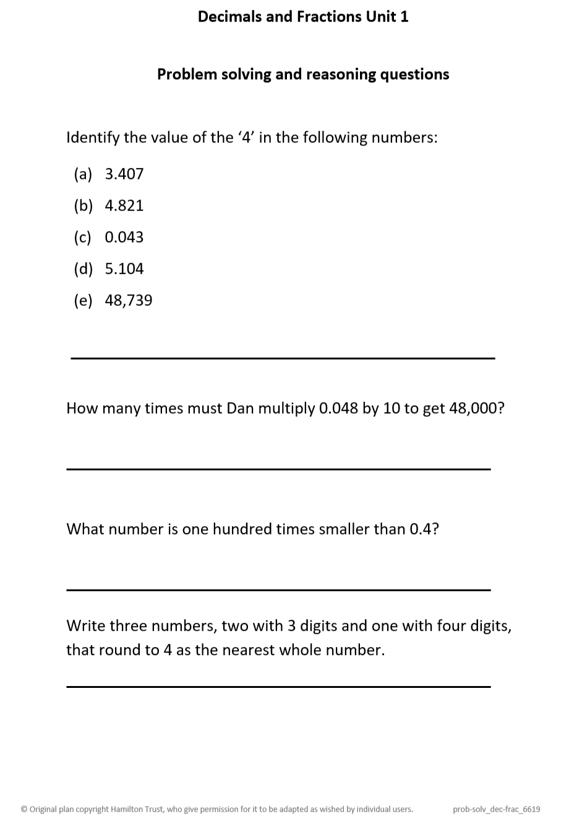

English
Day 1)
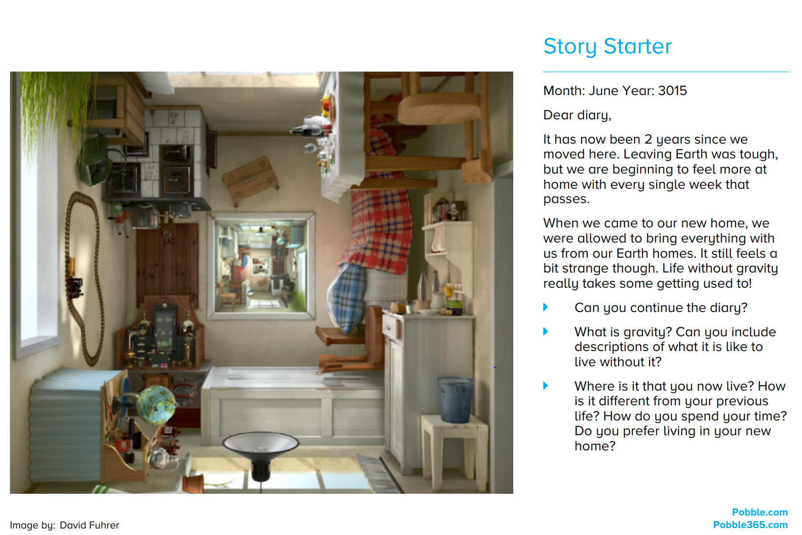

Day 2:
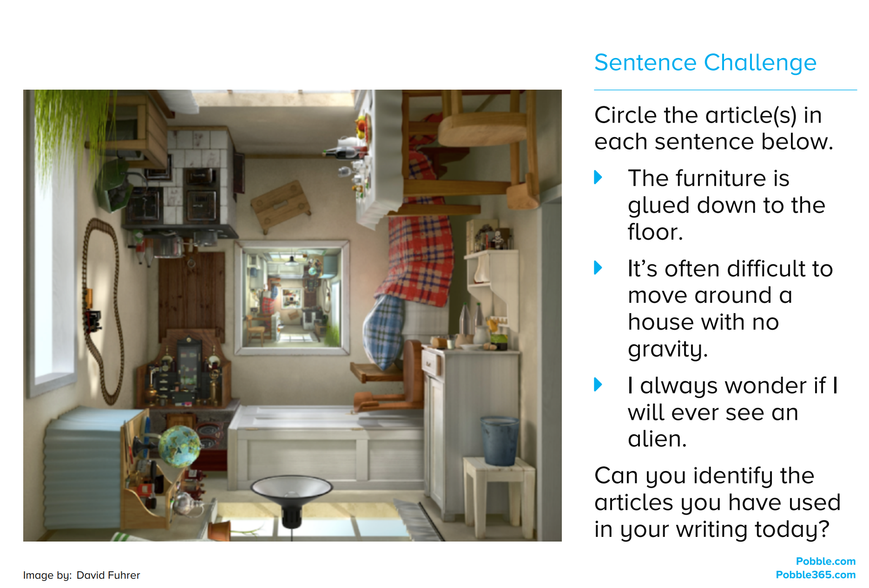

Day 3:
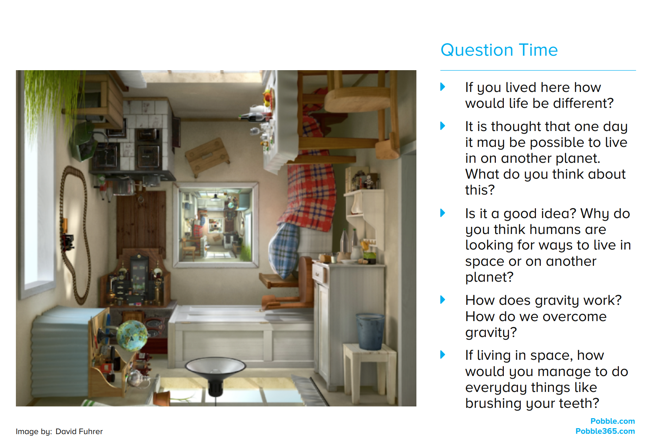

Day 4:

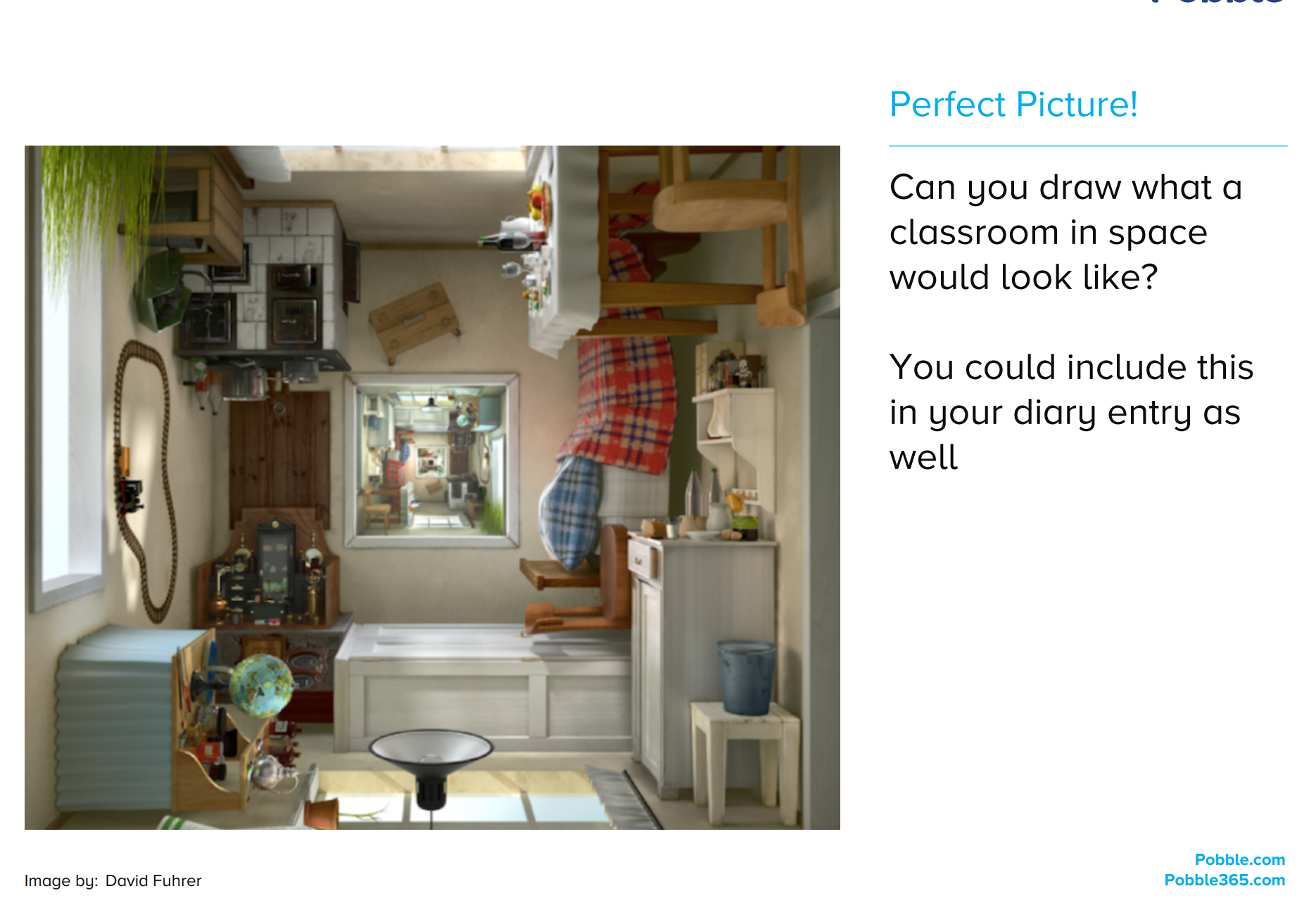

Science
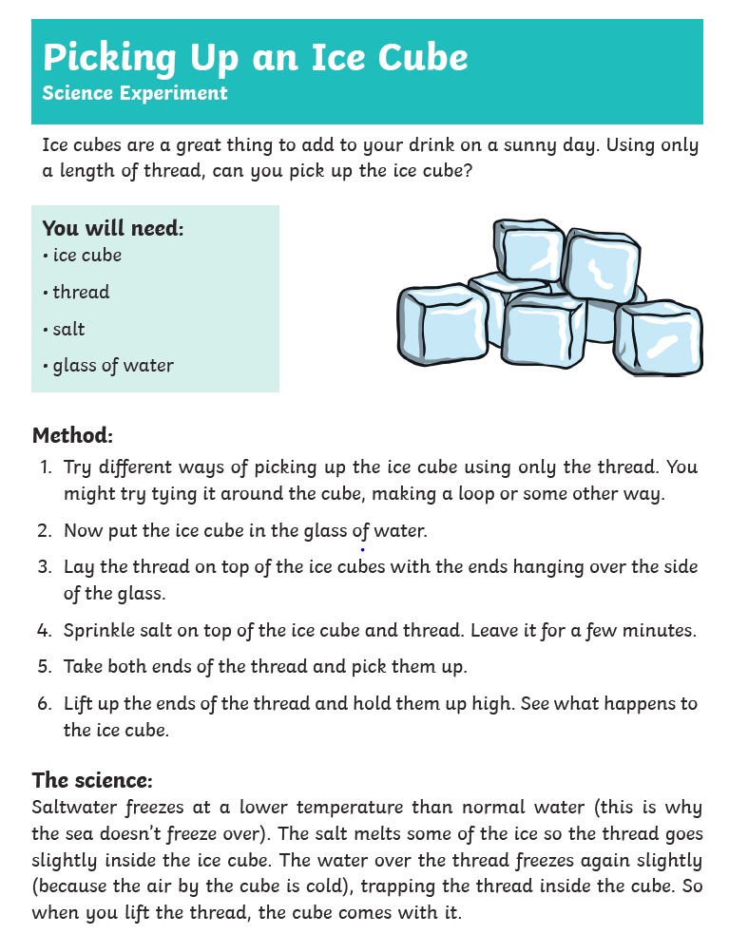
Topic Activity 1:
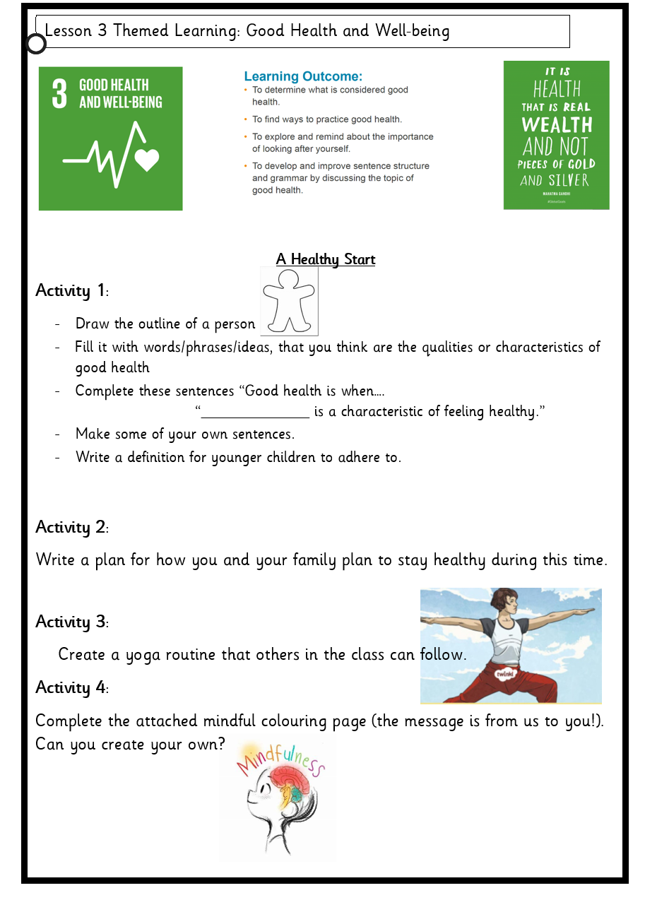

Topic 2: Dinosaurs and Fossils

Try your hand at being a palaeontologist by excavating rocks from your garden and from walks you go on.

Part 1:
- Do some research about Fossils
- What have you discovered?

Part 2:
- Find a rock that interests you or looks different
- Examine the rock
- Use another rock to tap away at it
- Did you find anything interesting hidden in the rock?
- Create some sketches of your rock

Part 3:
- Research Mary Anning
- Create a fact file about her

