Home Learning Week Commencing 8th June 2020

Maths
Day 1) Use short/long multiplication methods:

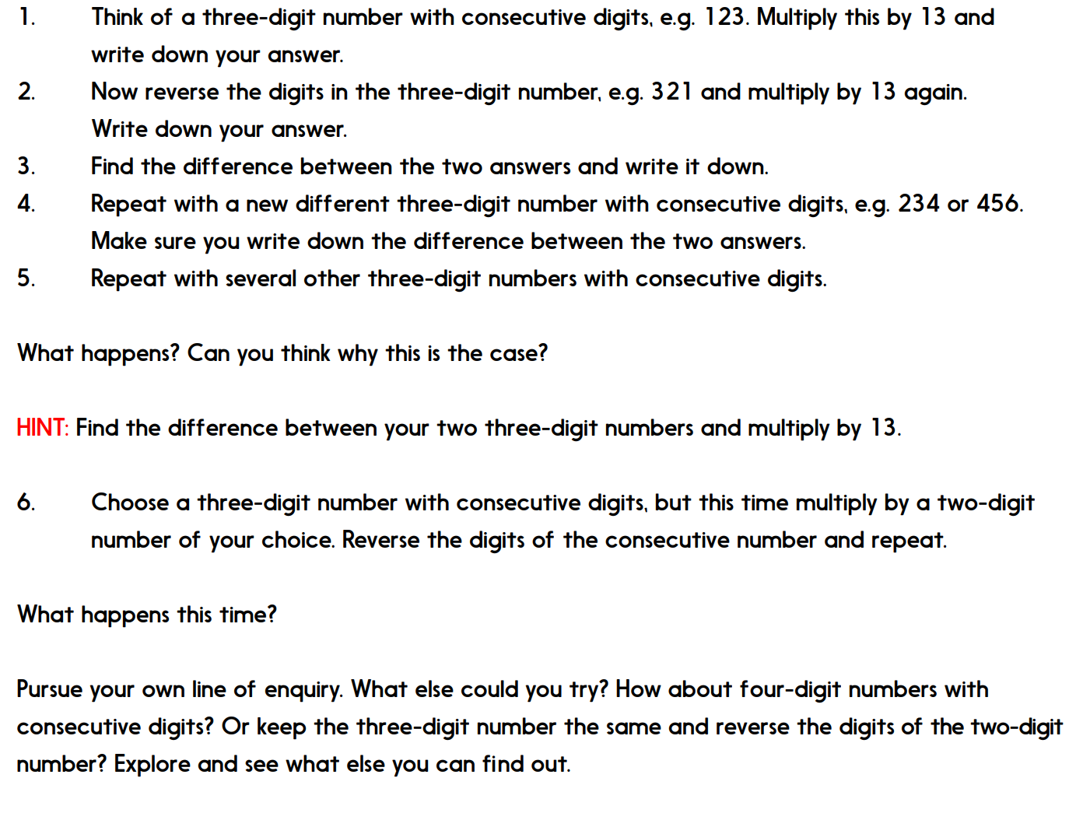

Day 2: Use short/long division
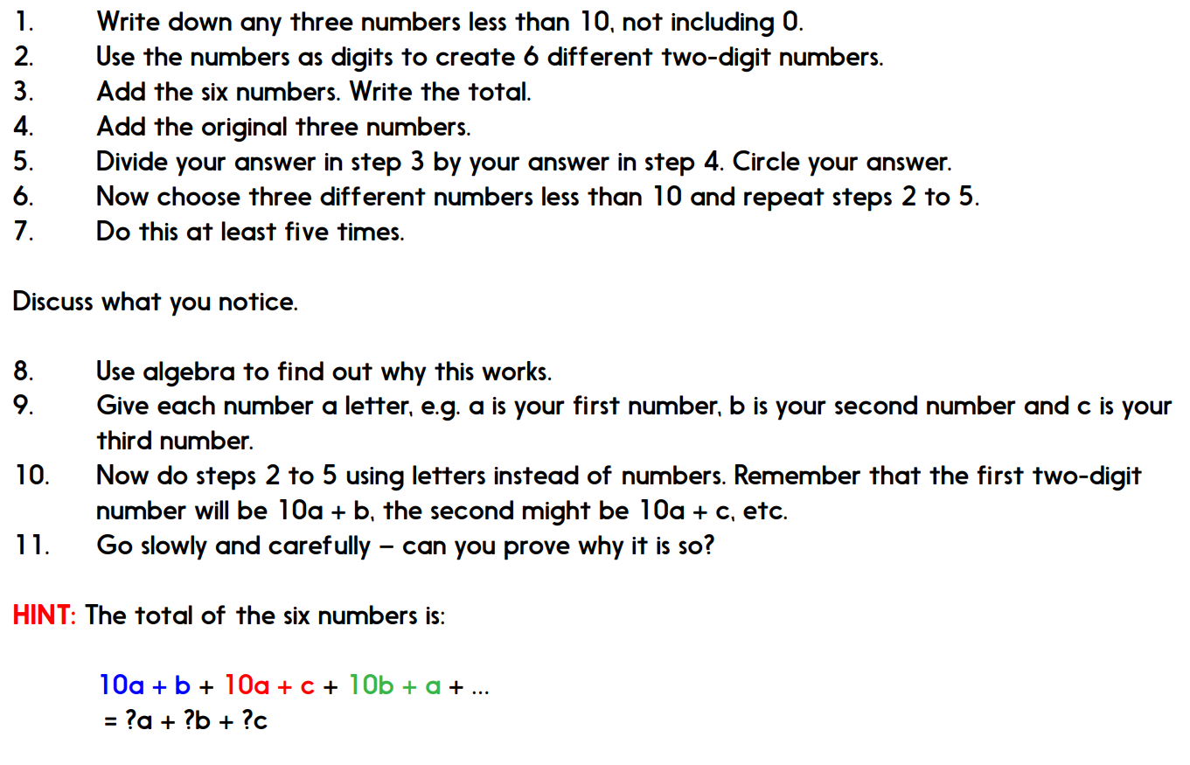

Day 3: BIDMAS

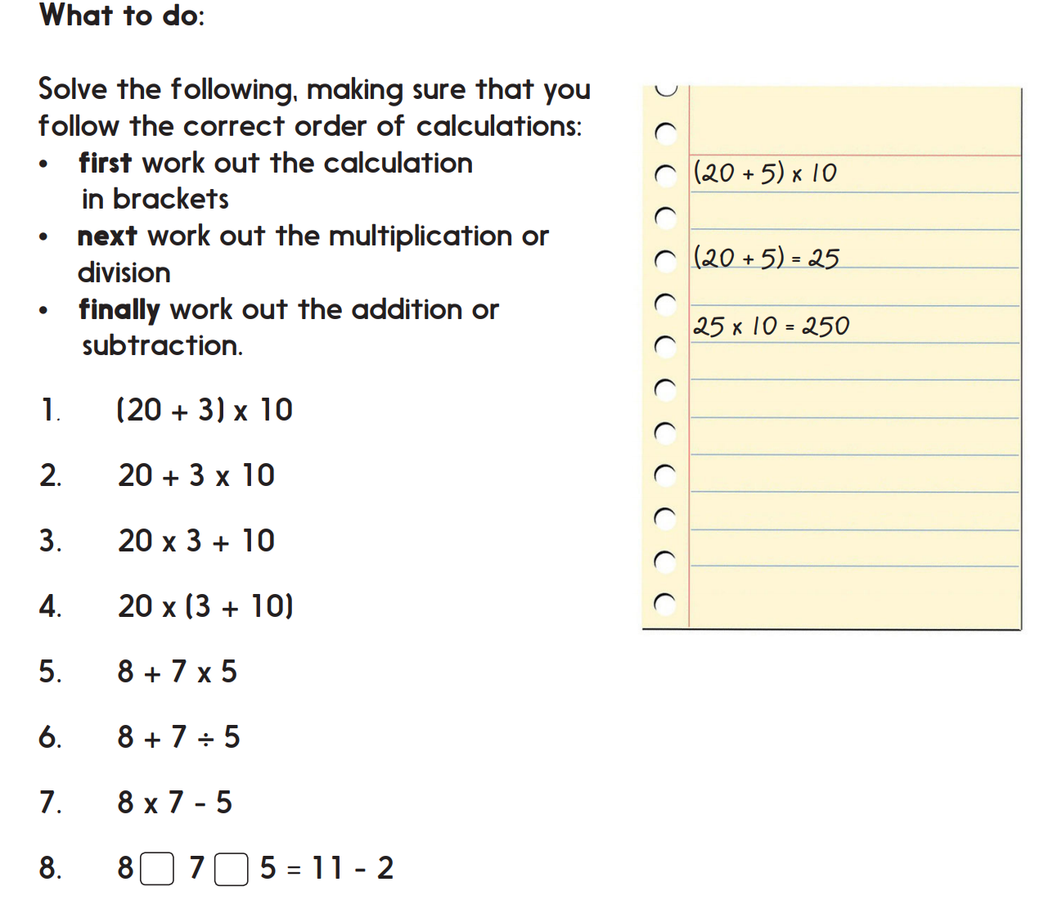

Day 4: Timetable Investigation
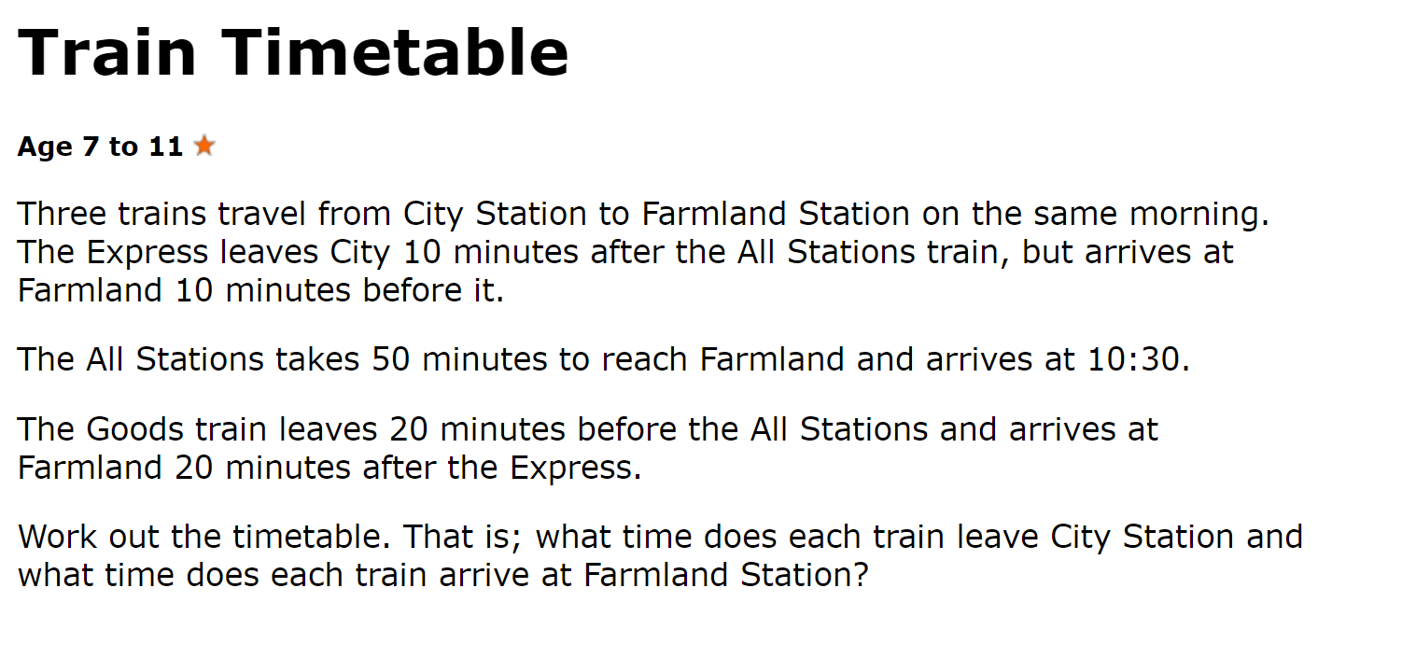

Day 5) Time investigation

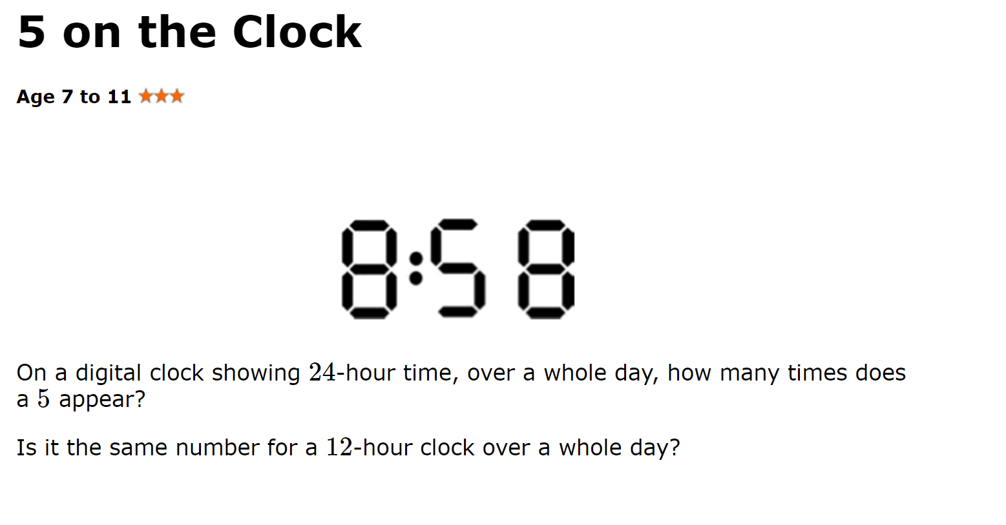

English

Day 1) Write your own story using the Year 6 writing criteria and this picture.
You can use this opening or create your own….

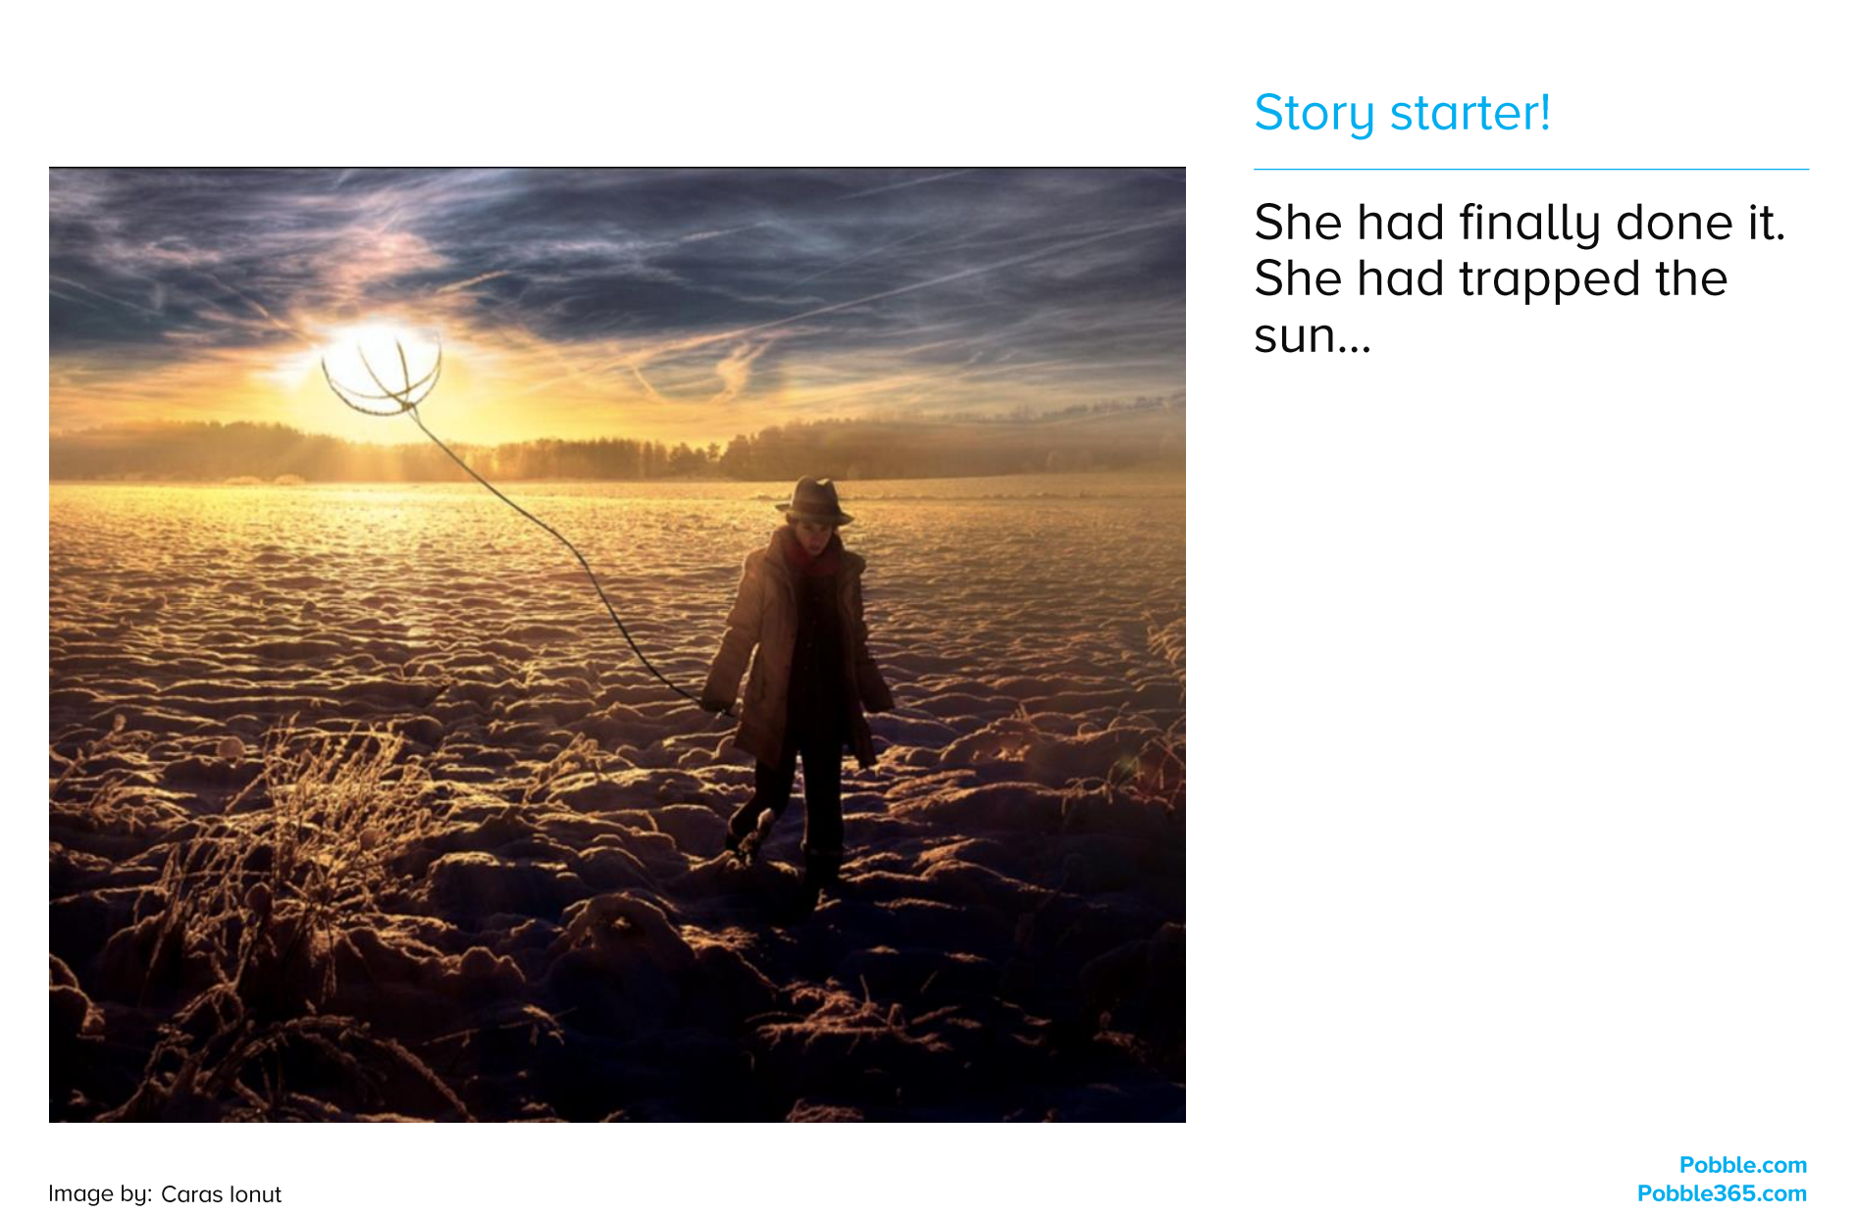

Day 2: Comprehension

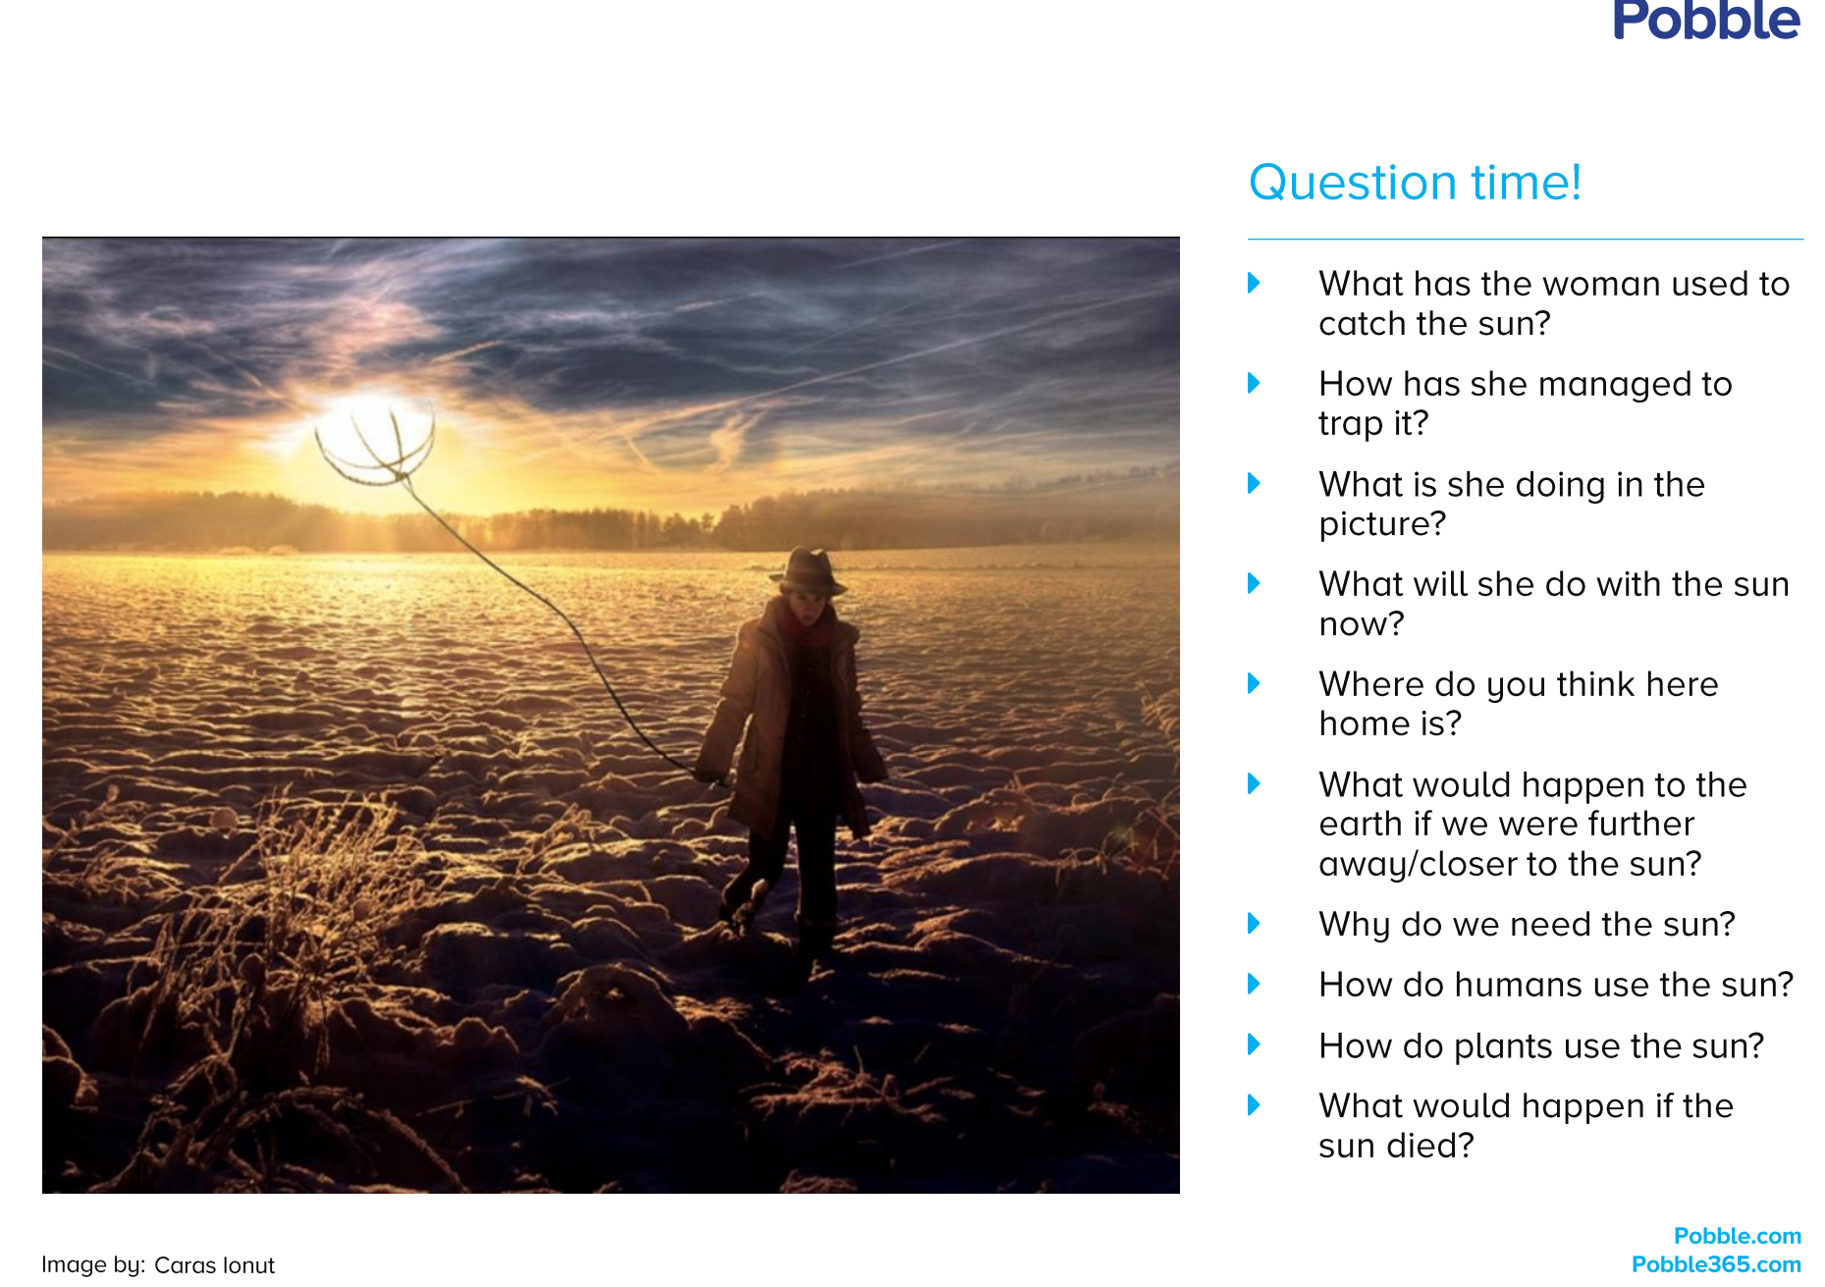

Day 3:

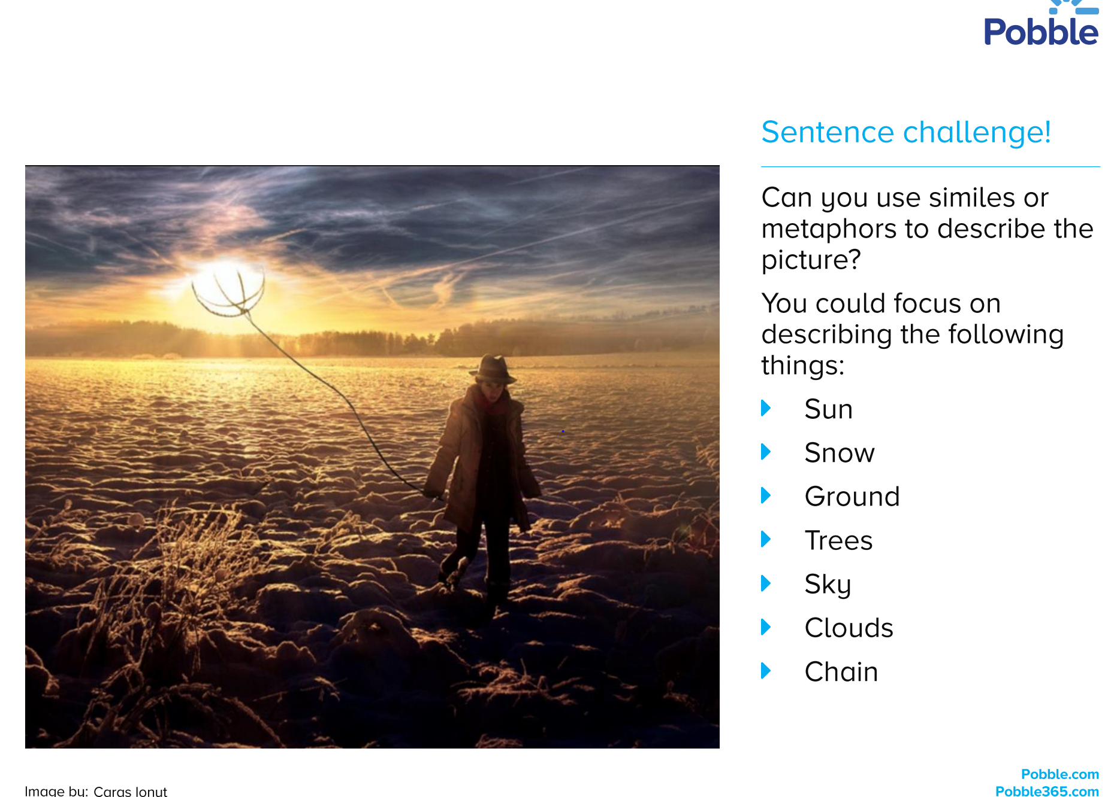

Day 4:

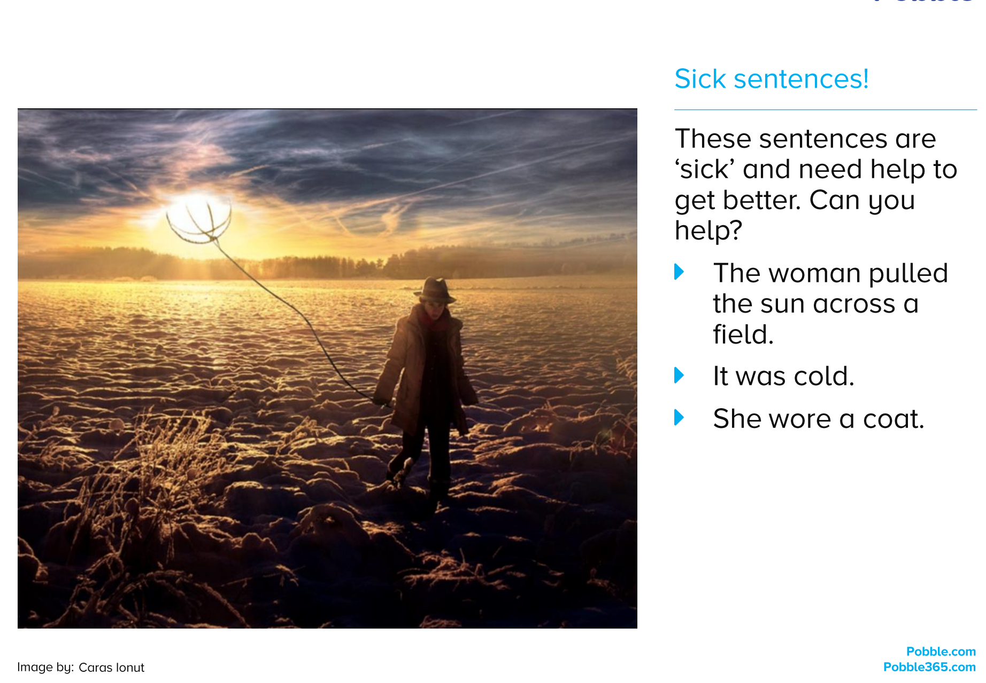

Day 5:
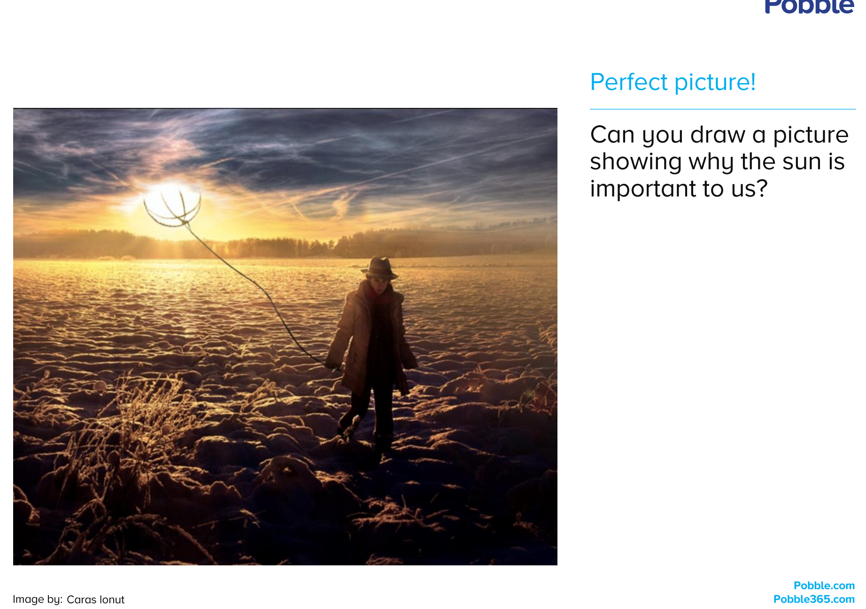
Science
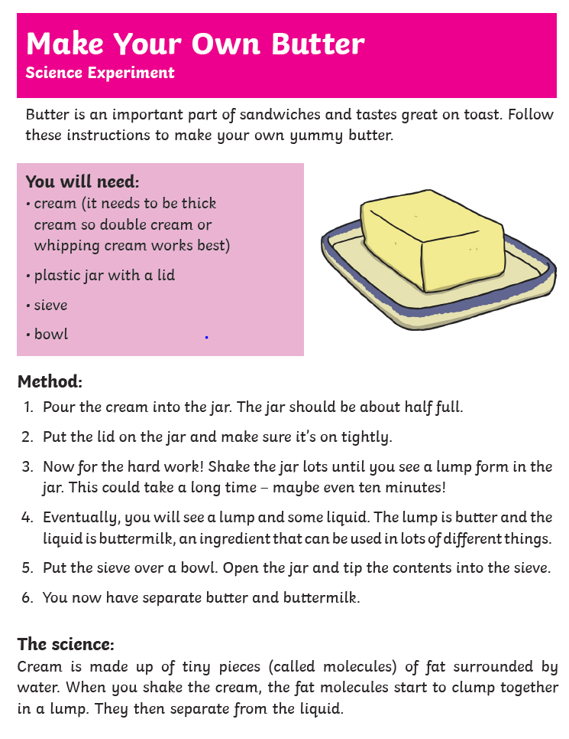
Topic Activity 1:
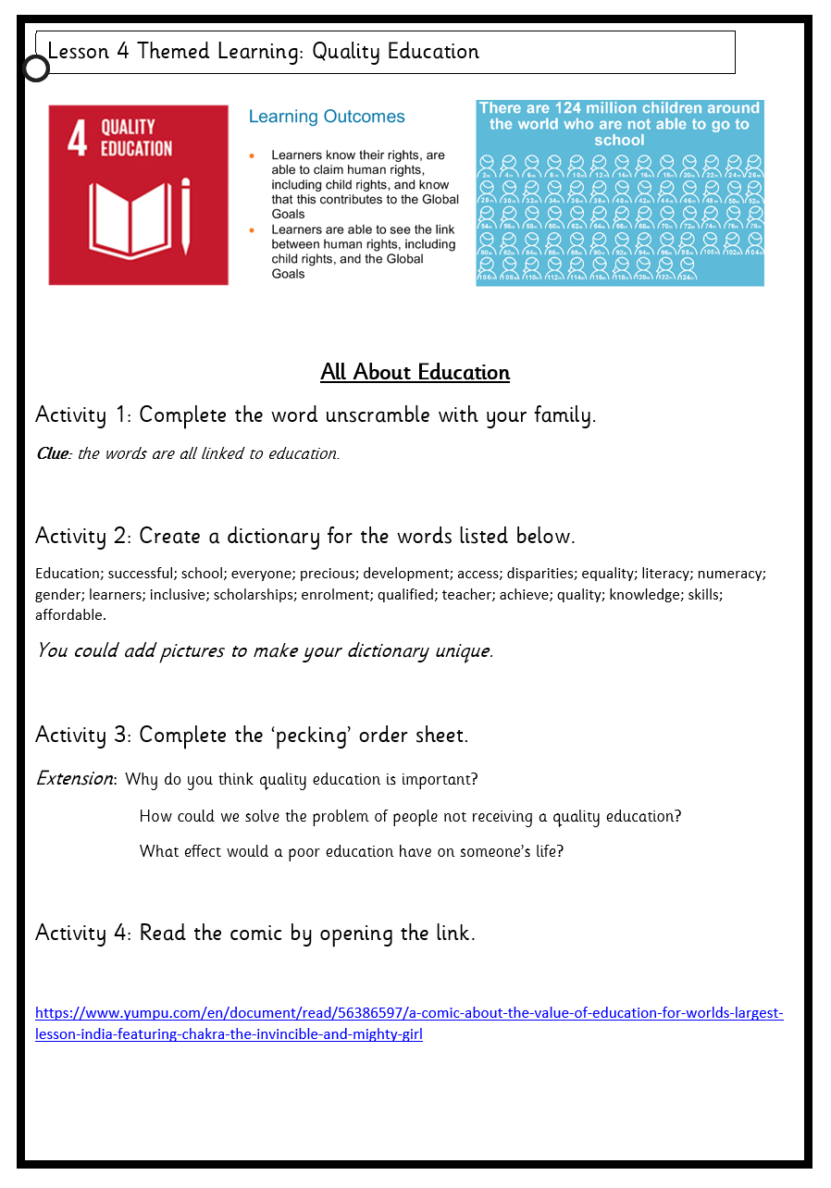

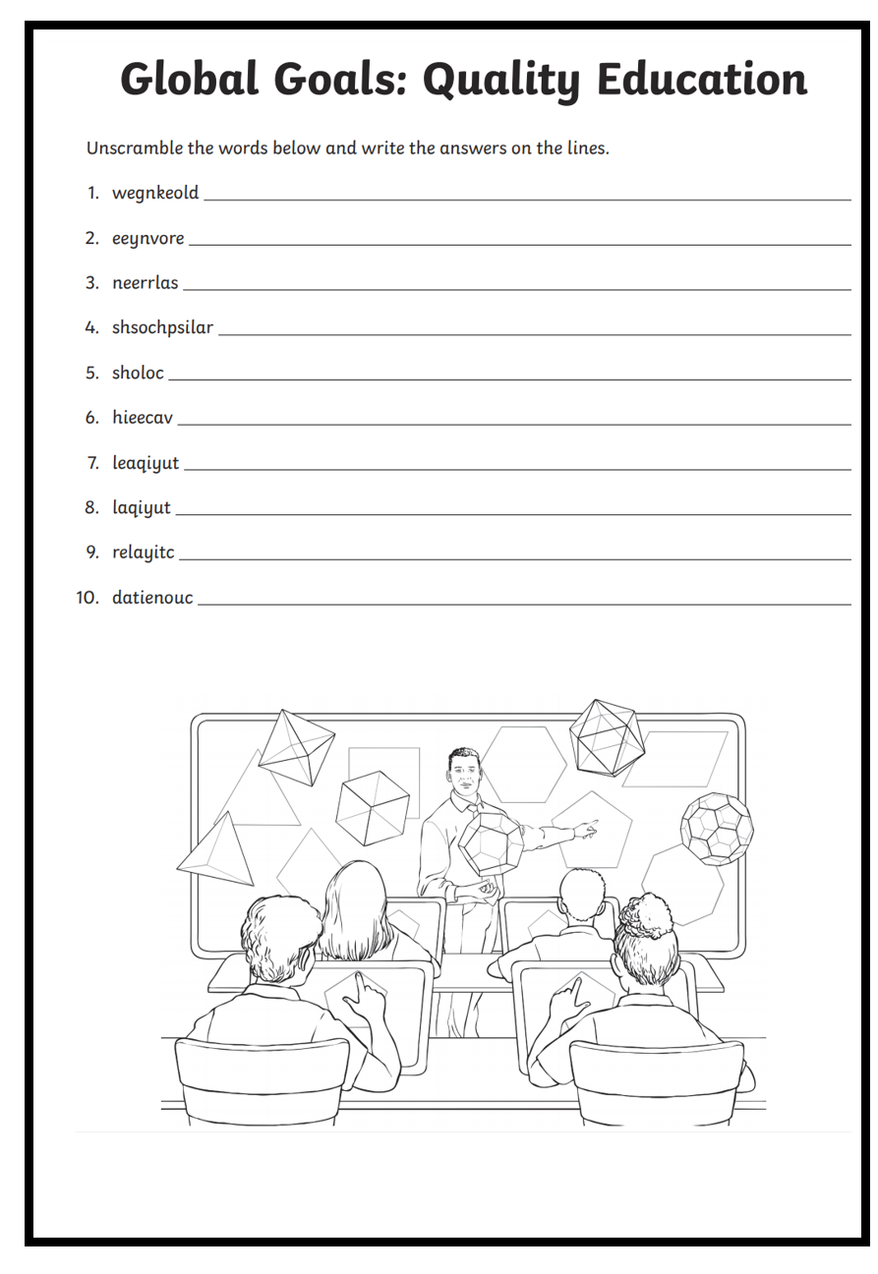

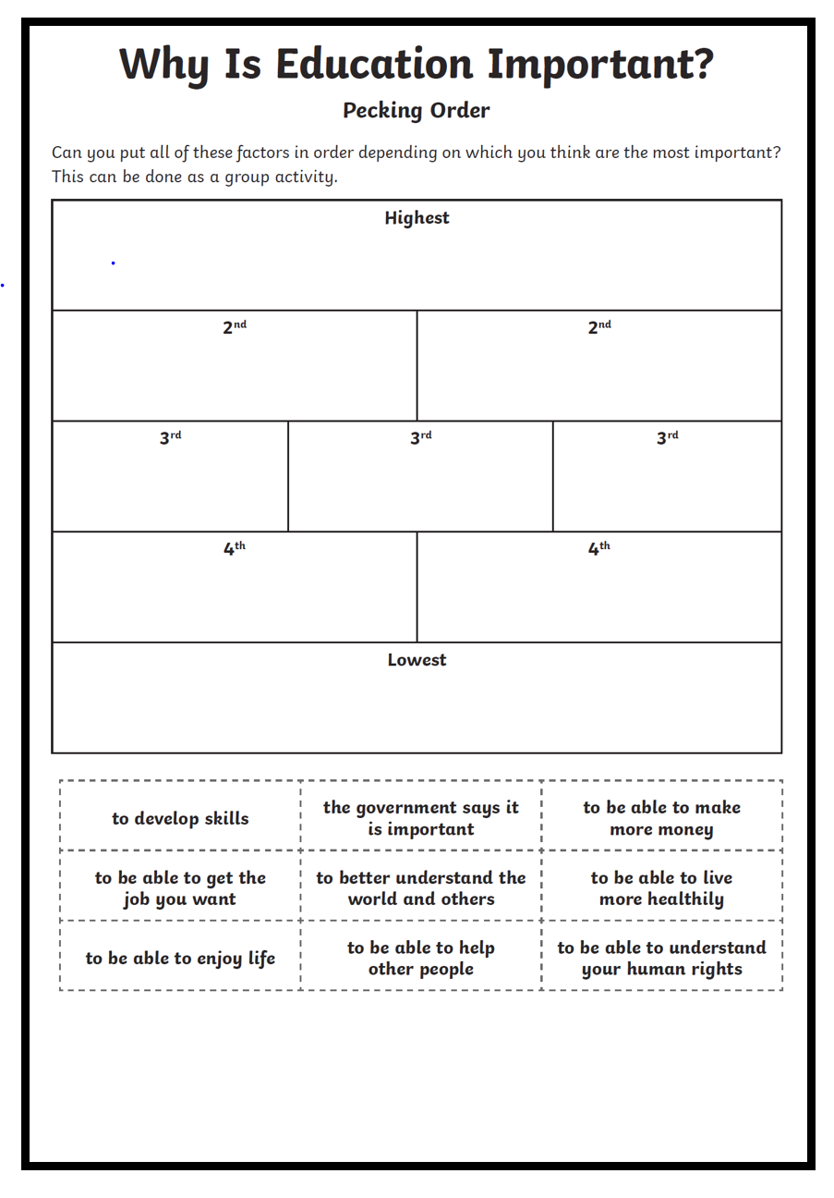

Topic 2: Learn about natural resources including agricultural and geological resources

Activity 1
What are natural resources?
Make a list

Activity 2
What are agricultural resources?
Make a list

Activity 3
What are geological resources?
Make a list

Activity 4
What natural resources do you use in your everyday life?
Complete the chart
