**Year 3 Home learning activities**

Week commencing 1st June

**English-**

This week we would like you to write a shape poem in the shape of an animal. Look at the examples at the bottom to help you.

When you have written please share it with us via seesaw!

This is how you could break this activity up across the week:

Monday- Look at lots of examples of shape poems. Read a few to find a style you like.

Tuesday- Decide what your shape poem is going to be about. Make notes describing that animal or leaf. Plan your ideas. Here is a planning grid to help you.

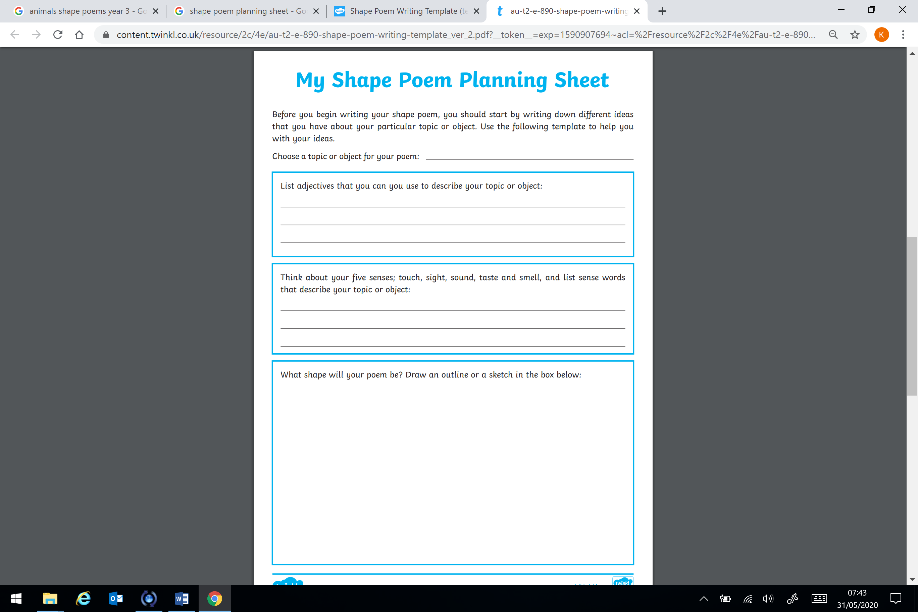

Wednesday- Start writing your shape poem. Draw the outline in pencil first then fill it in with your poem.

Thursday- Edit your poem for any spelling mistakes then write it up in best using pen. Remember to draw the outline in pencil again. Then you could rub out the outline afterwards if you want to.

Friday- Perform your poem and share it to seesaw!

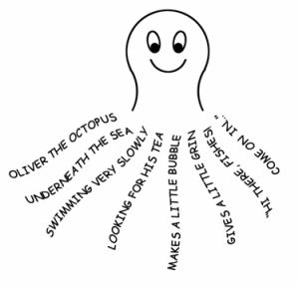 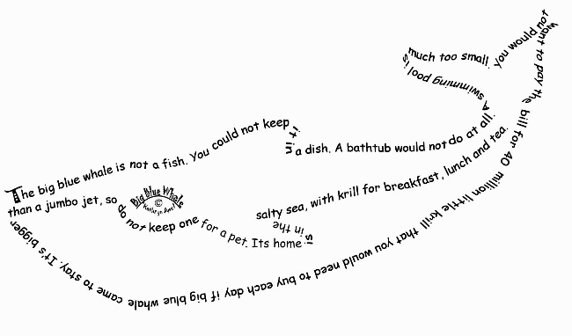

**Reading-** comprehension

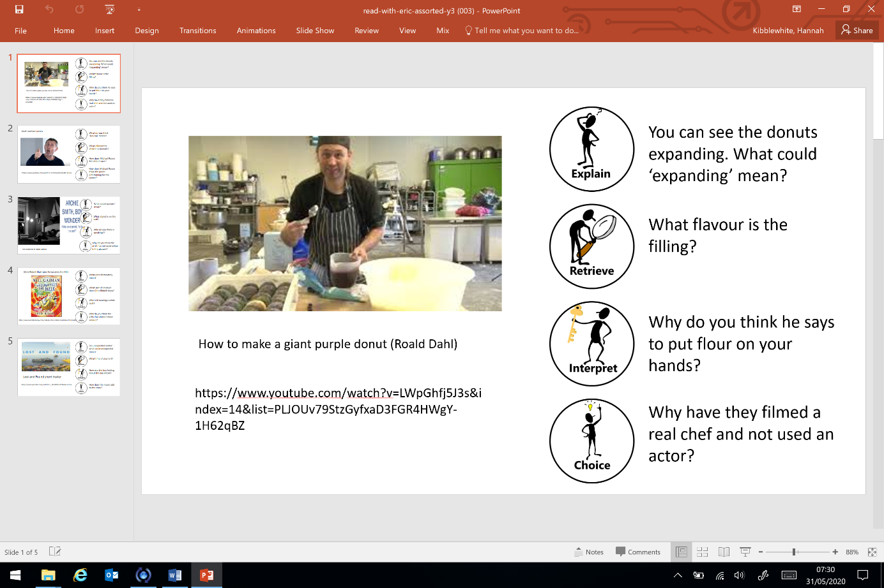As well as reading your books, we would like you to have a go at this comprehension activity. 

**How to make a giant purple donut (Roald Dahl)**

<https://www.youtube.com/watch?v=LWpGhfj5J3s&index=14&list=PLJOUv79StzGyfxaD3FGR4HWgY-1H62qBZ>

**Spellings-**

|  |  |
| --- | --- |
| **Red and Green** | **Blue and Yellow** |
| here | high |
| hear | night |
| plain | light |
| plane | bright |
| meat | right |
| meet | for |
| berry | short |
| bury | born |
| fair | horse |
| fare | morning |

**Maths-**

This week we are going to begin working on **Recognising right angles.**

This is a breakdown of the activity suggestions for each day.

**Monday-**

**Watch this video:** <https://www.youtube.com/watch?v=9RTM418qfdI>

Now create your own right angle finder-

Find as many right angles around your house- take a picture and share it on Seesaw of your right angle hunt.

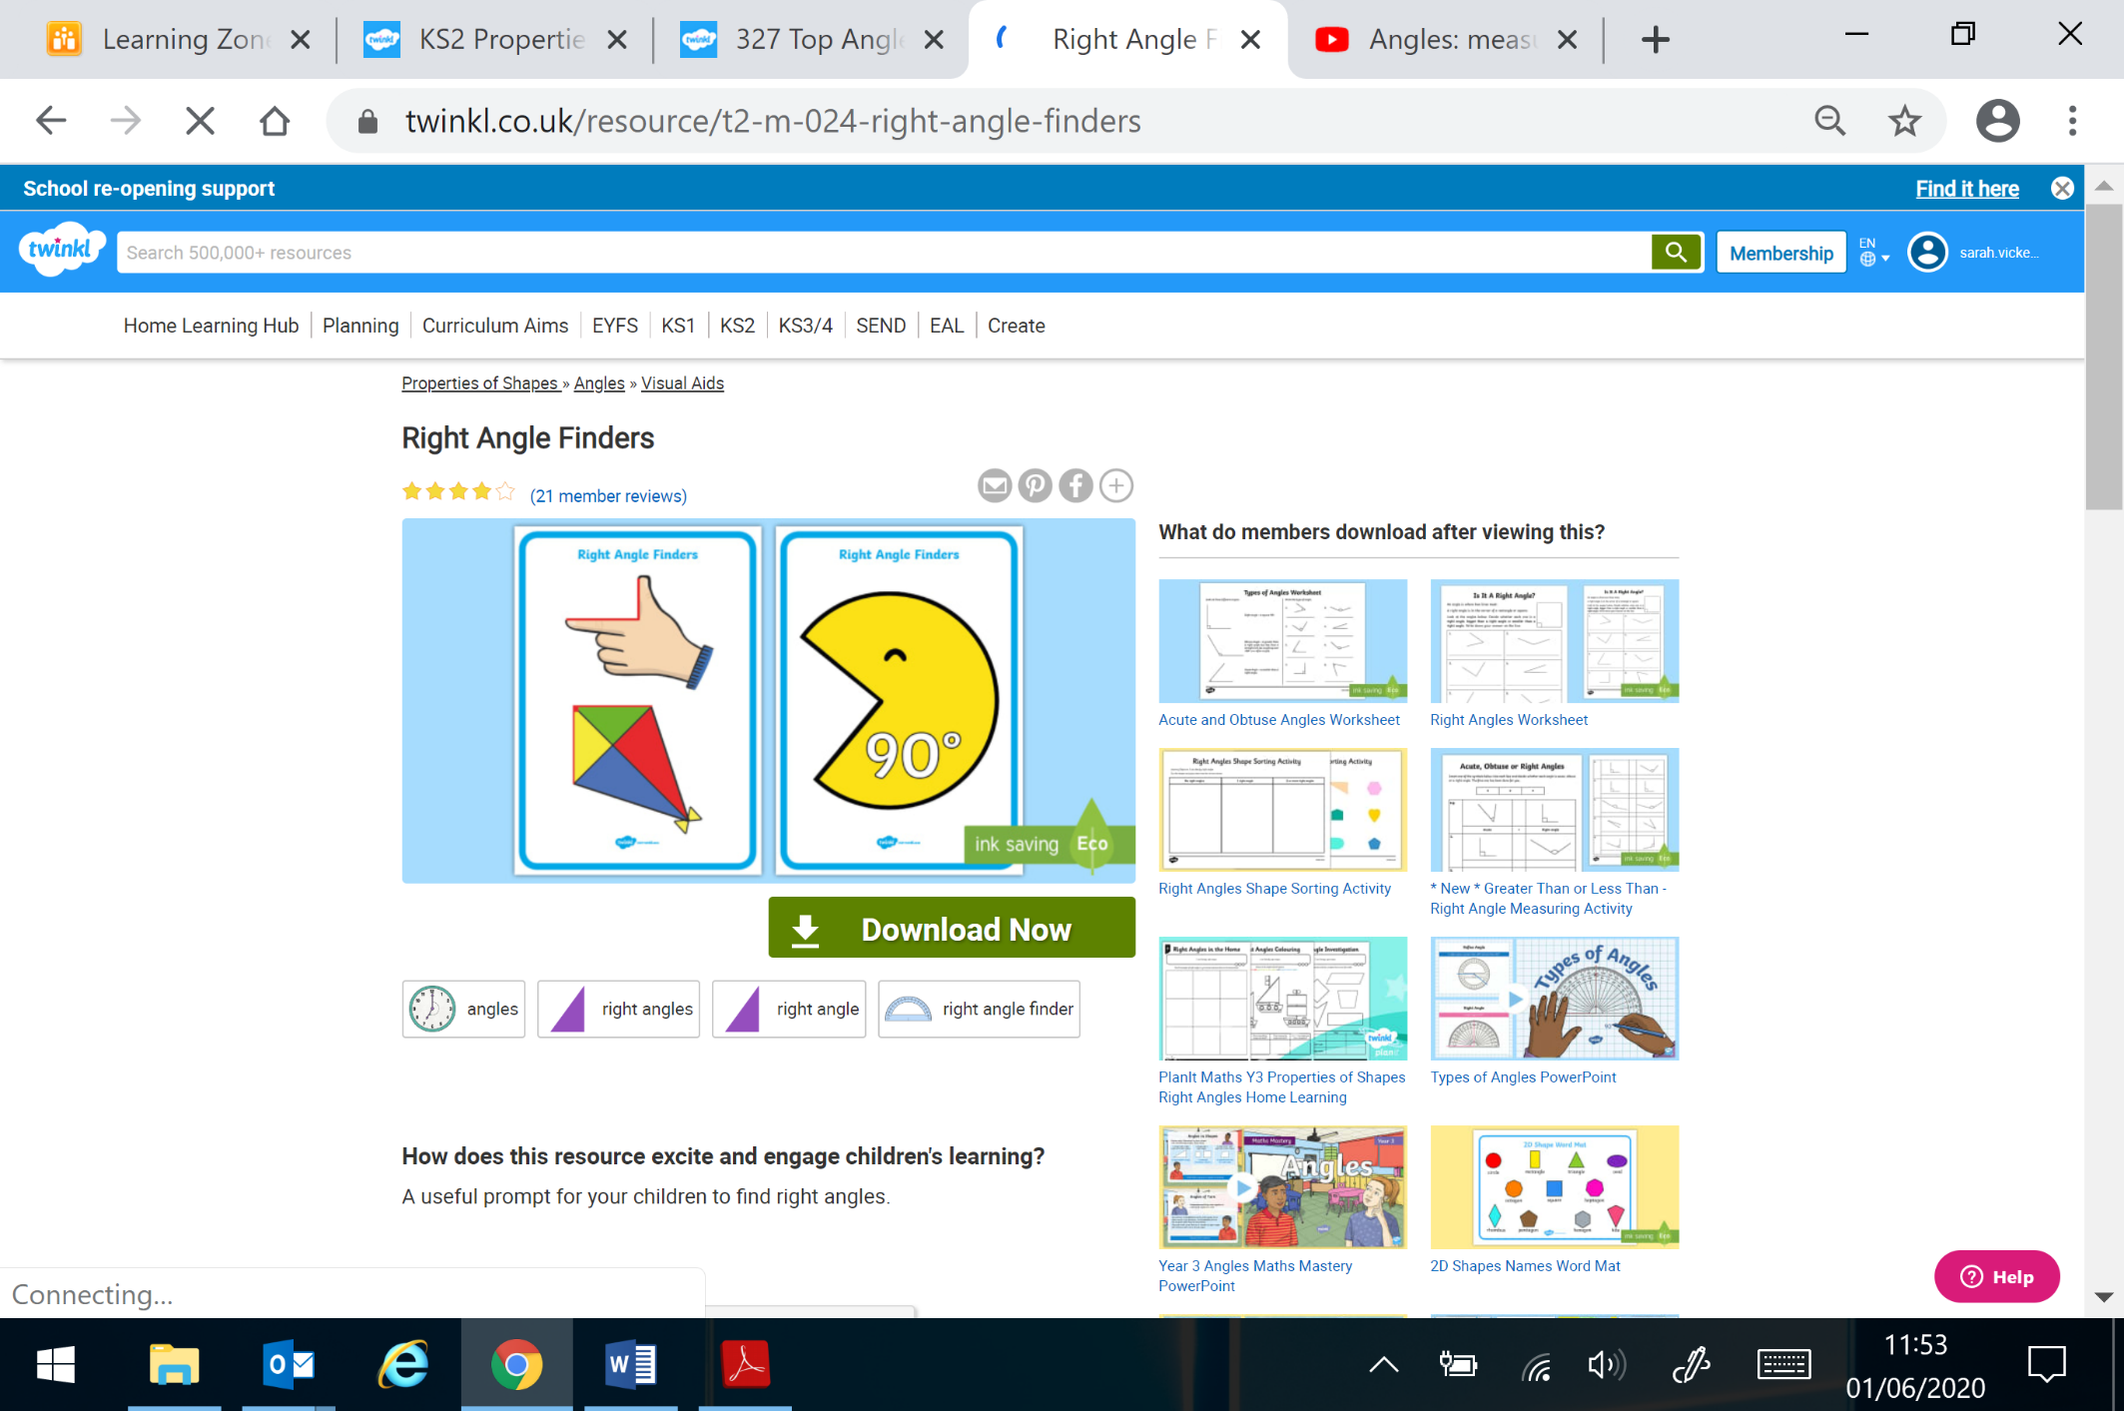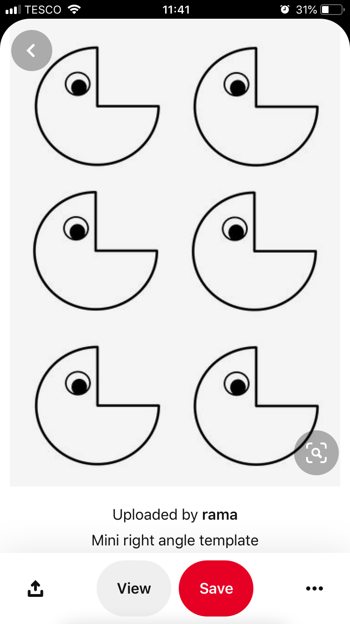

**Tuesday-**

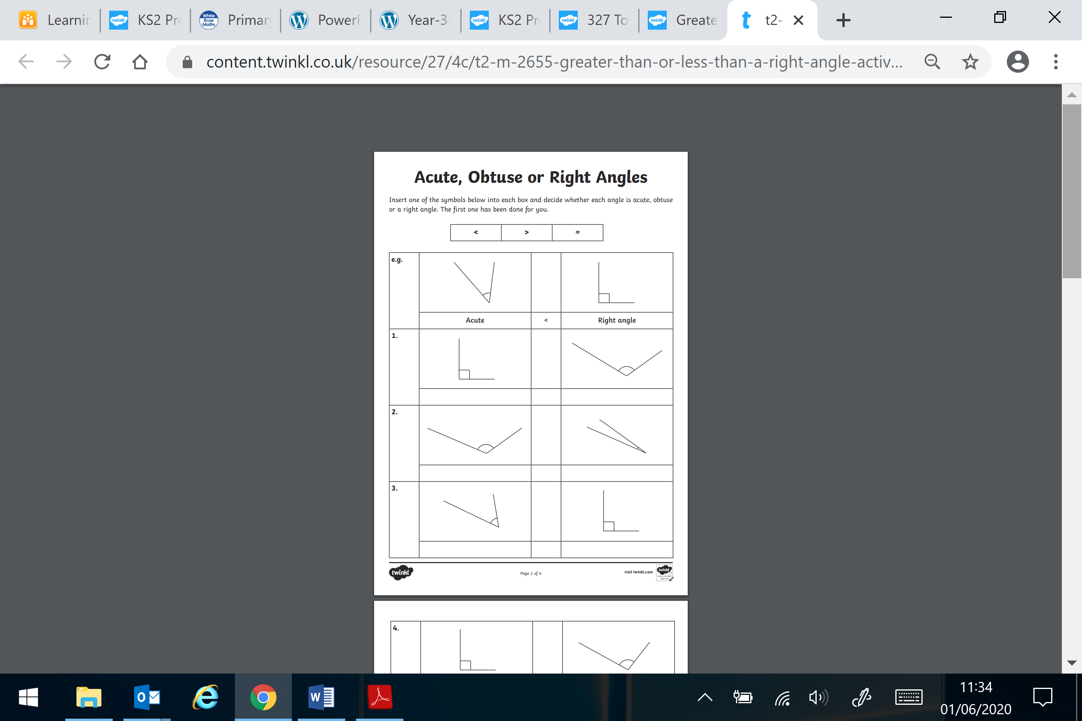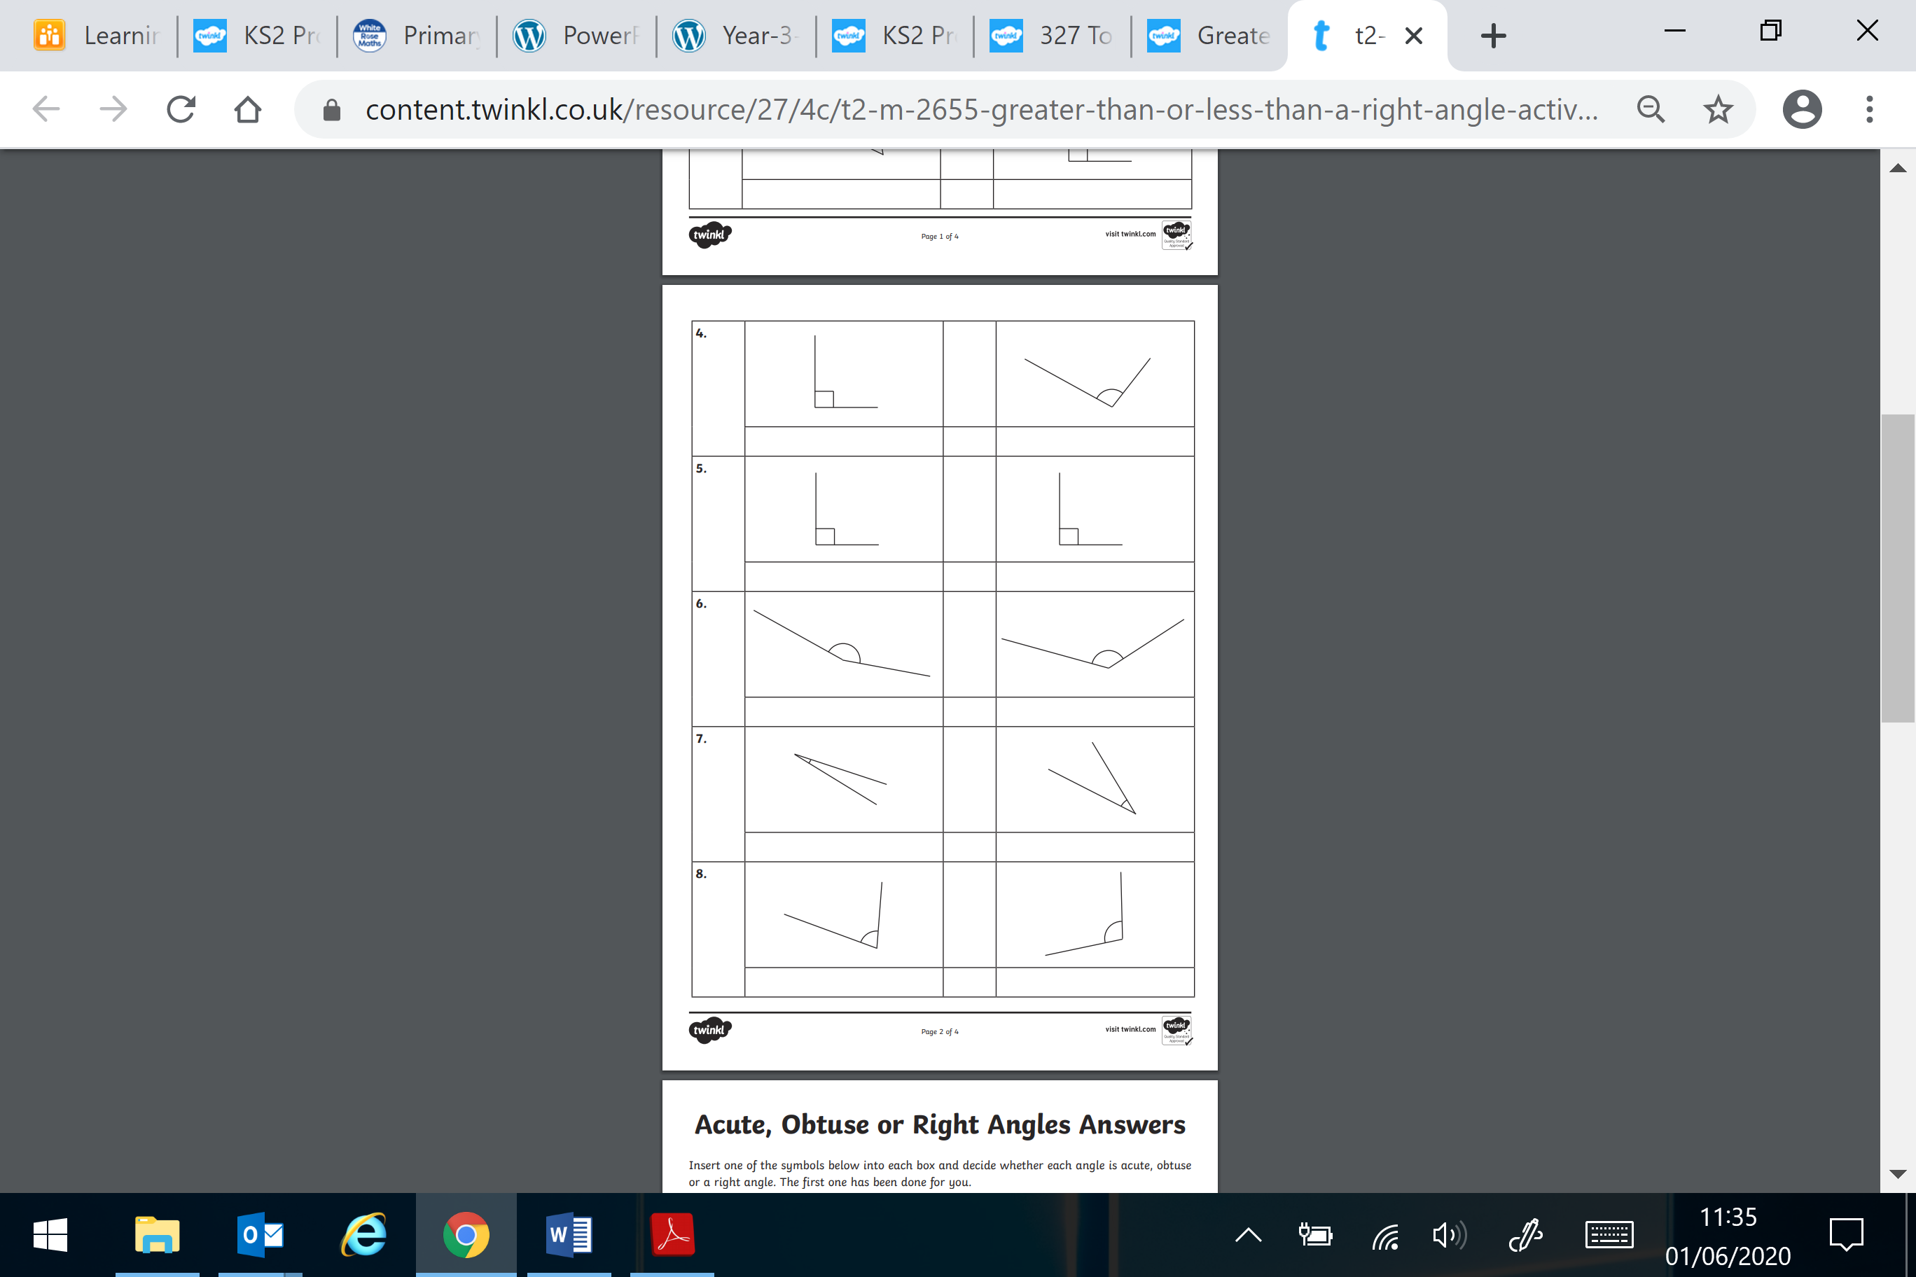

**Answers:**

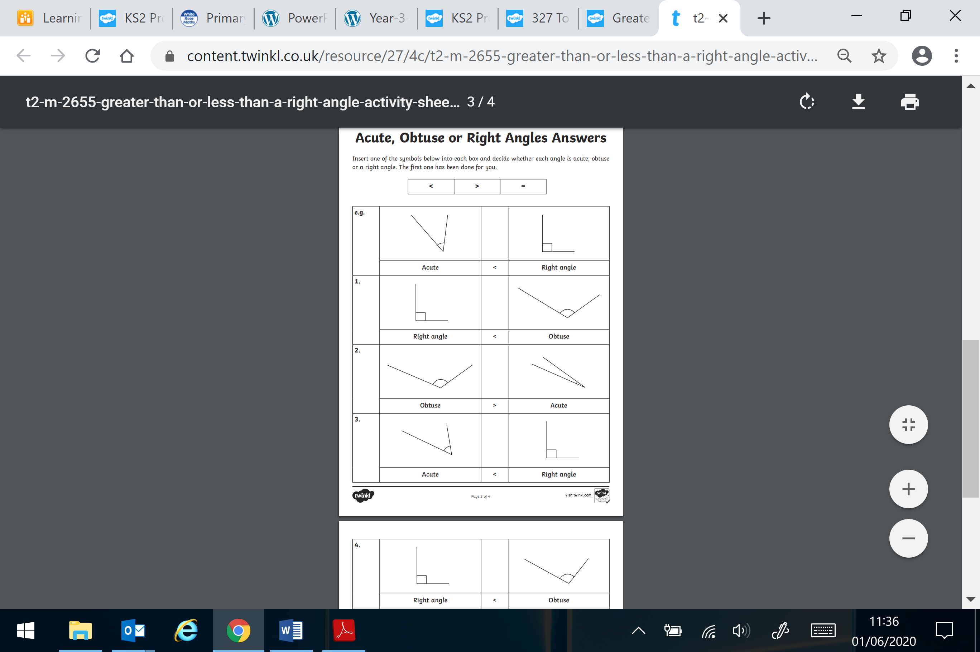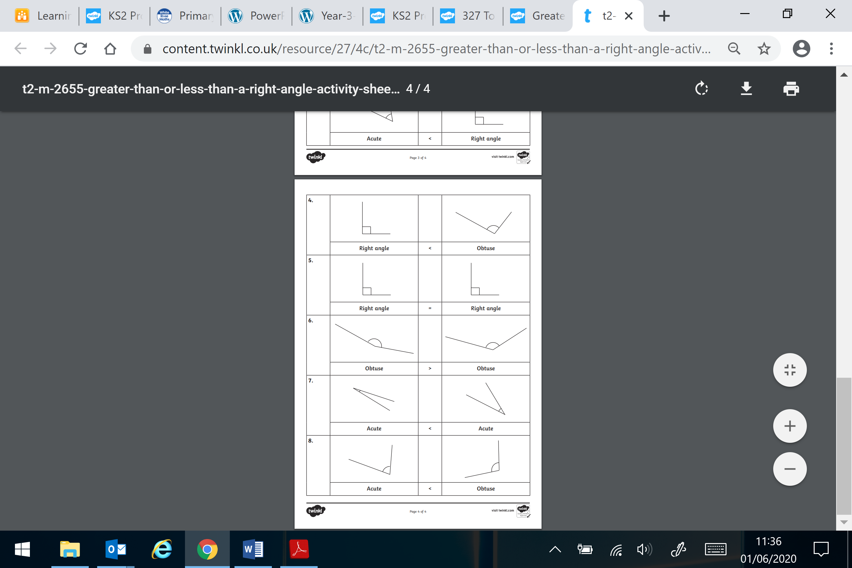

**Wednesday-**

On your walk collect as many sticks as you can- then create this-

<https://creativestarlearning.co.uk/maths-outdoors/outdoor-maths-investigating-right-angles-with-sticks/>

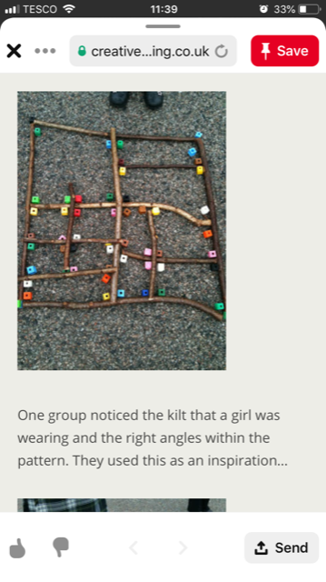

Find a way to show where you can see a right angle.

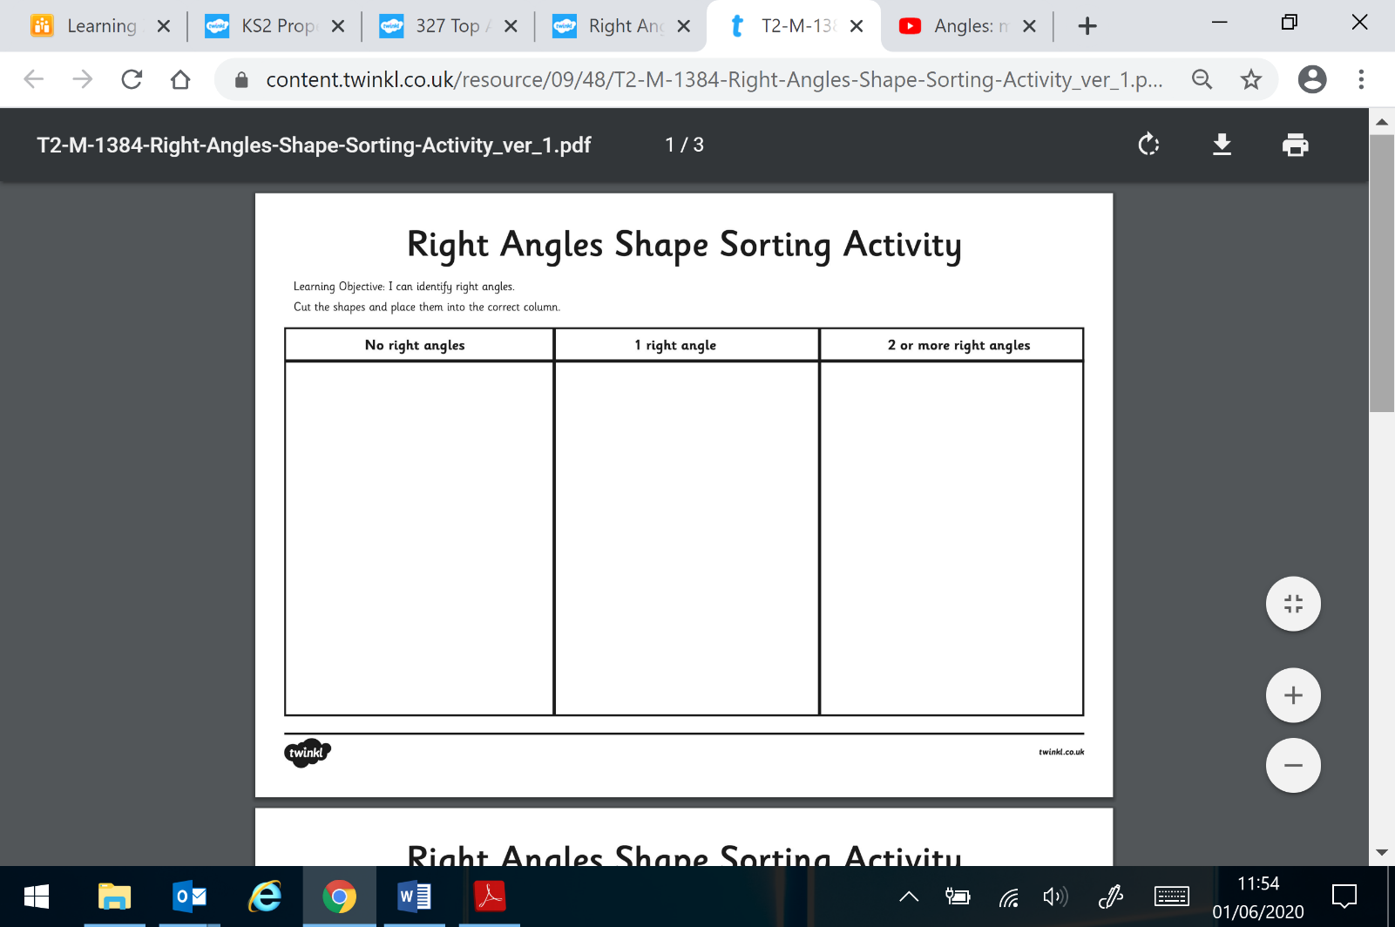**Thursday-**

Also your child has access to Timetable rock stars

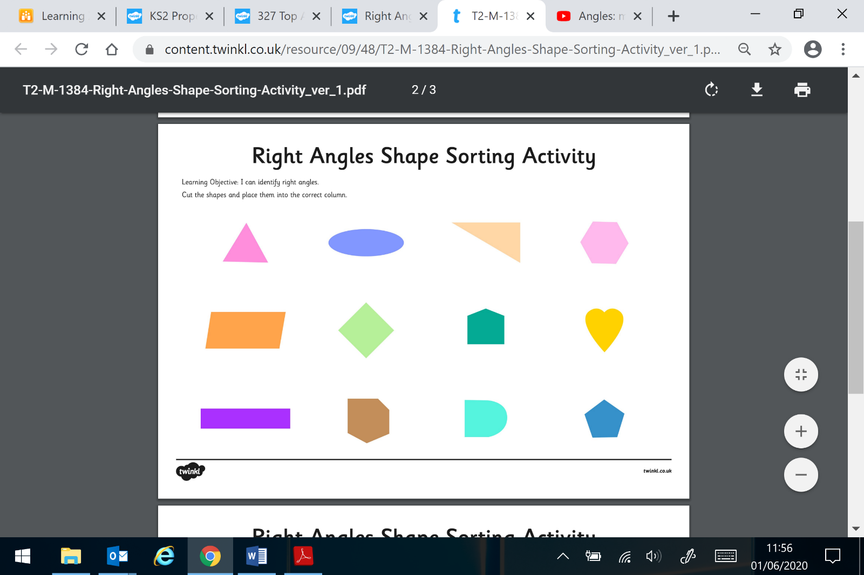

<https://play.ttrockstars.com/auth/school/student/16409>

If you do not have your child’s log in details- please ask us for them.

**Art**

This week we would like you to some observational drawings. You could choose a leaf, flower, fruit etc. Then you need to sketch it looking at it closely and include as much detail as possible. You could even choose a small section of it to draw rather than the whole object. Look at the examples below to help.

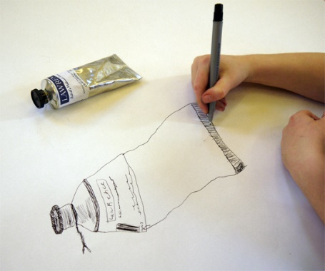 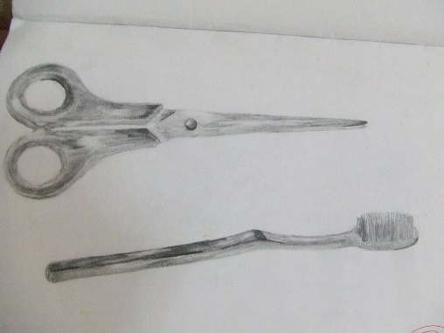 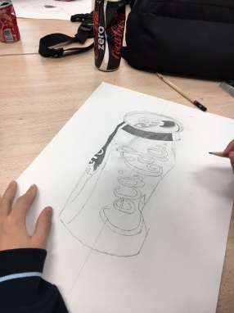

**PSHE**

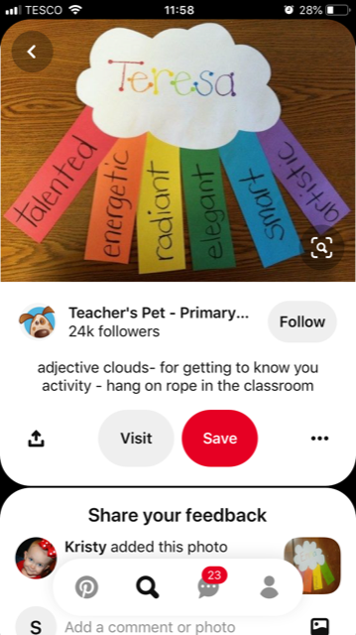Create a Wonderful Me cloud- think carefully about your lovely qualities- you may like to create them for other family member also- share your creations on Seesaw.

If you have any questions about any of the work set, or to simply allow your child to keep in touch with us- please ensure you have access to your child’s Seesaw account.

You can gain access by emailing us on

[sarah.vickers@taw.org.uk](mailto:sarah.vickers@taw.org.uk)

[hannah.kibblewhite1@taw.org.uk](mailto:hannah.kibblewhite1@taw.org.uk)

Have a wonderful week.

We miss you all very much.

Mrs Vickers and Mrs Kibblewhite.