Year 3 Home learning activities
Week commencing 15th June
English-
This week we would like you to design and write a character description. We are going to be building up to writing a story so your character needs to match the setting description you wrote last week! Remember your setting was in a rainforest. You could do two characters to go in your story!
When you have written please share it with us via seesaw!
This is how you could break this activity up across the week:
Monday- Look at some character descriptions online or in books at home. Write down some things you like about the ones you look at. Look for powerful adjectives that you can magpie for yours. I have put one below to get you started.
Tuesday- Research images of book characters with a grown up. Think about what you want your character to look like. What sort of person are they going to be? Will you choose a villain or a hero to describe?
Wednesday- Design your character or characters- draw them and label them with adjectives and descriptive language. Don’t forget to say what they are like as person on the inside not just on the outside.
Thursday- Write your character description. Remember to describe everything about your character. What they look like, what they sound like, what their personality is like.
Friday- Edit your character description. Make sure you write it up in your best handwriting and check your spellings using a dictionary.

Reading- comprehension
As well as reading your books, we would like you to have a go at this comprehension activity.
Lost and Found short trailer
https://www.youtube.com/watch?v=g-N-m0N0vtM
Spellings-
Red and Green | Blue and Yellow
accept | saw
except | draw
affect | yawn
effect | crawl
groan | paw
grown | claw
main | lawn
mane | fawn
missed | law
mist | jaw

Spelling ideas:
Create a scrambled letter game with a parent or a sibling

Maths-
This week we are going to work on Properties of shape
Follow this link to the Oak National academy resources- children can follow the lessons and record them on the paper. Take a picture and share it with us on Seesaw.

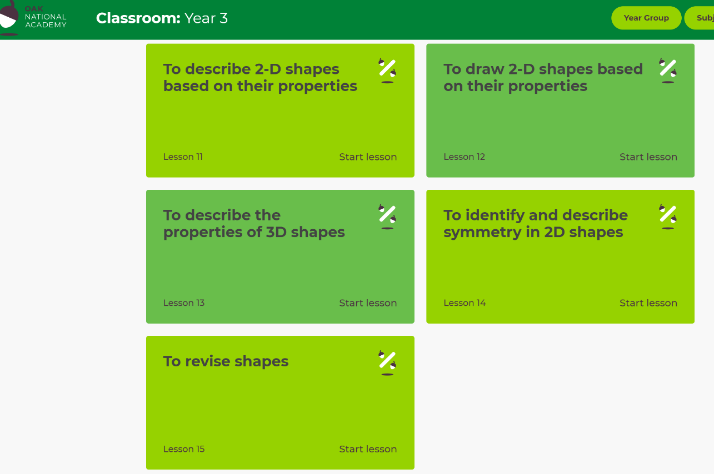
https://classroom.thenational.academy/subjects-by-year/year-3/subjects/maths
Monday
Tuesday

Wednesday
Thursday

Friday

Also your child has access to Timetable rock stars at https://play.ttrockstars.com/auth/school/student/16409
If you do not have your child’s log in details- please ask us for them.

Science
This week we are continuing looking at the skeletal system of a Human.
This week please create a Human skeleton using natural resources:
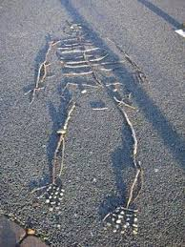

PSHE
We are thinking about our hopes and wishes for our future.

This week we like you to think in more detail about the job/carer you would like to pursue.

Create a page- with pictures/drawings related to the job. Think about and record the qualities that people who do this job have. Research what qualifications you would need. Why would you be good at this job?

Remember to show us your achievements via Seesaw.

If you have any questions about any of the work set, or to simply allow your child to keep in touch with us- please ensure you have access to your child’s Seesaw account.
You can gain access by emailing us on
sarah.vickers@taw.org.uk
hannah.kibblewhite1@taw.org.uk

Have a wonderful week.
We miss you all very much.
Mrs Vickers and Mrs Kibblewhite.

