Year 3 Home learning activities
Week commencing 22nd June
English-
This week we would like you to think about the build up and dilemma in your story. We are going to use a simple adventure story to help us come up with some ideas.
When you have written please share it with us via seesaw!
This is how you could break this activity up across the week:
Monday- Read the adventure story- underline or highlight the build up and the dilemma in the story.
Tuesday- Today you need to come up with some problems that your characters might face. Brainstorm some ideas about what could be a problem in a rainforest. In the example the characters go through a picture into a new world on a real pirate ship. Could your characters go into a rainforest in your story? Who could they meet? What will happen when they meet this person or animal?
Wednesday- It’s time to get writing. In the example story the characters are playing in a playground, which is the build up to them finding the picture. What will your characters be doing before they enter the rainforest? What will they find that helps them enter the rainforest? Write a short build up finishing with your characters entering the rainforest.
Thursday- Write up your dilemma using your ideas from Tuesday. Choose one things that happens to your characters. Don’t forget if you are putting speech in your story to use inverted commas to show who is speaking.
Friday- Read back through your build up and your dilemma. Check for spelling mistakes and make sure what you have written makes sense.

Reading- comprehension
As well as reading your books, we would like you to have a go at this comprehension activity.
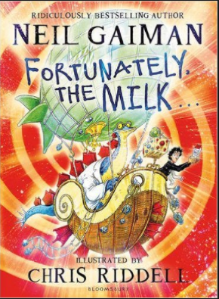
Chris Riddell illustrates Fortunately the Milk
http://www.worldbookday.com/videos/chris-riddell-illustrates-fortunately-the-milk
Spellings-
Red and Green | Blue and Yellow
ball | author
bawl | august
heel | dinosaur
heal | astronaut
he’ll | sauce
medal | haul
meddle | taught
peace | cause
piece | because
whose | applaud

Spelling ideas:
The weather is meant to be lovely this week so why don’t you learn your spellings using this fun activity?
Water Paint: Use water and a paintbrush to water paint the spelling words. On a hot sunny day the words will disappear quickly so you need to paint fast! Don’t forget to take a photo for seesaw before it dries!

Maths- This week we are going to work on Measure- Mass
Follow this link to the Oak National academy resources- children can follow the lessons and record them on the paper. Take a picture and share it with us on Seesaw.

https://classroom.thenational.academy/subjects-by-year/year-3/subjects/maths

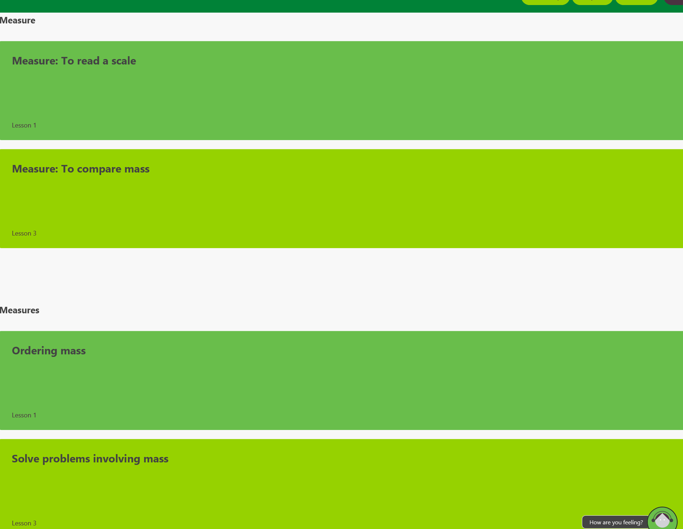
Thursday
Wednesday
Monday
Tuesday

Friday- Timetable Rockstars!

Science

PSHE
This week we are going to be talking about expressing our feelings and emotions.

PSHE
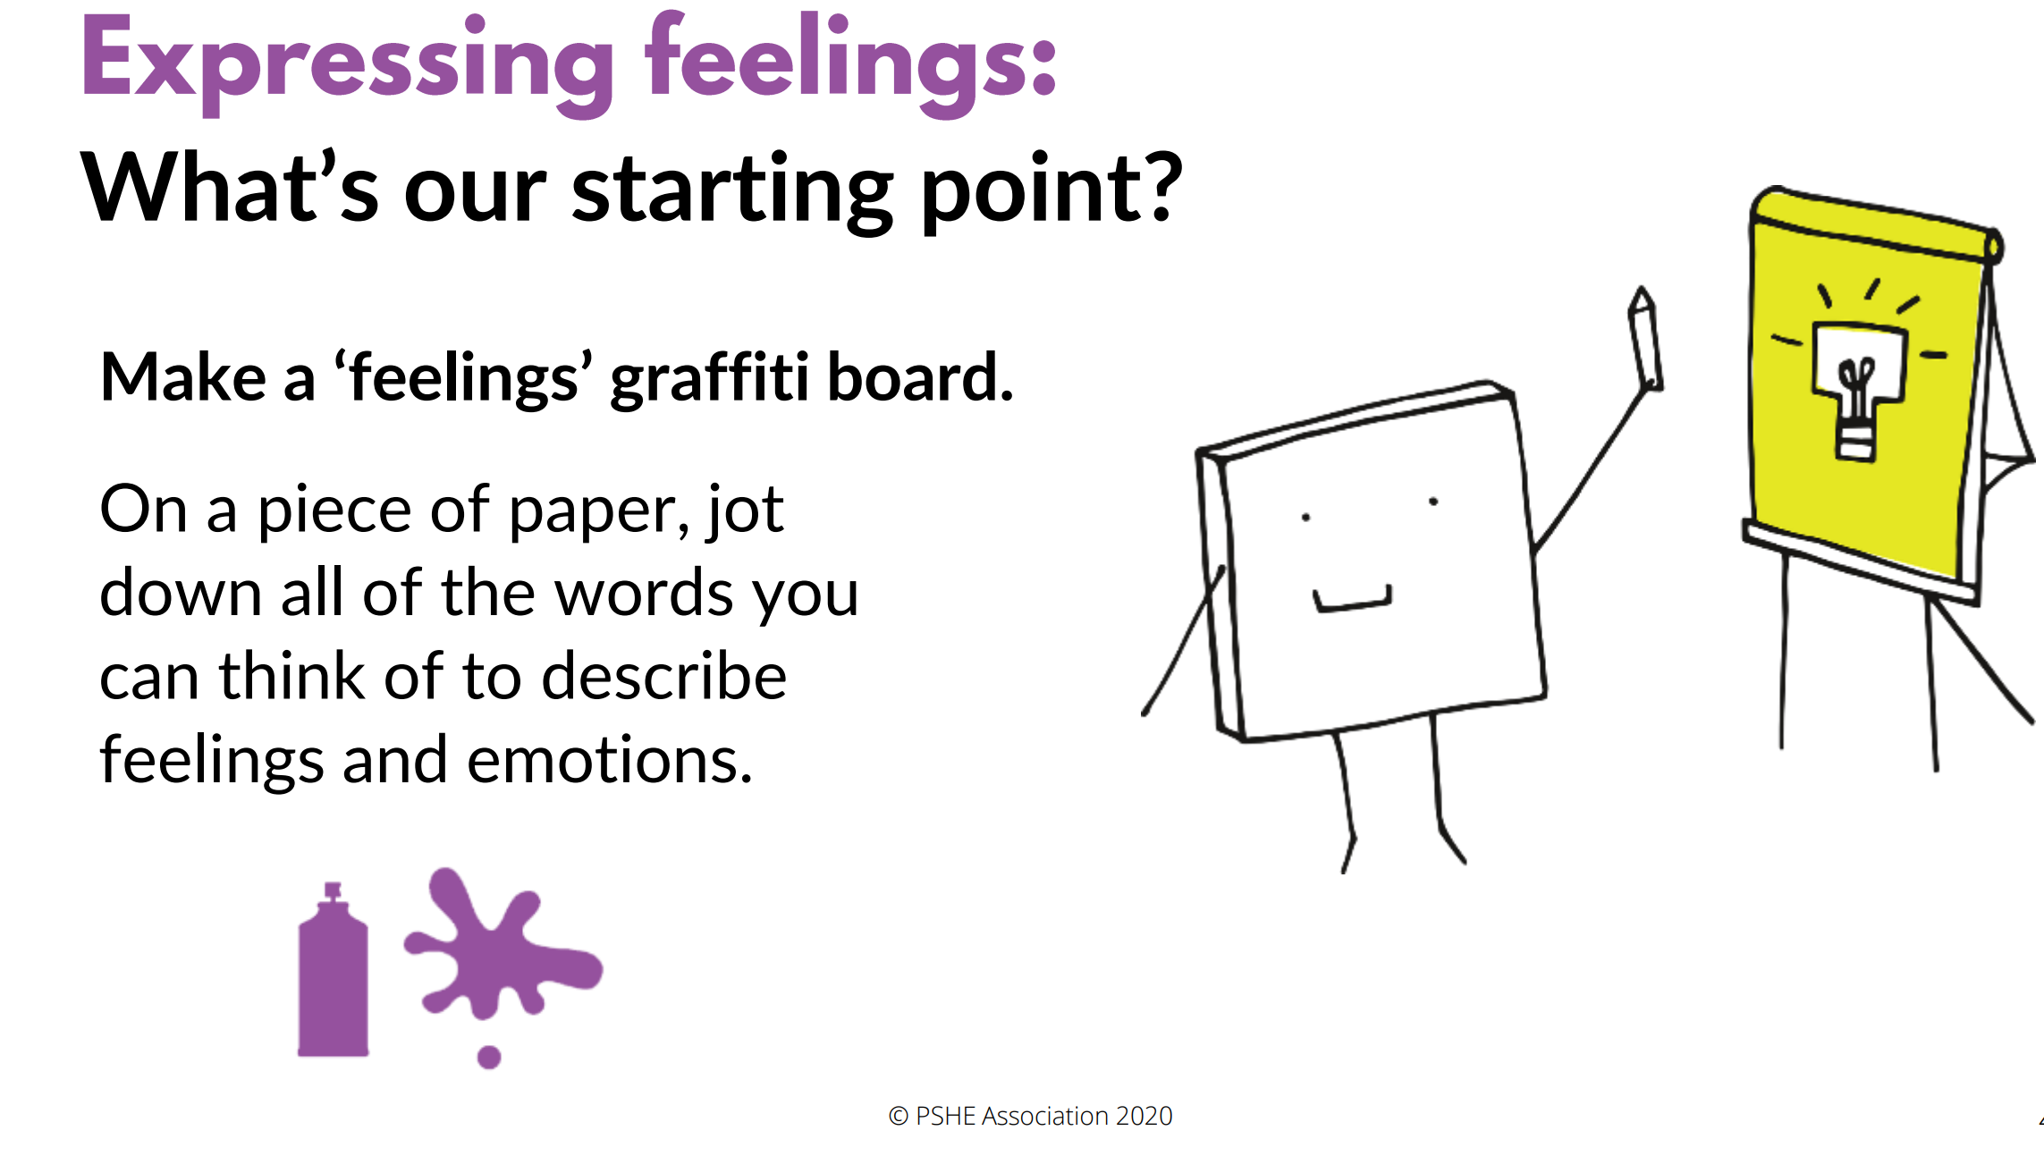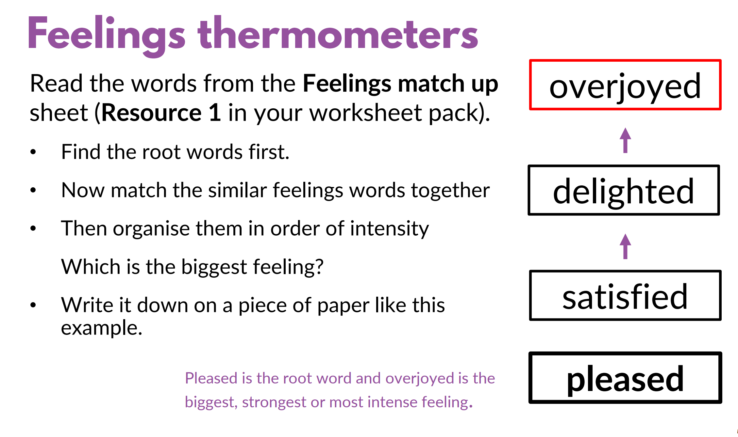
You don’t have to print this you could colour the root word in one colour and all the similar feelings in the same colour, using a different colour for each root word. Then you can simple write them down in a list of intensity.

Remember to show us your achievements via Seesaw.

If you have any questions about any of the work set, or to simply allow your child to keep in touch with us- please ensure you have access to your child’s Seesaw account.
You can gain access by emailing us on
sarah.vickers@taw.org.uk
hannah.kibblewhite1@taw.org.uk

Have a wonderful week.
We miss you all very much.
Mrs Vickers and Mrs Kibblewhite.

