Year 3 Home learning activities
Week commencing 29th June
English-
This week we would like you to think about the resolution and ending in your story. We are going to use the same simple adventure story to help us come up with some ideas.
When you have written please share it with us via seesaw!
This is how you could break this activity up across the week:
Monday- Read the adventure story- underline or highlight the resolution and the ending in the story.
Tuesday- Today you need to come up with a resolution for the dilemma in your story. Read through your writing from last week to remind you of what your dilemma was. Now brainstorm or list possible resolutions to this problem. How can this problem be solved? How will these affect the characters?
Wednesday- It’s time to get writing. In the example story one of the characters pushes the captain off the ship and this solves their problem. You need to write about how your dilemma is resolved and how this makes all the characters in your story feel.
Thursday- Now you can think about the ending of your story. In the example story the character is given a goblet that has the same picture as the beginning of the story and that is how they return home. What is going to happen to get your characters back home?
Friday- Read through your build up, dilemma, resolution and ending to make sure they flow together.

Reading- comprehension
As well as reading your books, we would like you to have a go at this comprehension activity.

Spellings-
Red and Green | Blue and Yellow
natural | there
occasional | their
actual | they’re
accidental | here
medical | hear
national | see
capital | sea
vocal | to
sensational | too
personal | two

Spelling ideas:
Voice record: Using a recording device spell out the word and then listen back to check you have got them right.

Maths- This week we are going to work on Measure
Follow this link to the Oak National academy resources- children can follow the lessons and record them on the paper. Take a picture and share it with us on Seesaw.

https://classroom.thenational.academy/subjects-by-year/year-3/subjects/maths
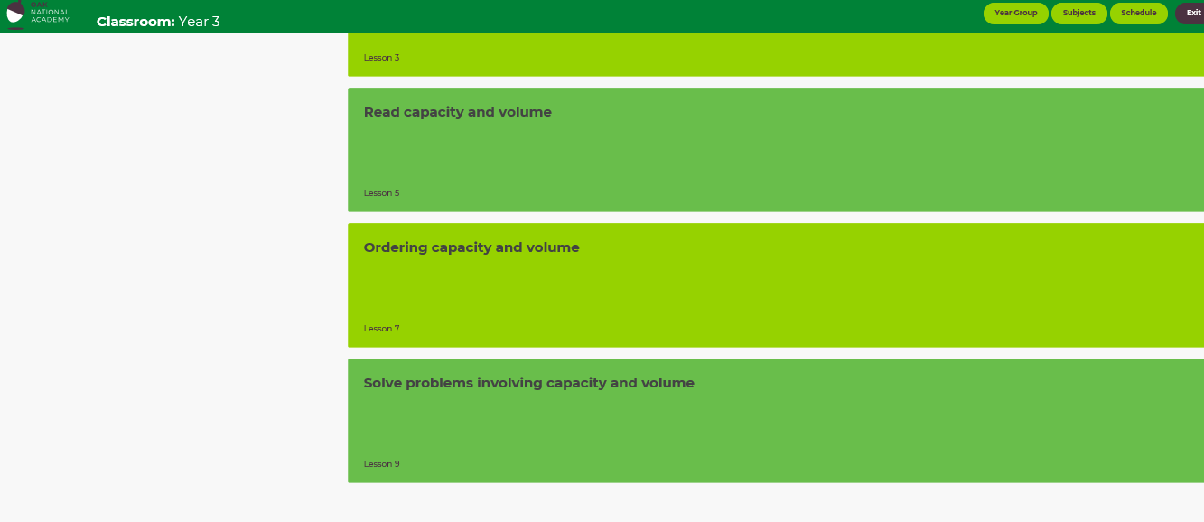

Monday

Tuesday

Wednesday

Thursday
Science
Can you help make something in the kitchen and read the scales- liquid or mass?
PSHE
This week we are going to be talking about expressing our feelings and emotions. You will need your work from last week to help you.

Remember to show us your achievements via Seesaw.

If you have any questions about any of the work set, or to simply allow your child to keep in touch with us- please ensure you have access to your child’s Seesaw account.
You can gain access by emailing us on
sarah.vickers@taw.org.uk
hannah.kibblewhite1@taw.org.uk

Have a wonderful week.
We miss you all very much.
Mrs Vickers and Mrs Kibblewhite.

