Year 3 Home learning activities
Week commencing 8th June
English-
This week we would like you to write a setting description. You are going to imagine you are in a rainforest. What can you see, hear, feel and smell? I have put some videos at the bottom for you to watch so you can get a sense of what it may be like to be in a rainforest.
When you have written please share it with us via seesaw!
This is how you could break this activity up across the week:
Monday- Research by looking at other setting descriptions to get some ideas of what a good one looks like. I have put an example here for you to look at but there are loads more out there! Look in reading books that you have at home or the internet.
Tuesday- Get planning! Now it is time to plan your setting description. Watch the videos below to give you inspiration and write some powerful adjectives and expanded noun phrases. I have put a planning grid below that we have used before to help you.
Title of the story:

See | Hear
Feel | Smell

Wednesday- Begin writing your setting description. You could choose two of the senses to write about today.
Thursday- Finish writing your setting description.
Friday- Edit your setting description. Check your punctuation and spellings. Also make sure that your sentences make sense.
https://www.youtube.com/watch?v=JEsV5rqbVNQ
https://www.youtube.com/watch?v=8myYyMg1fFE
https://www.youtube.com/watch?v=kSVqPAN1nCM

Reading- comprehension
As well as reading your books, we would like you to have a go at this comprehension activity.
The Mysteries of Harris Burdick

Spellings-
Red and Green | Blue and Yellow
break | more
brake | score
grate | before
great | wore
knot | shore
not | core
mail | store
male | snore
scene | explore
seen | ignore

Maths-
This week we are going to begin working on Lines
Follow this link to the Oak National academy resources- children can follow the lessons and record them on the paper. Take a picture and share it with us on Seesaw.

https://classroom.thenational.academy/subjects-by-year/year-3/subjects/maths
Monday

Tuesday
Wednesday

Thursday
Friday

Also your child has access to Timetable rock stars at https://play.ttrockstars.com/auth/school/student/16409
If you do not have your child’s log in details- please ask us for them.

Science
This week we are looking at joints. See if you can identify where the different joints are on a skeleton.
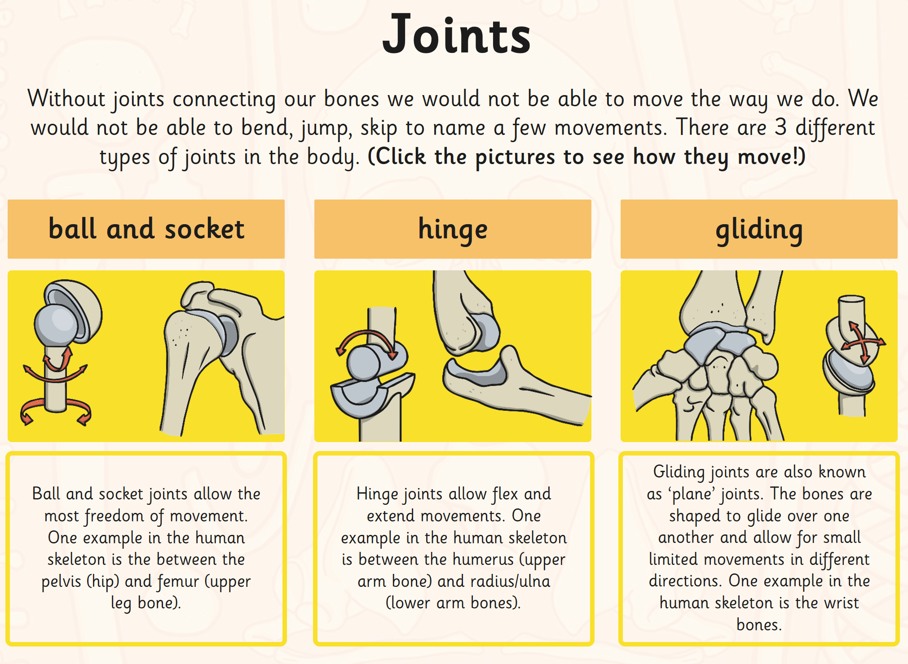

Computing
https://www.barefootcomputing.org/homelearning
Follow this link to play a variety of online, computing games

PSHE
We are going to be thinking about our hopes and wishes for our future.

Remember to show us your achievements via Seesaw.

If you have any questions about any of the work set, or to simply allow your child to keep in touch with us- please ensure you have access to your child’s Seesaw account.
You can gain access by emailing us on
sarah.vickers@taw.org.uk
hannah.kibblewhite1@taw.org.uk

Have a wonderful week.
We miss you all very much.
Mrs Vickers and Mrs Kibblewhite.

