Monday 22 June 2020,

Dear Parents and Carers,

We had a wonderful start to the further reopening of school last week. The children in Nursery, Reception, Year 1 and Year 6 had a great week and spent time in very small groups doing lots of fun activities, the rain did not stop them!

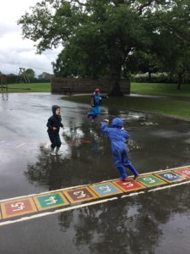 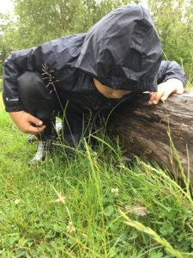 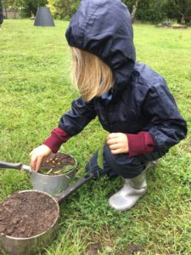 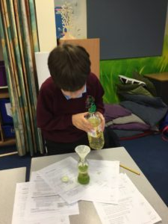

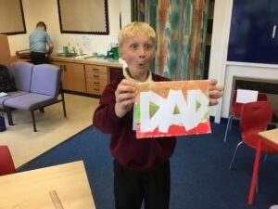

Our ‘key worker and critical care’ provision is increasing every week and it is a delight to see and hear the children in school. Over the last three months, school has not been the same wih such small numbers of children and staff.

We are hoping to increase the number of children who are accessing school in Nursery, Reception, Year 1 and Year 6 as the teachers miss their children and want to see their classes before the start of the six weeks holiday! As a school, we are following very strict guidelines and our risk assessment has been approved by Telford and Wrekin; in fact our school has never been so clean or smelling this nice.

If you have not said ‘yes’ to your child returning to school and would like to reconsider, you can! We want them in school. Please contact the school office and we will tell you when your child can start.

Best wishes,

Katy Tomlinson

Headteacher