Year 4 – Weekly activities – home learning - week commencing 1st June

Maths – Summer Term

White Rose - https://whiterosemaths.com/homelearning/year-4/

White rose are continuing to offer free PowerPoints to watch linked to year 4 themes (this next set is fractions). However, they are not offering free worksheets. If you have enjoyed watching these PowerPoints please email us for worksheets to compliment these PowerPoints.
Alternatively, why not try one of the following:-
Oak National Academy - https://www.thenational.academy/online-classroom/year-4/maths#subjects, which has lessons available on area and perimeter, measurement and money. This site is backed by the government and has PowerPoints of teachers running the lesson.
Hamilton home learning packs –
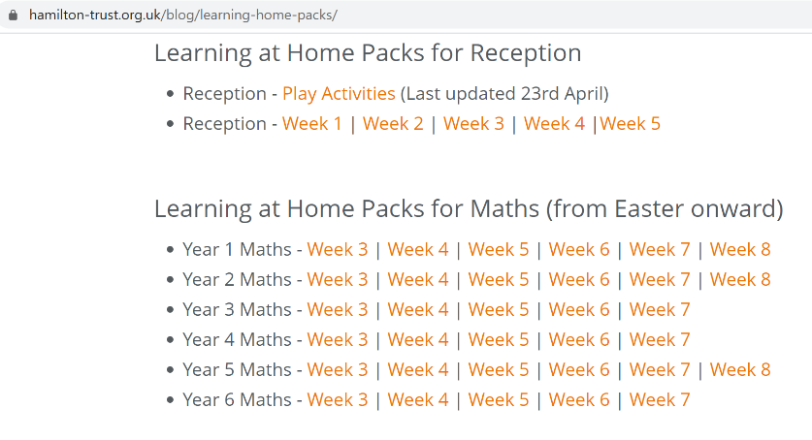

Different maths tasks will also be added to your child’s SeeSaw account daily.
Keep up the good work on times table rock stars.

OTHER FUN MATHS ACTIVIES

This website has many fun maths game ideas – choose 1 a week to try - https://thirdspacelearning.com/blog/fun-maths-games-activities-for-kids/

English
Write a diary entry for your favourite activity over half-term. Include your thoughts and feelings. What made this a special day? Now, edit your work – check for spelling, punctuation, cohesion. Can you improve any of your vocabulary?

Fancy some creative writing? Try one of the following activities:

Option 1 – Try one of Pie Corbett’s English talk for writing resources –
(1) https://www.talk4writing.co.uk/wp-content/uploads/2020/04/Y4-Maria-Aliens.pdf
(2) https://www.talk4writing.co.uk/wp-content/uploads/2020/05/Y4-Mission.pdf

Option 2 - https://www.pobble365.com/ every day, you will find an interesting picture, writing prompts and philosophical questions to spark creative writing.

OR

Use Hamilton Trust free home learning resources
https://www.hamilton-trust.org.uk/blog/learning-home-packs/
Please do not worry if you are still completing last week’s work, just work at your child’s own pace through the different weeks.

Click on Year 4 English – start the next relevant week.

There are a series of lessons to follow including PowerPoints to assist with completing the tasks. Complete the tasks at your own pace.

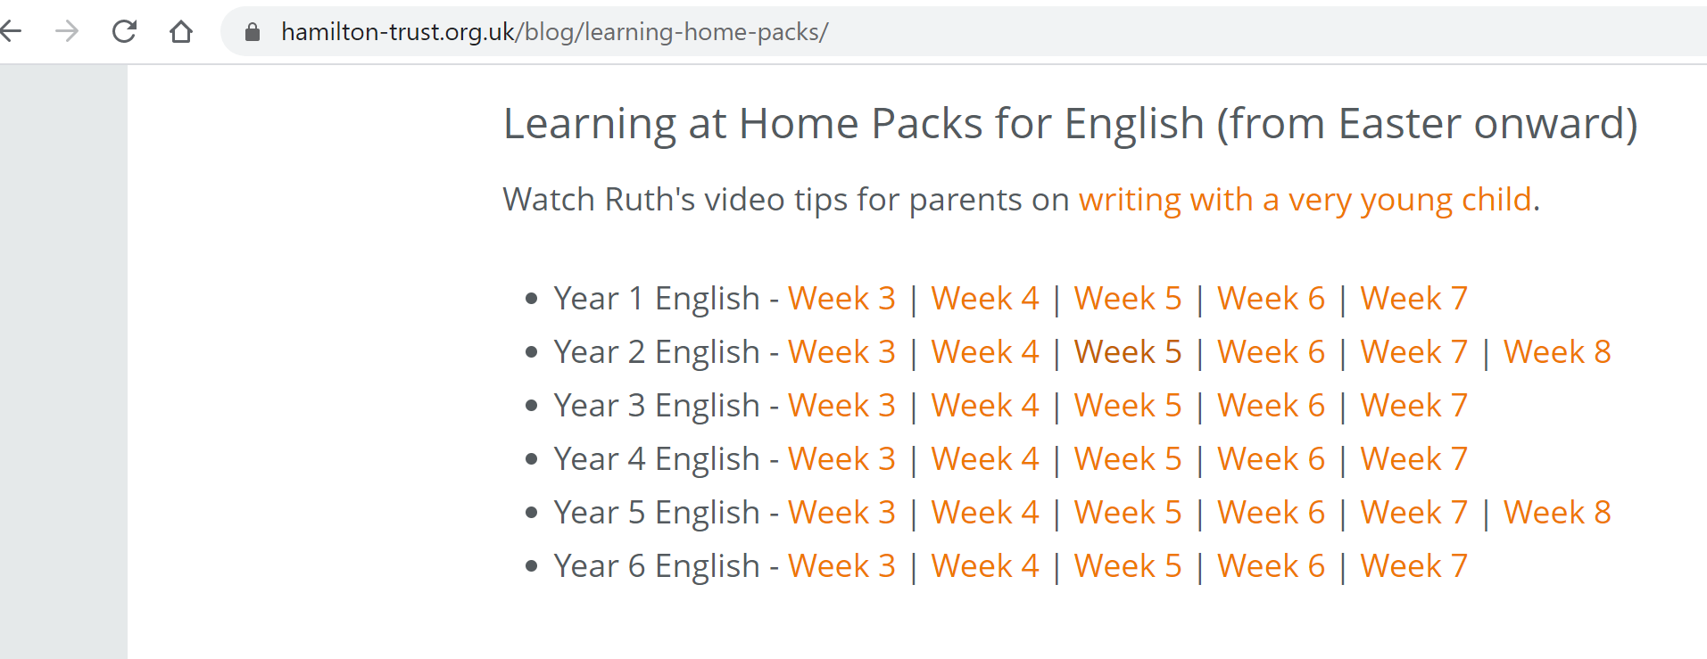

Reading

Read for 20 minutes a day. When you have completed a book, write a book review about what you have read. How does the story make you want to keep reading? Write down the phrases and words that you find effective in gripping the reader.

Optional follow on tasks:-

After reading a text, prepare a creative summary of what you have read using no more than 30 words.
Inference skills – choose a character and write about how this character feels at various stages through the story.

Computing

Each week try one different computing activity.
Barefoot Computing have put together some free home learning resources to help. With fun lesson-based activities and interactive games, children can work together with their families to develop their computational thinking skills. Choose one to try through https://www.barefootcomputing.org/homelearning.

Create a game on scratch https://scratch.mit.edu/ - can you design an obstacle course for a Roman gladiator challenge?

Have a go at one of the free scratch code club modules; there are free guides to complete each module.
https://projects.raspberrypi.org/en/codeclub/scratch-module-1

PE
Daily exercise is an essential part of healthy living. Many of you have been following Jo Wicks, keep up the hard work with these daily sessions https://www.youtube.com/user/thebodycoach1/video or if you fancy a change try one of the super mover videos https://www.bbc.co.uk/teach/supermovers .
Alternatively, why not try PE with our very own Mr Stevens – use the link from the school website.
Take a walk in a local forest with your family. Notice the sounds of the birds and enjoy the peaceful feeling that we gain from nature.
Make a Roman obstacle course in your garden.

RE

Try a different one each week - free home learning activities from NATRE
https://www.natre.org.uk/uploads/Free%20Resources/2%207-11%20RE%20Today%20and%20NATRE%20home%20learning%20Spirited%20Arts.pdf

Spellings
This week’s spellings are
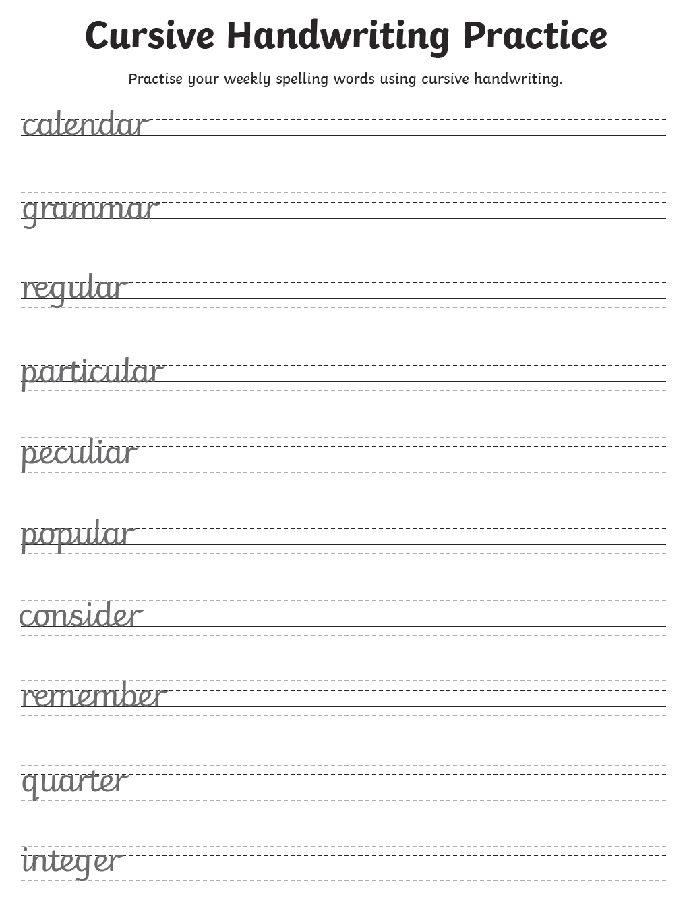
Practise them daily in your neatest cursive handwriting and get a grown up to test you on Friday.
EXTRA SPELLING FUN – visit https://spellingframe.co.uk/ - click on year 3 and 4 – choose the spelling rule you want to explore and click on free spelling tiles game.

Science

Choose a different task to explore each week.
- Investigate the best materials for Roman helmets or shields.

- Make your own exploding volcanoes and find out about the chemical reactions involved. Details of how to make a volcanoe can be found at the natural history museum website - https://www.nhm.ac.uk/discover/how-to-make-a-volcano.html

- Investigate different ways of cleaning old Roman coins. Try cola, vinegar, lemon juice or baking soda.

- Find out what kind of armour Roman soldiers wore to protect their bodies

- Learn about our skeletons and how they are designed to act like armour for different organs

History & Geography

Watch this video of the book ‘escape from Pompeii’ by Christina Balit
https://www.youtube.com/watch?v=K7aYNcv9uDI

Find out about how volcanoes are formed and where they are found.

HADRIAN’S WALL

Activity 1

Watch this history clip at https://www.bbc.co.uk/bitesize/clips/zhq76sg

Can you recall five facts from the video? Replay the video, what else can you recall? Continue to research on Hadrian’s Wall. How much of Hadrian’s Wall remains? Can you find images of it in books and online? What was the Antonine Wall built from? Is anything left on the Antonine Wall? What do pupils think happened to all the stone blocks now missing from Hadrian’s Wall?

Follow on activity:-

Create a tourist guide to encourage people to visit either Hadrian’s wall or another Roman site.

Art

Explore ways pf representing exploded volcanoes using paint techniques.
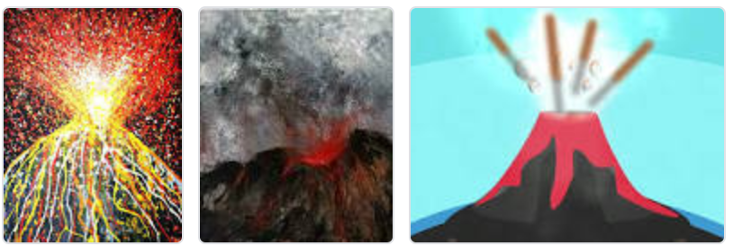

ALTERNATIVELY, take some time to relax and sit/ look outside, draw what you see.

Music

Choose a times table that you find challenging to create a song/ rap to.

Alternatively, complete one of the modules on charanga.

DT

Last term you may have designed and made a Roman shield and helmet. Add to your collection by making a Roman sword.
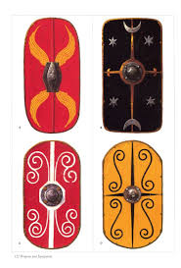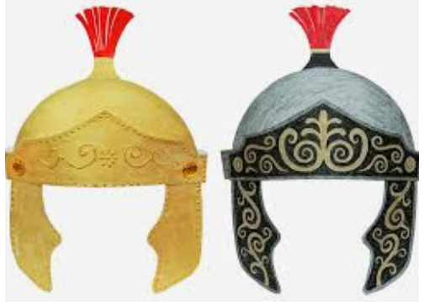

ALTERNATIVELY, create an edible Roman Road.
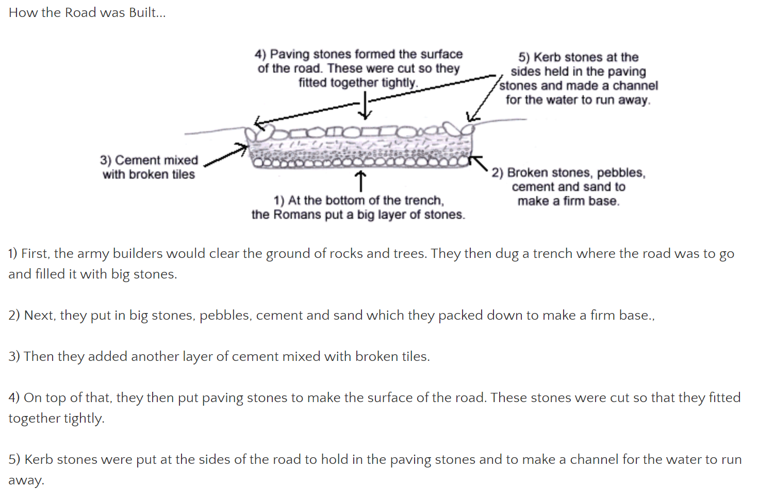
Can you find foods that represent each layer and make your own edible road? Here are some examples:-
The first picture has used a cup to represent the ditch the Romans would initially dig.
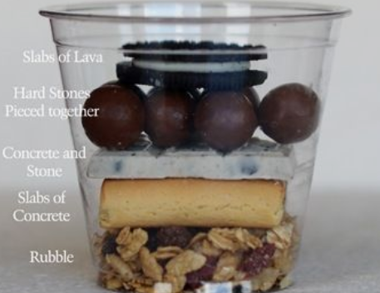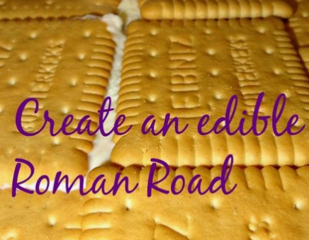

PSHE
Think about how we can still be a good friend to others that we maybe cannot see now. This maybe through writing a letter to a friend that you miss or drawing them a picture of a happy memory you have with them.

FOREST SCHOOL

Make a bird feeder at home; this video is a great lesson on how to make one.
https://www.thenational.academy/oak-activity-club/art-club/lesson/the-world-around-us-bird-feeders-primary#slide-1

French
Try learning how to ask some questions in French.
https://www.youtube.com/watch?v=6xu77JoubgE
Alternatively, recap on French numbers and colours
https://www.youtube.com/watch?v=urPJ9QTwqxk&list=PLXMCXZunVHHcqhZxPnk0UINhhDjNVNJlZ&index=5

Other available lessons
The BBC are also providing a vast range of activities for children. This link will give you three appropriate lessons a day to complete.
https://www.bbc.co.uk/bitesize/tags/z63tt39/year-4-lessons/1

Oak National Academy is a new collection of high-quality lessons and online resources. Backed by the government, you can find a range of lessons with PowerPoints/ videos free at https://www.thenational.academy/

If you have any queries about the work then please contact us via Seesaw or email me at Julie.lane1@taw.org.uk.

Thank you for your continued support.

Warm wishes

Mrs Lane

