Year 4 – Weekly activities – home learning - week commencing 15th June 2020

Maths – Summer Term

White Rose - https://whiterosemaths.com/homelearning/year-4/

White rose are continuing to offer free PowerPoints to watch linked to year 4 themes (this next set is fractions). However, they are not offering free worksheets. If you have enjoyed watching these PowerPoints please email us for worksheets to compliment these PowerPoints.
Alternatively, why not try one of the following:-
Oak National Academy - https://www.thenational.academy/online-classroom/year-4/maths#subjects, which has lessons available on area and perimeter, measurement and money. This site is backed by the government and has PowerPoints of teachers running the lesson.
Hamilton home learning packs –
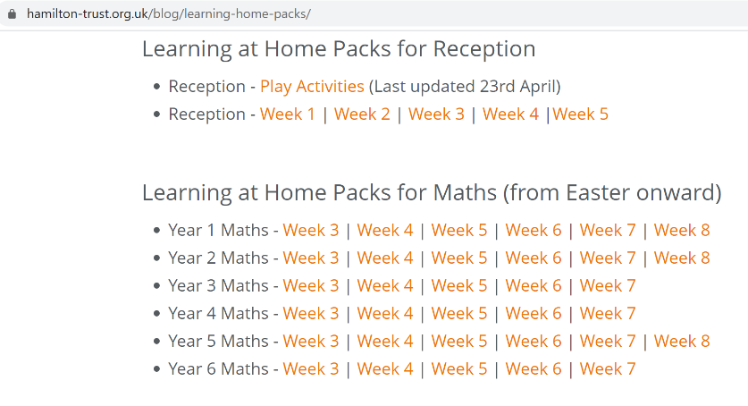

Different maths tasks will also be added to your child’s SeeSaw account daily.
Keep up the good work on times table rock stars.

OTHER FUN MATHS ACTIVIES

This website has many fun maths game ideas – choose 1 a week to try - https://thirdspacelearning.com/blog/fun-maths-games-activities-for-kids/

English

Fancy some creative writing? Try one of the following activities:

Option 1 – Try one of Pie Corbett’s English talk for writing resources –
(1) https://www.talk4writing.co.uk/wp-content/uploads/2020/04/Y4-Maria-Aliens.pdf
(2) https://www.talk4writing.co.uk/wp-content/uploads/2020/05/Y4-Mission.pdf
(3) https://www.talk4writing.com/wp-content/uploads/2020/06/Y4-Impossibly-Possible.pdf
Option 2 - https://www.pobble365.com/ every day, you will find an interesting picture, writing prompts and philosophical questions to spark creative writing.

OR

Use Hamilton Trust free home learning resources
https://www.hamilton-trust.org.uk/blog/learning-home-packs/
Please do not worry if you are still completing last week’s work, just work at your child’s own pace through the different weeks.

Click on Year 4 English – start the next relevant week.

There are a series of lessons to follow including PowerPoints to assist with completing the tasks. Complete the tasks at your own pace.

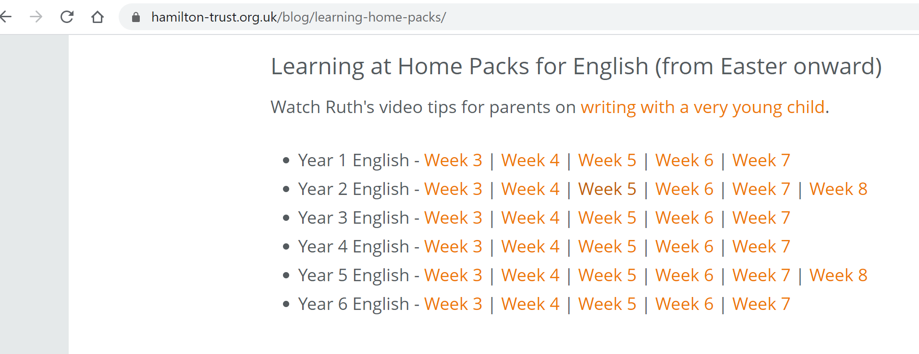

Reading

Read for 20 minutes a day. When you have completed a book, write a book review about what you have read. How does the story make you want to keep reading? Write down the phrases and words that you find effective in gripping the reader.

Optional follow on tasks:-

Either print out or make a reading dice. Either during or after reading roll the dice to reveal a question to ask your child about what they have read. Let the questions on the dice lead to conversations about the book and explore any themes your child may discuss from their reading.

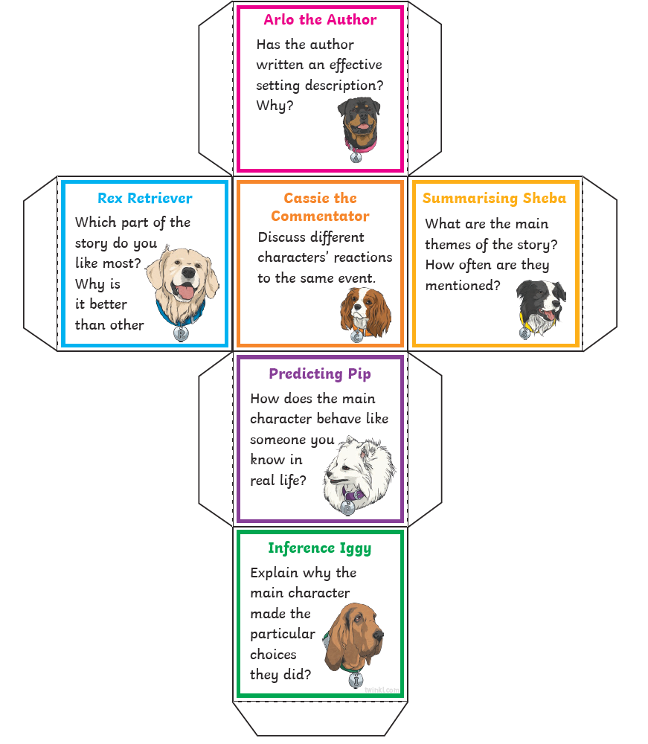

Computing

Each week try one different computing activity.
Barefoot Computing have put together some free home learning resources to help. With fun lesson-based activities and interactive games, children can work together with their families to develop their computational thinking skills. Choose one to try through https://www.barefootcomputing.org/homelearning.

The NCCE has produced some free home learning resources and have a live chat certain times of the day to assist you with the lessons. Here is a link to their free scratch lessons: https://teachcomputing.org/home-teaching/key-stage-2

PE
Daily exercise is an essential part of healthy living. Many of you have been following Jo Wicks, keep up the hard work with these daily sessions https://www.youtube.com/user/thebodycoach1/video or if you fancy a change try one of the super mover videos https://www.bbc.co.uk/teach/supermovers .
Alternatively, why not try PE with our very own Mr Stevens – use the link from the school website.
Try a Pokémon themed Cosmic Yoga adventure, https://www.youtube.com/watch?v=tbCjkPlsaes
Take a walk in a local forest with your family. Notice the sounds of the birds and enjoy the peaceful feeling that we gain from nature.
Make a Roman obstacle course in your garden.

RE

Try a different one each week - free home learning activities from NATRE
https://www.natre.org.uk/uploads/Free%20Resources/2%207-11%20RE%20Today%20and%20NATRE%20home%20learning%20Spirited%20Arts.pdf

Spellings
This week’s spellings are
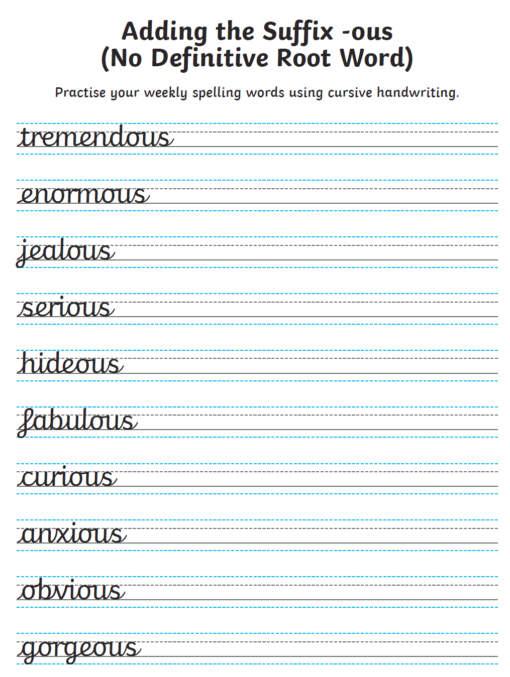
Practise them daily in your neatest cursive handwriting and get a grown up to test you on Friday.
EXTRA SPELLING FUN – visit https://spellingframe.co.uk/ - click on year 3 and 4 – choose the spelling rule you want to explore and click on free spelling tiles game.

Science

Choose a different task to explore each week.
- Investigate the best materials for Roman helmets or shields.

- Make your own exploding volcanoes and find out about the chemical reactions involved. Details of how to make a volcanoe can be found at the natural history museum website - https://www.nhm.ac.uk/discover/how-to-make-a-volcano.html

- Investigate different ways of cleaning old Roman coins. Try cola, vinegar, lemon juice or baking soda.

- Find out what kind of armour Roman soldiers wore to protect their bodies

- Learn about our skeletons and how they are designed to act like armour for different organs

- This website has lots of experiments that can be done at home http://www.sciencefun.org/kidszone/experiments/

History & Geography

Watch this video of the book ‘escape from Pompeii’ by Christina Balit
https://www.youtube.com/watch?v=K7aYNcv9uDI

Find out about how volcanoes are formed and where they are found.

Watch this video about Roman Emperors https://www.bbc.co.uk/bitesize/clips/zsf4dmn
Write character profiles for the discussed emperors’ profiles.

Make a Paper Mache Planet Earth. Here is a link on how to make one. https://www.youtube.com/watch?v=ZUuC6-8eMEY

Art
Enhance your drawing skills through these two lessons at oak academy.
Lesson 1 - https://classroom.thenational.academy/lessons/drawing-skills-how-can-we-use-texture-to-make-our-drawings-more-interest-e3b973/
Lesson 2 - https://classroom.thenational.academy/lessons/optical-illusions-and-using-shading-to-show-form-b592d5/activities/1/

ALTERNATIVELY, take some time to relax and sit/ look outside, draw what you see. Can you draw some of the insects or birds that you see in nature?

Music

Choose a times table that you find challenging to create a song/ rap to.

Alternatively, complete one of the modules on charanga.

DT

Last term you may have designed and made a Roman shield, helmet and sword. Last week many of you added to your collection by making a Roman purse. Next, why not make a Roman catapult this week. The following link gives advice to make one. https://www.instructables.com/id/How-to-make-a-model-Roman-catapult/

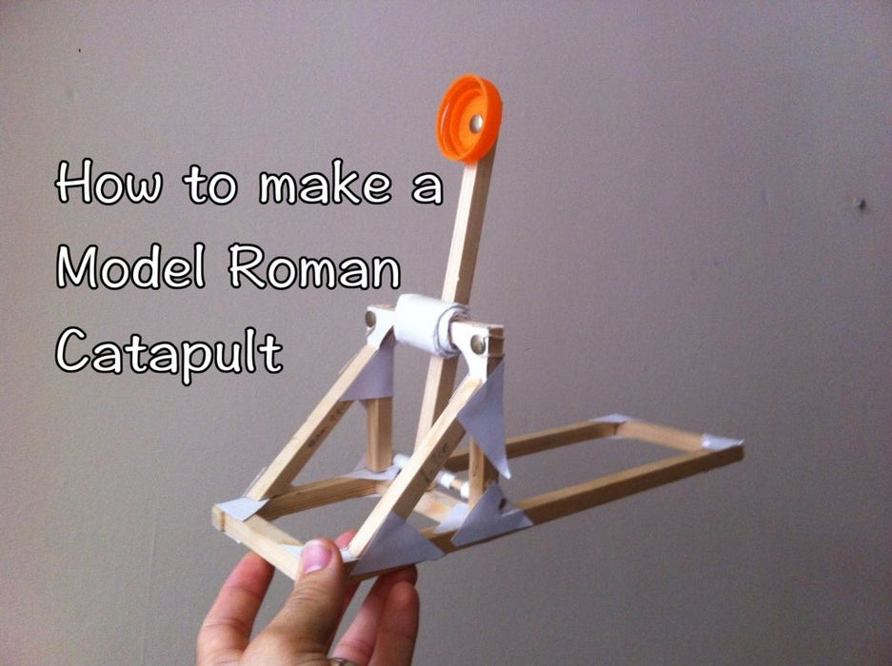

PSHE
Option 1 – Fill in the ‘I am an amazing person sheet’. Was it hard to think of things for each section?
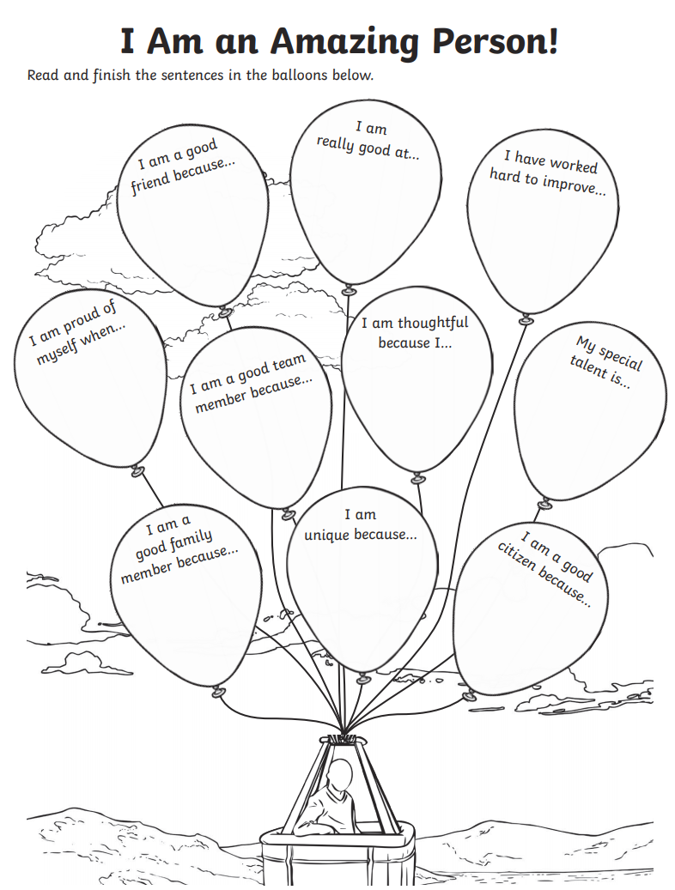

Option 2 - Think about how we can still be a good friend to others that we maybe cannot see now. This maybe through writing a letter to a friend that you miss or drawing them a picture of a happy memory you have with them.

FOREST SCHOOL

Make a bird feeder at home; this video is a great lesson on how to make one.
https://www.thenational.academy/oak-activity-club/art-club/lesson/the-world-around-us-bird-feeders-primary#slide-1
Follow on option – RSPB have a bird watch challenge, details are at:
https://www.rspb.org.uk/fun-and-learning/for-families/family-wild-challenge/activities/go-birdwatching/

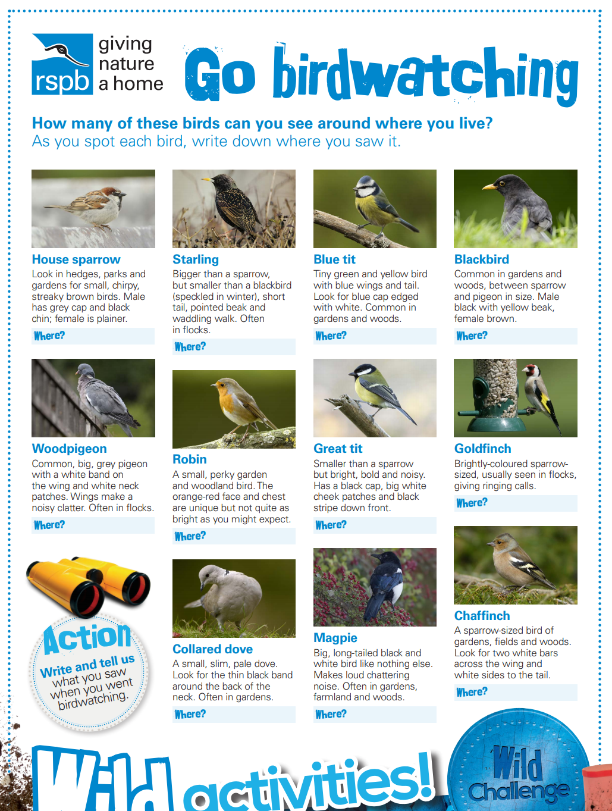
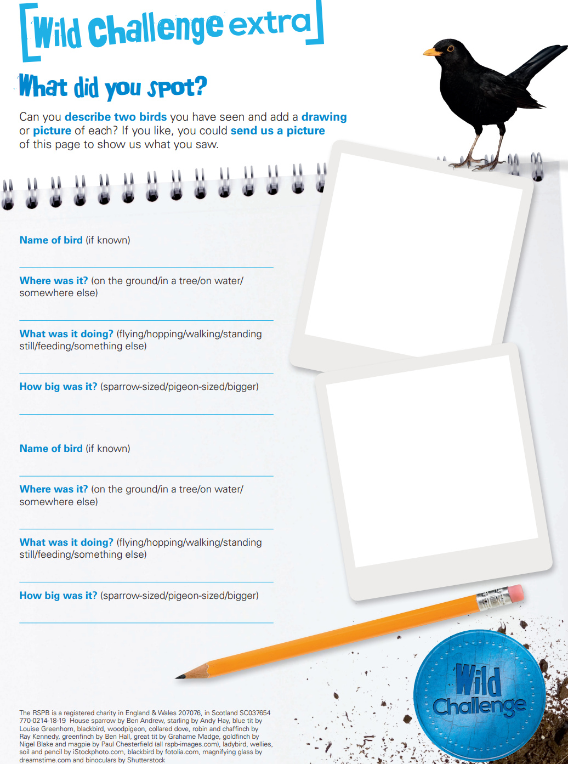

ALTERNATIVELY, MAKE A MINI BUG HOTEL
You Will Need:
- An Empty Plastic Bottle
- Scissors
- Sticks, bark, pine cones, leaves, bamboo canes
(Anything from your local environment you think will work!)
- Twine

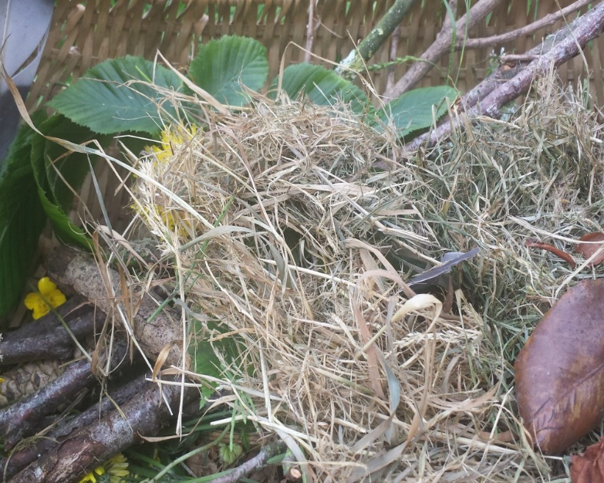

1. Cut off the ends of the plastic bottle to create a cylinder shape. (Make sure an adult helps you)

If you want to make a couple of smaller bug hotels you could cut the cylinder in half, but we decided to make one big one.

2. Look through all the materials you have and arrange them into your bottle. Add any natural items you can find, but make sure they are items you have found in your environment to make sure you attract local bugs (as opposed to tourists! Ha-ha)

3. Make sure you pack it all in tightly to ensure it does not fall out.

4. If you want to hang up your bug hotel, you can wrap twine or string around it. We just popped ours in a little hidden spot by the fence, and the mini one behind a bush.
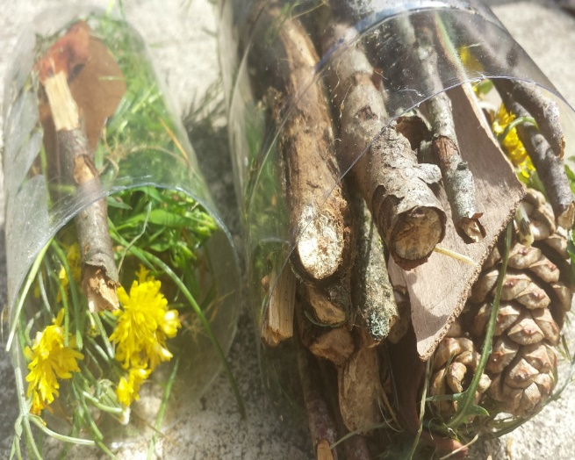

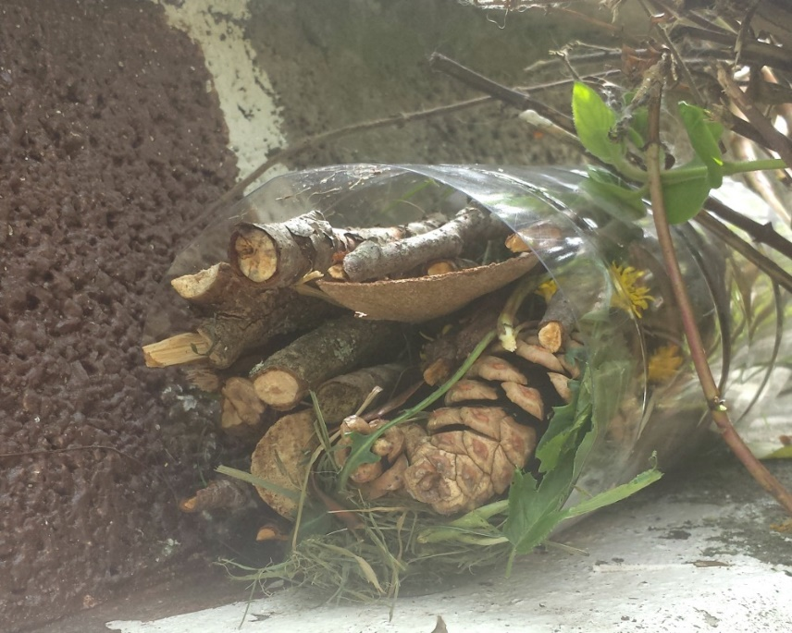

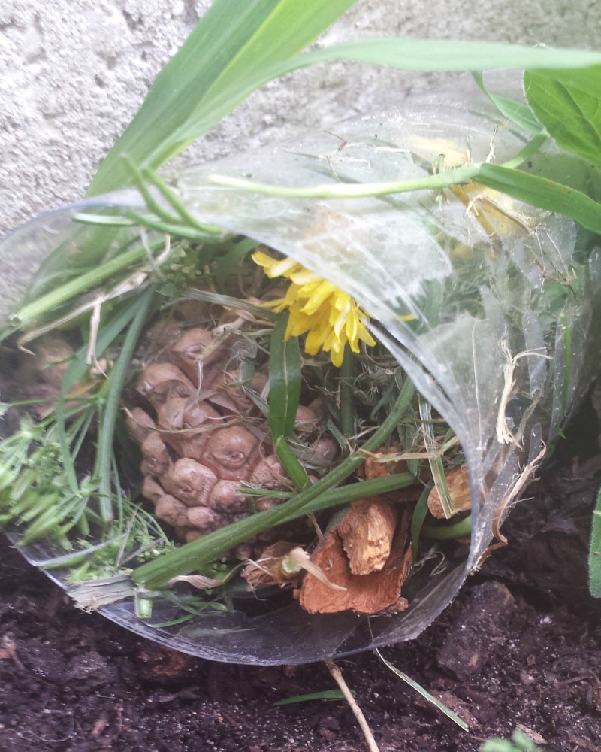

5. Wait for the bugs to pop by for a visit!

OTHER FOLLOW ON ACTIVITIES –
Create a chart of the different insects that use your bug hotel.

French
Try learning how to ask some questions in French.
https://www.youtube.com/watch?v=6xu77JoubgE
Alternatively, recap on French numbers and colours
https://www.youtube.com/watch?v=urPJ9QTwqxk&list=PLXMCXZunVHHcqhZxPnk0UINhhDjNVNJlZ&index=5
learn some French key spring vocabulary
https://www.youtube.com/watch?v=gH-Q1_KcG8E&t=17s

Other available lessons
The BBC are also providing a vast range of activities for children. This link will give you three appropriate lessons a day to complete.
https://www.bbc.co.uk/bitesize/tags/z63tt39/year-4-lessons/1

Oak National Academy is a new collection of high-quality lessons and online resources. Backed by the government, you can find a range of lessons with PowerPoints/ videos free at https://www.thenational.academy/

If you have any queries about the work then please contact me via Seesaw or email me at Julie.lane1@taw.org.uk.

Thank you for your continued support.

Warm wishes

Mrs Lane

