Reception Home Learning Activities Week beginning 6th July
Monday | Tuesday | Wednesday | Thursday | Friday
Numbers and Patterns  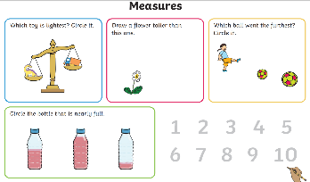  https://www.youtube.com/watch?v=WTeqUejf3D0 (sing along and recognise each shape)) | Numbers & Patterns  https://www.youtube.com/watch?v=0TgLtF3PMOc (counting to 100)  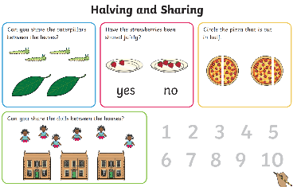 | Numbers & Patterns  https://www.youtube.com/watch?v=bT7282PUKnY (numberblocks- patterns)  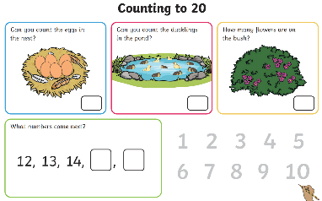 | Numbers & Patterns  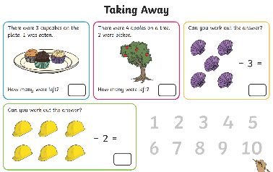  https://www.youtube.com/watch?v=Ftati8iGQcs (counting in 10’s) | Numbers & Patterns  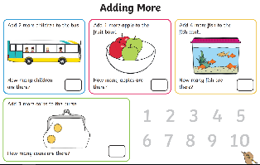  https://www.youtube.com/watch?v=srPktd4k_O8 (counting back from 20
Phonics/English  https://www.youtube.com/watch?v=gxACCZOxbyM | Phonics/English  https://www.youtube.com/watch?v=jMwtf5CRwZ0 | Phonics/English  Sing tricky word song then colour the balloons.  https://www.youtube.com/watch?v=3NOzgR1ANc4  PHASE 4 | Phonics/English  https://www.youtube.com/watch?v=u9DY5Hfjkck | Phonics/English  https://www.youtube.com/watch?v=wEL5mg2lOc4

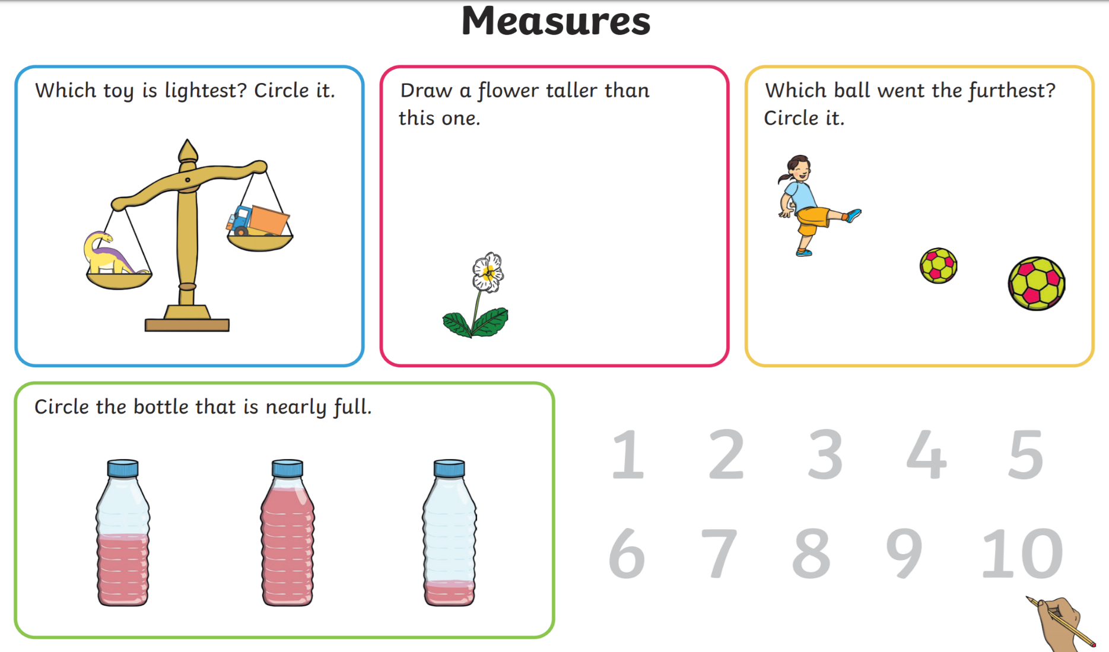
Monday https://www.youtube.com/watch?v=WTeqUejf3D0 (sing along and recognise each shape))

Tuesday https://www.youtube.com/watch?v=0TgLtF3PMOc (counting to 100)

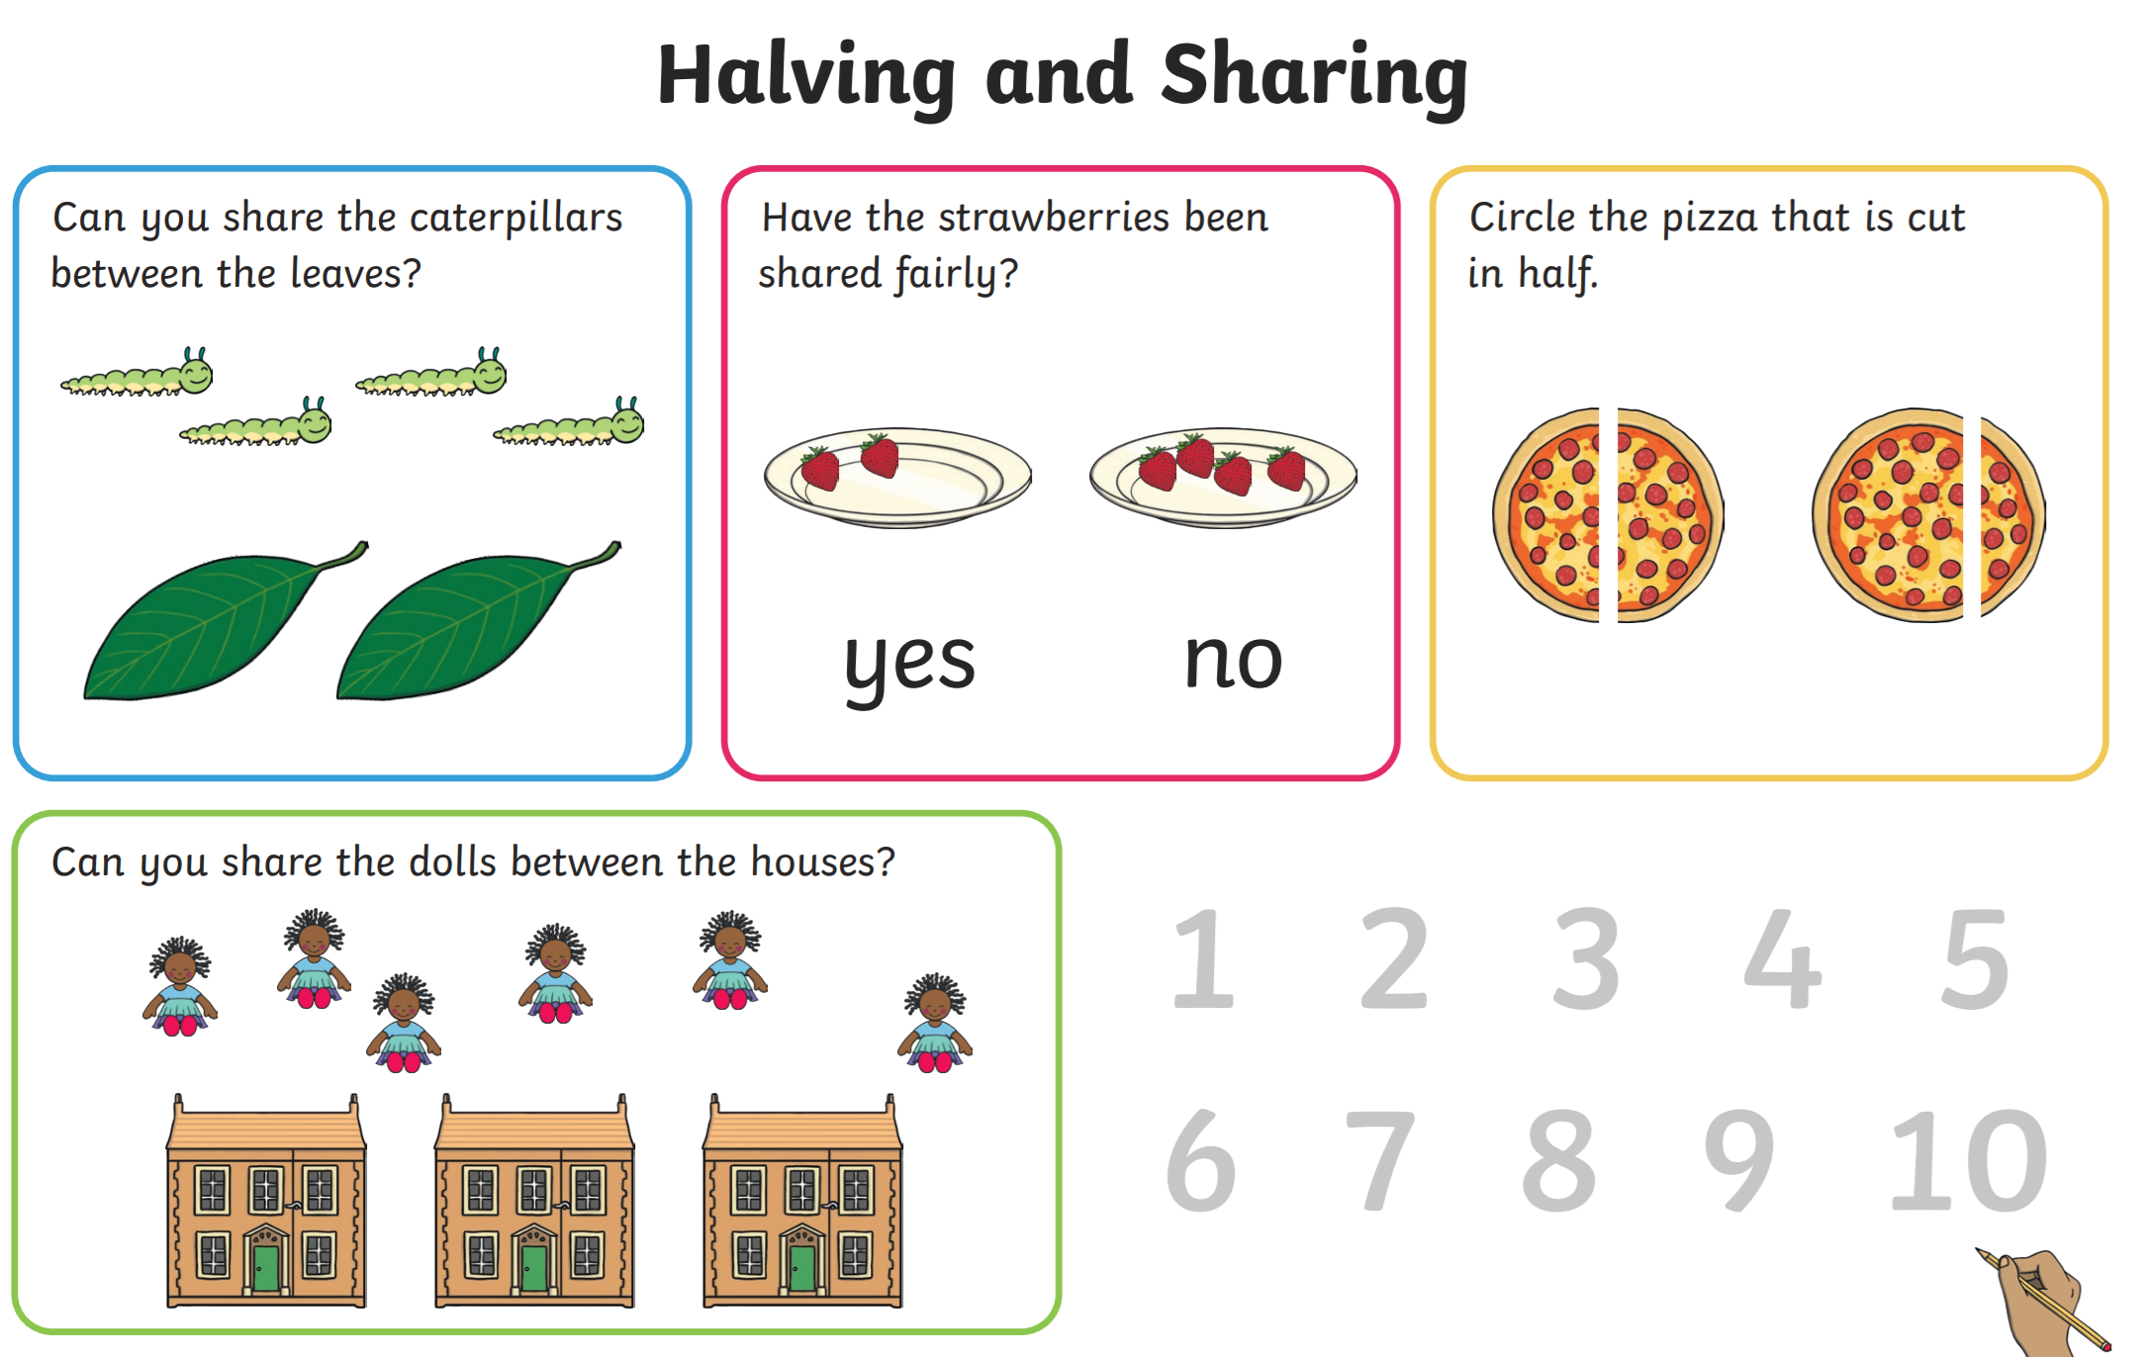
Wednesday https://www.youtube.com/watch?v=bT7282PUKnY (numberblocks- patterns)

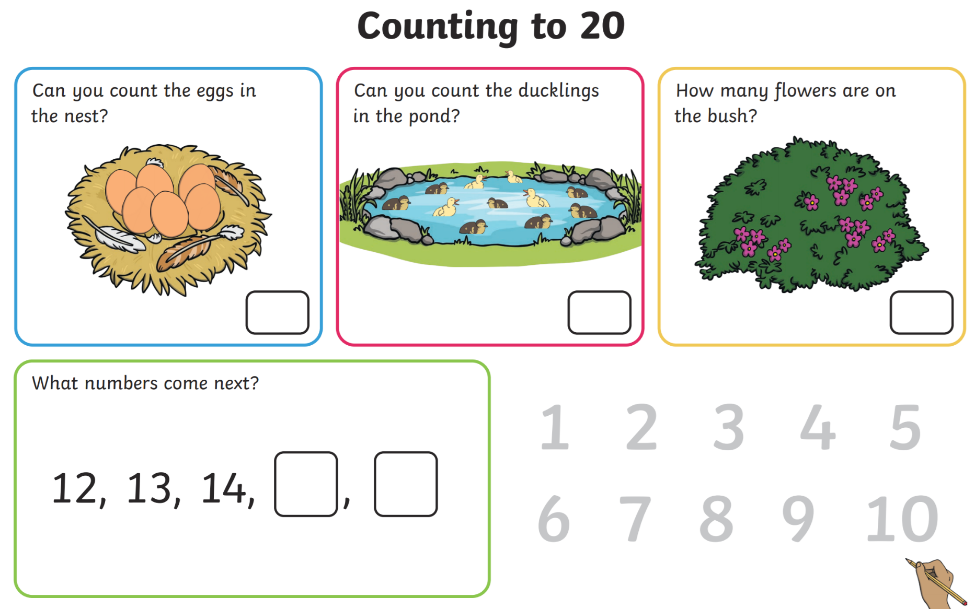
Thursday https://www.youtube.com/watch?v=Ftati8iGQcs (counting in 10’s)

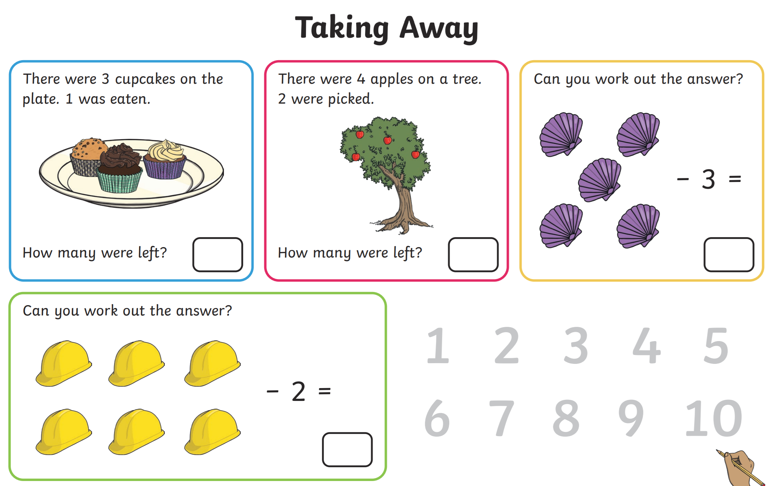
Friday https://www.youtube.com/watch?v=srPktd4k_O8 (counting back from 20)

