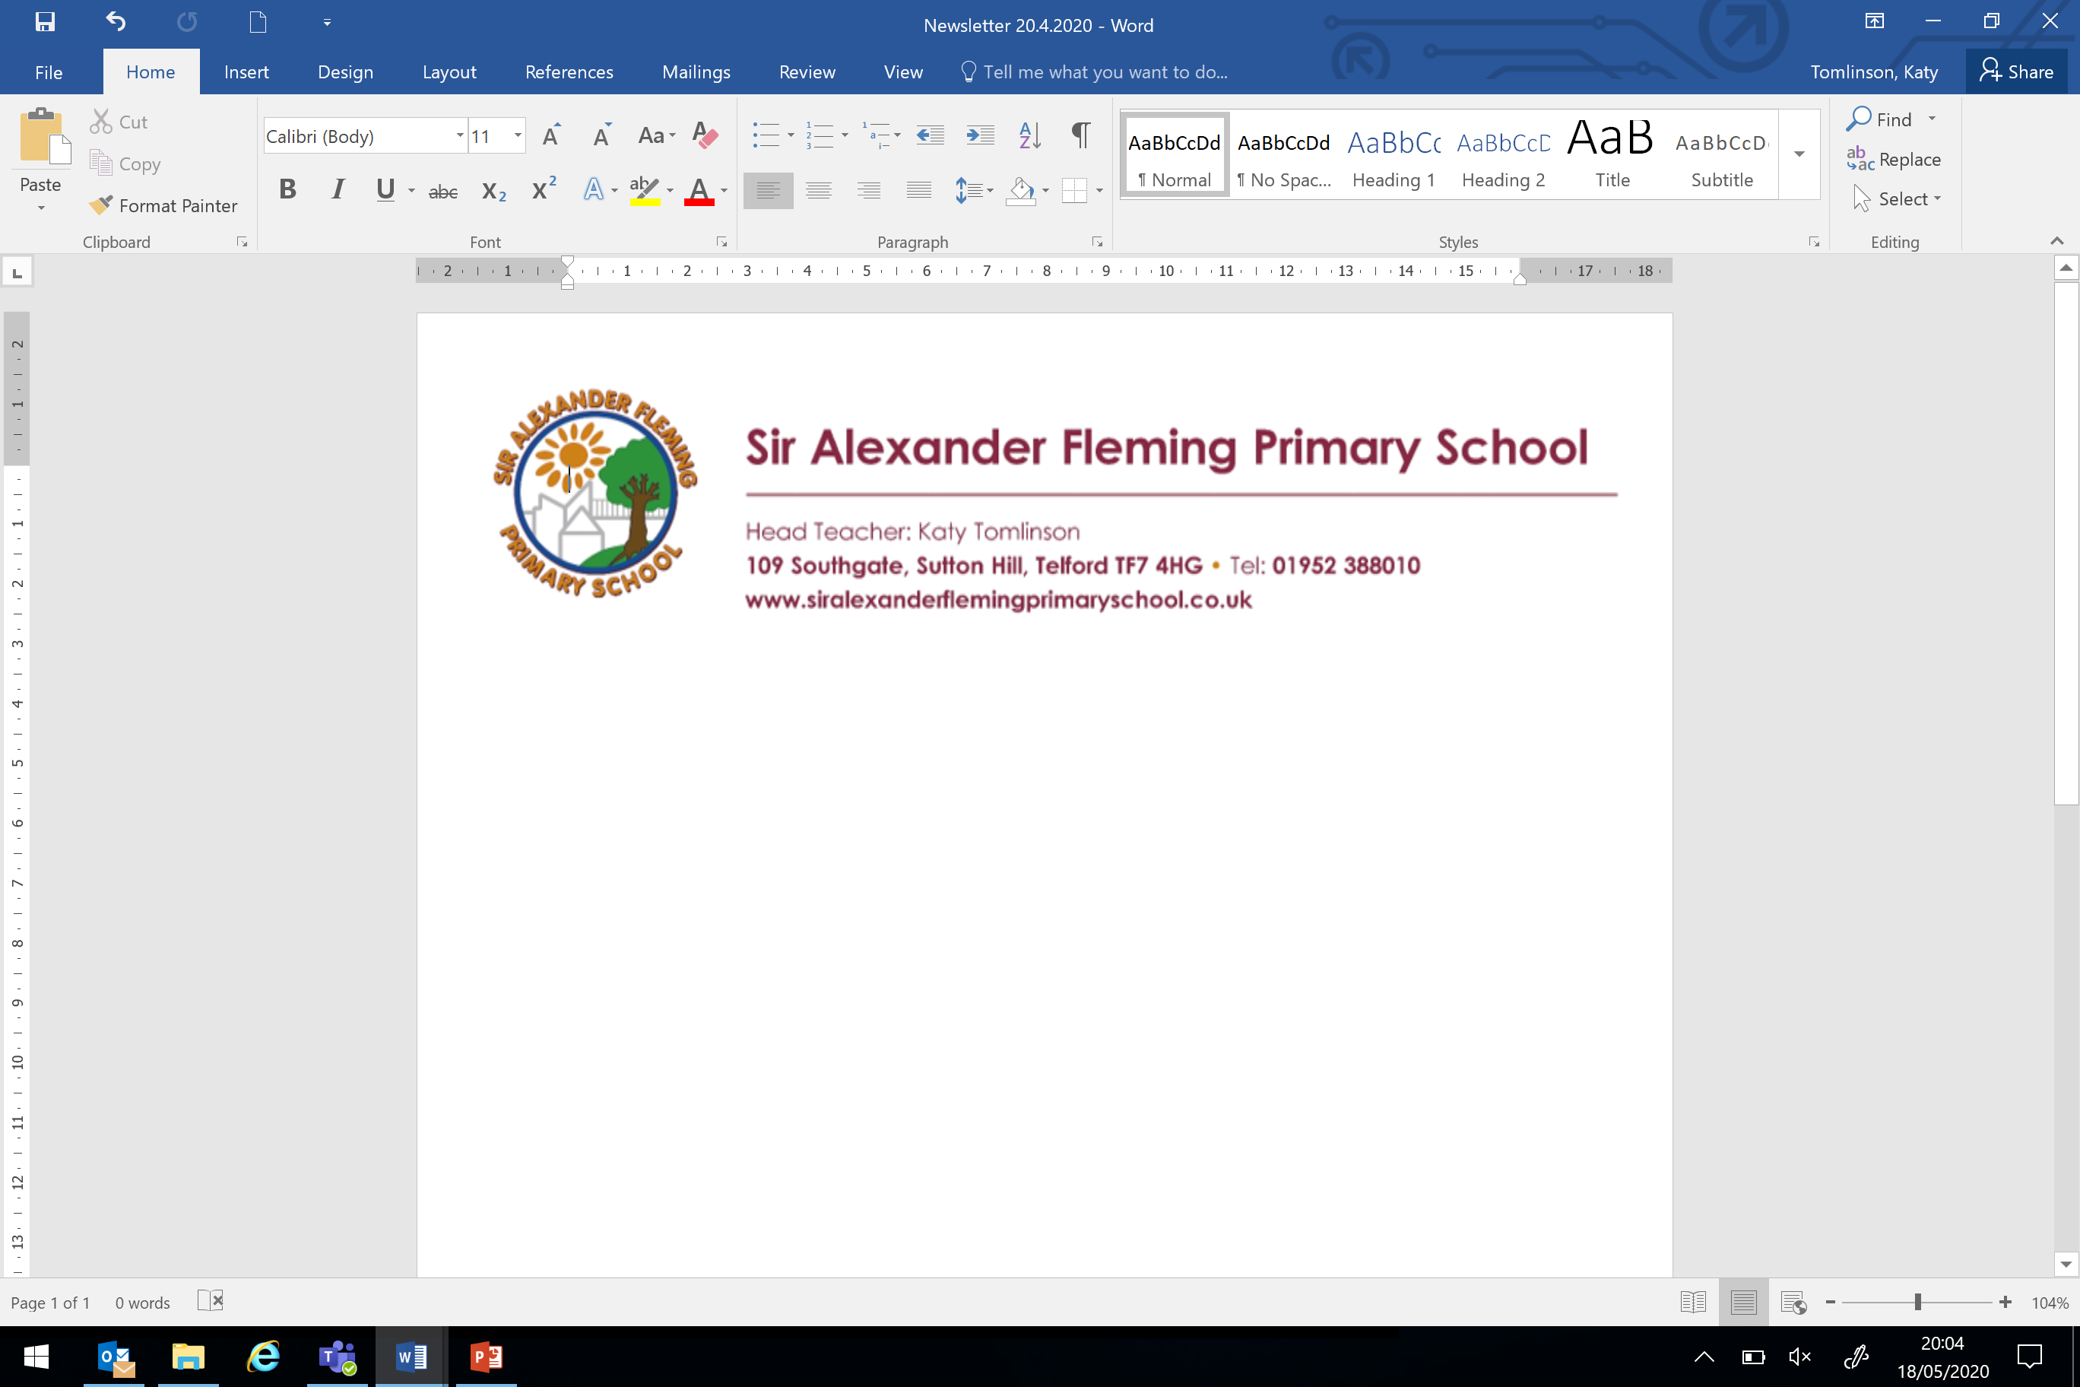

Wednesday 1 July 2020,

Dear Parents and Carers,

Usually, at this time of year, teachers are busily preparing to meet their new classes and begin to get to know them.

We will make plans for when the children arrive back in September for them to say goodbye to their old teacher and meet their new teacher before the ‘hard work’ starts. All of the teachers at Sir Alexander Fleming Primary School are exemplary and dedicated to enriching the lives of our children both academically, socially and emotionally.

Here are the teachers and their new year groups for September – it also tells you which class they will be having in September – lucky children ☺

**Early Years Team**

|  |  |  |
| --- | --- | --- |
| Year | Teacher for September |  |
| N | Miss Dornan  T:\Staff Photos\wow STAFF PHTOTS\staff Photos\TEACHERS PHOTOS\Miss Doran.jpg | Continues with Nursery children and new intake |
| R | Miss Lancett | The children moving into our Reception classes will have received their transition information already. |
| R | Mrs Casswell  T:\Staff Photos\wow STAFF PHTOTS\staff Photos\TEACHERS PHOTOS\Mrs Casswell.jpg |

**Key Stage One**

|  |  |  |
| --- | --- | --- |
| 1 | Miss Reese  T:\Staff Photos\wow STAFF PHTOTS\staff Photos\TEACHERS PHOTOS\Miss Reece.jpg | The children in Mrs Casswell’s class now will move to **Miss Reese** in September |
| 1 | Miss Hullin  T:\Staff Photos\wow STAFF PHTOTS\staff Photos\TEACHERS PHOTOS\MissHullin.jpg | The children in Mrs Geran’s class now will move to **Miss Hullin** in September |
| 2 | Mrs Geran  T:\Staff Photos\wow STAFF PHTOTS\staff Photos\TEACHERS PHOTOS\Mrs Gerran.jpg | The children in Miss Reese’s class now will move to **Mrs Geran** in September |
| 2 | Miss Kibblewhite  cid:9BEE8B01-E0CD-497C-B01F-FF306A726D8F-L0-001 | The children in Miss Hullin’s class now will move to **Miss Kibblewhite** in September |

**Lower Key Stage Two**

|  |  |  |
| --- | --- | --- |
| 3 | Mrs Vickers  T:\Staff Photos\wow STAFF PHTOTS\staff Photos\TEACHERS PHOTOS\Mrs Vicars.jpg  Mrs Tomlinson  T:\Staff Photos\wow STAFF PHTOTS\staff Photos\TEACHERS PHOTOS\Mrs Tomlinson.jpg | The children in Miss Pound’s class now will move to **Mrs Vickers** in September |
| 3 | Miss Pound  T:\Staff Photos\wow STAFF PHTOTS\staff Photos\TEACHERS PHOTOS\Miss Pound.jpg | The children in Mrs O’Reilly’s class now will move to **Miss Pound** in September |
| 4 | Mrs Lane  T:\Staff Photos\wow STAFF PHTOTS\staff Photos\TEACHERS PHOTOS\Mrs Lane.JPG | The children in Mrs Vickers’ class now will move to **Mrs Lane** in September |
| 4 | Mrs O’Reilly  T:\Staff Photos\wow STAFF PHTOTS\staff Photos\TEACHERS PHOTOS\MrsO'Riley.jpg | The children in Miss Kibblewhite’s class now will move to **Mrs O’Reilly** in September |

**Upper Key Stage Two**

|  |  |  |
| --- | --- | --- |
| 5 | Mr Broderick  T:\Staff Photos\wow STAFF PHTOTS\staff Photos\TEACHERS PHOTOS\Mrs Broderick.jpg | The children in Mrs Lane’s class now will move to **Mr Broderick** in September |
| 5 | Miss Killick  T:\Staff Photos\wow STAFF PHTOTS\staff Photos\TEACHERS PHOTOS\Miss Killick.JPG | The children in Mr Warren’s class now will move to **Miss Killick** in September |
| 6 | Miss Jones  T:\Staff Photos\wow STAFF PHTOTS\staff Photos\TEACHERS PHOTOS\MissJones.jpg | The children in Mr Broderick’s class now will move to **Miss Jones** in September |
| 6 | Miss Walters  T:\Staff Photos\wow STAFF PHTOTS\staff Photos\TEACHERS PHOTOS\Mis Walters.jpg | The children in Miss Jones’ class now will move to **Miss Walters** in September |

There will be a summer holiday challenge posted on your child’s new year group at the end of term – please look out for this!

Best wishes, stay safe,

Mrs Tomlinson

Head Teacher