[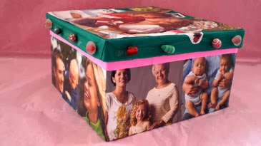](https://www.google.co.uk/url?sa=i&url=http%3A%2F%2Fmymisicom.blogspot.com%2F2014%2F03%2Fmothers-day-crafts-kids-can-make.html%3Fm%3D1&psig=AOvVaw0XUHWmRHXJw3IUtjgBRgkU&ust=1593254978197000&source=images&cd=vfe&ved=0CAIQjRxqFwoTCJCV0runn-oCFQAAAAAdAAAAABAF)[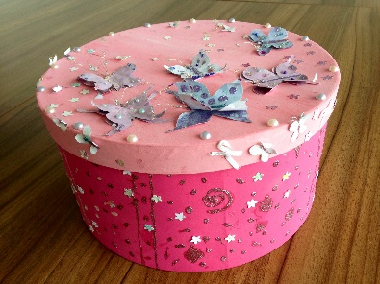](https://www.google.co.uk/url?sa=i&url=https%3A%2F%2Fjeremiahsjourney.org.uk%2Fgetting-creative%2F&psig=AOvVaw3JKbbiPOEkEG3_rc5pQ2mU&ust=1593254418215000&source=images&cd=vfe&ved=0CAIQjRxqFwoTCMjAkLmln-oCFQAAAAAdAAAAABAD)[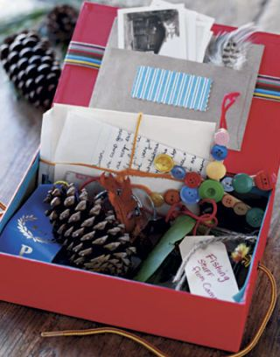](https://www.google.co.uk/url?sa=i&url=https%3A%2F%2Fwww.countryliving.com%2Fdiy-crafts%2Fhow-to%2Fg432%2Fmemory-boxes-0704%2F&psig=AOvVaw3JKbbiPOEkEG3_rc5pQ2mU&ust=1593254418215000&source=images&cd=vfe&ved=0CAIQjRxqFwoTCMjAkLmln-oCFQAAAAAdAAAAABAR)[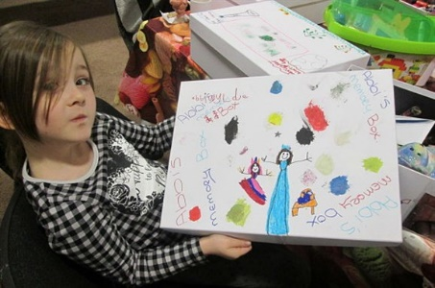](https://www.google.co.uk/url?sa=i&url=https%3A%2F%2Fwww.strichards.org.uk%2Fbereaved-children-store-treasured-memories%2F&psig=AOvVaw3JKbbiPOEkEG3_rc5pQ2mU&ust=1593254418215000&source=images&cd=vfe&ved=0CAIQjRxqFwoTCMjAkLmln-oCFQAAAAAdAAAAABAK)[](https://www.google.co.uk/url?sa=i&url=http%3A%2F%2Fwww.freevectors.com%2Fexploding-rainbow-box%2F&psig=AOvVaw1ZE-VVXBia6XHz-pUHBs_Z&ust=1593253838273000&source=images&cd=vfe&ved=0CAIQjRxqFwoTCKDny7ujn-oCFQAAAAAdAAAAABAQ)

**Memories**

**2020**

These examples might inspire you . . .

We can’t wait to meet you and have you in our Year 1 class!

“To let go does not mean to get rid of. To let go means to let be.” (Anonymous)

Over the summer we would like you to make a Memory Box of all the things you have done, thought or felt throughout Covid 19.

Decorate a cardboard box. You can put pictures, objects, drawing or writing inside your box. The more creative the better!

For example, you might draw a picture of the time you camped in your back garden or a recipe to remind you of all the baking you did! If you’ve celebrated a birthday you could put a birthday card inside. You could write about a time you felt very sad or a time when you helped someone and felt proud. Your memory box will be unique because it will represent your time over the past few months.

We are going to share and display these in class in order to reflect on and talk about the impact this strange and tricky time has had on us.

Stay safe over the summer and we look forward to seeing you in September.

Year 1 Holiday Challenge