EYFS Holiday Challenge
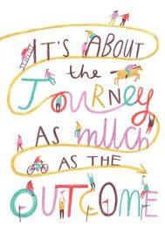
We are really looking forward to welcoming you all to our Reception class in September
Our Autumn Term Topic is
‘J’ is for Journey…
We have all been on lots of journeys in our lifetime, the most recent ‘Covid journey’ being unknown, strange and has hugely changed our familiar, daily lives.
We would really love for you to:
1. Send a photo of a journey you’ve been on, e.g. the park, the shops, a holiday, visiting a friend/family member, the swimming pool…

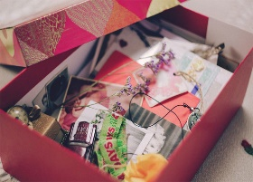
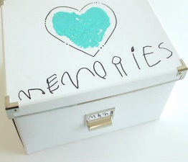
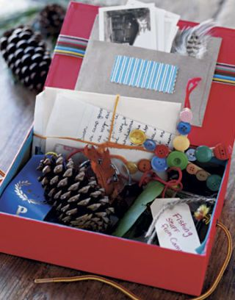
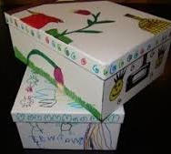
2. Fill a Memory Box (a decorated cardboard box is fine) with all of the special, unique things you have done, thought or felt during the lockdown. This may include drawings, objects, photos, writing, recipes etc. We are going to share and display these in class, in order to reflect on and talk about the impact this tricky time has had on us.
Please send photos to the class teacher’s email address:
hannah.dornan3@taw.org.uk (NURSERY)
kate.caswell@taw.org.uk (RECEPTION)
lola.lancett1@taw.org.uk (RECEPTION)

