Year 4 – Weekly activities – home learning - week commencing 13th July 2020

Maths – Summer Term

White Rose - https://whiterosemaths.com/homelearning/year-4/

White rose are continuing to offer free PowerPoints to watch linked to year 4 themes (this next set is statistics). However, they are not offering free worksheets. If you have enjoyed watching these PowerPoints please email us for worksheets to compliment these PowerPoints.
Alternatively, why not try one of the following:-
Oak National Academy - https://www.thenational.academy/online-classroom/year-4/maths#subjects, which has lessons available on area and perimeter, measurement, money, position and direction and shape. This site is backed by the government and has PowerPoints of teachers running the lesson.
Hamilton home learning packs –
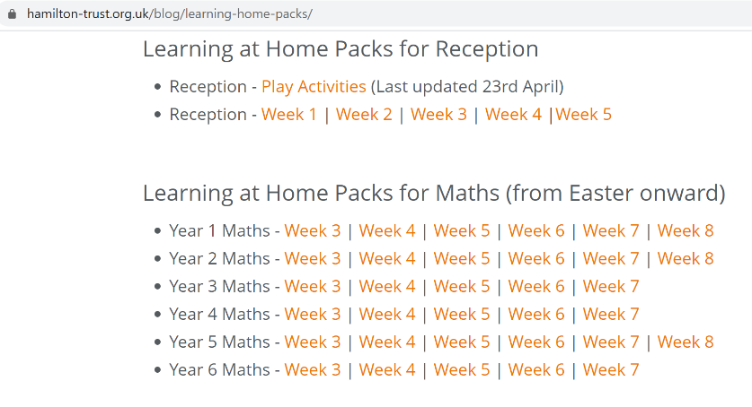

Different maths tasks will also be added to your child’s SeeSaw account daily.
Keep up the good work on times table rock stars.

OTHER FUN MATHS ACTIVIES

This website has many fun maths game ideas – choose 1 a week to try - https://thirdspacelearning.com/blog/fun-maths-games-activities-for-kids/

English

Fancy some creative writing? Try one of the following activities:

Option 1 – Try one of Pie Corbett’s English talk for writing resources –
(1) https://www.talk4writing.co.uk/wp-content/uploads/2020/04/Y4-Maria-Aliens.pdf
(2) https://www.talk4writing.co.uk/wp-content/uploads/2020/05/Y4-Mission.pdf
(3) https://www.talk4writing.com/wp-content/uploads/2020/06/Y4-Impossibly-Possible.pdf

Option 2 - https://www.pobble365.com/ every day, you will find an interesting picture, writing prompts and philosophical questions to spark creative writing.

OR

Use Hamilton Trust free home learning resources
https://www.hamilton-trust.org.uk/blog/learning-home-packs/
Please do not worry if you are still completing last week’s work, just work at your child’s own pace through the different weeks.

Click on Year 4 English – start the next relevant week.

There are a series of lessons to follow including PowerPoints to assist with completing the tasks. Complete the tasks at your own pace.

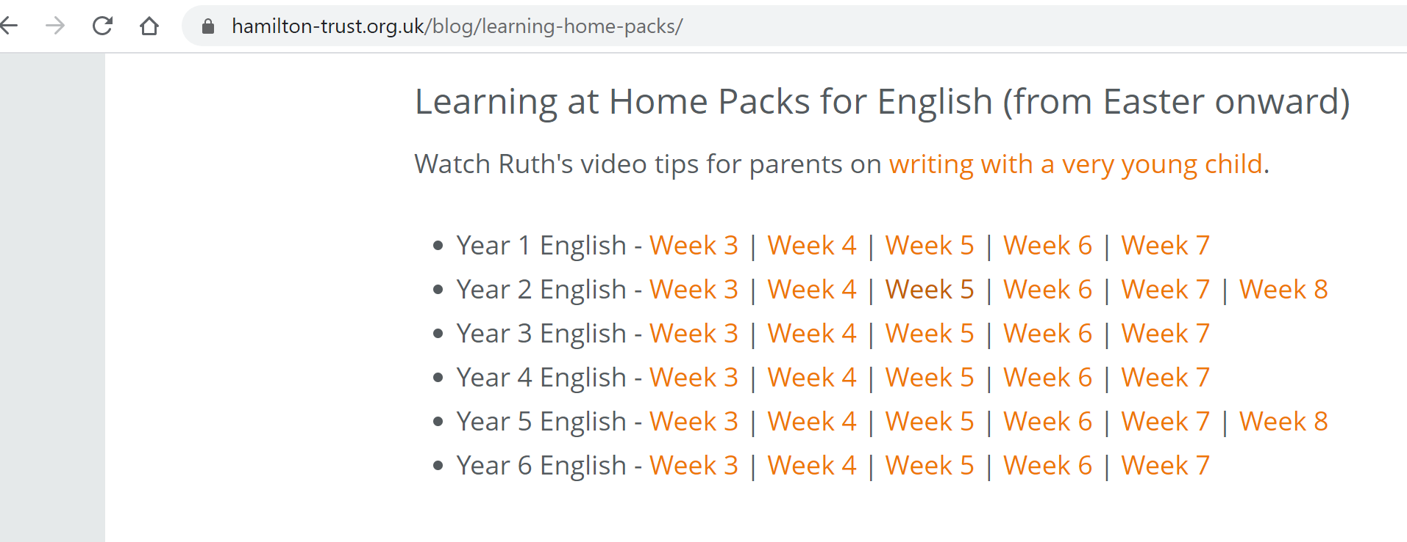

Reading

Read for 20 minutes a day. When you have completed a book, write a book review about what you have read. How does the story make you want to keep reading? Write down the phrases and words that you find effective in gripping the reader.

Optional follow on tasks:-

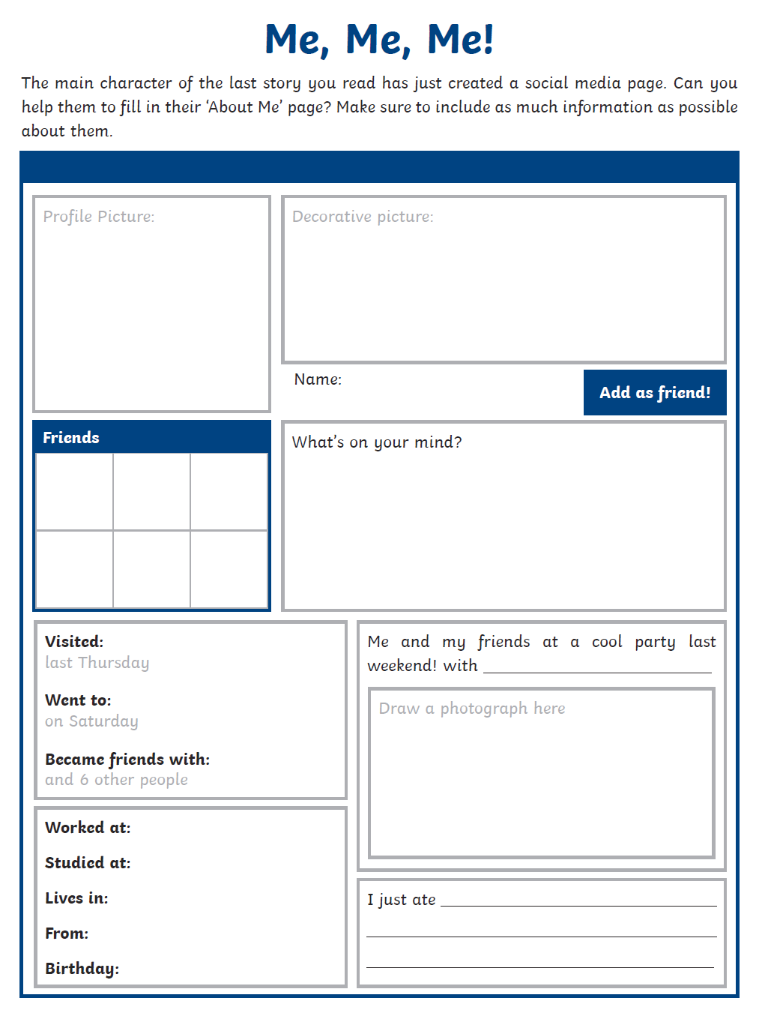

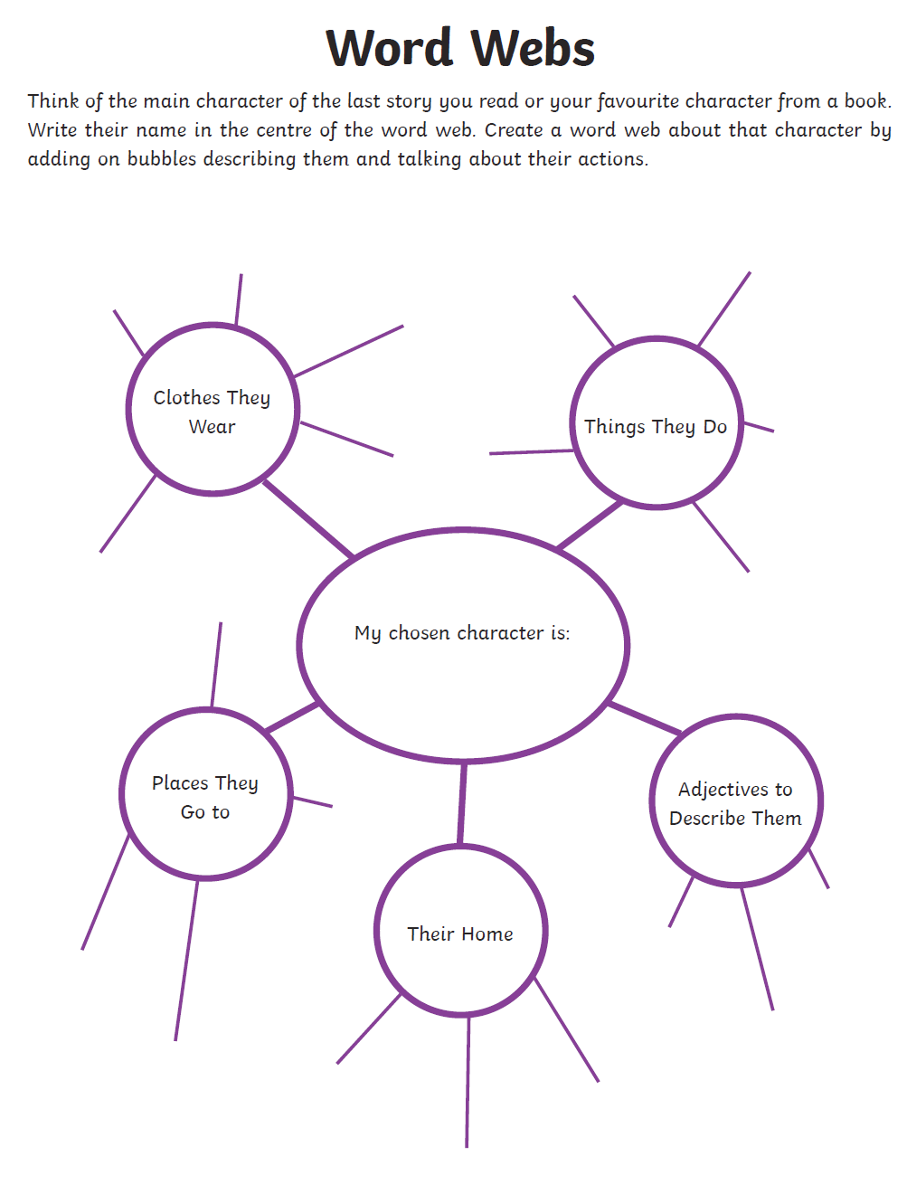

Computing

Each week try one different computing activity.
Barefoot Computing have put together some free home learning resources to help. With fun lesson-based activities and interactive games, children can work together with their families to develop their computational thinking skills. Choose one to try through https://www.barefootcomputing.org/homelearning.

The NCCE has produced some free home learning resources and have a live chat certain times of the day to assist you with the lessons. Here is a link to their free scratch lessons: https://teachcomputing.org/home-teaching/key-stage-2

SCRATCH
Go to https://scratch.mit.edu/ and click on create to start making your game.
OR Make a multiplication game in scratch.

PE
Daily exercise is an essential part of healthy living. Many of you have been following Jo Wicks, keep up the hard work with these daily sessions https://www.youtube.com/user/thebodycoach1/video or if you fancy a change try one of the super mover videos https://www.bbc.co.uk/teach/supermovers .
Alternatively, why not try PE with our very own Mr Stevens – use the link from the school website.
Try ‘Alice in Wonderland’ with Cosmic Kids Yoga, https://www.youtube.com/watch?v=u8sEfRXRuAw
Take a walk in a local forest with your family. Notice the sounds of the birds and enjoy the peaceful feeling that we gain from nature.
Make a Roman obstacle course in your garden.

RE

Try a different one each week - free home learning activities from NATRE
https://www.natre.org.uk/uploads/Free%20Resources/2%207-11%20RE%20Today%20and%20NATRE%20home%20learning%20Spirited%20Arts.pdf

Spellings
This week’s spellings are
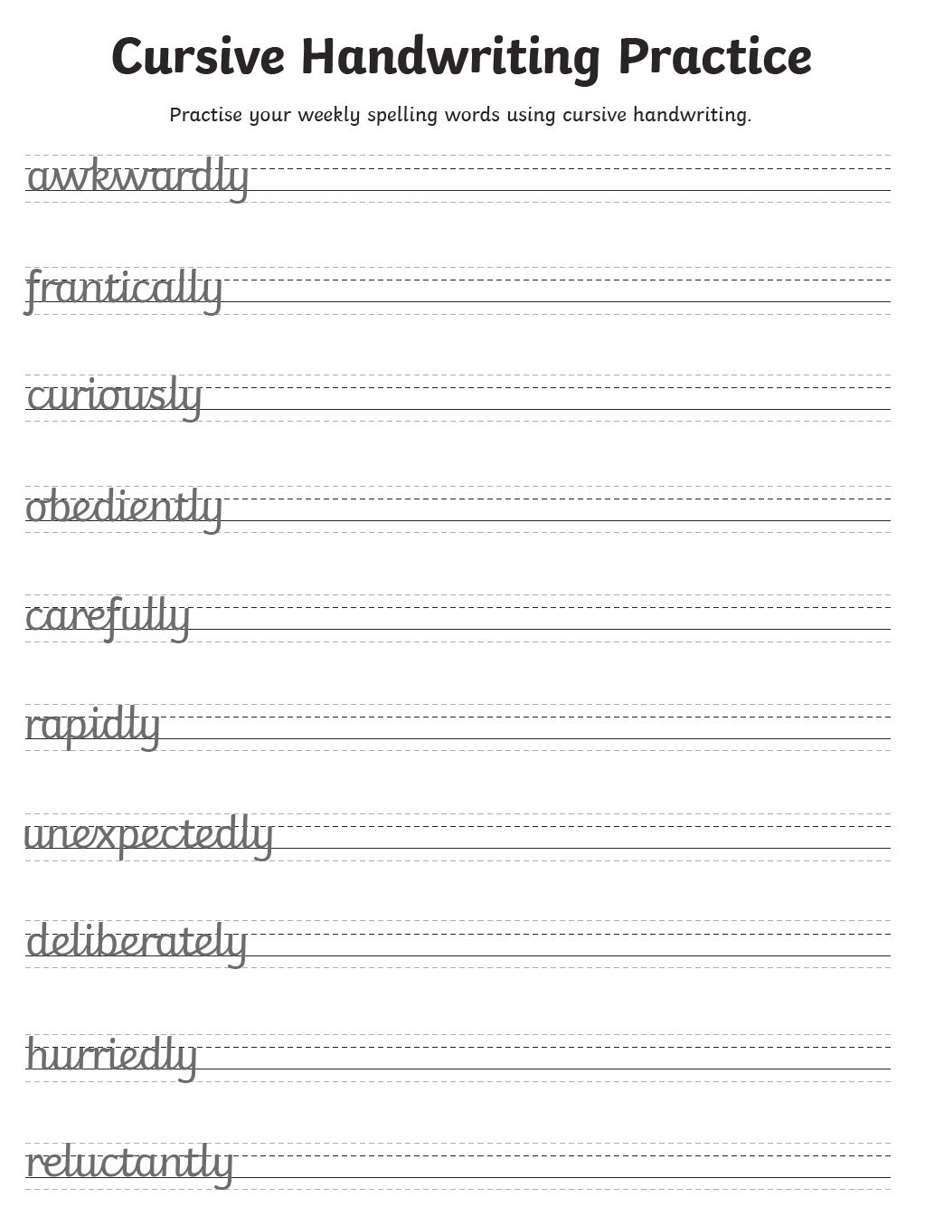
Practise them daily in your neatest cursive handwriting and get a grown up to test you on Friday.
EXTRA SPELLING FUN – visit https://spellingframe.co.uk/ - click on year 3 and 4 – choose the spelling rule you want to explore and click on free spelling tiles game.

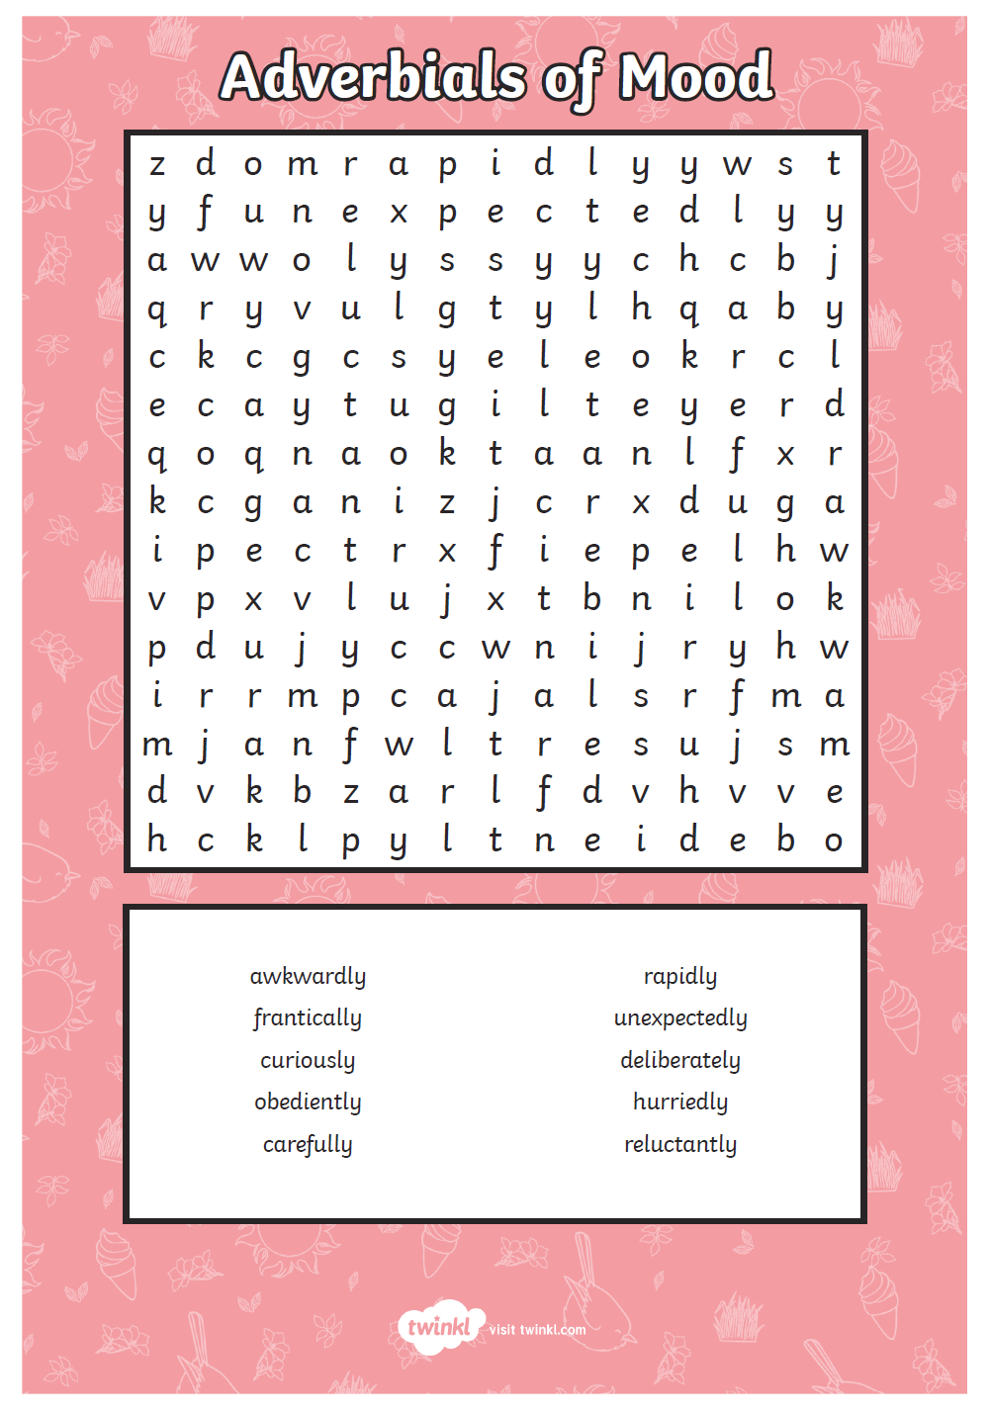

Science

Choose a different task to explore each week.
- Investigate the best materials for Roman helmets or shields.

- Make your own exploding volcanoes and find out about the chemical reactions involved. Details of how to make a volcanoe can be found at the natural history museum website - https://www.nhm.ac.uk/discover/how-to-make-a-volcano.html

- Investigate different ways of cleaning old Roman coins. Try cola, vinegar, lemon juice or baking soda.

- Find out what kind of armour Roman soldiers wore to protect their bodies

- Learn about our skeletons and how they are designed to act like armour for different organs

- This website has lots of experiments that can be done at home http://www.sciencefun.org/kidszone/experiments/

History

Explore this exciting lesson on ‘How and why did the Romans conquer Britain?’ on BBC Bitesize
https://www.bbc.co.uk/bitesize/articles/ztryxbk

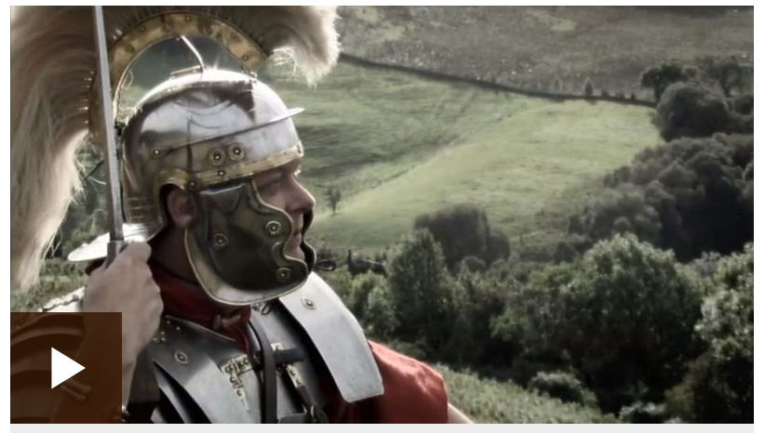

Geography

Work your way through oak academies excellent lessons on natural resources https://classroom.thenational.academy/subjects-by-year/year-4/subjects/foundation

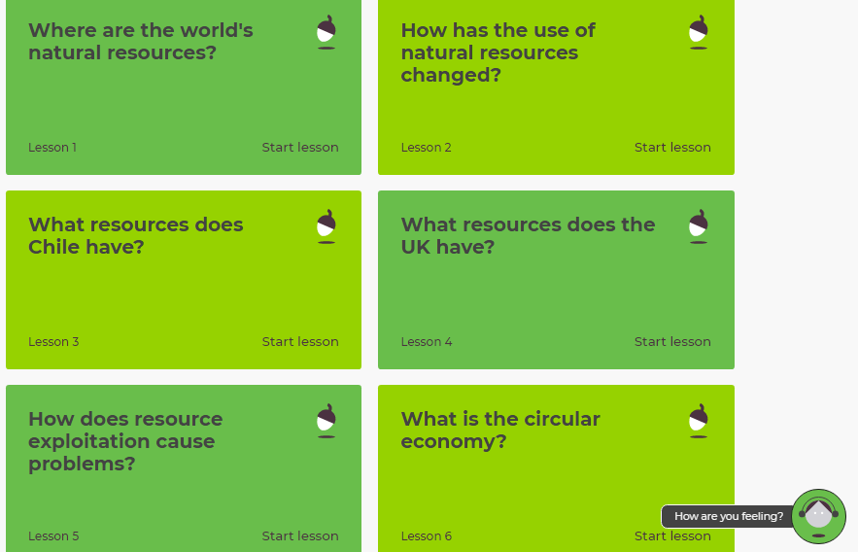

Art
Enhance your drawing skills through this new lesson at oak academy.
https://classroom.thenational.academy/lessons/juan-miro-and-automatic-drawing-6b09c2
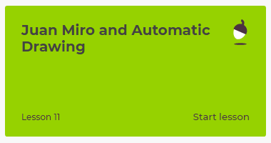
ALTERNATIVELY, take some time to relax and sit/ look outside, draw what you see. Can you draw some of the insects or birds that you see in nature?

Music

Choose some of your favourite songs from our past singing assemblies to listen and sing along too.
PSHE
Create an acrostic poem for a FRIEND. You might find it helpful to firstly mind map some ideas for each letter, e.g. F – friendly, fun, fantastic, forever there. Here is an example of a finished poem:-
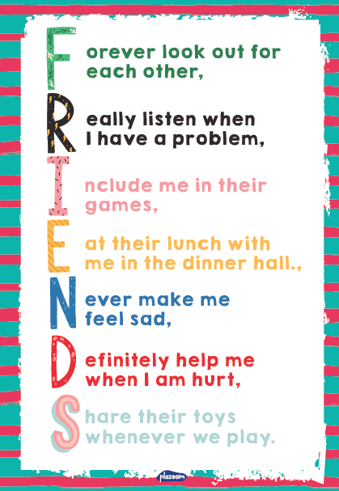
End of year activity
Create a scrapbook (see file attached) of your favourite memories from the year.

French
Try learning how to talk about your family and hobbies in French.
https://www.bbc.co.uk/bitesize/articles/zqy9vwx
Other available lessons
The BBC are also providing a vast range of activities for children. This link will give you three appropriate lessons a day to complete.
https://www.bbc.co.uk/bitesize/tags/z63tt39/year-4-lessons/1

Oak National Academy is a new collection of high-quality lessons and online resources. Backed by the government, you can find a range of lessons with PowerPoints/ videos free at https://www.thenational.academy/

If you have any queries about the work then please contact me via Seesaw or email me at Julie.lane1@taw.org.uk.

Thank you for your continued support. I wish you all a well-deserved break over the six weeks and look forward to hearing about your adventures in September.

Warm wishes

Mrs Lane

