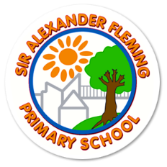
Sir Alexander Fleming Primary School and Nursery
Headteacher: Katy Tomlinson Chair of Governors: Terry Yarnall
109 Southgate, Sutton Hill, Telford, TF7 4HG – Tel: 01952 388010
www.siralexanderflemingprimaryschool.org.uk

Dear Parents, Carers and Governors,

Following Government advice, our school will be closing for Christmas on Thursday 17th December at 1pm.

I am sure that you will fully support this decision as many members of our school team have worked all through the pandemic and SLT will be responsible for contact tracing up until Wednesday 23rd December.

By breaking up a day early and moving a PD day from 7 June 2021, we will be able to ensure that all staff and children have 7 full days away from school prior to Christmas day. This will mean that they can meet with their families and other households safely.

Merry Christmas everyone!

Mrs Tomlinson
Last day of the Autumn term: Thursday 17th December 2020 at 1pm

PD Day: Friday 18th December 2020
PD Day: Monday 4th January 2021

Start back to school: Tuesday 5th January 2021

