Calculation Policy (EYFS/KS1):
 | Concrete | Pictorial | Abstract
Addition Vocabulary | Key language: sum, total, parts and wholes, plus, add, altogether, more, ‘is equal to’ ‘is the same as’.
Addition | Combining two parts to make a whole (using a range of manipulatives).  Counting on using number lines and manipulatives e.g. cubes or Numicon.  Regrouping to make 10; using ten frames and counters/cubes or using Numicon.  TO + O using dienes. Continue to develop understanding of partitioning and place value e.g. 41 + 8  TO + TO using dienes. Continue to develop understanding of partitioning and place value e.g. 36 + 25.  Use of place value counters to add HTO + TO, HTO + HTO etc. When there are 10 ones in the 1s column we exchange for 1 ten, when there are 10 tens in the 10s column, we exchange for 1 hundred.  Use place value counters, as appropriate, to support, especially when having to carry over.  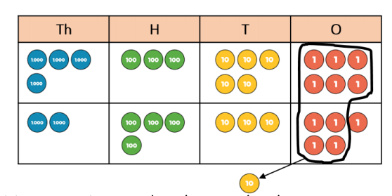  What happens when there is more than 9 in a place value column? | Children represent manipulatives using mark making. This can then be applied to part whole models to increase familiarity.  A bar model with encourages the children to count on, rather than count all.  Children will draw a ten frame and counters/cubes.  Children to represent dienes e.g. lines for tens and dots for ones.  Children to represent dienes in a place value chart.  Children to represent the counters in a place value chart, identifying when they make an exchange. | 4 + 3 = 7  Four is a part, three is a part and the whole is 7.  The abstract number line:  What is 2 more than 4?  What is the sum of 2 and 4?  What is the total of 4 and 2?  4 + 2 = ?  Children to develop an understanding of equality e.g.  Looking for ways to make 10.  Formal methods:  Column method used for integers and decimal numbers, including those with different numbers of decimal places.  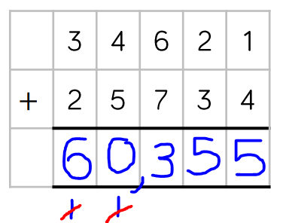  Is the column method always the best method?  When should we use mental calculations?  Encourage to use mental strategies where appropriate. Eg, when adding 999, it is easier to add 1,000 and then subtract 1; partitioning; using known facts.
Addition Conceptual Variation | Different ways to ask children to solve 21 + 34  .
Subtraction Vocabulary | Key language: take away, less than, the difference, subtract, minus, fewer, decrease.
 | Physically taking away and removing objects from a whole (ten frames, Numicon, multilink etc.)  e.g. 4 – 3 = 1  Counting back (using number lines or number tracks).  E.g. start with 6 and count back 2  6 – 2 = 4  Finding the difference (using multilink, Numicon or other manipulatives).  E.g. calculate the difference between 8 and 5.  Making 10 using ten frames.  14 – 5  Column method using dienes.  Column method using base 10 and having to exchange. E.g. 42 – 26  Column method using place value counters as appropriate. E.g. 234 - 88 | Children to draw the concrete resources they are using and cross out the correct amount. Bar models can also be used.  Children to represent what they see pictorially e.g.  Children to draw the multilink/concrete resources which they have used, or the bar model to illustrate what they need to calculate.  Children to present the ten frame pictiorally and discuss what they did to make 10.  Children to represent base 10 pictiorally.  Represent the base 10 pictorially, remembering to show the exchange.  Represent the place value counters pictorially; remembering to show what has been exchanged. | Children to represent the calculation on a number line or number track and show their jumps. Encourage children to use an empty number line.  Find the difference between 8 and 5.  8 – 5, the difference is  Children to explore why 9 – 6, 8 – 5 and 7 – 4 all have the same difference.  Children to show how they can make 10 by partitioning the subtrahend.  Column method or counting back (choose appropriate/efficient methods).  Formal column method. Children must understand that when they have exchanged the 10 they still have 41 because 41 = 30 + 11.  Formal column method. Children must understand what has happened when they have crossed out digits.  Column method used for integers and decimal numbers, including those with different numbers of decimal places.  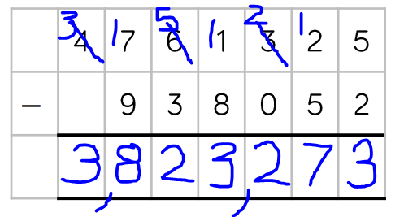  Is the column method always the best method?  When should we use mental calculations?  Encourage to use mental strategies where appropriate. Eg, when subtracting 999, it is easier to subtract 1,000 and then add 1; partitioning; using known facts.
Subtraction Conceptual Variation | Different ways to ask children to solve 391 – 186:
Multiplication Vocabulary | Key language: double, times, multiplied by, the product of, groups of, lots of, equal groups.
 | Repeated grouping/repeated addition:  3 x 4 = 4 + 4 + 4  There are 3 equal groups, with 4 in each group.  Number lines to show repeated groups  e.g. 3 x 4  Cuisenaire rods can be used too.  Formal column method with place value counters.  E.g. 6 x 23  When children start to multiply 3d x 3d and 4d x 2d etc., they should be confident with the abstract:  - To get 744 children have solved 6 x 124.  - To get 2480 they have solved 20 x 124. | Children to represent the practical resources in a picture and use bar models.  Represent this pictorially alongside a number line e.g.  Children to represent counters/dienes/base 10 pictorially e.g.  When children start to multiply 3d x 3d and 4d x 2d etc., they should be confident with the abstract:  - To get 744 children have solved 6 x 124.  - To get 2480 they have solved 20 x 124. | 3 x 4 = 12  4 + 4 + 4 = 12  Abstract number line showing three jumps of four.  3 x 4 = 12  Grid method (discuss partitioning approaches):  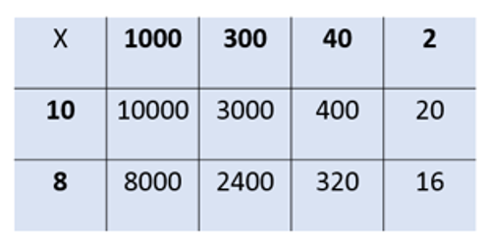  Formal written method.  Is the formal method always appropriate?  Encourage to use mental strategies where appropriate. Eg. multiplying by 10, 100, 1,000; known facts, partitioning.
Multiplication Conceptual Variation | Different ways to ask children to solve 6 x 23:
Division Vocabulary | Key language: share, group, divide, divided by, half.
Division | Sharing using a range of objects  e.g. 6 ÷ 2  Repeated subtraction using Cuisenaire rods above a ruler  e.g. 6 ÷ 2  2d ÷ 1d with remainders using manipulatives (e.g. lollipop sticks, Cuisenaire rods above a ruler etc.)  13 ÷ 4 using lollipop sticks to form wholes.  There are 3 wholes, with one left over.  Sharing using place value counters.  42 ÷ 3 = 14  Short division using place value counters to group.  615 ÷ 5  Make 615 with place value counters.  How many groups of 5 hundreds can you make with 6 hundred counters?  Exchange 1 hundred for 10 tens.  How many groups of 5 tens can you make with 11 ten counters?  Exchange 1 ten for 10 ones.  How many groups of 5 ones can you make with 15 ones? | Represent the sharing pictorially.  Children to represent repeated subtraction pictorially.  Children represent the lollipop sticks/manipulatives pictorially.  There are 3 wholes, with one left over.  Children to represent the place value counters pictorially.  Represent the place value counters pictorially.  Why is the context of the question important when deciding how to represent the remainders?  Remainders in contexts (‘4 r1’ means 4 full boxes and 1 left over, or 5 boxes are needed in total). | 6 ÷ 2 = 3  Children should also be encouraged to use their 2 times tables facts.  Abstract number line to represent the equal groups that have been subtracted.  13 ÷ 4 = 3 remainder 1  Children should be encouraged to use their times tables facts; they could also represent repeated addition on a number line.  “3 groups of 4, with 1 left over.”  Children to be able to make sense of the place value counters and write calculations to show the process.  42 ÷ 3  42 = 30 + 12  30 ÷ 3 = 10  12 ÷ 3 = 4  10 + 4 = 14  Children to solve the calculation using the short division scaffold.  Move on to dividing by 2 digits. Encourage to list multiples of the divisor.  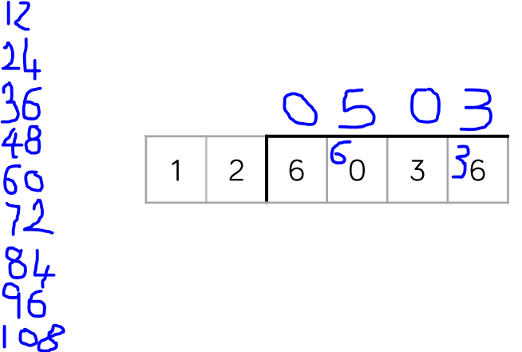  Key facts method:  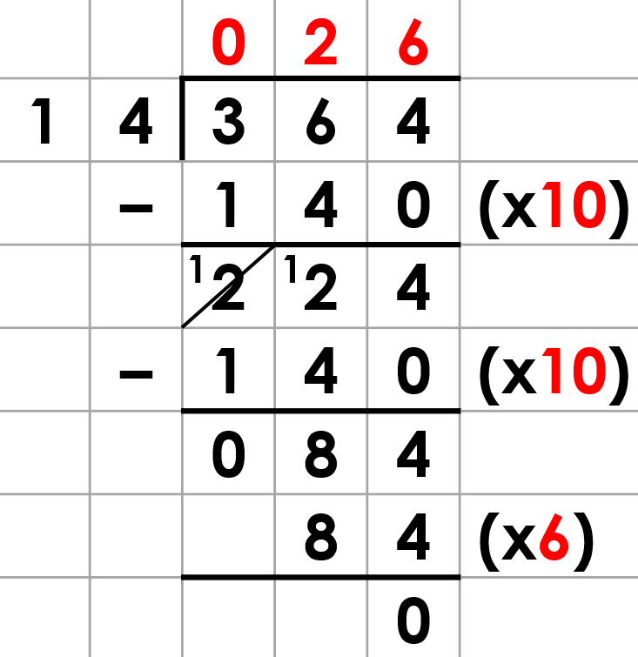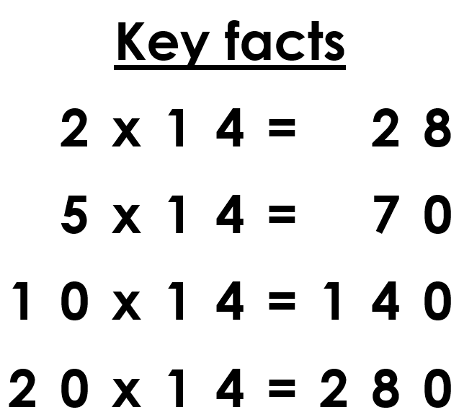  Show how to represent remainders as a decimal and as a fraction.
Long division using place value counters: 2544 ÷ 12
We can’t group 2 thousands into groups of 12 so will exchange them.

We can group 24 hundreds into groups of 12 which leaves us with 1 hundred.

After exchanging the hundred, we have 14 tens. We can group 12 tens into a group of 12, which leaves 2 tens.

After exchanging the 2 tens, we have 24 ones. We can group 24 ones into 2 groups of 12, which leaves no remainder.

‘Bringing down’ method:
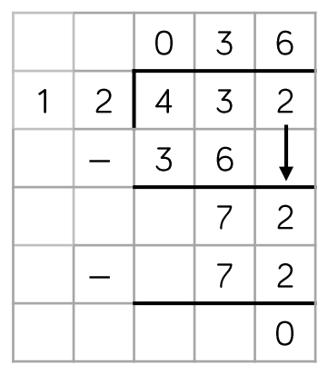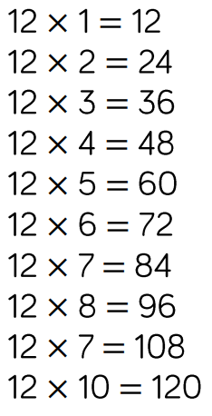

Division Conceptual Variation | Different ways to ask children to solve 615 ÷ 5

Calculation Policy Guidance
 | EYFS | Year 1 | Year 2 | Year 3 | Year 4 | Year 5 | Year 6
Addition | Combining two parts to make a whole: part-whole model.  Starting at the bigger number and counting on – using manipulatives.  Regrouping to make 10 using a ten frame. | Combining two parts to make a whole: part-whole model.  Starting at the bigger number and counting on – using manipulatives.  Regrouping to make 10 using a ten frame. | Adding three single digit numbers.  Use of manipulatives to combine two numbers. | Partitioning.  Column method – regrouping.  Using place value counters/dienes (up to 3 digits). | Column method – regrouping.  Using place value counters/dienes (up to 4 digits). | Column method – regrouping.  Using place value counters for adding decimal numbers. | Column method – regrouping.  Children are encouraged to choose appropriate methods depending on the numbers presented.
Subtraction | Taking away ones.  Counting back.  Finding the difference.  Part-whole models.  Make 10 using a ten frame. | Taking away ones.  Counting back.  Finding the difference.  Part-whole models.  Make 10 using a ten frame. | Counting back.  Finding the difference.  Part-whole models.  Make 10.  Dienes. | Column method – with regrouping.  Using place value counters/dienes (up to 3 digits). | Column method – with regrouping (up to 4 digits). | Column method – with regrouping.  Using place value counters for decimal numbers with the same amount of decimal places. | Column method – with regrouping.  Using place value counters for decimal numbers with the different amounts of decimal places.
Multiplication | Recognising and making equal groups.  Doubling. | Recognising and making equal groups.  Doubling.  Counting in equal groups using manipulatives. | Arrays, showing commutative multiplication.  Use of manipulatives. | Arrays.  2 digit x 1 digit using manipulatives. | Column multiplication introduced with place value counters  (2 and 3 digit multiplied by 1 digit). | Column multiplication – abstract (or with recap using manipulatives to support as needed). | Column multiplication – abstract methods.
Division | Sharing objects into groups using manipulatives. | Sharing objects into groups using manipulatives.  Drawing around ‘groups of’ objects. | Division as grouping.  Division within arrays – linking to multiplication.  Repeated subtraction. | Division with a remainder using manipulatives.  Links made to times tables and repeated subtraction.  2 digit divided by 1 digit using dienes and/or place value counters. | Division with a remainder.  Short division (up to 3 digits by 1 digit – concrete and pictorial). | Short division (up to 4 digits by a 1 digit number including remainders). | Short division.  Long division with place value counters initially (up to 4 digits by a 2 digit number).  Children should exchange into the tenths and hundredths columns.

