**Sir Alexander Fleming Primary School and Nursery**

**MATHEMATICS**

**Written: September 2020**

**Review: September 2022**

**Contents**

1. Intent
2. Implementation
3. Impact
4. Assessment
5. Planning and Resources
6. Early Years Foundation Stage
7. Equal Opportunities and Inclusion
8. Policy Links
9. **What is the intent of the Maths curriculum at Sir Alexander Fleming Primary School?**

Our long-term aim is to produce an ambitious, connected curriculum accessible to all pupils from Reception to the end of Year 6. We aim to develop pupils into mathematical thinkers. We want pupils to enjoy opportunities to become fluent in the fundamentals of mathematics, to be able to reason and to solve problems. It is our ambition to make substantial links between mathematical understanding and the real world, using mathematical language in a cross-curricular manner, supporting pupils to articulate their knowledge and learning.

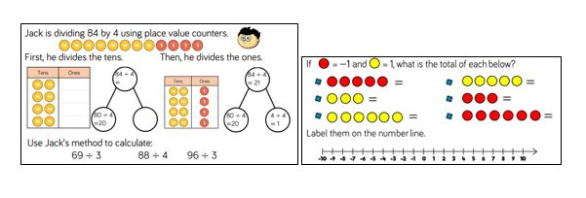Our curriculum embraces these National Curriculum aims, and provides guidance to help pupils to become confident and resilient:

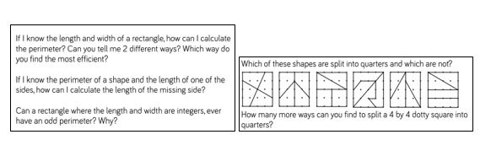Visualisers – we use the Concrete – Pictorial – Abstract (CPA) approach to help pupils understand mathematics and to make connections between different representations (models, images and graphics).

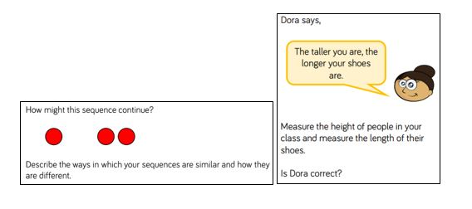Describers – we place great emphasis on mathematical language and questioning so pupils can discuss the mathematics they are doing, and so support them to take ideas further.

Experimenters – as well as being fluent mathematicians, we want pupils to love and learn more about mathematics.

Progression through the mathematics curriculum:  
To learn mathematics effectively, some things have to be learned before others, e.g. place value needs to be understood before working with addition and subtraction, addition needs to be learnt before looking at multiplication (as a model of repeated addition). We place a significant emphasis on number skills, carefully ordered, throughout our primary curriculum. For some other topics, the order is not as crucial, e.g. Shapes and Statistics need to come after number, but do not depend on each other. We mix these so pupils have as wide a variety of mathematical experiences as possible in each term and year.

1. **Implementation**

Teachers reinforce an expectation that all children are capable of achieving high standards in Mathematics.

The large majority of children progress through the curriculum content at the same pace. Differentiation is achieved by emphasising deep knowledge and through individual support and intervention.

Teaching is underpinned by methodical curriculum design and supported by carefully crafted lessons and resources to foster deep conceptual and procedural knowledge.

Practice and consolidation play a central role. Carefully designed variation within this builds fluency and understanding of underlying mathematical concepts.

Teachers use precise questioning in class to test conceptual and procedural knowledge and assess children regularly to identify those requiring intervention or extension.

To ensure whole consistency and progression, the school uses the Framework of the White Rose Maths scheme to inform coverage. Problem-solving activities prompt discussion and reasoning, as well as promoting an awareness of maths in relatable real-life contexts that link to other areas of learning. In KS1, these problems are almost always presented with objects (concrete manipulatives) for children to use. Children also often use manipulatives in KS2, however where appropriate, this is child-led. Adults use careful questions to draw out children’s discussions and their reasoning. The class teacher then leads children through strategies for solving the problem, including those already discussed. Independent work provides the means for all children to develop their fluency further, before progressing to more complex related problems. Mathematical topics are taught in blocks, to enable the achievement of ‘mastery’ over time, with more able children being offered rich and sophisticated problems, as well as exploratory, investigative tasks, within the lesson as appropriate.

1. **Impact**

Sir Alexander Fleming Primary School has a supportive ethos and our approaches support the children in developing their collaborative and independent skills. Children can underperform in Mathematics because they think they can’t do it or are not naturally good at it. We address these preconceptions by ensuring that all children experience challenge and success in Mathematics by developing a growth mindset. Regular and ongoing assessment informs teaching, as well as intervention, to support and enable the success of each child. These factors ensure that we are able to maintain high standards, with achievement at the end of KS2 in line with National Average.

The impact of classroom teaching is regularly monitored through use of classroom observations, learning walks, book looks and pupil voice questionnaires.

1. **How is mathematics assessed at Sir Alexander Fleming Primary School?**

Children receive effective feedback through teacher assessment, and Assessment for Learning (AfL) is integral to the design of each lesson. The majority of this feedback is given orally, at the point in time of teaching. The structure of the teaching sequence ensures that children know how to be successful in their independent work. Guided practice provides further preparation for children to be able to apply the skills, knowledge and strategies taught. Common misconceptions are addressed within the teaching sequence and key understanding within each ‘small step’ is reviewed and checked by the teacher and the children before progression to further depth. Opportunities for additional practice and consolidation are provided by adults, as appropriate, during marking, with a focus on promoting and achieving a growth mindset and resilience.

Formative assessment: short term assessment is a feature of each lesson. Observations and careful questioning enable teachers to adjust lessons and review the use of adult support. At the end of each blocked unit of work, the children also complete the carefully aligned White Rose Maths ‘End of Unit Assessment’. The outcome of this is used by the teacher to ensure that any identified gaps in understanding can be addressed before the next unit is taught. This also informs dialogue with parents and carers during parent consultations, as well as the judgements made at the end of the term as to the extent that each child has demonstrated their ability: ‘working towards the expected standard’, ‘secure at the expected standard’, or ‘working at a greater depth within the expected standard’.

Assessment data in maths is reviewed throughout the year to inform bespoke interventions and to also ensure that provision remains well-informed to enable optimum progress and achievement. End of year data is used to measure the extent to which attainment gaps for individuals and identified groups of learners are being closed. This data is used to inform whole school and subject development priorities for the upcoming academic year.

1. **Planning and Resources**

The use of Mathematics resources is integral to the concrete – pictorial – abstract approach and thus planned into teaching and learning. The school has a wide variety of good quality equipment and resources, both tangible and ICT based, to support our learning and teaching. These resources are used by staff and children in a number of ways including:

• Demonstrating or modelling an idea, an operation or method of calculation. Resources for this purpose could include: a number line; place value cards; dienes; place value counters and grids; money or coins; measuring equipment for capacity, mass and length; 5 bead strings; the interactive whiteboards and related software; 3D shapes and/or nets; multilink cubes; clocks; protractors; calculators; dice; number fans etc.

• Enabling children to use a calculation strategy or method that they couldn’t do without help, by using any of the above or other resources as required. Banks of standard resources such as number lines, multi-link cubes, dienes, hundred squares and counters are located within individual classrooms. Resources within individual classes are accessible to all children who should be encouraged to be responsible for their use. Further resources (often larger items shared by the whole school) are also available as part of a central supply.

• Teachers are encouraged to use any school space as an outdoor classroom when possible, for example, when teaching length, area or perimeter.

1. **Early Years Foundation Stage (EYFS)**

Children in the EYFS have a short daily Maths teaching session, during which time they begin to develop their understanding of simple mathematical concepts such as counting to 20, maintaining 1 to 1 correspondence, simple addition and subtraction facts, to recognise and describe simple 2d and 3d shapes. Children are taught these concepts using physical resources, pictorial resources, songs, games, and role-play. Throughout the week all children will experience whole class work, group teaching and individual practice. It also enables teachers to establish regular routines thereby maximising teaching time. It supports assessment on a daily basis, as well as individual feedback to children, ensuring that children receive immediate intervention as required during the supported focus activities. In both Nursery and Reception, the independent activities at the Maths table link to the focus for the week. In addition to these planned independent activities, children also have the opportunity to self-select Maths resources to consolidate their learning during child-initiated activities (‘open door’). We recognise the importance of play-based learning and therefore encourage children to develop their understanding during their play. Such opportunities are provided in both the inside and outside environment. Regular observations and assessments help to ensure that children that need additional intervention to consolidate their mathematical understanding are identified and supported by appropriate interventions.

1. **Equal Opportunities and Inclusion**

At Sir Alexander Fleming Primary School,l we plan to provide for all pupils regardless of gender, ethnicity, socio-economic status, cultural background, academic ability, Special Educational Need/Disability or vulnerability to achieve their full potential. We are committed to ensuring that children and staff are happy and that they enjoy coming to school. This policy will underpin excellent teaching, learning and progress. It will promote the high standards and high expectations set out in the school’s aims and code of conduct. We are committed to meeting the needs of each individual especially those identified in the 2010 Equality Act.

1. **Policy Links**

This policy should be read in conjunction with:

* Calculation Policy
* Long Term Overview and Progression Document for Mathematics
* Equality Objectives documentation
* SEND Policy
* Curriculum Policy