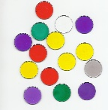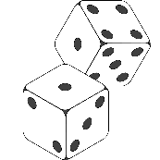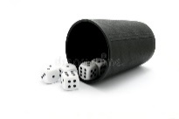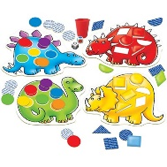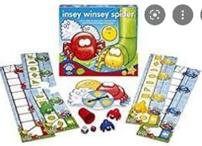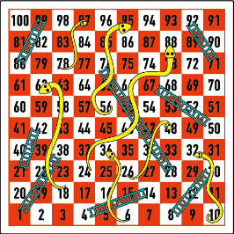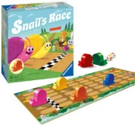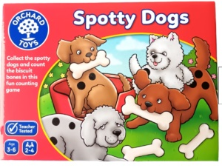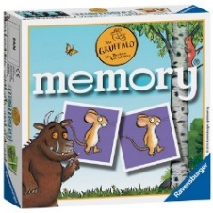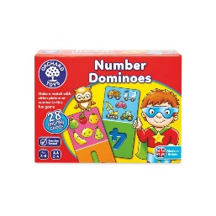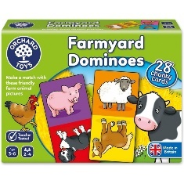

**Games involving adding.**

Combining sets of counters.

Increased challenge through . . .

* Using the board as a number track.
* Adding more than one number (repeated addition)
* Graphics/ recording equations
* More than one dice

**Games that develop 1:1 correspondence.**

Rolling a coloured dice and moving 1 place each turn.

Spinning a image spinner and moving 1 place each turn.

PD – rolling a dice in a cup

moving to rolling a dice with hands.

**Games involving finding the difference.**

“You are on 5, how many more do you need to get to 11?”

**Children solving problems.**

**Children are strategic with their turn!**

Children who try to cheat, may show they understand!

They use strategies for success; remembering where a card is during snap, planning where to go next during noughts and crosses, trying to tip a dice to the largest number!

**Games involving subtracting.**

**Removing objects as a result of landing on a certain part.**

Increased challenge through . . .

* Using the board as a number track.
* Removing more than one set.
* Graphics/ recording equations

**Games that develop 1:1 correspondence (more than 1)**

Counting out an amount of actions.

Counting more than 1 space on a board (model to image)

Increased challenge through . . .

* Number sequence

**Matching games involving number and numerals.**

Games with spinners and dice.

Selecting an image to match a number (image to image).

Increased challenge through . . .

* Dice 1-6, 1-9 (Are children counting dots or able to subitise?)
* Dice images changed to numerals.
* Do children have an understanding of how many 5 looks like? Are they estimating with a degree of accuracy?)

**To play a board game they know well, independently with a group of children.**

(To show good hand-eye co-ordination, know the rules, adhere to these using self-regulation skills, take turns, apply their mathematical knowledge, possibly recording their score)

**To join an adult, showing interest in a game.**

**To stay at the activity for a reasonable length of time.**

**To wait their turn**

Increased challenge through . . .

* amount of time dependent on stage of development – wait after one other child, wait after a round . . .

**Matching and sorting games.**

Pairs, pelmanism

Recognising images which are the same and different.

Increased challenge through . . .

* types of images (single characters, detailed pictures, mathematical images)
* number of cards being used