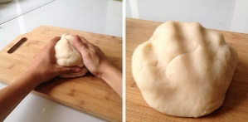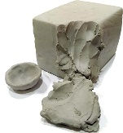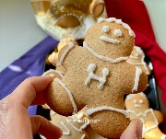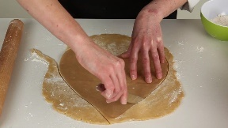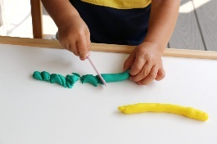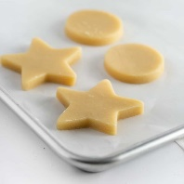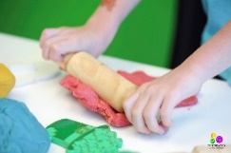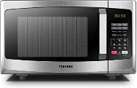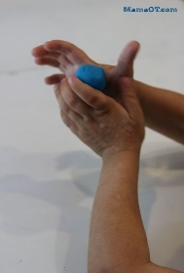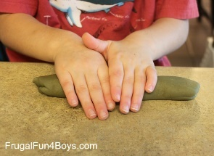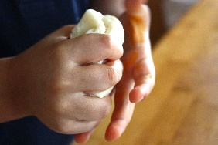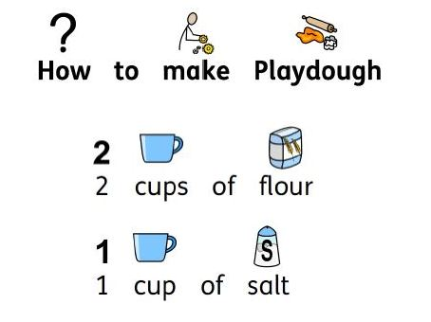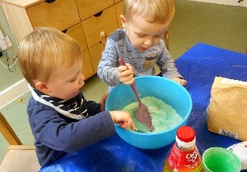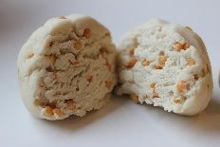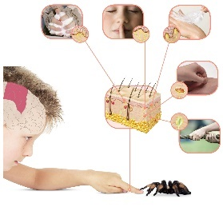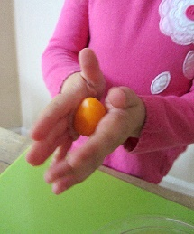

>

>

Level of precision

>

>

**To touch dough, recognising that it responds to touch.**

Increased challenge through . . .

* Vocabulary related to senses.
* Evoking feelings through touch.
* Experimenting with ways to change the dough.
* Adding different textures to the dough.
* A range of recipes.

**Participating in making dough.**

Increased challenge through . . .

* Number-counting actions, counting backwards microwave
* Measuring ingredients
* Instructional language and understanding
* Reading a recipe
* Physical development – stirring, mixing, pouring.

**Exploring effects of hands.**

Increased challenge through . . .

* Using harder materials such as clay.
* See ‘Common Play Behaviours’ – from squeezing to rolling.
* The amount of increased control.

**Exploring effects of tools.**

Increased challenge through . . .

* The type of tool; the amount of pressure required using fine-motor skills.
* The amount of risk associated with the tool.

**Using hands and tools for a purpose;**

Increased challenge through . . .

* Combining other areas of learning.
* Design considerations.
* Making amendments/ improvements.
* Type of design brief; problem solving.

**To design, plan and create a model using malleable material independently.**

(To show good fine-motor control, use of hands and tools safely and possibly record their creation)