Our Reading Offer in the EYFS
Context
Our curriculum is built on our fundamental belief that rhymes, stories and literature are crucial in ensuring positive outcomes for our children. We know that our setting is in an area of high deprivation and many children do not have access to books and that our parents may not have the means or understanding that this is important for children’s development.
Implementation
Therefore, we plan key rhymes, stories and texts throughout the year to match the needs of our children and ensure that they know and remember a bank of literature to build on as they move into year 1.
We are also adaptive and use songs, rhymes and stories which we have not planned into the long-term overview due to children’s interests or emerging needs.
In Nursery children listen to and read with an adult in small groups at least three times a week. Our aspirational target is for this to happen every day.
In Reception an adult plays in the book corner every day at 8:30am. They target children who are in need of higher amounts of adult interaction and do not read at home.
In Year 1 children
Staff use the key texts in the long term overview to plan experiences in carpet sessions, continuous provision and small group activities. Staff also plan a daily story time, sometimes, with different stories as the focus. Staff plan a daily nursery rhyme session using the rhymes from the long term overview and others. Staff take as much time as needed to embed the rhyme/ story based on the children’s needs. They return to rhymes children have been previously taught in order to ensure these are not forgotten. They ensure the pace is matched to children’s abilities but that children are also challenged sufficiently.
Parents are encouraged to read with their child every day. We support them to do this by ensuring all children in the EYFS take home a book that their parent can read to them.
We share the focus text and rhymes we are using on Seesaw, the online platform we use. In this way parents can support their children’s recall and understanding of what is being taught in school. They also see how the adult models reading to children in an engaging and developmentally appropriate way.

The Journey through Rhymes and Stories at Sir Alexander Fleming Primary School
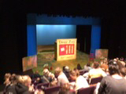
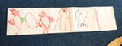
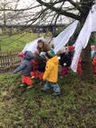
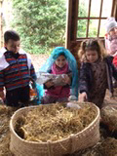
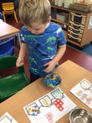
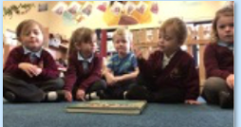
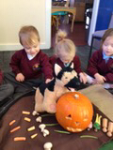
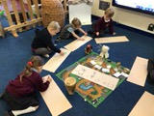
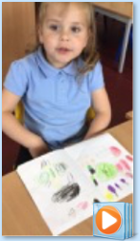
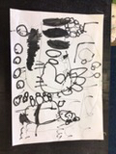
Talk > Mark-making > Writing
Children are immersed in a rhyme or story.
Adults lead retelling the text in a range of ways, such as with props, role-play, small world, powerpoints, other versions, story songs, story spoons, story journey.
Increased challenge through . . .
- Children recalling significant and less significant details.
Children retell the key text in a variety of ways. Including Helicopter Stories.
Increased challenge through . . .
- The detail being used depending on children’s stage of development.
- Open ended resources which involve the child knowing the text very well and engaging in symbolic play.

Adults plan activities in other areas to develop understanding of the focus text.
For example, creating incey wincey spider in the malleable area or using a ladle (from Aiken Drum) to share out soup on the fire at forest school.
Other books may be used at this stage to enable children to make connections, compare, apply and research concepts in the key texts.
Increased challenge through . . .
- The type of activity
- Adults targeting questioning
matched to children’s needs
Children are encouraged to make marks inspired by the key text.
Increased challenge through . . .
- The type of mark-making; a mark to represent a sound in the text , to the retrieval of a character, progressing to the sequence of events.
- Use of writing to label, describe the marks.
Adults model innovating the text.
For example,
Increased challenge through . . .
- The adult providing the innovation, the children describing the new ideas.
- Children making connections between the innovation and the original text.
Children attempt to innovate a text, initially verbally.
Increased challenge through . . .
- The number of innovations taking place.
- The type of innovation – a character progressing to a key piece of the plot!
- Beginning to mark-make and then write an innovation!
Children listen to the rhyme of story read by an adult.
Increased challenge through . . .
- Targeted questioning
- Types of questioning linked to rainbow reader domains – retrieval being easier and inference more difficult.
- The ways in which children join in; through eye-pointing, actions and words.
Yr N | Autumn  Access to high quality texts in a holistic way through adult-directed activities and enhancements in provision.  We are flexible and change our book choices and planning due to the children’s interests/ new inspirations.  Some of these books are in our Reading Spine.
Theme
U is for Unique
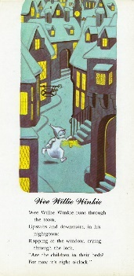
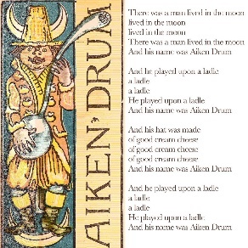
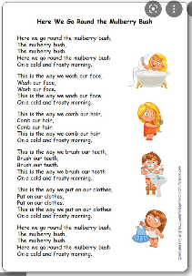
Poetry/ Nursery Rhymes
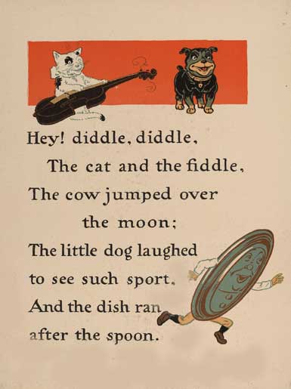
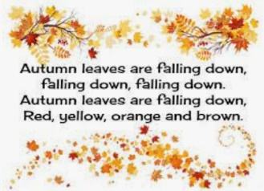
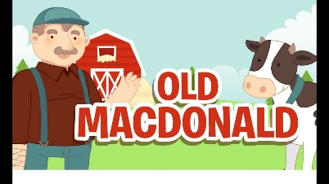

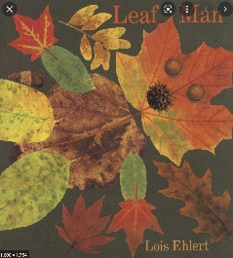
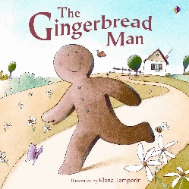
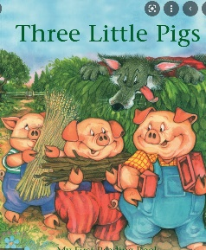
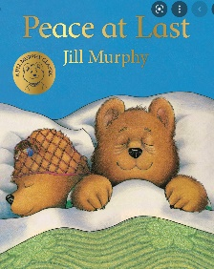
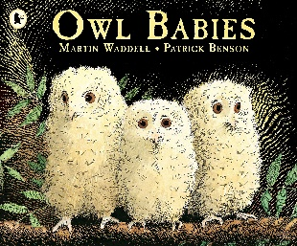
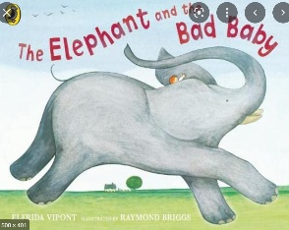
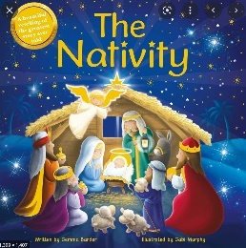
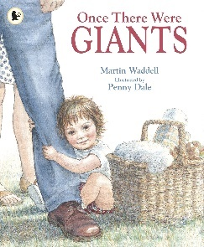
Fiction
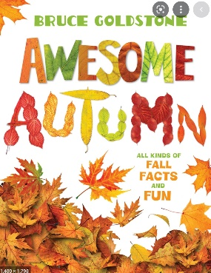
Non-fiction
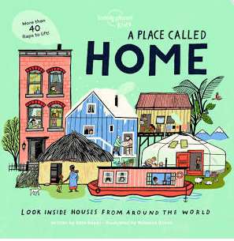
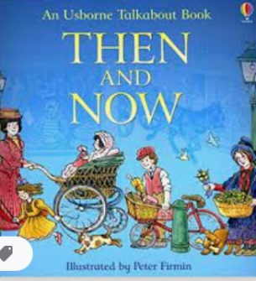
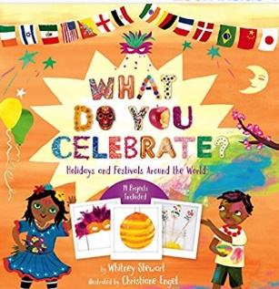
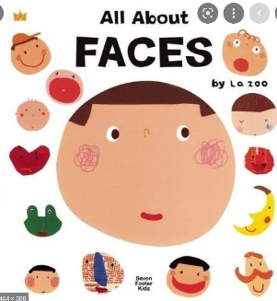

Yr N | Spring  Access to high quality texts in a holistic way through adult-directed activities and enhancements in provision.  We are flexible and change our book choices and planning due to the children’s interests/ new inspirations.  Some of these books are in our Reading Spine.
Theme
C is for Community
Poetry/ rhymes and songs following possible themes
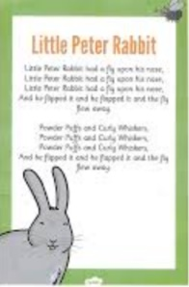
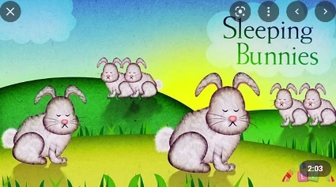
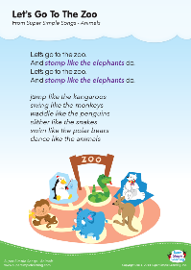
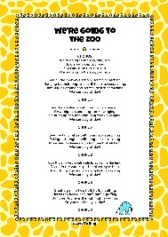
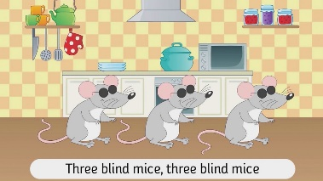

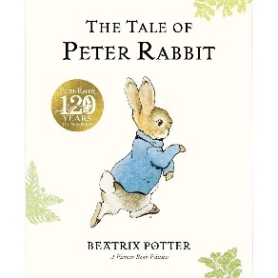
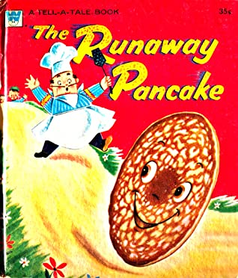
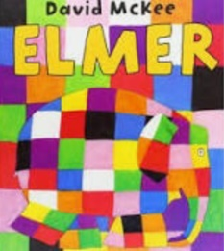
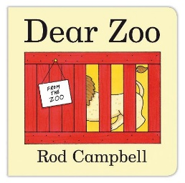
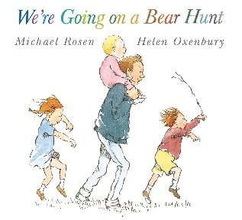
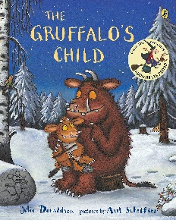
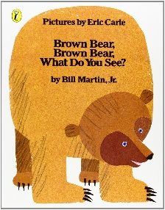
Possible Fiction
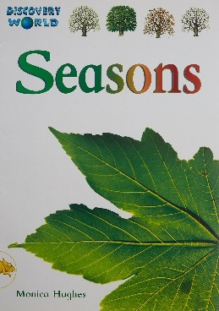
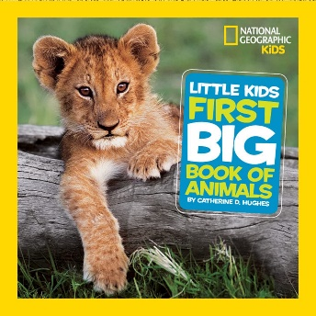
Possible Non-fiction
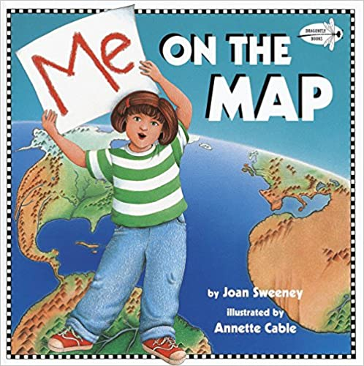
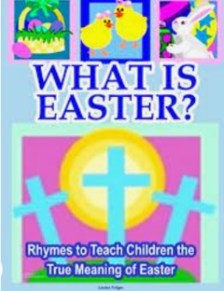
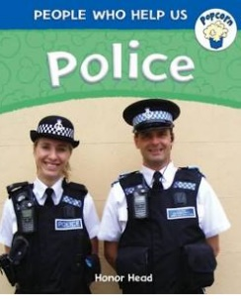

Yr N | Summer  Access to high quality texts in a holistic way through adult-directed activities and enhancements in provision.  We are flexible and change our book choices and planning due to the children’s interests/ new inspirations.  Some of these books are in our Reading Spine.
Theme
A is for Alive
Poetry/ rhymes and songs following possible themes
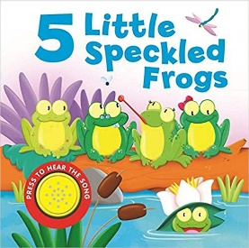
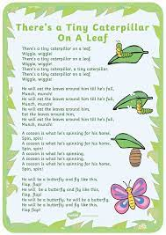
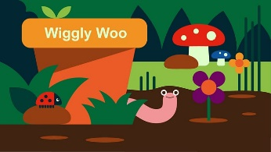
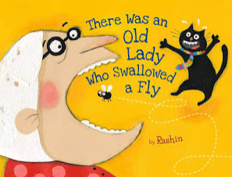

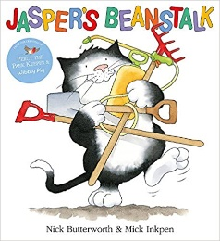
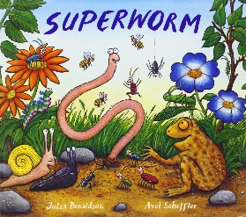
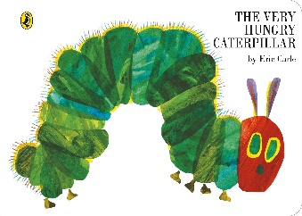
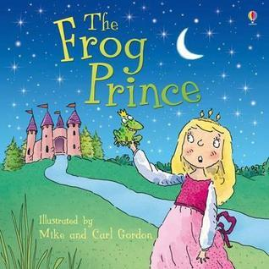
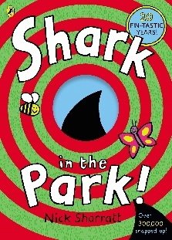
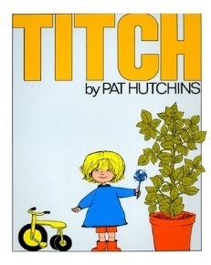
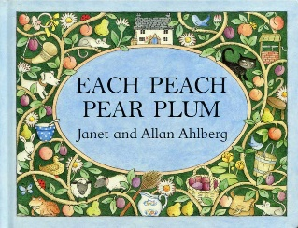
Possible Fiction
Possible Non-fiction
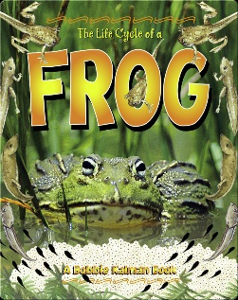
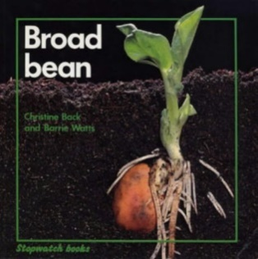
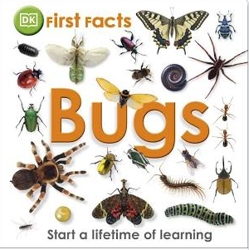

Yr R | Autumn  Access to high quality texts in a holistic way through adult-directed activities and enhancements in provision.  We are flexible and change our book choices and planning due to the children’s interests/ new inspirations.  Some of these books are in our Reading Spine.
Theme
U is for Unique
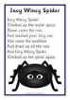
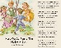
Poetry/ rhymes and songs following possible themes

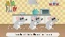
Possible Fiction
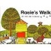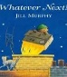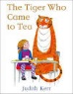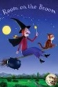

Possible Non-fiction
Then and Now Big Book.

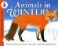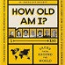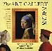

Yr R | Spring  Access to high quality texts in a holistic way through adult-directed activities and enhancements in provision.  We are flexible and change our book choices and planning due to the children’s interests/ new inspirations.  Some of these books are in our Reading Spine.
Theme
C is for Community
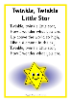
Poetry/ rhymes and songs following possible themes

Possible Fiction
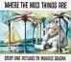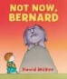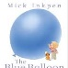

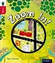
Possible Non-fiction

Yr R | Summer  Access to high quality texts in a holistic way through adult-directed activities and enhancements in provision.  We are flexible and change our book choices and planning due to the children’s interests/ new inspirations.  Some of these books are in our Reading Spine.
Theme
A is for Alive
Poetry/ rhymes and songs following possible themes
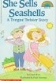
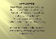
Humorous tongue twisters.

Possible Fiction
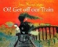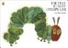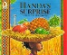
Possible Non-fiction

