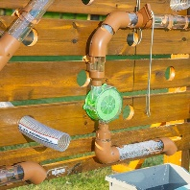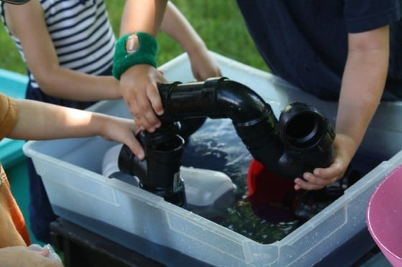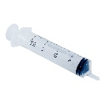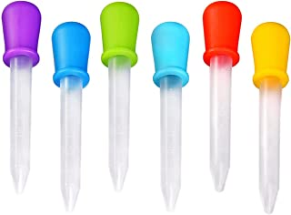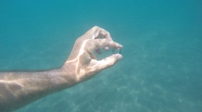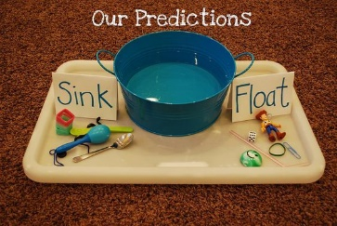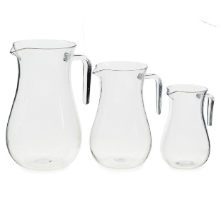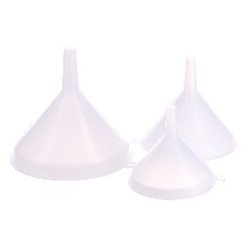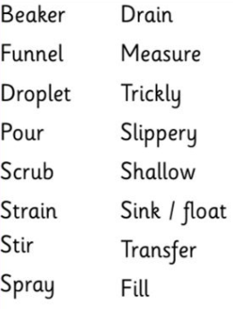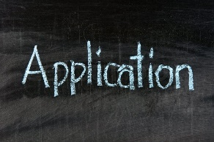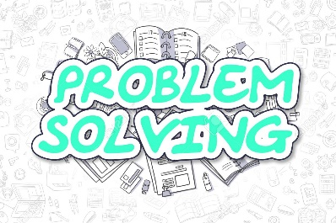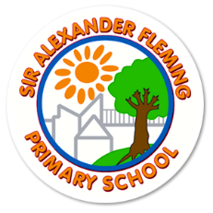

**To explore stemming the flow of water.**

Increased challenge through . . .

* The type of resources being used; valves or combining materials from other areas of the environment.

**Using hands and tools to transport water.**

Increased challenge through . . .

* Having a final destination for the water.
* The type of resources; joining tubes
* The distance to the destination
* Limiting the amount of water lost!

**To explore the manipulation of water.**

Increased challenge through . . .

* Being able to articulate what is happening.
* Resources which involve greater precision when being used; increased fine-motor control such as syringes.

**Exploring the concept of submerging**

Increased challenge through . . .

* The type of resources; regular and irregular objects
* Recognising how submerged objects look; what effect does water have on the look?
* Thinking about ways to submerge objects
* Comparing submerging objects and floating objects; having a theory and testing it out.

**To explore filling and emptying.**

Increased challenge through . . .

* Higher level capacity concepts – making comparisons, half- full
* Problem solving – which container holds the most water?
* Types of resources being used; lower level two handed with lips, higher level funnels and one-handed jugs.

**To touch and explore how water feels and sounds.**

Increased challenge through . . .

* Tier 2 and 3 vocabulary being used

**To solve a problem using a range of resources and application of these concepts.**

(To show good fine-motor control, develop theories about water and use them to solve a dilemma.)