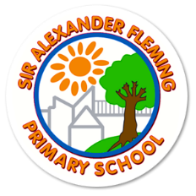
Sir Alexander Fleming Primary School and Nursery
Headteacher: Katy Tomlinson
109 Southgate, Sutton Hill, Telford, TF7 4HG – Tel: 01952 327820
www.siralexanderflemingprimaryschool.org.uk

Monday 8th May 2023

Dear pupils in Year 6,

Before you take part in your tests tomorrow, we just wanted to remind you of the following.

We know that you demonstrate huge amounts of commitment and will do your best in many ways, especially during the tests.

However, we want you to remember that these tests do not assess all of what it is that makes each and everyone of you special and unique. The people who create these tests and score them do not know each of you the way your teachers do, the way I do and certainly not the way your families do.

They do not know that many of you can speak two languages.
They do not know that you can play a musical instrument or that you can dance or paint a picture.
They do not know that your friends count on you to be there for them or that your laughter can brighten their dreariest day.
They do not know that you write poetry or songs.
They do not know that you play or participate in sports or wonder about the future.
They do not know that you sometimes take care of your little brother or sister before or after school.
They do not know that you have travelled to an exciting place or that you know how to tell a great story.
They do not know that you really love spending time with special family members and friends. They do not know that you can be trustworthy, kind, or thoughtful, and that you try, every day, to be your very best!
The scores you get will tell you something, but they will not tell you everything.
So, enjoy it! See it as an opportunity to show us what you know and be very proud of the effort and determination you are demonstrating but remember there are many reasons that you are important to us.
Do your best, try hard and let’s smash it!
See you bright and early for breakfast (7.30am) and make sure you get some sleep tonight.
Mrs T

