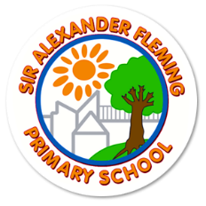

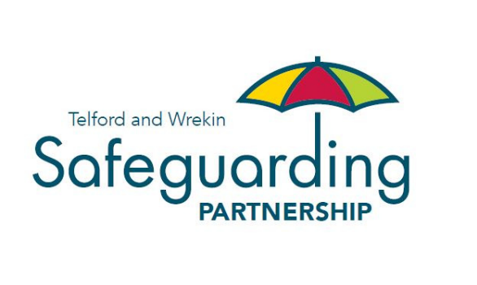

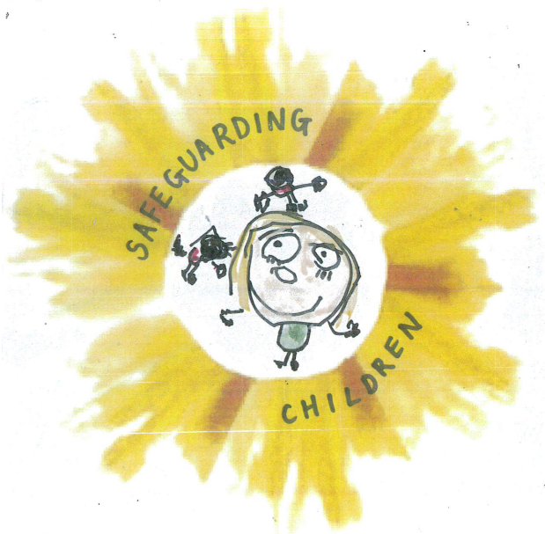

SIR ALEXANDER FLEMING PRIMARY AND NURSERY SCHOOL

Child Protection and Safeguarding Policy

Commitment to review

This policy will be flexible to change and will be reviewed on an ongoing basis to reflect where there are any changes in government legislation or any changes in the duty of statutory agencies in child protection and/or the wider safeguarding agenda. If it is not appropriate to refine the policy during the year, then this will be done as a matter of course on yearly basis by a named person responsible below, who shall be accountable for that action.

Child Protection Policy and Safeguarding Policy 2023-24 - Document Status
Date published by Telford and Wrekin Safeguarding Partnership: | Published in DRAFT 21 August 2023 | Authors: | Telford & Wrekin Council, Education Safeguarding Team
Date of policy creation: | 21.8.23 | Person responsible for creation: | Katy Tomlinson
Date of policy inception: | 1.9.23
Date of policy adoption by Governing Body | 7.9.23
Date of policy review for 2023/24: | September 2024 | Person responsible for review: | Katy Tomlinson

Contents

Our safeguarding team | Page 3
Safeguarding intent, implementation and impact | Page 4
Summary & aims | Page 6
Part one: Safeguarding information | Page 7
Part two: Management of safeguarding | Page 39
Part three: Safer recruitment | Page 53

This policy should be read in conjunction with:
- Mental health & well-being policy (template link provided and information available from STSA)
- Child-on-child abuse policy
- Drugs and substance abuse policy
- Procedure for managing safeguarding concerns, or allegations against staff (including supply staff and volunteers)
- Complaints policy
- Safer recruitment procedures
- Use of alternative provision policy
- Behaviour management policy
- Whistleblowing policy
- Suicide intervention policy (TWSP provided)
- Use of reasonable force policy
- Mobile and smart technology policy

Our policy and procedures has regard to the following:

- Statutory Framework for the Early Years Foundation Stage (2023) Section 3 – The Safeguarding and Welfare Requirements
- Keeping Children Safe in Education 2023
- Working Together to Safeguard Children 2018
- Telford and Wrekin Safeguarding Partnership policies and procedures
- Regional child protection procedures for West Midlands
- What to do if you are worried a child is being abused - Advice for practitioners.
- Information sharing: Advice for practitioners providing safeguarding services to children, young people, parents and carers 2018

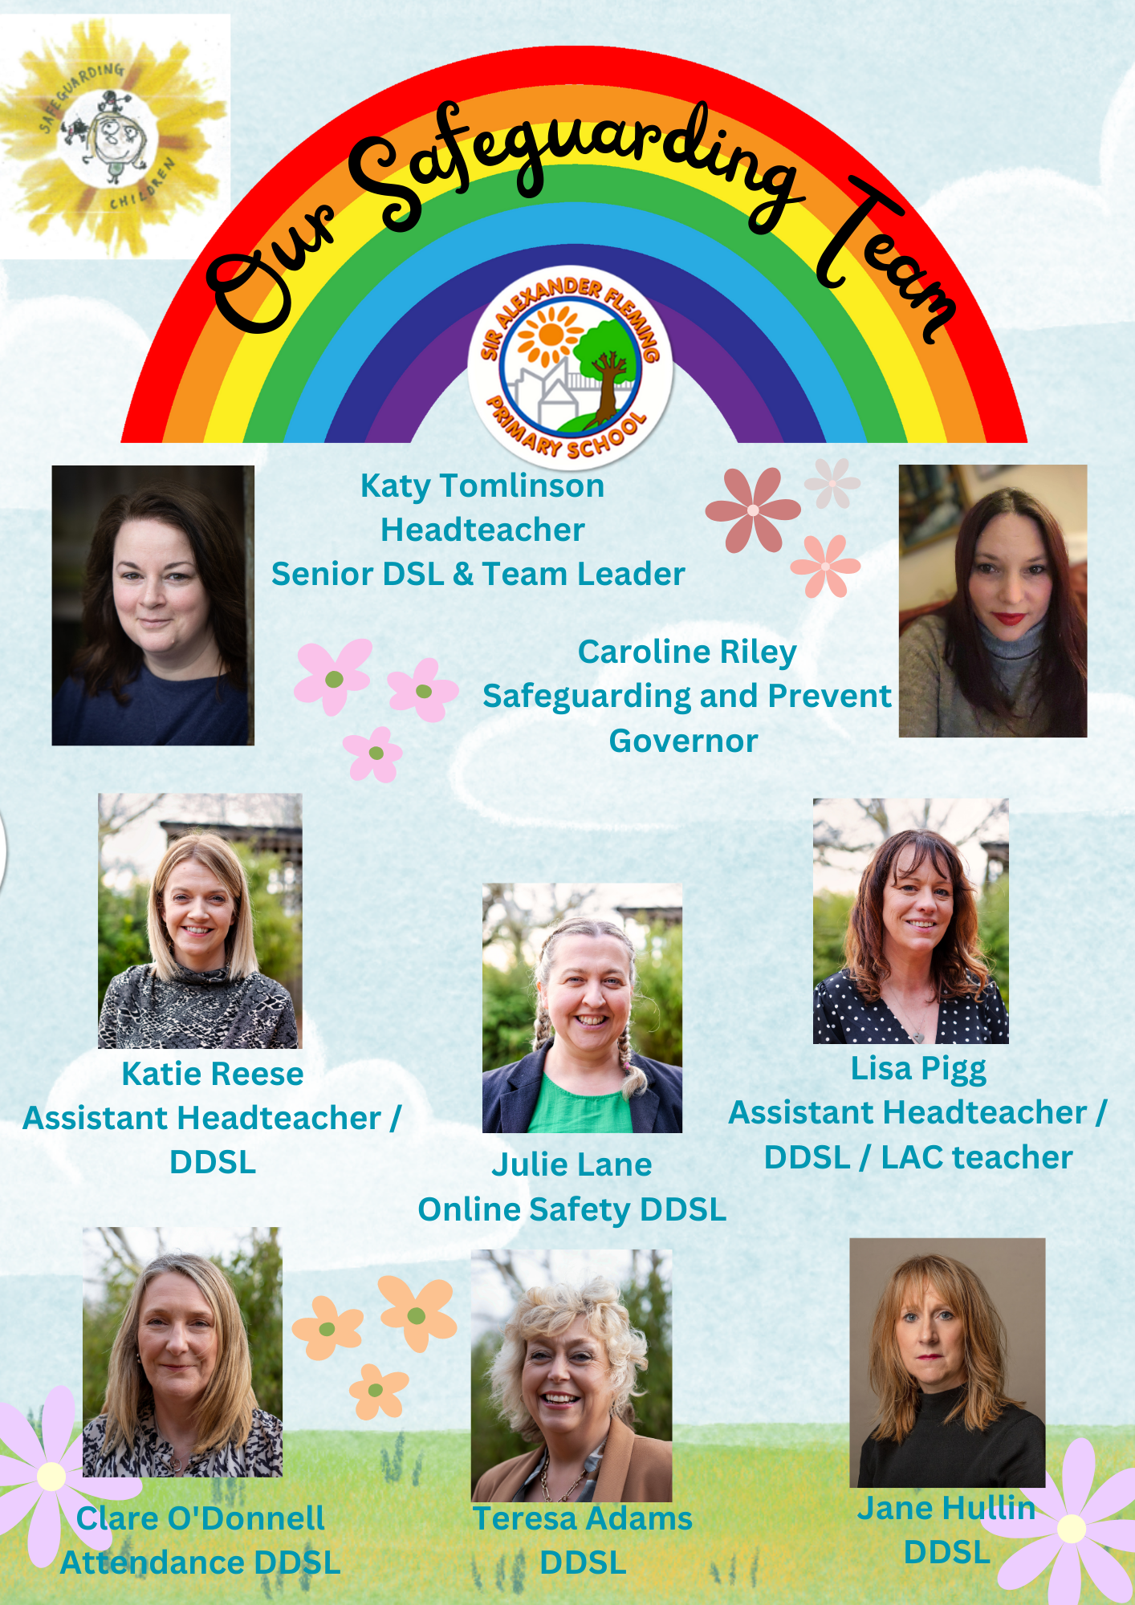

Our Safeguarding Approach

Intent

Sir Alexander Fleming Primary School and Nursery was officially opened in September 2002. It is an average-sized primary school with approximately 399 pupils on roll and a Nursery. It is situated in Sutton Hill, South Telford, where there are high levels of social deprivation in the catchment area as shown in the Indices of Deprivation 2019.

The school is situated in one of the most deprived areas being ranked in the top 10% of most deprived areas nationally for Income, Employment, Education, Training and Skills and Sutton Hill is the second most deprived LSOA in the Borough which is ranked 409th nationally which places us in the top 5% of most deprived areas. In 2015, we were ranked at 575 nationally, so in 4 years there has been an increase in relative deprivation. Sir Alexander Fleming Primary School is in quintile 5, most deprived of all schools in Telford and Wrekin with 65% of families receiving free school meals, which is well above the national average. These figures are constantly changing and increasing.

The safeguarding risks that are pertinent to our area are: domestic abuse, neglect, exploitation, child-on-child abuse, impact of high levels of poverty, children with parents who misuse drugs and alcohol and mental ill-health.

At Sir Alexander Fleming Primary School and Nursery, we adopt a child-centred approach to safeguarding. This approach is fundamental to safeguarding and promoting the welfare of every child and it means keeping the child in focus when making decisions about their lives and working in partnership with them and their families. Safeguarding is a high priority within our school, and we ensure that we have a rigorous and effective safeguarding culture.

Implementation

At Sir Alexander Fleming Primary School and Nursery, safeguarding is of high priority. We have a dedicated team of 8 DSLs who ensure that practice is effective and rigorous. Four of our DDSLs are non-class based and their main role is safeguarding and child protection; one DDSL whose role is focused on online safety and concerns and one DDSL who is also our Attendance Support Officer. All DSLs and DDSLs are part of our Rainbow Room, which is a designated child-friendly room / office where children know that they can go if they need to talk. We have regular inclusion meetings and DDSLs are supervised with all cases; no decision is made alone. All DSLs and DDSLs are up-to-date with training and receive regular updates from TWSB.

We ensure that the training and updates cascade to all colleagues within school and offer early help to families in need. We offer an open, honest and non-judgemental approach with parents and families and offer support and guidance. If needed, we look at completing an Early Help Referral to enable them to receive further support within the family home.

As a team, we pride ourselves on acting quickly and decisively to ensure the safety of our children’ this is paramount.

Our children are aware of our school values and demonstrate these in every aspect of school life. Our safeguarding curriculum contributes and supports the safeguarding and child protection of our school. We ensure our children know how to keep themselves safe inside and outside of school.

We are always aware that ‘it could happen here!’.

Impact

Our children are able to articulate our school values and in the main they demonstrate these in everyday school life. Our children know who they can trust and in a Pupil Voice, July 2022 they were able to say who they could trust and talk to and the role of the safeguarding leads within school.

Our children and families do not see the Rainbow Room as merely an office but a room where they can go and sing, play games, read their books when they have not managed at home, to get breakfast if they are hungry, to find school uniform, shoes and coats or to have their uniform washed.

We pride ourselves on not being just an adult to these children but a support that they can come to when and if they need us – we are their extended family!

Our Governing Body form a Safeguarding and Personal Development committee and ask questions to ensure that we are effective on safeguarding.

Summary & Aims

We have regard for the statutory guidance from the Department for Education (DfE) issued under Section 175 of the Education Act 2002 (as amended), the Education (Independent School Standards) Regulations 2014, the Non-Maintained Special Schools (England) Regulations 2015 and the Apprenticeships, Skills, Children and Learning Act 2002 (as amended). This policy has been developed in line with legal obligations, including, where applicable, the Human Rights Act 1998, the European Convention on Human Rights, the Domestic Abuse Act 2021, the Children and Social Work Act 2017, the Equality Act 2010 and the Public Sector Equality Duty.

We will adhere to the statutory guidance Working Together to Safeguard Children 2018 and Keeping Children Safe in Education 2023 (KCSIE). We will follow the DfE of What to do if you are Worried a Child is Being Abused - Advice for Practitioners. We recognise the NSPCC website also provides us additional information on abuse and neglect and what to look out for.

We provide early years provision and adhere to the Statutory Framework for the Early Years Foundation Stage 2023 (EYFS).

All child protection matters will be dealt with in line with the arrangements of Telford and Wrekin Safeguarding Partnership (TWSP) and West Midlands Child Protection and Safeguarding Procedures or, if relevant, the safeguarding partnership area children reside in, under the care of or with designated responsibility.

This policy replaces the previous policy of September 2023.

We have a duty of care to all pupils and their families, and staff; the safety and protection of all children is of paramount importance to all those involved in education. The aim of this policy is to make all within our setting feel safe, promote their welfare and have clear roles and responsibilities in place for that to happen. We are committed to inter-agency working to keep children safe. All our community believe that our setting should provide a caring, positive, safe and stimulating environment, which promotes the social, physical and moral development of the individual child.

The governing body will ensure that all staff have read at least part one of KCSIE (or annex A if appropriate) and those working with children will also read Annex B of KCSIE. All members of the governing body and the Designated Safeguarding Lead (DSL) and their deputies will read all parts of KCSIE, relevant parts of Working Together to Safeguard Children and Part three: safeguarding and welfare of the EYFS. We will maintain a record of this. We recognise that best practice would be for all staff to be acquainted with all parts of KCSIE. The governing body will ensure that mechanisms are in place to assist staff to understand and discharge their role and responsibilities as set out in Part one (or Annex A if appropriate) of KCSIE.

Our policy and all supplementary policies and procedures are published on our website for all to view.

Part one: Safeguarding information

A child centred and coordinated approach to safeguarding.

All those who are part of our school, including our staff are an important part of the wider safeguarding system for our pupils.

It is everyone’s responsibility to safeguard and promote the welfare of children; this includes everyone who encounters children and their families. Everyone will consider, always, what is in the best interest for the child and ensure their practice is child centred.

No one will manage concerns about a child in insolation. Everyone will identify concerns, share information and take prompt action to help children and families receive the right help at the right time.

For the purpose of this policy, safeguarding and promoting the welfare of children is defined as:
- protecting children from maltreatment;
- preventing impairment of children’s mental and physical health or development;
- ensuring that children grow up in circumstances consistent with the provision of safe and effective care; and
- taking action to enable all children to have the best outcomes.

Children includes everyone under the age of 18.

The role of our staff

Our staff will identify concerns early, provide help for children, promote children’s welfare and prevent concerns from escalating. They will provide a safe environment in which children can learn.

We are committed to identifying children who may benefit from early help. Early help means providing support as soon as a problem emerges at any point in a child’s life.

The DSL and their deputies role is to advise on safeguarding concerns, support others to carry out their safeguarding duties and liaise with other agencies.

All teachers, including the Headteacher in accordance with the Teachers’ Standards 2012 will safeguard children’s well-being and maintain public trust in the teaching profession as part of their professional duties.

Staff training and induction

All staff will receive an induction, so they are aware of our safeguarding systems. This will include the child protection policy, child-on-child abuse policy and procedures, behaviour policy, staff behaviour policy, safeguarding response to children who are absent from education and role of the DSL (including the identity of the DSL and any deputies). We will provide copies of policies and a copy of Part one (or Annex A, if appropriate) or KCSIE to all staff at induction.

Staff will receive appropriate safeguarding and child protection training (including online safety which, amongst other things, includes an understanding of the expectations, applicable roles and

responsibilities in relation to filtering and monitoring) at induction. This training will be updated regularly (as a minimum every three years). All staff will also receive at least annual child protection and safeguarding updates (including online safety), to provide them with relevant skills and knowledge to safeguard children effectively. All staff will receive annual training in child sexual exploitation awareness. We will ensure staff safeguarding training is integrated, aligned and considered as part of whole school/college safeguarding approach and wider staff training and curriculum planning.

All staff will be made aware of the following:
- Telford & Wrekin early help process and their role within it;
- the process for making referrals to children’s social care and for statutory assessments under the Children Act 1989, especially section 17 (children in need) and section 47 (a child suffering, or likely to suffer, significant harm) and the role they might be expected to play in such assessments;
- what to do if a child tells them he/she is being abused, exploited or neglected;
- how to reassure victims they are being taken seriously and that they will be supported and kept safe;
- that children may not feel ready or know how to tell someone that they are being abused, exploited or neglected, and/or they may not recognise their experiences as harmful;
- staff should be professionally curious and speak to the DSL or their deputies if they have concerns about a child, and
- staff should build trusted relationships with children which facilitate communication.

We will encourage staff to consider the TWSP briefing on professional curiosity.

Staff know how to manage the requirement to maintain an appropriate level of confidentiality. This means only involving those who need to be involved, such as the DSL (or a deputy) and children’s social care. Staff will never promise a child that they will not tell anyone about a report of any form of abuse, as this may ultimately not be in the best interests of the child. All staff will reassure victims that they are being taken seriously and that they will be supported and kept safe. A victim will never be given the impression that they are creating a problem by reporting abuse, sexual violence or sexual harassment. Nor will a victim ever be made to feel ashamed for making a report.

Early Help

We believe that any child may benefit from early help, and we ensure that all staff are alert to the potential need for early help for a child who:
- is disabled or has certain health conditions and has specific additional needs;
- has special educational needs (whether or not they have a statutory Education, Health and Care Plan);
- has a mental health need
- is a young carer;
- is showing signs of being drawn in to anti-social or criminal behaviour, including gang involvement and association with organised crime groups or county lines;
- is frequently missing/goes missing from care or from home;
- is at risk of modern slavery, trafficking or exploitation;
- is at risk of being radicalised or exploited;
- has a family member in prison, or is affected by parental offending;
- is in a family circumstance presenting challenges for the child, such as drug and alcohol misuse, adult mental health issues and domestic abuse;
- is misusing drugs or alcohol themselves;
- has returned home to their family from care;
- is at risk of so-called ‘honour’-based abuse, such as Female Genital Mutilation or Forced Marriage;
- is a privately fostered child; and
- is persistently absent from education, including persistent absences for part of the day.

Abuse and Neglect

All staff are trained on the indicators of abuse and neglect and understand children can be at risk of harm inside and outside of our school, inside and outside of the home, and online. Staff will exercise professional curiosity and know what to look out for because this is vital for the early identification of abuse and neglect to identify cases of children who may be in need of help or protection.

We believe that abuse, neglect and safeguarding issues are rarely stand-alone events. All staff, but especially the DSL and deputies will consider whether children are at risk of abuse or exploitation in situations outside their families. Extra-familiar harms take a variety of different forms and children can be vulnerable to multiple harms.

All staff are aware that technology is a significant component in many safeguarding and well-being issues. We understand children are at risk of abuse online as well as face-to-face. In many cases, abuse will take place concurrently via both online and offline. Children can also abuse other children online, this can take the form of abusive, harassing, and misogynistic/misandrist messages, the non-consensual sharing of indecent images, especially around chat groups, and the sharing of abusive images and pornography, to those who do not want to receive such content.

Indicators of abuse and neglect

Abuse: a form of maltreatment of a child. Somebody may abuse or neglect a child by inflicting harm or by failing to act to prevent harm. Harm can include ill treatment that is not physical as well as the impact of witnessing ill treatment of others. This can be particularly relevant, for example, in relation to the impact on children of all forms of domestic abuse. Children may be abused in a family or in an institutional or community setting by those known to them or, more rarely, by others. Abuse can take place wholly online, or technology may be used to facilitate offline abuse. Children may be abused by an adult or adults or by another child or children.

Physical abuse: a form of abuse which may involve hitting, shaking, throwing, poisoning, burning or scalding, drowning, suffocating or otherwise causing physical harm to a child. Physical harm may also be caused when a parent or carer fabricates the symptoms of, or deliberately induces, illness in a child.
The fabrication or induction of illness (FII) in children is a relatively rare form of child abuse. Where concerns exist about FII, it requires professionals to work together, evaluating all the available evidence, in order to reach an understanding of the reasons for the child’s signs and symptoms of illness. At all times professionals need to keep an open mind to ensure that they have not missed a vital piece of information’. We adopt the guidance Safeguarding children in whom illness is fabricated or induced and TWSP FII Best Practice Guidance.

Emotional abuse: the persistent emotional maltreatment of a child such as to cause severe and adverse effects on the child’s emotional development. It may involve conveying to a child that they are worthless or unloved, inadequate, or valued only insofar as they meet the needs of another person. It may include not giving the child opportunities to express their views, deliberately silencing them or ‘making fun’ of what they say or how they communicate. It may feature age or developmentally inappropriate expectations being imposed on children. These may include interactions that are beyond a child’s developmental capability as well as overprotection and limitation of exploration and learning or preventing the child from participating in normal social interaction. It may involve seeing or hearing the ill-treatment of another. It may involve serious bullying (including cyberbullying), causing children frequently to feel frightened or in danger, or the exploitation or corruption of children. Some level of emotional abuse is involved in all types of maltreatment of a child, although it may occur alone.

Sexual abuse: involves forcing or enticing a child or young person to take part in sexual activities, not necessarily involving a high level of violence, whether or not the child is aware of what is happening. The activities may involve physical contact, including assault by penetration (for example rape or oral sex) or non-penetrative acts such as masturbation, kissing, rubbing and touching outside of clothing. They may also include non-contact activities, such as involving children in looking at, or in the production of, sexual images, watching sexual activities, encouraging children to behave in sexually inappropriate ways, or grooming a child in preparation for abuse. Sexual abuse can take place online, and technology can be used to facilitate offline abuse. Sexual abuse is not solely perpetrated by adult males. Women can also commit acts of sexual abuse, as can other children. The sexual abuse of children by other children is a specific safeguarding issue in education and all staff are aware of the settings policy and procedures of dealing with this.

Neglect: the persistent failure to meet a child’s basic physical and/or psychological needs, likely to result in the serious impairment of the child’s health or development. Neglect may occur during pregnancy, for example, as a result of maternal substance abuse. Once a child is born, neglect may involve a parent or carer failing to: provide adequate food, clothing and shelter (including exclusion from home or abandonment); protect a child from physical and emotional harm or danger; ensure adequate supervision (including the use of inadequate caregivers); or ensure access to appropriate medical care or treatment. It may also include neglect of, or unresponsiveness to, a child’s basic emotional needs.

Safeguarding issues

All staff are trained on safeguarding issues that can put children at risk of harm.

Child-on-child abuse

All staff are aware that children can abuse other children. This can happen inside or outside of our setting and online.

All staff will be trained in our policy and procedures with regard to child-on-child abuse and the important role they have to play in preventing it and responding to where they believe a child may be at risk from it.

All staff understand that even if there are no reports in our setting it does not mean it is not happening, it maybe it is just not being reported. If staff have any concerns regarding child-on-child abuse, even if there are no reports in our setting, they should still speak to the DSL (or deputy).

All staff are expected to challenge inappropriate behaviours between peers, many of which are listed below, that are actually abusive in nature. Downplaying certain behaviours, for example dismissing sexual harassment as “just banter”, “just having a laugh”, “part of growing up” or “boys being boys” can lead to a culture of unacceptable behaviours, an unsafe environment for children and in worst case scenarios a culture that normalises abuse leading to children accepting it as normal and not coming forward to report it.

Child-on-child abuse is most likely to include, but may not be limited to:
- bullying (including cyberbullying, prejudice-based and discriminatory bullying);
- abuse in intimate personal relationships between children (sometimes known as ‘teenage relationship abuse’);
- physical abuse such as hitting, kicking, shaking, biting, hair pulling, or otherwise causing physical harm (this may include an element of online which facilitates, threatens and/or encourages physical abuse);
- sexual violence, such as rape, assault by penetration and sexual assault (this may include an online element which facilitates, threatens and/or encourages sexual violence);
- sexual harassment, such as sexual comments, remarks, jokes and online sexual harassment, which may be stand-alone or part of a broader pattern of abuse;
- causing someone to engage in sexual activity without consent, such as forcing someone to strip, touch themselves sexually, or to engage in sexual activity with a third party;
- consensual and non-consensual sharing of nudes and semi nudes images and or videos (also known as sexting or youth produced sexual imagery);
- upskirting, which typically involves taking a picture under a person’s clothing without their permission, with the intention of viewing their genitals or buttocks to obtain sexual gratification, or cause the victim humiliation, distress or alarm, and
- initiation/hazing type violence and rituals (this could include activities involving harassment, abuse or humiliation used as a way of initiating a person into a group and may also include an online element).

We will actively seek to raise awareness of and prevent all forms of child-on-child abuse by:
- educating all governors, our senior leadership team, staff, students, and parents about this issue;
- educating children about the nature and prevalence of child-on-child abuse, positive, responsible and safe use of social media, and the unequivocal facts about consent, via the curriculum;
- engaging parents on these issues;
- supporting the on-going welfare of the student body by drawing on multiple resources that prioritise student mental health, and by providing in-school/college counselling and therapy to address underlying mental health needs;
- working with governors, senior leadership team, and all staff, students and parents to address equality issues, to promote positive values, and to encourage a culture of tolerance and respect amongst all members of the school/college community;
- creating conditions in which our students can aspire to, and realise, safe and healthy relationships fostering a whole-school/college culture;
- responding to cases of child-on-child abuse promptly and appropriately; and
- ensuring that all child-on-child abuse issues are fed back to the DSL and deputies so that they can spot and address any concerning trends and identify students who may be in need of additional support.

We will actively engage with TWSP in relation to child-on-child abuse, and work closely with, for example, children’s social care, the police and other education settings. The relationships our setting has built with these partners is essential to ensuring that we are able to prevent, identify early, and appropriately handle cases of child-on-child abuse. The DSL (or deputy) will regularly review behaviour incident logs which can help to identify any changes in behaviour and/or concerning patterns or trends at an early stage.

We recognise that any child can be vulnerable to child-on-child abuse due to the strength of peer influence, especially during adolescence, and staff should be alert to signs of such abuse amongst all children. Individual and situational factors can increase a child’s vulnerability to abuse by their peers. We know that research suggests:
- child-on-child abuse may affect boys differently from girls (i.e. that it is more likely that girls will be victims and boys perpetrators). However, all child-on-child abuse is unacceptable and will be taken seriously;
- children with Special Educational Needs and/or Disabilities (SEND) are three times more likely to be abused than their peers without SEND, and
- some children may be more likely to experience child-on-child abuse than others as a result of certain characteristics such as sexual orientation, ethnicity, race or religious beliefs.
Child-on-child sexual violence and sexual harassment
All those who are part of our community believe that sexual violence and sexual harassment is not acceptable and will not be tolerated.
We understand that sexual violence and sexual harassment can occur between two or more children of any age and sex. It can occur online. It can also occur through a group of children sexually assaulting or sexually harassing a single child or group of children. Sexual violence and sexual harassment exist on a continuum and may overlap.
We recognise that children who are victims of sexual violence and sexual harassment will likely find the experience stressful and distressing. This will, in all likelihood, adversely affect their educational attainment and will be exacerbated if the alleged perpetrator(s) attends our setting.
We will work to ensure our whole-school community are aware of the importance of:
- challenging inappropriate behaviours;
- making clear that sexual violence and sexual harassment is not acceptable, will never be tolerated and is not an inevitable part of growing up;
- not tolerating or dismissing sexual violence or sexual harassment; and,
- challenging physical behaviours (potentially criminal in nature), such as grabbing bottoms, breasts and genitalia, pulling down trousers, flicking bras and lifting up skirts. Dismissing or tolerating such behaviours risks normalising them.
For the purpose of this policy, we use the term ‘victim’, ‘alleged perpetrator(s)’ or where appropriate ‘perpetrator(s)’. Ultimately, the use of appropriate terminology will be determined, as appropriate, on a case-by-case basis.
Along with providing support to children who are victims of sexual violence or sexual harassment, we will provide the alleged perpetrator(s) with an education, safeguarding support as appropriate and implement any disciplinary sanctions. We recognise that a child abusing another child may be a sign they have been abused themselves or a sign of wider issues that require addressing within the culture of our setting. Taking disciplinary action and providing appropriate support, can, and should, occur at the same time if necessary.
We understand that reports of sexual violence and sexual harassment are extremely complex to manage. We know it is essential that victims are protected, offered appropriate support and every effort is made to ensure their education is not disrupted. We also know it is also important that other children, adult students and our staff are supported and protected as appropriate.
We will try to be aware of, and respond appropriately to all reports and concerns, including those outside of our setting, and or online.
Whilst the focus of this policy is on protecting and supporting children, we will of course protect any adult students and engage with adult social care, support services and the police as required.
Sexual violence
Our staff are aware of sexual violence and the fact children can, and sometimes do, abuse their peers in this way both inside and outside of our setting. We refer to sexual violence as sexual offences under the Sexual Offences Act 2003 as described below:

Rape: A person (A) commits an offence of rape if: he intentionally penetrates the vagina, anus or mouth of another person (B) with his penis, B does not consent to the penetration and A does not reasonably believe that B consents.

Assault by Penetration: A person (A) commits an offence if: s/he intentionally penetrates the vagina or anus of another person (B) with a part of her/his body or anything else, the penetration is sexual, B does not consent to the penetration and A does not reasonably believe that B consents.

Sexual Assault: A person (A) commits an offence of sexual assault if: s/he intentionally touches another person (B), the touching is sexual, B does not consent to the touching and A does not reasonably believe that B consents.

Causing someone to engage in sexual activity without consent: A person (A) commits an offence if: s/he intentionally causes another person (B) to engage in an activity, the activity is sexual, B does not consent to engaging in the activity, and A does not reasonably believe that B consents. (This could include forcing someone to strip, touch themselves sexually, or to engage in sexual activity with a third party.)
We believe that consent is about having the freedom and capacity to choose. Consent to sexual activity may be given to one sort of sexual activity but not another, e.g.to vaginal but not anal sex or penetration with conditions, such as wearing a condom. Consent can be withdrawn at any time during sexual activity and each time activity occurs. Someone consents to vaginal, anal or oral penetration only if s/he agrees by choice to that penetration and has the freedom and capacity to make that choice.
Sexual consent
- a child under the age of 13 can never consent to any sexual activity;
- the age of consent is 16;
- sexual intercourse without consent is rape.
Sexual harassment
When referring to sexual harassment we mean ‘unwanted conduct of a sexual nature’ that can occur online and offline, both inside and outside of our setting. When we reference sexual harassment, we do so in the context of child-on-child sexual harassment. Sexual harassment is likely to: violate a child’s dignity, and/or make them feel intimidated, degraded or humiliated and/or create a hostile, offensive or sexualised environment.
Whilst not intended to be an exhaustive list, sexual harassment can include:
- sexual comments, such as: telling sexual stories, making lewd comments, making sexual remarks about clothes and appearance and calling someone sexualised names;
- sexual “jokes” or taunting;
- physical behaviour, such as: deliberately brushing against someone, interfering with someone’s clothes;
- displaying pictures, photos or drawings of a sexual nature,
- upskirting, and
- on-line sexual harassment.

We will follow the guidance set out in UKCIS Sharing nudes and semi-nudes: advice for education settings working with children and young people.
Upskirting
The Voyeurism (Offences) Act, which is commonly known as the Upskirting Act, came into force on 12 April 2019. We recognise ‘Upskirting’ is where someone takes a picture under a person’s clothing (not necessarily a skirt) without their permission and or knowledge, with the intention of viewing their genitals or buttocks (with or without underwear) to obtain sexual gratification, or cause the victim humiliation, distress or alarm. It is a criminal offence. Anyone of any sex, can be a victim.
Harmful sexual behaviour

Children’s sexual behaviour exists on a wide continuum, from normal and developmentally expected to inappropriate, problematic, abusive and violent. Problematic, abusive and violent sexual behaviour is developmentally inappropriate and may cause developmental damage. We use the term “harmful sexual behaviour” (HSB). HSB can occur online and/or face to face and can also occur simultaneously between the two. We will consider HSB in a child protection context.

We will follow the specialist support and advice on HSB available from the specialist sexual violence sector. Our DSL will undertake training in HSB and incorporate this into our approach to managing sexual violence and sexual harassment. This training will include the Brook Traffic Light Tool.

Addressing inappropriate behaviour can be an important intervention that helps prevent problematic, abusive and/or violent behaviour in the future. Children displaying HSB have often experienced their own abuse and trauma. We understand it is important that they are offered appropriate support.

Hate crime
A hate crime, or hate incident, is an act motivated by, or perceived to be motivated by, prejudice against who the victim is, or what they appear to be, in relation to their race, religion, sexual orientation, gender identity, or disability. These are known as protected characteristics. It does not matter if the person targeted has the characteristic that the prejudice is directed toward. Only that they are perceived to have that characteristic or belong to that community.
A hate crime does not have to amount to a criminal offence to be considered a hate crime. Non-criminal hate crime incidents can still be reported to the police to be recorded. Evidence of a hate crime is not required – it is enough that one person, such as the victim or a witness, perceives the incident to be a hate crime.
The Police and CPS define hate crime as: "Any criminal offence which is perceived by the victim or any other person, to be motivated by hostility or prejudice, based on a person's disability or perceived disability; race or perceived race; or religion or perceived religion; or sexual orientation or perceived sexual orientation or transgender identity or perceived transgender identity."
Hate Crime covers a range of behaviours, including discrimination, exclusion, verbal abuse, physical assault, bullying including cyber-bullying and inciting hatred.

Hate Crime can manifest in the school/college environment. Our response may involve action and support from various agencies, including statutory agencies or educating the perpetrator about their language and impact. Following the incident, we will schedule check-ins with the victim to check on their well-being and ensure the issue has not continued.

All hate crime incidents reported in our setting must be recorded. The DSL will regularly review this data to identify emerging themes and inform preventative and responsive work around hate crime.

Racist incidents

A racist incident is "any incident which is perceived to be racist by the victim or any other person", according to the Stephen Lawrence Inquiry report.
We will comply with the Equality Act 2010, and not unlawfully discriminate against pupils or prospective pupils on the grounds of race (or other protected characteristics).
In line with the public sector equality duty (PSED) we will:
- Eliminate discrimination and other conduct that is prohibited by the Act.
- Advance equality of opportunity between people who share a protected characteristic and people who do not share it.
- Foster good relations across all characteristics – between people who share a protected characteristic and people who do not share it.
- Comply with both specific education law on exclusions, and general law on discrimination, when suspending or permanently excluding pupils.

All racist incidents reported in our setting must be recorded.

Telford and Wrekin Council requires all schools and colleges to report racist incidents on an Individual and Annual Return, Racist Incident Reporting and Recording System (IRIS). The reporting of incidents should take place within 7 days of the incident being reported or as soon as reasonably practicable. The DSL will regularly review this data to identify emerging themes and inform preventative and responsive work around racist incidents.

We will manage racist incidents in line with our anti-bullying policy and behaviour policy.

Our approach to preventing all forms of child-on-child abuse
We will undertake pre-planning, training for staff and implement an effective child-on-child abuse policy to help us develop the foundation for a calm, considered and appropriate response to any reports. We will review these regularly. The DSL (or a deputy) will engage with the local response to child-on-child abuse.
We understand the best responses to child-on-child abuse are based on a whole setting approach to safeguarding and child protection and we will involve our whole community in this.

Systems are in place, well promoted throughout our setting, and understandable and accessible for our pupils to confidently report abuse, sexual violence and sexual harassment, knowing their concerns will be treated seriously, and that they can safely express their views and give feedback.

As part of our commitment to our pupils, we have identified the following deputy DSL’s, who are not part of our setting’s senior leadership team, as staff in our setting, pupils can report child-on-child abuse to, if they choose not to report directly to a member of the senior leadership team.
Teresa Adams
Jane Hullin
Clare O’Donnell

All staff in our setting will undertake training in how to respond to child-on-child abuse, including reports of sexual violence or sexual harassment. Our DSL will undertake training to manage a report.

We accept the most effective preventative education programme will be through a whole setting approach that prepares pupils for life in modern Britain. Our setting has a clear set of values and standards, and these will be upheld and demonstrated throughout all aspects of school/college life. This is underpinned by our behaviour policy and pastoral support system, and by our planned programme of evidence-based content delivered through the whole curriculum. Our programme is developed to be age and stage of development appropriate. The DSL will support teachers in their delivery of this part of our curriculum. We recognise good practice allows children an open forum to talk through things. Such discussions can lead to increased safeguarding reports. Children will be made aware of the processes to raise their concerns or make a report and how any report will be handled. This will include processes when they have a concern about a friend or peer. All staff are aware of how to support children and how to manage a safeguarding report from a child.

The DSL will consider if external support or intervention is necessary as part of our approach to sexual violence and sexual harassment. We recognise specialist organisations can offer a different perspective and expert knowledge.

Our response to child-on-child abuse, including reports of sexual violence or sexual harassment and hate crime

It is our aim to always recognise, acknowledge and understand the scale of harassment and abuse. We aim to never downplay some behaviours related to abuse that can lead to a culture of unacceptable behaviour, an unsafe environment and in worst case scenarios a culture that normalises abuse leading to children accepting it as normal and not coming forward to report it.
Where necessary we will work with other professionals, agencies and partners in our response. This may include the TWSP partners, the relevant local authority children’s social care departments, the police and other services.
We recognise that children may not find it easy to tell staff about their abuse verbally. Children can show signs or act in ways that they hope adults will notice and react. In some cases, the victim may not make a direct report.

The immediate response to a report
If a member of staff thinks for whatever reason that a child may be at risk of or experiencing abuse by another child/ren, or that a child may be at risk of abusing or may be abusing another child/ren, they should discuss their concern with the DSL (or deputy) without delay.
We will reassure all victims that they are being taken seriously, regardless of how long it has taken them to come forward and that they will be supported and kept safe. Abuse that occurs online or outside of our setting will not be downplayed and will be treated equally seriously. We will never give a victim the impression that they are creating a problem by reporting child-on-child abuse, including sexual violence or sexual harassment. Nor will we make a victim feel ashamed for making a report. We will explain that the law is in place to protect children and young people rather than criminalise them, and this will be explained in such a way that avoids alarming or distressing them.
Risk assessment and safety planning & support
We take the view that child-on-child abuse does happen even if it is not reported. Therefore, on the advice of the TWSP we have implemented a risk assessment to help to minimise the risk of child-on-child abuse.
As per the advice of TWSP we refer to safety planning and support which is used for individual children in response to an alleged or actual incident child-on-child abuse, including sexual violence and where appropriate, incidents of sexual harassment.
When there has been a report of sexual violence, the DSL (or a deputy) will implement an immediate safety and support plan to identify risk and need. Where there has been a report of sexual harassment, the need for a safety and support plan will be considered on a case-by-case basis, but as good practice should be completed.
The risk and needs assessment should consider:
- the victim, especially their protection and support;
- whether there may have been other victims;
- the alleged perpetrator(s);
- all the other children, (and, if appropriate, adult students and staff) at the school or college, especially any actions that are appropriate to protect them from the alleged perpetrator(s), or from future harms, and
- the time and location of the incident, and any action required to make the location safer.

If any of the children involved has SEND, the DSL will liaise with the SENDCO to assist in the management of the report. If the report involves an online safety element, the DSL will liaise with the online safety lead if this is not the DSL.

Safety and support plans must be recorded (written or electronic) and will be kept under review. At all times, we will be actively considering the risks posed to all of our pupils and students and put adequate measures in place to protect them and keep them safe.

The DSL (or a deputy) will engage with children’s social care and specialist services as required. Where there has been a report of sexual violence, it is likely that professional safety and support plans by social workers and or sexual violence specialists will be required. Our safety and support plan is not intended to replace the detailed assessments of expert professionals. Any such professional assessments will be used to inform our approach to supporting and protecting our pupils and updating our own risk assessment.

Action following a report of child-on-child abuse, including sexual violence and/or sexual harassment

Our DSL (and deputies) have a complete safeguarding picture and they are the most appropriate people to advise on our initial response. Important considerations will include:
- the wishes of the victim in terms of how they want to proceed. This is especially important in the context of sexual violence and sexual harassment. Victims should be given as much control as is reasonably possible over decisions regarding how any investigation will be progressed and any support that they will be offered. This will however need to be balanced with our duty and responsibilities to protect other children;
- the nature of the alleged incident(s), including whether a crime may have been committed and/or whether HSB has been displayed;
- the ages of the children involved;
- the developmental stages of the children involved;
- any power imbalance between the children. For example, is the alleged perpetrator(s) significantly older, more mature or more confident? Does the victim have a disability or learning difficulty?;
- if the alleged incident is a one-off or a sustained pattern of abuse (sexual abuse can be accompanied by other forms of abuse and a sustained pattern may not just be of a sexual nature);
- that sexual violence and sexual harassment can take place within intimate personal relationships between peers;
- are there ongoing risks to the victim, other children, adult students or school or college staff; and,
- other related issues and wider context, including any links to child sexual exploitation and child criminal exploitation.

As always when concerned about the welfare of a child, all staff will act in the best interests of the child. In all cases, we will follow general safeguarding principles. Immediate consideration will be given as to how best to support and protect the victim and the alleged perpetrator(s) (and any other children involved/impacted).

The starting point regarding any report will always be that there is a zero-tolerance approach to sexual violence and sexual harassment, and it is never acceptable and it will not be tolerated.

As a matter of effective safeguarding practice, we will do all we reasonably can to protect the anonymity of any children involved in any report of sexual violence or sexual harassment, especially where a case is progressing through the criminal justice system.

Options to manage the report

When to inform the alleged perpetrator(s) will be a decision that will be carefully considered. Where a report is going to be made to children’s social care and/or the police, then, as a general rule, we will speak to the relevant agency and discuss next steps and how the alleged perpetrator(s) will be informed of the allegations. However, as per general safeguarding principles, this does not and will not stop us taking immediate action to safeguard our children, where required.

We will regularly review our decisions and actions, consider our relevant policies and any lessons learnt. We will look out for potential patterns of concerning, problematic or inappropriate behaviour. Where a pattern is identified, we will decide on a course of action. Consideration will be given to whether there are wider cultural issues within our setting that enabled the inappropriate behaviour to occur and where appropriate extra teaching time and/or staff training could be delivered to minimise the risk of it happening again.

The DSL (or deputy) will use their professional judgement to: (a) assess the nature and seriousness of the alleged behaviour, and (b) determine whether it is appropriate for the alleged behaviour to be dealt with internally and, if so, whether any external specialist support is required. The DSL and their deputies will consult the relevant local partnership threshold guidance to support their decision making and will engage in discussions with the statutory safeguarding partners to agree the levels for the different types of assessment and services to be commissioned and delivered, part of the local arrangements.

In borderline cases the DSL (or deputy) may consult with Family Connect, and/or other relevant agencies on a no-names basis (where possible) to determine the most appropriate response.

Where the DSL (or deputy) considers or suspects that the alleged behaviour in question might be abusive or violent on a spectrum or where the needs and circumstances of the individual child/children in question might otherwise require it, the DSL (or deputy) will contact Family Connect or the local social care team for the child and/or the police immediately and, in any event, within 24 hours of the DSL (or deputy) becoming aware of the alleged behaviour. The DSL (or deputy) will discuss the concern(s) or allegation(s) with the agency and agree on a course of action, which may include:
  - manage internally;
  - early help;
  - referral to children’s social care; and
  - reporting to the police.

All concerns, discussions, decisions, and reasons for decisions will be recorded (written or electronic).

If bail conditions are in place, we will consider what additional measures may be necessary to manage any assessed risk of harm that may arise within our setting.

There may be delays in any case that is being progressed through the criminal justice system. We will not wait for the outcome (or even the start) of a police investigation before protecting the victim, alleged perpetrator(s) and other children and adult students in the school or college. The DSL (or a deputy) will work closely with the police (and other agencies as required), to ensure any actions we take do not jeopardise the police investigation.

If a child is convicted or receives a caution for a sexual offence, we will update our risk assessment. We understand it is important that we ensure both the victim and alleged perpetrator(s) remain protected. Where cases are classified as “no further action” (NFA’d) by the police or Crown Prosecution Service, or where there is a not guilty verdict, we will continue to offer support to the victim and the alleged perpetrator(s).

If a report is determined to be unsubstantiated, unfounded, false or malicious, the DSL will consider whether the child and/or the person who has made the allegation is in need of help or may have been abused by someone else and this is a cry for help. In such circumstances, a referral to Family Connect or the relevant children’s social care team may be appropriate. If a report is shown to be deliberately invented or malicious, we will consider whether any disciplinary action is appropriate against the individual who made it as per our own behaviour policy.

Ongoing response to child-on-child abuse, including sexual violence or sexual harassment and hate crime

We will consider the principles based on effective safeguarding practice and to help shape any decisions regarding safeguarding and supporting the victim and the alleged perpetrator(s). We will consider what support is the most appropriate to support all children involved.

Victims may not talk about the whole picture immediately. It is essential that dialogue is kept open and encouraged. We will offer victims a designated trusted adult in our setting to talk about their needs.

A victim of sexual violence is likely to be traumatised and, in some cases, may struggle in a normal classroom environment. We will avoid any action that would have the effect of isolating the victim, in particular from supportive peer groups, there may be times when the victim finds it difficult to maintain a full-time timetable and may express a wish to withdraw from lessons and activities. This will be because the victim wants to, not because it makes it easier to manage the situation. If required, we will provide a physical space for victims to withdraw.

While we will give all the necessary support to victims to remain in our setting, if the trauma results in the victim being unable to do this, alternative provision or a move to another setting will be considered to enable them to continue to receive suitable education. This will only be at the request of the victim (and following discussion with their parents or carers).

Please refer to our policy and procedures with regard to child-on-child abuse.

We will always check in with all children involved or alleged to have been involved in child-on-child abuse that are in our school/college. This is to ensure our procedures have been followed and to understand their perception of the effectiveness of our procedures.

Child Sexual Exploitation (CSE) and Child Criminal Exploitation (CCE)

We recognise both CSE and CCE are forms of abuse. They both occur where an individual or group takes advantage of an imbalance in power to coerce, manipulate or deceive a child into sexual or criminal activity, in exchange for something the victim needs or wants, and/or for the financial advantage or increased threat of violence. CSE and CCE can affect children, both male and female and can include children who have been moved for the purpose of exploitation.

We know that different forms of harm often overlap, and that perpetrators may subject children and young people to multiple forms of abuse, such as criminal exploitation and sexual exploitation.

In some cases, the exploitation or abuse will be in exchange for something the victim needs or wants, and/or will be to the financial benefit or other advantage, such as increased status, of the perpetrator or facilitator.

Children can be exploited by adult males or females, as individuals or in groups. They may also be exploited by other children, who themselves may be experiencing exploitation – where this is the case, it is important that the child perpetrator is also recognised as a victim.

Whilst the age of the child may be a contributing factor for an imbalance of power, there are a range of other factors that could make a child more vulnerable to exploitation, including, sexual identity, cognitive ability, learning difficulties, communication ability, physical strength, status, and access to economic or other resources.

Some of the following can be indicators of both child criminal and sexual exploitation where children:
- appear with unexplained gifts, money or new possessions;
- associate with other children involved in exploitation;
- suffer from changes in emotional well-being;
- misuse drugs and alcohol;
- go missing for periods of time or regularly come home late; and
- regularly miss school or education or do not take part in education.

We will provide additional support to children who have been exploited to help maintain them in education.

Staff understand that the experience of girls who are criminally exploited can be very different to that of boys. The indicators may not be the same, they are aware that girls are at risk of criminal exploitation too. It is also important to note that both boys and girls being criminally exploited may be at higher risk of sexual exploitation.

If we feel that children may be being abused through exploitation, we will consult in the normal way with the relevant local authority social care team to seek advice through consultation. In Telford & Wrekin we will consider whether the incident follows a CE care and support Pathway. The concerns will be followed through sensitively and appropriately with fellow professionals and the CE referral form will be completed. In relation to the CATE Risk Panels, where concerns are expressed around a child attending our setting, we will ensure attendance whenever possible as part of the established multi-agency process. Alongside this, we have taken the same steps and made all staff aware of the TWSP, A guide for professionals CATE leaflet. Due to the high number of reports in our borough, we will be particularly alert to CSE and CCE.

We will make parents and carers, children and young people aware of the relevant TWSP CATE leaflets. We will provide them with information on CEOP, the Child Exploitation and Online Protection command. Children and adults can use CEOP to report if they are concerned that a child is being sexually abused or groomed online.

We will take a proactive approach to minimising the risk of all types of exploitation. We will engage with lived experience work from the St. Giles Trust and other partners to benefit the whole-school/college community, including staff, children and parents. All staff will receive training and updates on child exploitation.

As a primary school our curriculum includes a programme of appropriate exploitation awareness, especially CSE raising awareness.

The Headteacher/Principal and DSL will exchange any relevant information with local partners in relation to exploitation as required to enable all professionals to react, monitor and protect children. As a primary school the DSL or deputy DSL attend a termly exploitation briefing with the police and Telford and Wrekin Council.

The DSL will work with one of their deputies to focus on child exploitation, especially CSE and provide any required information to partners. The CSE lead will be known to parents and children. We will ensure the CSE lead is accessible to children.

We record all concerns about a child’s welfare, including those relating to exploitation, especially CSE. We detail what the concerns are, what action was taken and what follow up is needed. The DSL will review all recorded safeguarding concerns, especially those pertaining CCE and CSE, as a minimum every six months to ensure all concerns are routinely recorded and shared with partner agencies.

We will carry out an annual review to consider the adequacy of our site security provision, including monitoring and recording any unauthorised access to our site, to ensure that our pupils are protected from potential perpetrators of child exploitation, especially CSE while at school/college. Any concerns will be shared as required with the police and/or Family Connect. Our site security audit findings will be used to update and review our site security risk assessment.

We act in the spirit of the recommendations pertaining to schools and colleges from the published report of the Independent Inquiry Telford Child Sexual Exploitation, published July 2022.

We will use the Telford & Wrekin Partnership Threshold Guidance, Child Exploitation Risk Threshold Indicator to identify the care and support needs of children involved in exploitation. Where vulnerable care and support needs are identified as ‘vulnerable,’ we will consult with the CATE Team, Telford and Wrekin Council. Where care and support needs are identified as ‘complex’ or ‘acute,’ we will refer to Family Connect. We will complete the West Mercia Police Protected Partner Intel form to share any relevant exploitation intelligence, this will be emailed to protect@westmercia.pnn.police.uk. In emergencies we will report information to the police via 999 for non-emergencies we will report information to the police via 101 or contactus@westmercia.police.uk

Child Criminal Exploitation (CCE)

Some specific forms of CCE can include children being forced or manipulated into transporting drugs or money through county lines, working in cannabis factories, shoplifting or pickpocketing. They can also be forced or manipulated into committing vehicle crime or threatening/committing serious violence to others.

We recognise that this type of exploitation can trap children as perpetrators can threaten victims (and their families) with violence or entrap and coerce them into debt. They may be coerced into carrying weapons such as knives or begin to carry a knife for a sense of protection from harm from others. As children involved in criminal exploitation often commit crimes themselves, their vulnerability as victims is not always recognised by adults and professionals, (particularly older children), and they are not treated as victims despite the harm they have experienced. They may still have been criminally exploited even if the activity appears to be something they have agreed or consented to.

Child Sexual Exploitation (CSE)

CSE is a form of child sexual abuse. Sexual abuse may involve physical contact, including assault by penetration (for example, rape or oral sex) or non-penetrative acts such as masturbation, kissing, rubbing, and touching outside clothing. It may include non-contact activities, such as involving children in the production of sexual images, forcing children to look at sexual images or watch sexual activities, encouraging children to behave in sexually inappropriate ways or grooming a child in preparation for abuse including via the internet.

CSE can be a one-off occurrence or a series of incidents over time and range from opportunistic to complex organised abuse. It can involve force and/or enticement-based methods of compliance and may, or may not, be accompanied by violence or threats of violence. It may happen without the child’s immediate knowledge e.g., through others sharing videos or images of them on social media.

CSE can affect any child, who has been coerced into engaging in sexual activities. This includes 16- and 17-year-olds who can legally consent to have sex. Some children may not realise they are being exploited e.g., they believe they are in a genuine romantic relationship.

Some additional specific indicators that may be present in CSE are children who:
- have older boyfriends or girlfriends; and
- suffer from sexually transmitted infections, display sexual behaviours beyond expected sexual development or become pregnant.

We will make the following further information on signs of a child’s involvement in sexual exploitation available to staff. Child sexual exploitation: guide for practitioners

County lines

County lines is a term used to describe gangs and organised criminal networks involved in exporting illegal drugs using dedicated mobile phone lines or other form of “deal line.” This activity can happen locally as well as across the UK - no specified distance of travel is required. Children and vulnerable adults are exploited to move, store/ sell drugs and money. Offenders will often use coercion, intimidation, violence (including sexual violence) and weapons to ensure compliance of victims.

Children can be targeted and recruited into county lines in a number of locations including our setting, other education settings, children’s homes and care homes.

Children are also increasingly being targeted and recruited online using social media. Children can easily become trapped by this type of exploitation as county lines gangs can manufacture drug debts which need to be worked off or threaten serious violence and kidnap towards victims (and their families) if they attempt to leave the county lines network.

A number of the indicators for CSE and CCE as detailed above may be applicable to where children are involved in county lines. Some additional specific indicators that may be present where a child is criminally exploited through involvement in county lines are children who:
- go missing and are subsequently found in areas away from their home;
- have been the victim or perpetrator of serious violence (e.g. knife crime);
- are involved in receiving requests for drugs via a phone line, moving drugs, handing over and collecting money for drugs;
- are exposed to techniques such as ‘plugging’, where drugs are concealed internally to avoid detection;
- are found in accommodation that they have no connection with, often called a ‘trap house or cuckooing’ or hotel room where there is drug activity;
- owe a ‘debt bond’ to their exploiters; and
- have their bank accounts used to facilitate drug dealing.

We will make the Home Office guidance on the signs of a child’s involvement in county lines available to staff.

If a child is suspected to be at risk of or involved in county lines, a safeguarding referral will also be considered alongside consideration of availability of local services/third sector providers who offer support to victims of county lines exploitation, such as CLIMB.

Modern Slavery and the National Referral Mechanism (NRM)

Staff understand that Modern slavery encompasses human trafficking and slavery, servitude and forced or compulsory labour. Exploitation can take many forms, including: sexual exploitation, forced labour, slavery, servitude, forced criminality and the removal of organs.

We know that information on the signs that someone may be a victim of modern slavery, the support available to victims and how to refer them to the NRM is available in the Modern Slavery Statutory Guidance.

Mental Health

All staff are aware that mental health problems can, in some cases, be an indicator that a child has suffered or is at risk of suffering abuse, neglect or exploitation.

We recognise only appropriately trained professionals should attempt to make a diagnosis of a mental health concern. Staff, however, are well placed to observe children day-to-day and identify those whose behaviour suggests that they may be experiencing a mental health concern or be at risk of developing one.

Where children have suffered abuse and neglect, or other potentially traumatic adverse childhood experiences, this can have a lasting impact throughout childhood, adolescence and into adulthood. Staff will be made aware of how these children’s experiences; can affect their mental health, behaviour, and education.

If staff have a mental health concern about a child that is also a safeguarding concern, immediate action should be taken, by speaking to the DSL or a deputy and recording their concern.

We will follow the DfE guidance on Mental Health and Behaviour in Schools.

Please refer to our Mental Health & Well-being policy.

Serious violence

All staff are aware of the indicators, which may signal that children are at risk from, or are involved with serious violent crime. These may include increased absence from school, a change in friendships or relationships with older individuals or groups, a significant decline in performance, signs of self-harm or a significant change in well-being, or signs of assault or unexplained injuries. Unexplained gifts or new possessions could also indicate that children have been approached by, or are involved with, individuals associated with criminal networks or gangs and may be at risk of criminal exploitation. We recognise that the likelihood of involvement in serious violence may be increased by factors, such as being male, having been frequently absent or permanently excluded from school and having experienced child maltreatment and having been involved in offending.
Staff are aware of the associated risks and understand the measures in place to manage these.

We will consider the risk in the hours just before or just after school, when pupils are travelling to and from school is when violence can often peak, and these times can be particularly risky for young people involved in serious violence.

We will follow the advice provided in the Home Office’s Criminal exploitation of children and vulnerable adults: county lines guidance.

We recognise to help prevent violence in our setting this can require a mix of universal, targeted or specialist interventions. Our setting leaders will aim to:
- develop skills and knowledge to resolve conflict as part of the curriculum;
- challenge aggressive behaviour in ways that prevent the recurrence of such behaviour;
- understand risks for specific groups, including those that are gender-based, and target interventions;
- safeguard, and specifically organise child protection, when needed;
- carefully manage individual transitions between educational establishments, especially into Pupil Referral Units (PRUs) or alternative provision; and
- work with local partners to prevent anti-social behaviour or crime.

In order to tackle violence affecting our setting and the community, we know it is important to:
- understand the problems that young people are facing both in our setting and in their local community;
- consider possible avenues of support; and
- work with local partners (who may have valuable information, resources or expertise).

Working with the local community safety partnership, Serious Violence Duty Sub-group, the youth offending team and the neighbourhood police team will help us to achieve a full understanding of the context we are working in. As part of our emergency management planning, we have in place systems for targeting and responding to individual or group violence. Even if violent incidents themselves do not appear to be an immediate concern, there may be a need to build resilience to such problems for the future.

We will co-operate with the specified authorities, such as police, local government, youth offending teams, health and probation services as part of the Police, Crime, Sentencing and Courts Act 2022.

Evidence shows that early-stage intervention is an effective strategy for preventing children becoming involved in violence, crime or antisocial behaviour later in life. We will assess what will work best in preventing violence in our setting to decide who to involve in providing intervention.

Child abduction and community safety incidents

We recognise child abduction as the unauthorised removal or retention of a minor from a parent or anyone with legal responsibility for the child. Child abduction can be committed by parents or other family members; by people known but not related to the victim (such as neighbours, friends and acquaintances); and by strangers.

We know that other community safety incidents in the vicinity of our setting can raise concerns amongst children and parents, for example, people loitering nearby or unknown adults engaging children in conversation.

As children get older and are granted more independence (for example, as they start walking to school on their own) we will give them practical advice on how to keep themselves safe. This may include outdoor-safety lessons run by teachers or other professionals. We will aim to build on building children’s confidence and abilities rather than simply warning them about all strangers.

Children and the court system

We recognise that sometimes children are required to give evidence in criminal courts, for crimes committed against them or for other crimes they have witnessed. We will follow the age appropriate guides to support children 5-11 year-olds and 12-17 year-olds.

We will follow these guides to ensure the correct process is followed and support and special measures are made available.

We understand that when child arrangements via the family courts are made following separation, this can be a stressful time, and entrench conflict in families and this can be stressful for children. We will follow the guidance of the Ministry of Justice in managing these situations.

We will signpost them to the guides for young people.

Children with family members in prison

We recognise that children who have a parent in prison are at risk of poor outcomes including poverty, stigma, isolation and poor mental health. We will use the information from NICCO, to help mitigate negative consequences for those children.

Cybercrime

We understand cybercrime is criminal activity committed using computers and/or the internet. It is broadly categorised as either ‘cyber-enabled’ (crimes that can happen off-line but are enabled at scale and at speed on-line) or ‘cyber dependent’ (crimes that can be committed only by using a computer). Cyber-dependent crimes include;
- unauthorised access to computers (illegal ‘hacking’), for example accessing a school’s computer network to look for test paper answers or change grades awarded;
- denial of Service (Dos or DDoS) attacks or ‘booting’. These are attempts to make a computer, network or website unavailable by overwhelming it with internet traffic from multiple sources; and,
- making, supplying or obtaining malware (malicious software) such as viruses, spyware, ransomware, botnets and Remote Access Trojans with the intent to commit further offence, including those above.

Children with particular skill and interest in computing and technology may inadvertently or deliberately stray into cyber-dependent crime.

If there are concerns about a child in this area, the DSL (or a deputy), will consider referring into the Cyber Choices programme.

Parent conflict

We are committed to helping families to communicate better. We know that relationships are key and positive communication is what we want to see.

Good quality relationships are a right and not a privilege. For many families, stress is a large part of everyday life and stress is often the reason relationships feel strained and communication is poor. Whilst it can be hard to eliminate stress from everyday life, we understand that we can work towards improving the way we react, by communicating in more constructive ways.

When supporting families, we have a unique opportunity to enable communication in a more positive manner as opposed to in a way that ultimately damages their relationship.

We will work with families using solution focused ways to guide people towards working out what better, looks life for them. We understand this is a more effective strategy than offering our own advice and solutions. When supporting families with struggling relationships we will consider the following:
- don’t assume you know what is going on, explore both parties’ thoughts and feelings;
- be curious, what is really going on?;
- encourage a culture of appreciation between the people you are supporting. Kindness wins over blame every time;
- Remember that not everyone feels able to change, all we can do is offer support, but someone needs to want things to be different in order to make change happen, and
- It’s normal to feel uncomfortable sometimes talking to someone about their relationship, we will not try to fix things or give advice but instead ask thoughtful, open questions.

Domestic abuse

Domestic abuse can encompass a wide range of behaviours and may be a single incident or a pattern of incidents. That abuse can be, but is not limited to, psychological, physical, sexual, financial or emotional. Children can be victims of domestic abuse. They may see, hear, or experience the effects of abuse at home and/or suffer domestic abuse in their own intimate relationships (teenage relationship abuse). All of which can have a detrimental and long-term impact on their health, well-being, development, and ability to learn.

Types of domestic abuse include intimate partner violence, abuse by family members, teenage relationship abuse and child/adolescent to parent violence and abuse. Anyone can be a victim of domestic abuse, regardless of sexual identity, age, ethnicity, socio-economic status, sexuality or background and domestic abuse can take place inside or outside of the home.

All children can witness and be adversely affected by domestic abuse in the context of their home life where domestic abuse occurs between family members. Experiencing domestic abuse and/or violence can have a serious, long lasting emotional and psychological impact on children. In some cases, children may blame themselves for the abuse or may have had to leave the family home as a result.

Young people can also experience domestic abuse within their own intimate relationships. This form of child-on-child abuse is sometimes referred to as ‘teenage relationship abuse’. Depending on the age of the young people, this may not be recognised in law under the statutory definition of ‘domestic abuse’ (if one or both parties are under 16). However, as with any child under 18, where there are concerns about safety or welfare, child-safeguarding procedures should be followed and both young victims and young perpetrators should be offered support.

We will always liaise with agencies in a two-way process where domestic abuse is a factor in a household. Children within our care will be supported where needed. We are part of the Operation Encompass process where domestic incidents are shared directly with us, so that we have an initial awareness. To this end, we will be part of any agency referral, in a two-way process, such as the Domestic Violence Multi-agency Risk Assessment Conference (MARAC) and Multi Agency Public Protection Arrangements (MAPPA) or any other named agencies where these specific issues are a factor that may impair and impact on children’s development.

Refuge runs the National Domestic Abuse Helpline, which can be called free of charge and in confidence, 24 hours a day on 0808 2000 247. Its website provides guidance and support for potential victims, as well as those who are worried about friends and loved ones. It also has a form through which a safe time from the team for a call can be booked.

We will use the following additional advice on identifying children who are affected by domestic abuse and how they can be helped:
- NSPCC- UK domestic-abuse Signs Symptoms Effects
- Refuge what is domestic violence/effects of domestic violence on children
- SafeLives: young people and domestic abuse
- Domestic abuse: specalist sources of support
- Home : Operation Encompass

Homelessness

We understand that being homeless or being at risk of becoming homeless presents a real risk to a child’s welfare. The DSL (and deputies) are aware of contact details and referral routes in to the Local Housing Authority so they can raise/progress concerns at the earliest opportunity. Indicators that a family may be at risk of homelessness include household debt, rent arrears, domestic abuse and anti-social behaviour, as well as the family being asked to leave a property. As appropriate, we will make referrals and/or hold discussions with the Local Housing Authority. However, this does not, and will not, replace a referral into children’s social care where a child has been harmed or is at risk of harm.

We will consider homelessness in the context of children who live with their families, and intervention will be on that basis.

We recognise in some cases 16- and 17-year-olds could be living independently from their parents or guardians, for example through their exclusion from the family home, and will require a different level of intervention and support. Children’s services will be the lead agency for these young people and the designated safeguarding lead (or a deputy) will ensure appropriate referrals are made based on the child’s circumstances. In these cases will follow the department and the Ministry of Housing, Communities and Local Government joint statutory guidance on the provision of accommodation for 16 and 17 year olds who may be homeless and/ or require accommodation.

So-called ‘honour-based’ abuse (including Female Genital Mutilation and Forced Marriage)

We recognise that so-called ‘honour-based’ abuse (HBA) encompasses incidents or crimes which have been committed to protect or defend the honour of the family and/or the community, including female genital mutilation (FGM), forced marriage, and practices, such as breast ironing. Abuse committed in the context of preserving “honour” often involves a wider network of family or community pressure and can include multiple perpetrators. We are aware of this dynamic and will consider additional risk factors when deciding what form of safeguarding action to take. We see all forms of HBA as abuse (regardless of the motivation) and will handle and escalate as such. We will ensure our community are alert to the possibility of a child being at risk of HBA, or already having suffered HBA.

Actions

If staff have a concern regarding a child that might be at risk of HBA or who has suffered from HBA, they should speak to the DSL (or deputy). As appropriate, they will activate the local safeguarding procedures by contacting Family Connect/local social care team for the child and if necessary the police.

FGM

We understand that FGM comprises of all procedures involving partial or total removal of the external female genitalia or other injury to the female genital organs. It is illegal in the UK and a form of child abuse with long-lasting harmful consequences.

We will follow the National FGM Centre Female Genital Mutilation: Guidance for schools.

FGM mandatory reporting duty for teachers

Section 5B of the Female Genital Mutilation Act 2003 (as inserted by section 74 of the Serious Crime Act 2015) places a statutory duty upon teachers along with regulated health and social care professionals in England and Wales, to report to the police where they discover (either through disclosure by the victim or visual evidence) that FGM appears to have been carried out on a girl under 18. Those failing to report such cases will face disciplinary sanctions. It will be rare for teachers to see visual evidence, and they should not be examining pupils or students, but the same definition of what is meant by “to discover that an act of FGM appears to have been carried out” is used for all professionals to whom this mandatory reporting duty applies. Information on when and how to make a report can be found at Mandatory reporting of female genital mutilation procedural information.

Teachers must personally report to the police cases where they discover that an act of FGM appears to have been carried out. Unless the teacher has good reason not to, they should still consider and discuss any such case with our DSL (or deputy) and involve children’s social care as appropriate. The duty does not apply in relation to those at risk or suspected cases (i.e. where the teacher does not discover that an act of FGM appears to have been carried out, either through disclosure by the victim or visual evidence) or in cases where the woman is 18 or over. In these cases, teachers will follow our local safeguarding procedures and report to Family Connect or the local social care team for the child. The following is a useful summary of the FGM mandatory reporting duty: FGM Fact Sheet.

In respect of FGM we will adopt the local FGM Practice Guidelines and Resource Pack as part of safeguarding responsibilities and inform/educate our staff in this particular area.

Forced marriage

We understand that forcing a person into a marriage is a crime in England and Wales. We know that a forced marriage is one entered into without the full and free consent of one or both parties and where violence, threats or any other form of coercion is used to cause a person to enter into a marriage. Threats can be physical or emotional and psychological. A lack of full and free consent can be where a person does not consent or where they cannot consent (if they have learning disabilities, for example). Nevertheless, some perpetrators use perceived cultural practices as a way to coerce a person into marriage. We play an important role in safeguarding children from forced marriage.

We will follow the Forced Marriage Unit published statutory guidance and Multi-agency guidelines. Our staff can contact the Forced Marriage Unit if they need advice or information, contact: 020 7008 0151 or email fmu@fco.gov.uk

Preventing radicalisation

We understand children are vulnerable to extremist ideology and radicalisation. Similar to our role in protecting children from other forms of harms and abuse, we will also protect children from this risk as part of our safeguarding approach.

- Extremism is the vocal or active opposition to our fundamental British values, including democracy, the rule of law, individual liberty and the mutual respect and tolerance of different faiths and beliefs. This also includes calling for the death of members of the armed forces.
- Radicalisation refers to the process by which a person comes to support terrorism and extremist ideologies associated with terrorist groups.
- Terrorism is an action that endangers or causes serious violence to a person/people; causes serious damage to property; or seriously interferes or disrupts an electronic system. The use or threat must be designed to influence the government or to intimidate the public and is made for the purpose of advancing a political, religious or ideological cause.

We accept that there is no single way of identifying whether a child is likely to be susceptible to an extremist ideology. Background factors combined with specific influences, such as family and friends may contribute to a child’s vulnerability. Similarly, radicalisation can occur through many different methods (such as social media or the internet) and settings (such as within the home).

We understand it is, where possible, our role to protect vulnerable people from extremist ideology and intervene to prevent those at risk of radicalisation being radicalised. As with other safeguarding risks, through appropriate training staff will be alert to changes in children’s behaviour, which could indicate that they may be in need of help or protection. Staff will use their judgement in identifying children who might be at risk of radicalisation and act proportionately which must include reporting their concerns to the DSL (or deputy) who will consider making a Prevent referral.

The Prevent duty

We are subject to a duty under section 26 of the Counter-Terrorism and Security Act 2015 (the CTSA 2015), in the exercise of our functions, to have “due regard to the need to prevent people from being drawn into terrorism”. This duty is known as the Prevent duty.

We see The Prevent duty as part of our wider safeguarding obligation. Our DSL and deputies and other senior leaders are familiar with the revised Prevent duty guidance: for England and Wales, especially paragraphs 57-76.

As a college/sixth form we will follow the additional guidance: Prevent duty guidance: for further education institutions in England and Wales that applies to colleges.

We will follow the published advice for schools on the Prevent duty.

We aim to ensure all staff have completed training on the Prevent duty.

Channel

Channel is voluntary, as a confidential support programme which focuses on providing support at an early stage to people who are identified as being vulnerable to being drawn into terrorism. We will refer to the relevant Channel programme if we are concerned that an individual might be vulnerable to radicalisation. We will always seek the individual’s consent to do so. We will attend and engage with the Channel panel to assist in any assessment.

We will follow the Channel guidance.

If we feel children are being abused through extremism or being radicalised, we will consult directly with the local police Counter Terrorism Unit (CTU). This is done with a Prevent referral form, following the Prevent flowchart. The referral will be sent to the police. As with all referrals, this referral will be dealt with appropriately with professionals. If it is deemed from the Prevent team that the intervention is not criminal and does not warrant a Channel Panel, but needs local support, we will work with those professional leads for Telford & Wrekin Council. Presently that is Jas Bedesha, jas.bedesha@telford.gov.uk. The education lead for Telford & Wrekin Council is Joanne Hanslip, joanne.hanslip@telford.gov.uk. Where necessary, the DSL (or deputy) will consult with the Telford and Wrekin professional lead, education lead or CTU officers: Alison Potts, a.potts@west-midlands.pnn.police.uk, or Holly Aungiers, holly.aungiers@westmercia.police.uk, to seek advice on making prevent referrals.

Telford & Wrekin Prevent Pathway
Referral form completed and emailed to:
- ctu_gateway@westmidlands.police.uk for de conflict to take place
- f

Family Connect (MASH):
Complete risk assessment
Risk Identified
Familyconnect@telford.gov.uk

Police:
Send to CTU prevent hub for registering onto the system and onward allocation to CTCO.
CTCO to complete police gateway assessment & send to Family Connect to assess for any other vulnerabilities

All relevant agencies

MASH Strategy discussion taken place

No further action
Yes
If there is sufficient information to indicate a level of ‘risk’, police contact local Prevent Lead to organise and chair a ‘Channel’ Panel meeting. (A Senior Officer from FC will form part of the Channel Panel)

Yes
Family Connect (MASH) email referrer requesting Consent and a Request for Services Form
On receipt:
Outcomes fed back to
All relevant agencies
No
No risk identified case closed

Information Share

Prevent officers collate information to inform panel

Safeguarding
Triage
Channel panel meet on a monthly basis
All cases will be discussed until the case is either closed or stepped down and managed locally by relevant T&W services. Channel members to agree who will contact and update referrer.

Police to update Referrer

Outcomes fed back to
Police Prevent Team via FC / MASH
And to Referrer

- Family Connect (MASH) will discuss with Police HAU to support the completion of a risk assessment at the earliest opportunity.
- If referral is adult led and children are identified as being present / resident within the family home, the referral form will be shared with Family Connect along with all supporting evidence.
- Safeguarding, Triage and No further action are key outcomes following the completion of ‘Request for services’ form.
- Agreed outcomes will shared between Family connect and Police.

What to do if you have concerns about a child

Staff working in our setting maintain the attitude of ‘it could happen here’ where safeguarding is concerned and will always act in the best interests of the child.

If staff have any concerns about a child’s welfare, they must act on them immediately. The following flow chart sets out the process for staff when they have concerns about a child.

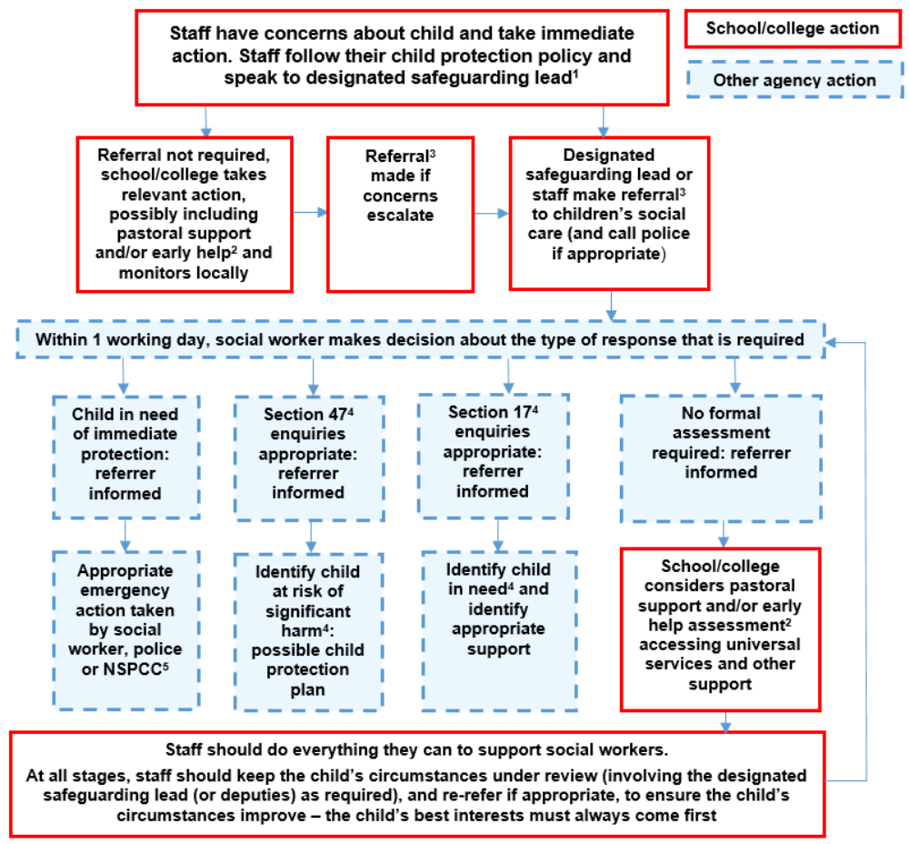

Where someone has a concern about the welfare of a child, they should speak to the DSL (or deputy). Options will then include;
- managing any support for the child internally via our own pastoral support processes;
- undertaking an early help assessment; or
- making a referral to statutory services, for example, as the child is in need or suffering or likely to suffer significant harm or impairment. This will involve contacting Family Connect or the local social care team for the child.

Where we discover a child is alone or we believe a child is alone at home or in the community we will contact the police immediately and not escort the child back to school. We will report this to the police, via 101. If the child is in immediate danger, then we will report to the police, via 999. We will then notify Family Connect or the emergency duty team as soon as reasonably practicable.

NPCC- When to call the police will be considered by the DSL to help them understand when they should consider calling the police and what to expect when they do.

All referrals to the local social team must be followed up in writing using the social care team’s relevant referral/request forms. For referrals in Telford & Wrekin we will use the Request for service form.

If in exceptional circumstances, the DSL or a deputy is not available, the person who has the concern should speak to a member of the senior leadership team and/or take advice from Family Connect or the local social care team for the child. In these circumstances, any action taken should be shared with the DSL (or deputy) as soon as is practically possible.

Staff should not assume a colleague, or another professional will take action and share information that might be critical in keeping children safe. They should be mindful that early information sharing is vital for effective identification, assessment and allocation of appropriate service provision. Information Sharing: Advice for Practitioners Providing Safeguarding Services to Children, Young People, Parents and Carers supports staff who have to make decisions about sharing information. If in any doubt about sharing information, staff should speak to the DSL or a deputy.

In the unlikely event of a person in our school/college who has a concern for a child is not satisfied with the action taken by the DSL or a deputy they should speak to them again to share their concerns. If they remain unsatisfied with the response, then the person who had the original concern should speak to another trained DSL to seek resolution. If following speaking to another trained DSL the person remains concerned that appropriate action has not been taken to safeguarding or protect the child, the person should report their original concern to Family Connect or the local social care team for the child and follow the school/college Whistleblowing procedures.

Referral agencies

Telford & Wrekin social care team  Family Connect  01952 385385  Out of Hours  01952 676500 | Shropshire social care team  First Point of Contact  0345 678 9021  Out of Hours  0345 678 9040 |  | Staffordshire social care team  Childrens Advice and Support Service  0300 111 8007  Out of Hours  0345 604 2886 |  | Wolverhampton social care team  MASH  01902 555392  Out of Hours  01902 552999
If you think a child is in immediate danger, call the police on 999
Childline  0800 1111 |  | NSPCC  0800 800 5000 |  | Protecting Vulnerable People (West Mercia Police): 101

Immediate response to a child or parent

Staff will follow effective safeguarding practice which includes:
- if possible, managing reports with two members of staff present, (preferably one of them being the designated safeguarding lead or a deputy). However, this is not always possible;
- where the report includes an online element, we will be aware of searching, screening and confiscation advice (for schools) and UKCIS sexting advice (for schools and colleges). The key consideration is for staff not to view or forward illegal images of a child. The highlighted advice provides more details on what to do when viewing an image is unavoidable. In some cases, it may be more appropriate to confiscate any devices to preserve any evidence and hand them to the police for inspection;
- not promising confidentiality at this initial stage as it is very likely a concern will have to be shared further (for example, with the DSL or children’s social care) to discuss next steps. Staff will only share the report with those people who are necessary in order to progress it. It is important that the victim understands what the next steps will be and who the report will be passed to;
- recognising a child is likely to disclose to someone they trust: this could be anyone in our setting. It is important that the person to whom the child discloses recognises that the child has placed them in a position of trust. They should be supportive and respectful of the child;
- keeping in mind that certain children may face additional barriers to telling someone because of their vulnerability, disability, sex, ethnicity and/or sexual orientation;
- listening carefully to the child, reflecting back, using the child’s language, being non-judgmental, being clear about boundaries and how the report will be progressed, not asking leading questions and only prompting the child where necessary with open questions – where, when, what, etc or TED ‘tell me’, ‘explain to me’ and ‘describe’. It is important to note that while leading questions should be avoided, staff can ask children if they have been harmed and what the nature of that harm was;
- considering the best way to make a record of the report. Best practice is to wait until the end of the report and immediately write up a thorough summary. This allows the staff member to devote their full attention to the child and to listen to what they are saying. It may be appropriate to make notes during the report (especially if a second member of staff is present). However, if making notes, staff should be conscious of the need to remain engaged with the child and not appear distracted by the note taking. Either way, it is essential a first-hand written record is made;
- only recording the facts as the child presents them. The notes should not reflect the personal opinion of the note taker. We are aware that notes of such reports could become part of a statutory assessment by children’s social care and/or part of a criminal investigation; and
- informing the DSL (or deputy), as soon as practically possible, if the DSL (or deputy) is not involved in the initial report.

If conversations need to take place and confidentiality is paramount to welfare, then these conversations will be held in appropriate settings and away from any general areas, where that confidentiality may be compromised.

We will never allow fears about sharing information to stand in the way of the need to promote the welfare and protect the safety of children. We expect concerns that arise in a morning will be reported to the DSL (or deputies) by lunchtime that day. Concerns that arise in an afternoon should be reported by or as close to the end of the school day, or as soon as reasonably practicable. Any concerns arising outside of the normal school day should be reported as quickly as possible. If in doubt concerned, parties should talk with the DSL (or deputy). Delay is unacceptable and may result in disciplinary action.

Where a child is suffering, or is likely to suffer from harm or impairment, we will make a referral to children’s social care (and if appropriate the police) immediately. If we are unsure which local authority the child lives in we will use the online tool Report Child Abuse to Your Local Council to direct us to the relevant local children’s social care contact number.

Children’s social care assessments should consider where children are being harmed in contexts outside the home. Therefore, we will provide as much information as possible as part of the referral process. This will allow any assessment to consider all the available evidence and enable a contextual approach to address such harm.

Our role is to refer the information received and under no circumstances become the investigator.
We will work appropriately with each child, their family and other agencies to protect in all cases the welfare of the child. We will work in partnership and fulfil the ethos and abide by the principles of the 2023 Telford and Wrekin threshold guidance or the threshold guidance for the local social care team for the child.

Staff working at this setting may be required to support other agencies and professionals in an early help assessment, in some cases acting as the lead professional. Any such cases will be kept under constant review and consideration given to a referral to children’s social care assessment for statutory services if the child’s situation does not appear to be improving or is getting worse.

Staff working at this setting will be made aware of the process for making referrals to children’s social care and statutory assessments. This is under the Children Act 1989, especially section 17 (children in need) and section 47 (a child suffering, or likely to suffer, significant harm), that may follow a referral; along with the role staff might be expected to play in such assessments.

A child in need is defined under the Children Act 1989 as a child who is unlikely to achieve or maintain a reasonable level of health or development, or whose health and development is likely to be significantly or further impaired, without the provision of services; or a child who is disabled. Local authorities are required to provide services for children in need for the purposes of safeguarding and promoting their welfare. Children in need may be assessed under section 17 of the Children Act 1989.

Local authorities, with the help of other organisations as appropriate, have a duty to make enquiries under section 47 of the Children Act 1989 if they have reasonable cause to suspect that a child is suffering, or is likely to suffer, significant harm. Such enquiries enable them to decide whether they should take any action to safeguard and promote the child’s welfare and must be initiated where there are concerns about maltreatment, including all forms of abuse and neglect, female genital mutilation or other so-called ‘honour based’ violence, and extra-familial threats like radicalisation and sexual exploitation.

Where there are visible injuries, all staff should record these on a body map diagram and describe them the best they can. We will assume good evidential practice to get two persons involved who have seen the injury and can account for it on the body map, then immediately follow up with a referral as described above.

Under no circumstances will staff photograph injuries seen on children. Our staff are not expert witnesses. If the concern is around non-accidental injury, then that is a matter that requires immediate attention on the day resulting in an appropriate referral to Family Connect or the local social care team for the child. Those professionals will control the process of photographic evidence gathering and assessment.

For staff to interpret any concerns we will assess each incident as it appears. In respect of assessing any bruising to a child we will refer to the Bruising of Children guidance produced by the TWSP to assist their decision making.

The role of the local authority

Within one working day of a referral being made, a local authority social worker should acknowledge receipt to us as the referrer and make a decision about the next steps and the type of response that is required. This will include determining whether:
- the child requires immediate protection and urgent action is required;
- any services are required by the child and family and what type of services;
- the child is in need, and should be assessed under section 17 of the Children Act 1989;
- there is reasonable cause to suspect the child is suffering or likely to suffer significant harm, and whether enquiries must be made and the child assessed under section 47 of the Children Act 1989; and
- further specialist assessments are required to help the local authority to decide what further action to take.

The referrer will, even if they are not the DSL (or deputy), follow up if this information if it is not forthcoming.

If, after a referral, the child’s situation does not appear to be improving, we will consider following TWSP local escalation procedures or those for the safeguarding partnership for the child to ensure our concerns have been addressed and, most importantly, that the child’s situation improves.

The Telford & Wrekin Council Director of Children’s Services is Jo Britton.

Record keeping

All concerns will be recorded first hand by the person raising the concern, using the relevant paper or electronic recording system used by visitors, staff and supply staff. Concerns will be passed onto the DSL or Deputy DSL in a timely manner. DSLs will record in writing any discussions and decisions made, and the reasons for those decisions, Information will be kept confidential and stored securely. We will keep concerns and referrals in a separate child protection file for each child.

Records should include:
- a clear and comprehensive summary of the concern;
- details of how the concern was followed up and resolved; and
- a note of any action taken, decisions reached and the outcome.

If in doubt about recording requirements, visitors, staff and supply staff will discuss with DSL (or deputy).

Anyone who has a safeguarding concern should follow these recording principles:
- record the date, time, place and context of the concern, recording facts and who you shared them with;
- record where you spoke with the child or parent and personal safety details, such as ‘I discussed the incident with the child in the Headteacher’s office with the door open’ or justify if it were closed, but naming those who you told this to be the case. If alone, reason that rationale stating ‘the child stated they would only confide in me if I was alone’;
- if it is observation of bruising or an injury try to record detail, e.g. ‘right arm, above elbow’, ‘bruise approximately 5cm in diameter noticed on back of lower right leg’;
- note the non-verbal behaviour and the key words in the language used by the child or parent (try not to translate into ‘proper terms’ ensuring that you use the child or parent’s own words). Body language should be noted and support any record of disclosure; and
- it is important to retain on file signed original handwritten notes and pass them on to the DSL (or deputy) who may ask you to complete a written referral to children’s social care.

We adopt guidance from TWSP Workbook for Designated Safeguarding Leads and Governors/Committee Members/Trustees/Proprietors with responsibility for safeguarding, incorporating: Advice note on Child Protection record keeping.

Visitors, staff and supply staff note down concerns on a yellow Cause for Concern form available from reception, the Rainbow Room or the staff room. The visitor or supply member of staff should inform the DSL (or deputy) as soon as their concern arises. Once completed, they should hand the Cause for Concern form to the DSL (or deputy). All Cause for Concern forms will be uploaded directly to CPOMS/placed into the child’s safeguarding record to help to maintain a first-hand record.

This school has adopted an electronically maintained recording system called Child Protection Online Management System (CPOMS). The CPOMS system is a totally secure system of record keeping which enables us to quickly encapsulate a child journey with us.

The DSL and deputies record all concerns on CPOMS. We will ensure that a restricted number of staff will have full access to this system as named key holders. If concerns have been logged by staff via this process it should not be presumed that this is an instant notification that has been seen immediately. If appropriate the issue should not assume anything and a verbal conversation should also take place if needed for clarification.

Concerns are stored chronologically in electronically for that child.

What to do if you have safeguarding concerns about another staff member

If staff have safeguarding concerns, or an allegation is made about another member of staff (including supply staff, volunteers and contractors) posing a risk of harm to children, then:
- this should be referred to the Headteacher;
- where there are concerns/allegations about the Headteacher, this should be referred to the chair of governors; and

Any concerns about staff must be recorded on CPOMS staff safe and referred to the relevant person above.

Any allegations that may meet the harms threshold will be addressed as set out in Part four, Section one of KCSIE. Any concerns that do not meet the harm threshold, referred to, as ‘low level concerns’ will be addressed as in Part four, Section two of KCSIE. When an allegation is made, the DSL will be responsible for ensuring that a child is not at risk and refer cases of suspected abuse to Family Connect or the child’s local social care team.

We will only undertake basic enquiries to help determine whether there is any foundation to the allegation.

The LADO for Telford & Wrekin Council is Glenn Ashbrooke who will be informed of all allegations that come to our attention and appear to the meet the criteria set out in Part Four, Section One of KCSIE, so they can consult police and children’s social care services as appropriate. All LADO referrals must be made via Family Connect, unless the subject child is open to a social worker and then the LADO referral must be made via the child’s allocated social worker.

The governing body, will be notified of any allegations or low-level concerns at each scheduled meeting. The governor responsible for safeguarding will be informed soon after the allegation or low-level concern has been received. Their role is not to know details of the persons or concern but to ensure policies and procedures are adhered to and to provide relevant support.

We will make a referral to the Disclosure and Barring Service (DBS) if a person in regulated activity has been dismissed or removed due to safeguarding concerns or would have been had they not resigned.

We believe that those who work within our community are in positions of trust and as such codes of conduct are based on the underlying principle that the highest standards are expected from all. In line with KCSIE a separate code of conduct policy will be adopted by this setting for staff, volunteers, contractors and governors.

Guidance for safer working practice for those working with children and young people in educational settings produced by the Safer Recruitment Consortium, provides excellent guidance on the expected standards of all those that work with children. We will make all those in our community aware of its existence and this will work alongside the separate code of conduct mentioned above and any established human resources processes currently in place.

To help avoid potential allegations and safeguarding concerns, and for the safety and welfare of pupils and the protection of staff, we will make classrooms highly visible places whereby easy viewing is possible. The masking of windows is forbidden and as such treated as a safeguarding issue for the protection of all. There may be exceptional circumstances where masking of classrooms is needed and justified, for example, for the teaching of drama; in these cases, the Headteacher will make a judgement on a case-by-case basis being appropriate, balanced and proportionate.

Please see our procedure for managing safeguarding concerns, or allegations against staff (including supply staff, volunteers and contractors) – Managing low-level concerns policy.

What to do if you are concerned about another safeguarding practice in the school

All staff and volunteers should feel able to raise concerns about poor or unsafe practice and potential failures in our safeguarding regime and know that such concerns will be taken seriously by our senior leadership team.

Please refer to our Whistleblowing procedures.

Where staff feel that they cannot report a concern through the above channels general guidance can be found at Advice on whistleblowing. The NSPCC whistleblowing helpline is available for staff who do not feel able to raise concerns regarding child protection failures internally. Staff can call 0800 028 0285 or email help@nspcc.org.uk

Part two: The management of safeguarding

The designated governor with responsibility for safeguarding is Caroline Riley

The designated governor/proprietor with responsibility for ‘Prevent’ is Caroline Riley

Their role is to take leadership responsibility for our safeguarding arrangements.

The governing body/proprietor has strategic leadership responsibility for our safeguarding arrangements and must ensure that we comply with their duties under legislation. They must have regard to KCSIE, ensuring our policies, procedures and training in our setting are effective and comply with the law at all times.

Our Headteacher will ensure that the policies and procedures, adopted by this governing body/proprietor, are understood, and followed by all staff.

All governors/proprietors have received appropriate safeguarding and child protection training (including online safety) training at induction. This will ensure they have the knowledge to provide strategic challenge to test and assure themselves that the safeguarding policies in our setting are effective and support the delivery of a robust whole-setting approach to safeguarding. This training will be updated annually.

The governing body will act under their obligations under the Data Protection Act 2018 and the UK GDPR, Human Rights Act 1998, the Equality Act 2010, (including the Public Sector Equality Duty), and their local multi-agency safeguarding arrangements.

Our approach to safeguarding

This governing body will ensure that we facilitate a whole setting approach to safeguarding. This means ensuring safeguarding and child protection are at the forefront and underpin all relevant aspects of process and our policy development. Ultimately, all systems, processes and policies will operate with the best interests of the child at the heart.

Where there is a safeguarding concern, our governing body and our senior leaders will ensure the child’s wishes and feelings are taken into account when determining what action to take and what services to provide. Systems are in place, and they will be well promoted, easily understood and easily accessible for children to confidently report abuse, knowing their concerns will be treated seriously, and knowing they can safely express their views and give feedback. We will work with children to remove any barriers to reporting.

We will facilitate staff to contribute to and shape our safeguarding arrangements and Child Protection policy.

We will ensure that suitable arrangements are in place to provide access for all staff to access safeguarding supervision. Please see our Safeguarding Supervision policy.

Policies and procedures

We aim to ensure there are appropriate policies and procedures in place in order for appropriate action to be taken in a timely manner to safeguard and promote children’s welfare.

The designated safeguarding lead (DSL)

Our governing body has appointed Katy Tomlinson to be the DSL of this school and Lisa Pigg, Katie Reese, Jane Hullin, Teresa Adams, Julie Lane and Clare O’Donnell to be their deputies. We will set out their responsibilities in their job description.

Katy Tomlinson will take ultimate responsibility for safeguarding and child protection, online safety, and understanding the filtering and monitoring systems and processes in place at our setting as the DSL and as an appropriate senior member of staff from our leadership team.

During term time, the DSL and/or a deputy will always be available (during our normal operating hours) for the staff to discuss any safeguarding concerns with. During out of hours/out of term activities we will provide appropriate cover by ensuring the DSL and/or a deputy is available.

Prior to any education visit, a risk assessment will be completed to consider if the DSL (or a deputy) needs to be present. We will always consider how quickly a DSL can respond to a safeguarding issue if they are not present. Where safeguarding concerns are raised during an educational visit the DSL (or deputy) must be notified immediately, even if they are not physically present at the site of the educational visit. They will liaise with the person responsible for the education visit to manage the concern and refer to the relevant agencies.

The DSL and any deputies will undergo two-day ‘newly appointed designated safeguarding lead’ training as recognised by TWSP to provide them with the knowledge and skills required to carry out the role. They will attend one-day ‘designated safeguard lead refresher training’ as recognised by TWSP every two years. In addition to their formal training as set out above, their knowledge and skills will be updated, for example, via Telford & Wrekin Council’s Education Safeguarding e-bulletins, attending termly designated safeguarding lead refreshers and taking time to read and digest safeguarding developments, at regular intervals, and at least annually, to keep up with any developments relevant to their role. We aim to ensure at least one DSL and any deputies attend each termly update. All designated safeguarding leads and any deputies will disseminate training to all relevant staff and governors.

The designated safeguarding lead will form part of a borough wide network, where information is shared, in a two-way process, with the Telford & Wrekin Council, Education Safeguarding Team.

They will complete the Safeguarding Audit - Education each year and submit to TWSP. The Safeguarding Audit – Education, will be supplied by the Telford & Wrekin Council Education Safeguarding Team.

The DSL and their deputies will fulfil their role and responsibilities as set out in Annex C KCSIE.

Multi-agency working

The DSL and any deputies will work with other agencies in line with Working Together to Safeguard Children.

Our governing body and the DSL are familiar with the TWSP arrangements. In Telford & Wrekin schools and colleges have been named as relevant agencies by the TWSP. We will engage with the TWSP as required and follow the Telford & Wrekin Threshold Guidance or the appropriate threshold guidance for where the child resides or for who is responsible for the child, to follow the local protocol for assessments.

The governing body of this setting expect staff to work with social care, the police, health services and other services to promote the welfare of children and protect them from harm. This includes us providing a coordinated offer of early help when additional needs are identified by us or another agency. We will never restrict access for children’s social care to conduct a section 17 or section 47 assessment.

The DSL is expected to consider the requirement for children to have an Appropriate Adult. Further information can be found in the Statutory guidance - PACE Code C 2019.

Information sharing

We recognise that information is vital in identifying and tackling all forms of abuse and neglect, and in promoting children’s welfare, including their educational outcomes. Schools and colleges have clear powers to share, hold and use information for these purposes.

We expect all staff to share information with practitioners and local agencies. We are committed to sharing information as early as possible to help identify, assess and respond to risks or concerns about the safety and welfare of children, whether this is when problems are first emerging, or where a child is already known to the local authority children’s social care.

All child protection records are clearly marked as such and are kept securely locked on the premises within CPOMS, the nominated persons are responsible, accountable, documented and are identifiable within our setting for total security. Also, procedures are in place when a member of staff leaves the setting or is on long term sick leave for their access to cease. Withdrawal of child protection records from our setting by staff will be noted and signed for, as will files released to professionals.

The child protection file is a separate file to the educational records. It must be noted that if files are asked to be secured, both files are key elements in any processes for which they are needed. It is important that on releasing files they are signed for on release and on return.

Pupil record files must be kept until the individual reaches the age of 25 years or in certain circumstances later. At this point the file should be disposed of confidently.

In respect of files being released when requested by the Police under Section 29 of the Data Protection Act 2018 a form entitled ‘Request to external organisation for the disclosure of personal data to the police-Under Schedule 2 Part 1 Paragraph 2 of the Data Protection Act 2018 and GDPR Article 6(1))d)’ should accompany that release and a copy will be retained for our records.
This school will also seek advice and adopt the Information sharing advice for safeguarding practitioners. If in any doubt we will seek advice from our Data Protection Officer. Upon releasing records, the school will request ID Badges for release. If the Police are only after minimal data e.g., address or phone number, we will ensure we check the police ID and we will record what information was asked for and the name of the police officer requesting it. A permission form may not be required on these occasions.

No named statistics in relation to child protection are an important part of performance information. These may be shared by the DSL with staff, other agencies or the governing body/proprietor/management committee.

In our management of information sharing we will use the following:
- Chapter one of Working Together to Safeguard Children, which includes a myth-busting guide to information sharing;
- Information Sharing: Advice for Practitioners Providing Safeguarding Services to Children, Young People, Parents and Carers. The seven golden rules for sharing information will be especially useful;
- The Information Commissioner’s Office (ICO), which includes ICO GDPR FAQs and guidance from the department; and
- Data protection: toolkit for schools - Guidance to support schools with data protection activity, including compliance with the GDPR.

When a child leaves the school, the DSL will ensure their child protection file is transferred to the new school as soon as possible (within five working days of the child starting at their new school or college), ensuring secure transit, and confirmation of receipt will be obtained. We will transfer the child protection file separately from the main pupil file. As a receiving school we will ensure key staff such as DSL’s and SENDCO’s, are aware as required. In addition to the child protection file. The DSL will share any relevant safeguarding information with the new school or college in advance of a child leaving, including where a child has been or is open to ‘Channel’ Panel. If we are the current host school, we will not photocopy and retain child protection records. This is deemed from the Information Commissioners Office that this would contravene The Data Protection Act 2018, but rather produce a chronology to pass on with the child protection records and retain a copy of this chronology for themselves for audit purposes, this would be deemed as best practice.
All child protection records are reviewed at the end of each half-term by the Senior DSL and checked to be chronological, tidy, legible and factual in content. The exception to this is safeguarding records where there are concerns of CSE, these are checked by the DSL every six months. This should be undertaken each year, as records may sometimes be immediately required by professionals. Where reports are needed for child protection and safeguarding meetings, these should include attendance figures.

Fears about sharing information must not be allowed to stand in the way of the need to safeguard and promote the welfare of children.

We will follow the guidance on the child protection file set out in Annex C KCSIE.

Opportunities to teach safeguarding

We will teach children about how to keep themselves and others safe, including online. We tailor the education provided to the specific needs and vulnerabilities of individual children, including children who are victims of abuse, and children with special educational needs and/or disabilities. We will do this through our Relationships Education/Relationships and Sex Education/Heath Education.

We will ensure that appropriate filters and monitoring systems that are in place, do not lead to unreasonable restrictions as to what children can be taught with regard to online teaching and safeguarding.
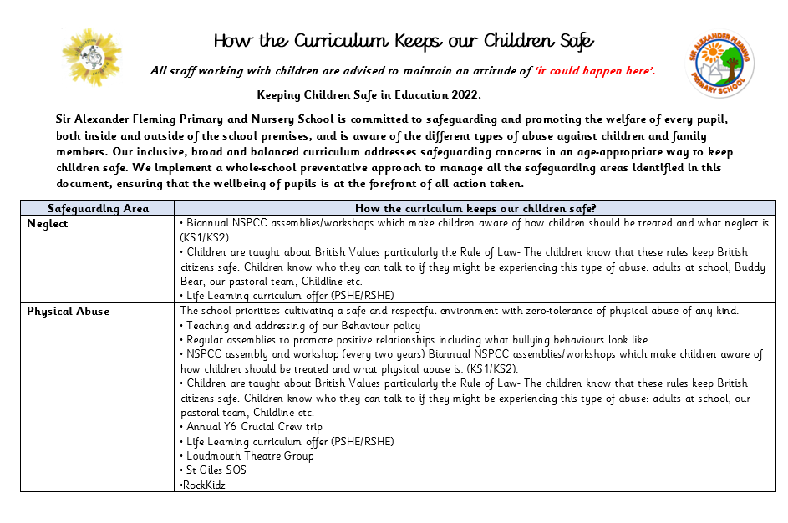

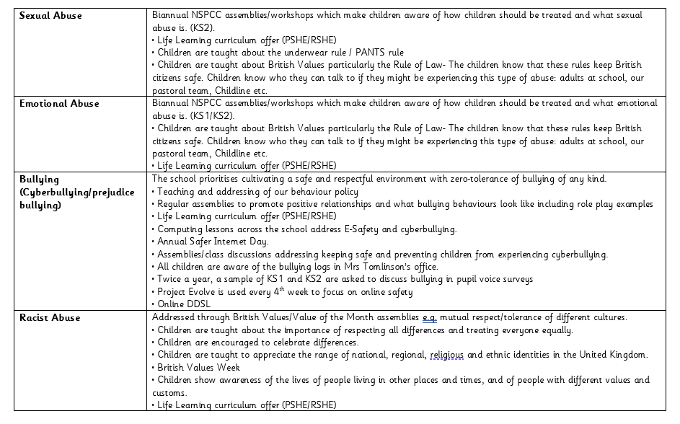
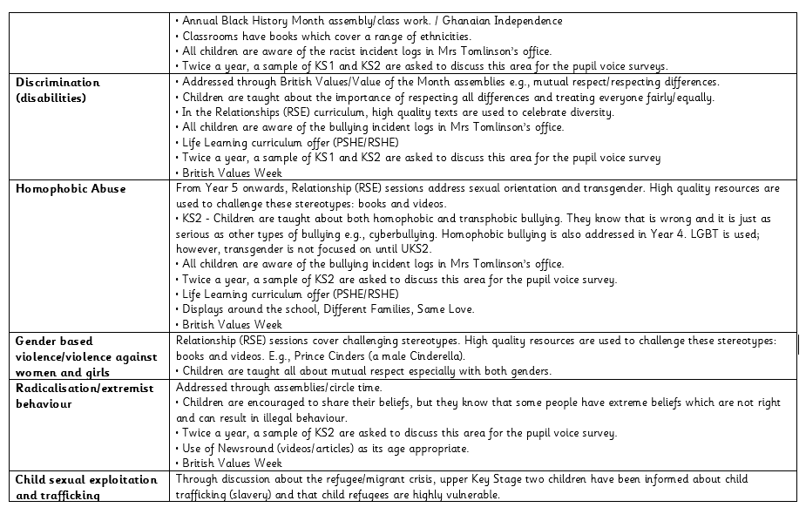

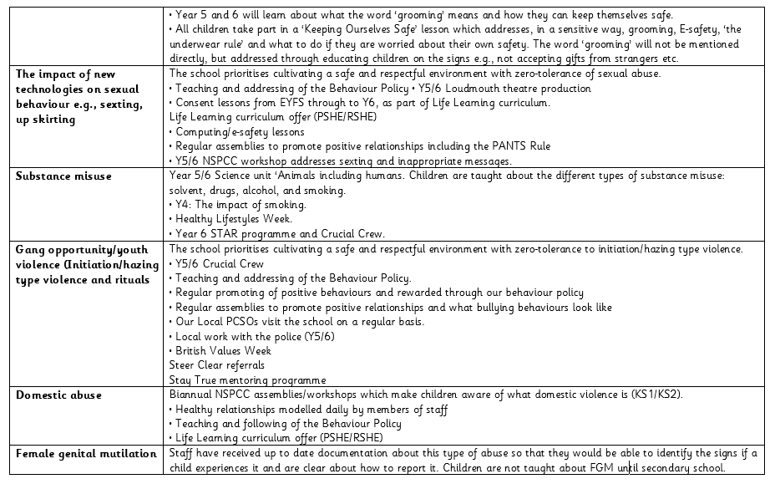

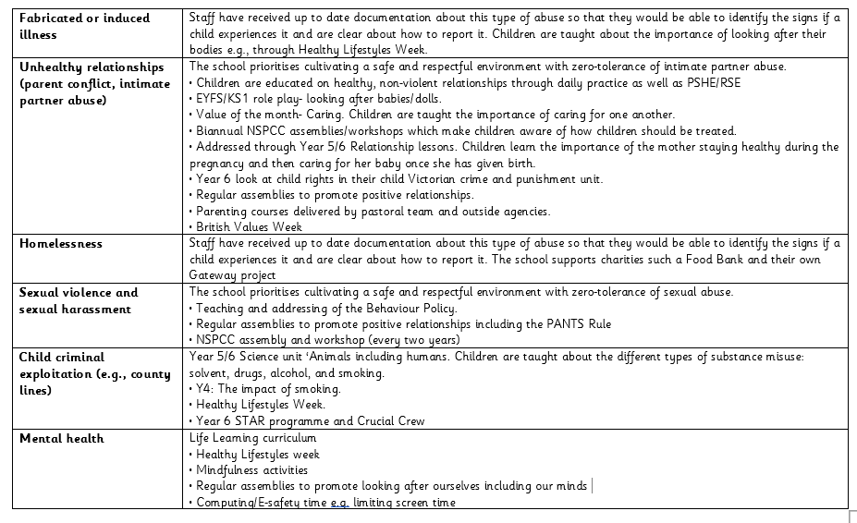

Online safety

We recognise online safety is a major concern for all professionals.

We believe it is essential that children are safeguarded from potentially harmful and inappropriate online material.

The aim of our approach to online safety is empowerment to protect and educate pupils and staff in their use of technology and establish mechanisms to identify, intervene in, and escalate any concerns where appropriate. We will ensure appropriate filtering and monitoring on school/college devices and networks. We aim to protect children from illegal, inappropriate or harmful content, and harmful online interaction with other users. We aim for our pupils to exhibit positive personal online behaviour and recognise inappropriate online conduct. We aim to protect children from commercial risks.

We use Project Evolve and Education for a Connected World materials to ensure that we cover all areas of online safety from Year 1 to Year 6. We use these materials at the beginning of every computer session.

The breadth of issues classified within online safety is considerable, but can be categorised into four areas of risk:
- content: being exposed to illegal, inappropriate or harmful content, for example: pornography, fake news, racism, misogyny, self-harm, suicide, anti-Semitism, radicalisation and extremism.
- contact: being subjected to harmful online interaction with other users; for example: child to child pressure, commercial advertising and adults posing as children or young adults with the intention to groom or exploit them for sexual, criminal, financial or other purposes’.
- conduct: personal online behaviour that increases the likelihood of, or causes, harm; for example, making, sending and receiving explicit images (e.g. consensual and non-consensual sharing of nudes and semi-nudes and/or pornography, sharing other explicit images and online bullying; and
- commerce: risks such as online gambling, inappropriate advertising, phishing and or financial scams. If we feel our pupils, students or staff are at risk, we will report it to the Anti-Phishing Working Group (https://apwg.org/).

We will ensure online safety is a running and interrelated theme whilst devising and implementing policies and procedures. This will include considering how online safety is reflected as required in all relevant policies and considering online safety while planning the curriculum, any teacher training, the role and responsibilities of the DSL (and deputies) and any parental engagement.

We take seriously our duties to assist parents and help them with online safeguarding resources. As such, we will make them aware of relevant support services.

Where children are being asked to learn online at home we will follow the advice to support schools and colleges do so safely: safeguarding in schools colleges and other providers and safeguarding and remote education. We recognise the NSPCC and PSHE Association also provide helpful advice.

Through our regular communications with parents, we will reinforce the importance of children being safe online and tell parents what systems we use to filter and monitor online use. We will make parents aware of what their children are being asked to do online, including the sites we asked them to access. We will always be clear who from our school/college (if anyone) a child is going to be interacting with online.

While considering our responsibility to safeguard and promote the welfare of children and provide them with a safe environment in which to learn, we will do all that we reasonably can to limit children’s exposure to risks from our IT system. We will ensure we have appropriate filters and monitoring systems in place. The leadership team and relevant staff, such as online safety lead will obtain an understanding of the filtering and monitoring provisions in place and manage them effectively and know how to escalate concerns when identified. We will do this by considering the age range of our children, the number of children, how often they access the IT system and the proportionality of costs versus risks.

The appropriateness of our filters and monitoring systems have been informed in part, by the risk assessment required by the Prevent Duty. To meet this duty we will work to meet the digital and technology standards. We will:

• identify and assign roles and responsibilities to manage filtering and monitoring systems.
• review filtering and monitoring provision at least annually.
• block harmful and inappropriate content without unreasonably impacting teaching and learning.
• have effective monitoring strategies in place that meet safeguarding needs.

We have the appropriate level of security protection in place, in order to safeguard our systems, staff and learners and we will review the effectiveness of these procedures periodically to keep up with evolving cyber-crime technologies.

We will carry out an annual review of our approach to online safety, supported by an annual risk assessment that considers and reflects the risks their children face.

Our governing body will question school leaders to gain a basic understanding of our approach to keeping children safe online; learn how to improve this approach where appropriate; and find out about tools, which can be used to improve the approach.

Mentors of trainee teachers and newly qualified teachers induct mentees and provide ongoing support, development and monitoring on online safety.

As a maintained school we adhere to The Corporate Information Security Policy (CISP) including Acceptable Use of Equipment and the Social Media Policy-Acceptable Use for Employees. We will make all aware of its existence and importance. Where appropriate, intervention will take place when anyone uses e-technology in an unacceptable fashion.

Mobile and smart technology

Please see our policy on the safe use of mobile and smart technology.

We recognise that many children have unlimited and unrestricted access to the internet via mobile phone networks. This access means some children, while at our setting sexually harass, bully, and control others, via their mobile and smart technology, share indecent images consensually and non-consensually and view and share pornography and other harmful content.

All staff, pupils and visitors are restricted from using mobile phones or smart technology within the school building apart from in the designated area of the staffroom.

Inspection

We recognise our responsibilities for safeguarding within the remit of Ofsted.

The use of ‘reasonable force’

There are circumstances when it is appropriate for staff in our setting to use reasonable force to safeguard children and young people. The term ‘reasonable force’ covers the broad range of actions used by staff that involve a degree of physical contact to control or restrain children. This can range from guiding a child to safety by the arm, to more extreme circumstances such as breaking up a fight or where a young person needs to be restrained to prevent violence or injury. ‘Reasonable’ in these circumstances means us ‘using no more than is needed.’ Our use of force may involve either passive physical contact, such as standing between pupils or blocking a pupil’s path, or active physical contact such as leading a pupil by the arm out of the classroom.

We will always follow the advice for schools on the Use of Reasonable Force in Schools. We will also have regard to additional guidance Reducing the Need for Restraint and Restrictive Intervention for children and young people with learning disabilities, autistic spectrum conditions and mental health difficulties in health and social care services and special education settings.

We believe that the adoption of a ‘no contact’ policy in our setting could leave staff unable to fully support and protect our pupils and students. We will adopt a sensible approach allowing staff to make appropriate physical contact. The decision on whether to or not to use reasonable force to control or restrain a child is down to the professional judgement of the staff concerned and should always depend on individual circumstances.

When using reasonable force in response to risks presented by incidents involving children with SEND, mental health or with medical conditions, we will consider the risks carefully because we recognise the additional vulnerability of these groups. We will consider our duties under the Equality Act 2010 in relation to making reasonable adjustments, non-discrimination and our Public Sector Equality Duty.

We will plan positive and proactive behaviour support, for instance through drawing up individual behaviour plans for more vulnerable children, and agreeing them with parents and carers, we aim to reduce the occurrence of challenging behaviour and the need to use reasonable force. We will only use reasonable force where de-escalation processes have failed.

Hiring out our facilities and premises

Where we hire or rent out our facilities/premises to organisations or individuals (for example to community groups, sports associations, and service providers to run community or extra-curricular activities) we will ensure that appropriate arrangements are in place to keep children safe.

When services or activities are provided by us, under our own direct supervision or management, our own arrangements for child protection will apply. However, where services or activities are provided separately by another body this is not necessarily the case. We will therefore seek assurance that the body concerned has appropriate safeguarding and child protection policies and procedures in place including inspecting these; and ensure that there are arrangements in place to liaise with us on these matters where appropriate. We will also ensure safeguarding requirements are included in any transfer of control agreement (i.e., lease or hire agreement), as a condition of use and occupation of the premises; and that failure to comply with this may lead to termination of the agreement.

The guidance on Keeping children safe in out-of-school settings details the safeguarding arrangements that schools and colleges should expect these providers to have in place.

Absent and missing from education

We believe children being absent from education for prolonged periods and/or on repeat occasions can act as a vital warning sign to a range of safeguarding issues. Our response to persistently absent pupils and children missing education will support identifying such abuse, and in the case of absent pupils, helps prevent the risk of them becoming a child missing education in the future. This includes when problems are first emerging but also where children are already known to local authority children’s social care and need a social worker (such as a child who is a child in need or who has a child protection plan, or is a looked after child), where being absent from education may increase known safeguarding risks within the family or in the community.

The recognised figure for severely absent is 50% or less and persistent absence is being less than 90%, although concerns may still be raised if above this.
We will require the behaviour and attendance lead to refer to and use the established protocol document of notification to the Local Authority, filling out the appropriate paperwork, policies and procedures for identifying pupils who are absent from education and policies and procedures for pupils on a modified timetable (available from Telford & Wrekin Council).

In addition to the above and where reasonably possible we will endeavour to hold more than one emergency contact number for each pupil. This goes beyond the legal minimum and is good practice to give us additional options to make contact with a responsible adult when a child is absent from education and poses a potential welfare/safeguarding concern. Where a child is on a Child Protection Plan has been missing from school for two consecutive days, we will notify the child’s allocated social worker.

Where children leave the classroom or leave our grounds without permission, this is covered within our behaviour management policy and is also set against the backdrop of the legal framework of the Children Act 1989 s3 (5); ‘Anyone who has care of a child without parental responsibility may do what is “reasonable” in all the circumstances to safeguard and promote the child’s welfare. It is likely to be “reasonable” to inform the police, or children’s services departments, and, if appropriate, their parents, of the child/young person’s safety and whereabouts’. However, in principle, if a pupil runs out of class we will establish where he or she has gone. Staff will not run after them but will seek additional support. It is advisable to keep a watchful eye on any children who has taken themselves out of our building and possibly out of our grounds, unless this watchful eye provokes the child to run further. It is and will be a judgement call for staff to take what they feel is reasonable action in line with the advice above. If a child is no longer on the premises, we will contact parents in the first instance. If they are not contactable, we will inform the police that a pupil has left and is at risk.

Where children have gone missing, we will follow the West Mercia Pathway for Children who go Missing from Home, care or Education.

Elective Home Education (EHE)

We understand that many home educated children have an overwhelmingly positive learning experience. We would expect that any parents’ decision to home educate to be made with their child’s best education at the heart of the decision. However, we know this is not the case for all, and home education can mean some children are less visible to the services that are there to keep them safe and supported in line with their needs.

From September 2016 the Education (Pupil Registration) (England) Regulations 2006 were amended. This means we inform Telford & Wrekin Council of all deletions from our admission register when a child is taken off roll.

Where a parent/carer has expressed their intention to remove a child from school with a view to educating at home, we will facilitate a meeting with the local authority education team, ourselves and other relevant schools, other key professionals and where possible parents/carers. Ideally, this will be before a final decision has been made, to ensure the parents/carers have considered what is in the best interests of each child. This is particularly important where a child has SEND, is vulnerable, and/or has a social worker. We will invite the local authority education team by emailing ehe@telford.gov.uk.

We understand it is our responsibility to identify parents or carers who we need to meet with to discuss EHE before they make their final decision. We will record if parents refuse to attend this meeting. If parents decline this meeting, we will still meet with the local authority.

We will follow the Telford & Wrekin Council, EHE pathway.

Children who need a social worker (Child in Need and Child Protection Plans)

Children may need a social worker due to safeguarding or welfare needs. Children may need this help due to abuse, neglect and complex family circumstances. A child’s experiences of adversity and trauma can leave them vulnerable to further harm, as well as educationally disadvantaged in facing barriers to attendance, learning, behaviour and mental health.

Local authorities should share the fact a child has a social worker, and the DSL will hold and use this information so that decisions can be made in the best interests of the child’s safety, welfare and educational outcomes.

Where children need a social worker, this information will be used by the DSL (or deputies) to inform decisions about safeguarding (for example, responding to unauthorised absence or missing education where there are known safeguarding risks) and about promoting welfare (for example, considering the provision of pastoral and/or academic support, alongside action by statutory services).

Children requiring mental health support

We recognise that we have an important role to play in supporting the mental health and wellbeing of our pupils.

Mental health concerns can, in some cases, be an indicator that a child has suffered or is at risk of suffering abuse, neglect or exploitation. The governing body have put clear systems and processes in place for identifying possible mental health concerns, including routes to escalate and clear referral and accountability systems.

We will help prevent mental health concerns by promoting resilience as part of our integrated, whole setting approach to social and emotional wellbeing, which is tailored to the needs of our pupils.

Our senior mental health lead is Katy Tomlinson. They are a member of our senior leadership team. The appointed member of our senior leadership team who supports our senior mental health lead is Lisa Pigg.

Please see our mental health and well-being policy.

Suicide Intervention

We accept and understand that thoughts of suicide are common and the leading cause of death in young people. As such, suicide intervention is our business too. We to work with our pupils and work in partnership to support anyone in our community that may have thoughts of suicide. We will follow our Suicide Intervention Policy to assist wherever we can in making those in our care as safe as is possible. We will also make staff aware of the following useful link in raising awareness of the subject http://zerosuicidealliance.com/

Looked after children and previously looked after children

We recognise that the most common reason for children becoming looked after is as a result of abuse and/or neglect. All staff at our setting have the knowledge and skills to keep looked after children safe. The DSL will hold the details of each child’s social worker and the name of the virtual school head in the authority that looks after the child. They are responsible for ensuring all staff have the information they need in relation to a child’s looked after status and the child’s contact arrangements with birth parents or those with parental responsibility. They will also have information about the child’s care arrangements and the levels of authority delegated to the carer by the authority looking after him/her.

We recognise a previously looked after child potentially remains vulnerable.

When dealing with looked after children and previously looked after children we will work with all agencies to take prompt action where necessary to safeguard these children.

The designated teacher

The governing body appoint Lisa Pigg as the designated teacher to work with the local authorities to promote the educational achievement of registered pupils who are looked after. With the commencement of sections 4 to 6 of the Children and Social Work Act 2017, designated teachers have responsibility for promoting the educational achievement of children who have left care through adoption, special guardianship or child arrangement orders or who were adopted from state care outside England and Wales. The designated teacher has appropriate training and relevant qualifications and experiences to fulfil this role.

We will follow the statutory guidance on The Roles and Responsibilities of the Designated Teacher.

Virtual school heads

As a maintained school, the designated teacher will work with the virtual school head to discuss how funding can be best used to support the progress of looked after children in the school and meet the needs identified in the child’s personal education plan. The designated teacher also works with the virtual school head to promote the educational achievement of previously looked after children.

We will follow the statutory guidance on Promoting the Education of Looked After Children.

The DSL, Headteacher, governors, SENCO and senior mental health lead will work with the virtual school head to promote educational attendance, attainment and progress of children with a social worker.

The virtual school head for Telford and Wrekin is: Michelle Salter.

Children who have special educational needs and disabilities (SEND) or health issues

We recognise that children who have SEND or certain health or physical health conditions can face additional safeguarding challenges. We accept the additional barriers that can exist when recognising abuse and neglect of children in this group of children. These can include:
- assumptions that indicators of possible abuse such as behaviour, mood and injury relate to the child’s disability without further exploration;
- being more prone to peer group isolation than other children;
- the potential for children with SEND being disproportionally impacted by behaviours such as bullying, without outwardly showing any signs; and
- communication barriers and difficulties in overcoming these barriers.

To help address these additional challenges we will provide extra pastoral support for children with SEND. For any reports of abuse involving children with SEND, the DSL (or a deputy) and the SENCO will liaise closely.

Children who are lesbian, gay, bi or trans (LGBT)

We recognise that the fact that a child or a young person may be LGBT is not in itself an inherent
risk factor for harm. However, children who are LGBT can be targeted by other children. In some cases, a child who is perceived by other children to be LGBT (whether they are or not) can be just as vulnerable as children who identify as LGBT.

Risks can be compounded where children who are LGBT lack a trusted adult with whom they can be open. All staff will endeavour to reduce the additional barriers faced and provide a safe space for them to speak out or share their concerns with members of staff.

Staff

All staff, supply staff, contractors and visitors, are informed of the name of the DSL and deputies and our procedures for protecting children, for example, how to report their concerns, suspicions and how to receive, record and report disclosures.

Staff should not accept personal invitation visits to the homes of children unless permission or instruction has been sought from the Headteacher and it is viewed as a professional appointment, for example, supporting education welfare issues etc. This should be viewed on a case-by-case basis. To support this, guidance from the Department of Education (September 2010) states ‘Meetings with pupils away from the school premises should only be arranged with the specified approval of the head teacher and the prior permission of the pupil in question’. We accept this guidance from the Department of Education (September 2010) stating that in the case of private meetings; ‘Staff and volunteers should be aware that private meetings with individual pupils could give cause for concern. There will be occasions when a confidential interview or a one-to-one meeting is necessary. Such interviews should be conducted in a room with visual access or an area which is likely to be frequented by other people. Another pupil or adult should be present or nearby. Where conditions cannot apply, staff should ensure that another adult knows that the interview is taking place’.

Parents

Parents play an important role in protecting their children from abuse. We are required to consider the safety of the child and should a concern arise, professional advice may be sought prior to contacting parents. If deemed appropriate, parents will be contacted, and we will continue to work with them to support the needs of their child. Consent from the parents will be sought, although in exceptional circumstances and with the best interests of the child being considered, this may be overridden.

We aim to help parents to understand their responsibility for the welfare of all children, which includes their duty to refer cases to social care services and/or police in the interests of the child. The governing body will include a child protection statement on our website and all parents can view a copy of this policy.

Parents that have concerns regarding a member of staff can in the first instance raise those with the Headteacher. This may involve sharing those concerns with the relevant agencies. Where the parent has concerns regarding the Headteacher, the chair of governors should be consulted in the first instance.

Parents can liaise with Ofsted on such conduct issues or regulatory concerns, advice can be found on its website www.ofsted.gov.uk.

On occasions Ofsted may forward complaints that may raise a safeguarding concern about our school via Family Connect. In such instances, we will work with all agencies within Family Connect to clearly respond to Ofsted on a case by case basis.

Parents/Carers can also access Ofsted Parent View which is an online survey questionnaire where parents can give their views. Where possible, this will be monitored regularly by the school/college to quickly address any concerns.

Parents can liaise with the Independent Schools Inspectorate (ISI) on such conduct issues or regulatory concerns, advice can be found on its website https://www.isi.net/parents-and-pupils/concerns-about-a-school or contact can be made direct to ISI, you can email concerns@isi.net or call 020 7600 0100 and ask to talk to an appropriate member of staff.

All complaints should be made via our complaint’s procedures.

We will keep parents informed of all areas of safeguarding and child protection through the regular methods of communication.

We wish to make it clear to parents the standards, behaviour and respect we expect from them and conversely from us. If a parent’s behaviour is a cause for concern, then we will ask them to leave our premises. We wish to make it clear that in serious cases, the head teacher can/will notify parents in writing that their implied licence to be on our premises is temporarily revoked, subject to any representations that the parent may wish to make. This setting will give parents the opportunity to formally express their views on the decision to bar in writing and this will be reviewed via the complaints policy.

Our setting is private place. We will therefore act to ensure they remain a safe place for all. The public has no automatic right of entry.

We expect parents to talk to us about any concerns they have about care and education provided by us in the first instance. We urge all parents not to express these concerns on social media platforms, at least not before sharing these concerns with us first.

Changing in school

We consider arrangements for safe changing of children for physical education (PE). We will be guided by the NSPCC guidance Best Practice for PE Changing Rooms. This consideration will come under our duty and remit of health & safety and in the context of children’s welfare. We follow the guidance and do what we need to do in relation to organising changing facilities for children; staff supervision; changing areas for children with additional needs; changing considerations for drama productions and using off-site changing rooms. NSPCC factsheet

Part three: Safer Recruitment

We will meet all requirements as set out in Part three: Safer recruitment KCISE.

We commission Telford and Wrekin human resources service to assist in the management of safer recruitment procedures.

Please see our safer recruitment procedures.

Recruitment and selection process

We aim to create a culture that safeguards and promotes the welfare of all children. As part of this culture, we will adopt robust recruitment procedures that help to deter and prevent people who are unsuitable to work with children from applying for or securing employment, or volunteering opportunities in our setting.

We will ensure that all those involved with the recruitment and employment of staff to work with children have received appropriate safer recruitment training. At least one person on each interview panel have completed safer recruitment training. These persons will complete the TWSP recommended Safer Recruitment Consortium training.

The following persons have completed safer recruitment training in our setting:

Katy Tomlinson

Katie Reese

Lisa Pigg

Karen Davies

Pre-appointment vetting checks, regulated activity and recording information

We will abide by the legal requirements when appointing individuals to engage in regulated activity relating to children. We understand the importance of ensuring the correct pre-appointment checks are carried out. These checks will help us to identify whether a person may be unsuitable to work with children (and in some cases is legally prohibited from working with children and/or working as a teacher). We see this as part of our wider safeguarding regime which will carry on following appointment.

Other checks that may be necessary for staff, volunteers and others

We will carry out the checks that are necessary for individuals who have lived or worked outside the UK; agency and third-party staff; contractors; trainee teachers; volunteers; governors and proprietors. We will fulfil our responsibilities in relation to other settings, including alternative provision, work experience and host families.

Visitors

We have different types of visitors, those with a professional role, those connected with the building, grounds maintenance, children’s relatives or other visitors attending an activity.

We will not request DBS checks or barred list checks, or ask to see existing DBS certificates, for visitors such as children’s relatives or other visitors attending a sports day. The Headteacher/Principal will use their professional judgment about the need to escort or supervise such visitors.

For visitors who attend our setting in a professional capacity we will check their ID and seek assurance that the visitor has had the appropriate DBS check (or the visitor’s employers have confirmed that their staff have appropriate checks). We will not ask to see DBS certificates.

Whilst external organisations can provide a varied and useful range of information, resources and speakers that can help us enrich children’s education; careful consideration will be given to the suitability of any external organisations.

Alternative provision

Where we place a pupil with an alternative provision provider, we continue to be responsible for the safeguarding of that pupil and will undertake checks to be satisfied that the provider meets the needs of the pupil.

We will obtain written confirmation from the alternative provider that appropriate safeguarding checks have been carried out on individuals working at the establishment.

Please see our Alternative provision policy.

Adults who supervise children on work experience

When organising work experience placements, we will ensure that the placement provider has policies and procedures in place to protect children from harm.

Children’s barred list checks via the DBS might be required on some people who supervise a child under the age of 16 on a work experience placement. We will consider the specific circumstances of the work experience and give consideration in particular to the nature of the supervision and the frequency of the activity being supervised, to determine what, if any, checks are necessary. These considerations will include whether the person providing the teaching/training/instruction/supervision to the child on work experience will be:
- unsupervised themselves, and
- providing the teaching/training/instruction frequently (more than three days in a 30- day period, or overnight).
If the person working with the child is unsupervised and the same person is in frequent contact with the child, the work is likely to be regulated activity relating to children. If so, we may ask the employer providing the work experience to ensure that the person providing the instruction or training is not a barred person.

We are not able to request that an employer obtains an enhanced DBS check with children’s barred list information for staff supervising children aged 16 to 17 on work experience. If an activity undertaken by a child on work experience takes place in a ‘specified place’, such as a school or sixth form college, and gives the opportunity for contact with children, this may itself be considered to be regulated activity relating to children.

Children staying with host families (homestay)

If we arrange a homestay, we will consider the suitability of the adults in the respective families who will be responsible for the visiting child during the stay.

We will always consider what intelligence/information will best inform our assessment of the suitability of the adults in those families who will be responsible for the visiting child during the stay. We will use our professional judgement to decide what will be relevant. To help inform our assessment, we will obtain a DBS enhanced certificate with barred list information. This check will not only establish whether the adults are barred from engaging in regulated activity relating to children, but where criminal record information is disclosed, it will also allow us to consider, alongside all other intelligence that we have obtained, whether the adults would be a suitable host for a child. We will also decide whether it is necessary to obtain a DBS enhanced certificate in respect of anyone aged 16 or over in the household where the child will be staying.

Host families – homestay during exchange visits

We have a duty to safeguard and promote children’s welfare. This extends to considering their safety and how best to minimise risk of harm to those children during any exchange visit we arrange, and when organising for the care and accommodation of a child with a host family (known as homestays) as part of the exchange.

We will follow the guidance set out in Annex E of KCSIE with regard to arranging homestay – suitability of adults in UK host families, homestay – suitability of adults in host families abroad and the additional action for extended homestays.

We will always ensure pupils understand who to contact during a homestay, should an emergency occur or a situation arise which makes them feel uncomfortable.

Private fostering

We recognise that a private fostering arrangement occurs when a child under the age of 16 (under 18, if disabled) is provided with care and accommodation by a person who is not a parent, person with parental responsibility for them or a relative in their own home.

A child is not privately fostered if the person caring for and accommodating them has done so for less than 28 days and does not intend to do so for longer. Such arrangements may come to the attention of school staff through the normal course of their interaction, and promotion of learning activities, with children.

By law, a parent, private foster carer or other persons involved in making a private fostering arrangement must notify children’s social care as soon as possible. If we become aware of a private fostering arrangement for a student that has not been notified to children’s social care, we will encourage parents and private foster carers to notify them and will share information with children’s social care as appropriate.

Our ongoing safeguarding of children and the legal reporting duties on us

We understand the importance of safeguarding vigilance beyond the recruitment process.

We believe safer recruitment is not just about carrying out the right DBS checks. Similarly safeguarding should not be limited to recruitment procedures. Good safeguarding requires a continuing commitment from our whole community to ensure the safety and welfare of children is embedded in all of our processes and procedures, and consequentially enshrined in our ethos.

We aim to promote continuous vigilance, maintaining an environment that deters and prevents abuse and challenges inappropriate behaviour.

We aim to create the right culture and environment so that our staff feel comfortable to discuss matters both within, and where it is appropriate, outside of the workplace, which may have implications for the safeguarding of children. This can help assist us as employers to support staff, where there is a need, and help them manage children’s safety and welfare. Potentially providing them with information that will help them consider whether there are further measures or changes to procedures that need to be put in place to safeguard children in our care.

We will undertake our duty to refer to the Disclosure and Barring Service and to the Teaching Regulation Agency where required.

