An EYFS Designer will know . . .
N I can use two methods of joining materials such as glue and tape. I use these techniques with increasing accuracy.
I can use spring scissors to cut strips off from paper.
I can snip with regular scissors. I begin to cut food with a knife.
I begin to create models with a purpose. I can talk about my design choices.
I can do a simple fold using regular paper.
I can use a rolling pin to roll out play dough for a purpose such as cutting out a flat shape.
I can roll a sausage by pushing my hands forwards and backwards, on the table.
I can roll a sausage in the palms of my hands.
R I can join a range of materials in a variety of ways, safely.
I select a method based on the purpose/ properties of materials.
I can use regular scissors to cut around a shape and remove it. I make good attempts to cut cardboard and fabric. I use tools to cut and shape foods with increasing independence.
I can build model. I use materials that are small.
I can do a complex fold such as creating a fan with thicker paper.
I can roll out dough, clay and plasticene evenly using tools.
I can use my hands to roll a ball of dough, clay and plasticene. I can roll large and small spheres.
I can use tools to squeeze and knead materials for a purpose.

An EYFS Designer will say . . .
N up, down, side, fix, tape, I have, fold, push, squeeze, roll, cut, chop, knife
R Material, cardboard, split pin, metal, thick, thin, join, fold, tie, cardboard, fabric, slice, shapes-round, square clay, playdough, knead, peel

Key Texts
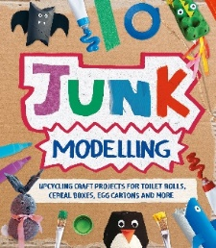
Understanding the World
Being Imaginative and Expressive
Creating with Materials
Displays/ folders
What did we do last time?
Last term?
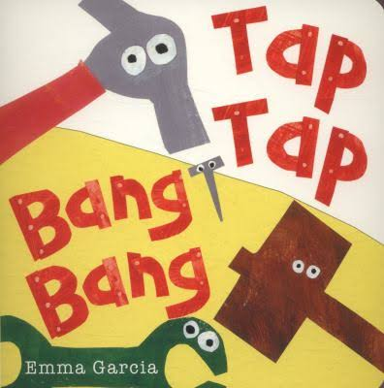
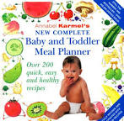

Construction Area;
indoor and outdoor
(large and small)
Junk modelling Area

Woodwork Area
EYFS Designer will take part in DT projects
Autumn Term: U is for Unique
- Design and make a patterned Christmas decoration using malleable materials
- Design and make a baby food using fruits and vegetables
Spring Term: C is for Community
- Designing and making buildings
- Designing and making pathways
Summer Term: A is for Alive
- Design and make a seeded flapjack
- Design and make a birdfeeder

DT opportunities
in our environment

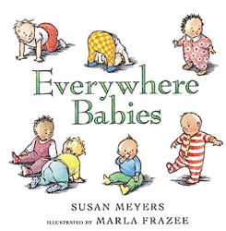
Forest School;
Cookery,
crafts using
natural materials

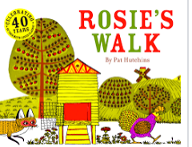
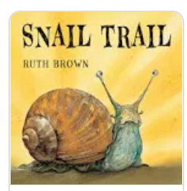
Mud kitchen
Malleable Area
Cookery during Adventure Time
Tools at forest school
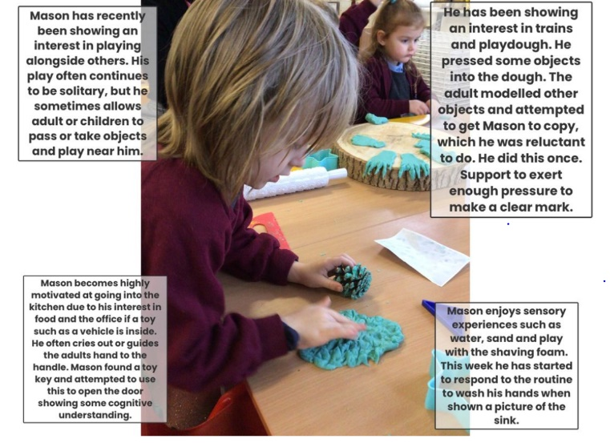
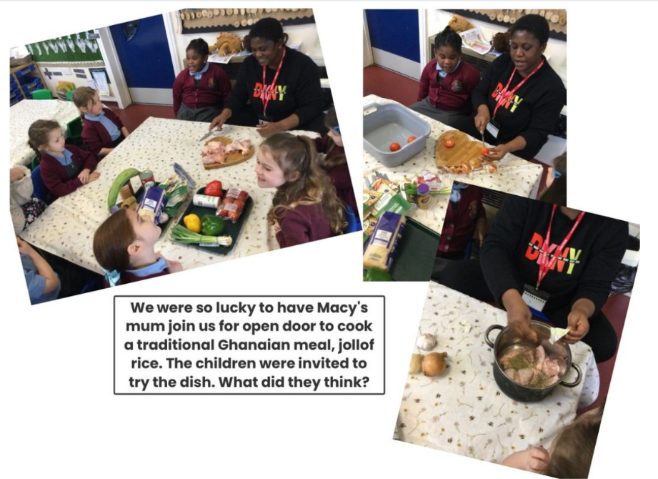
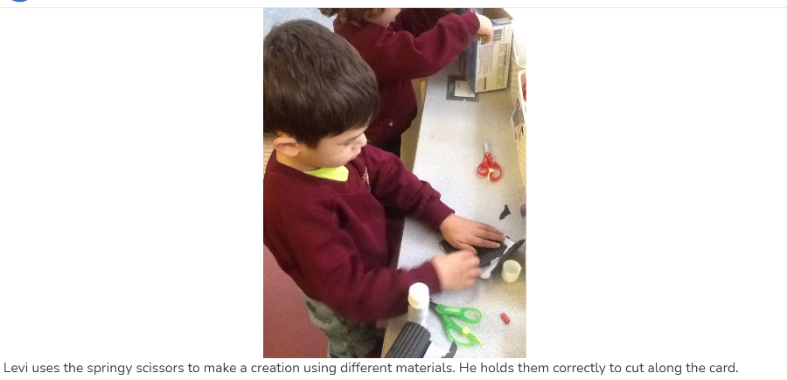
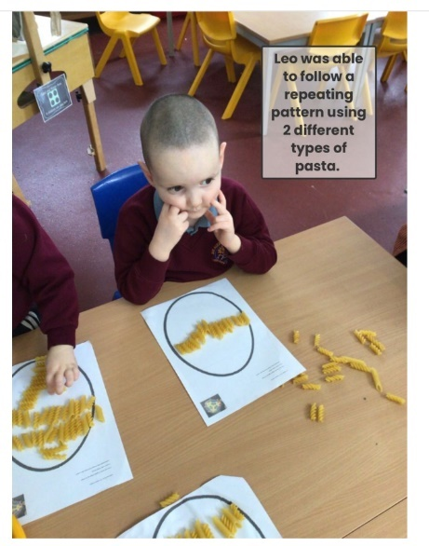
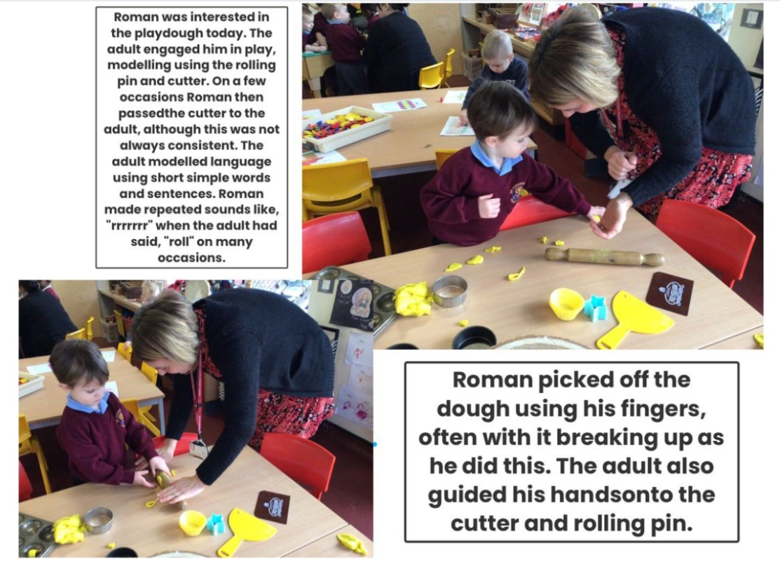
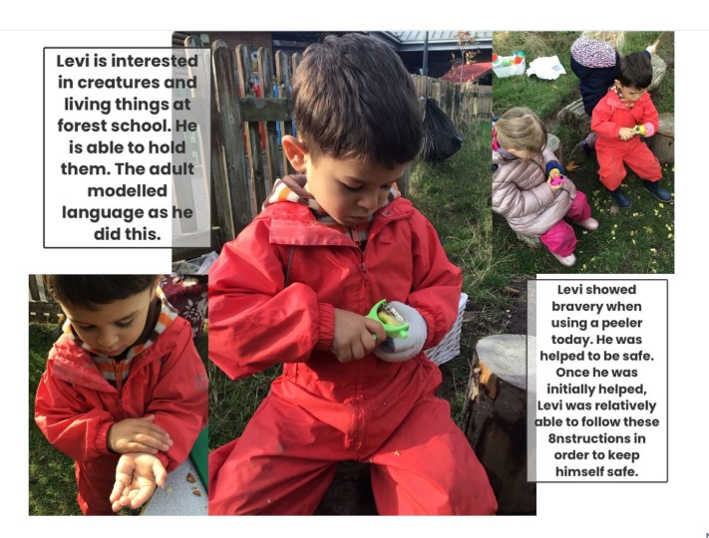
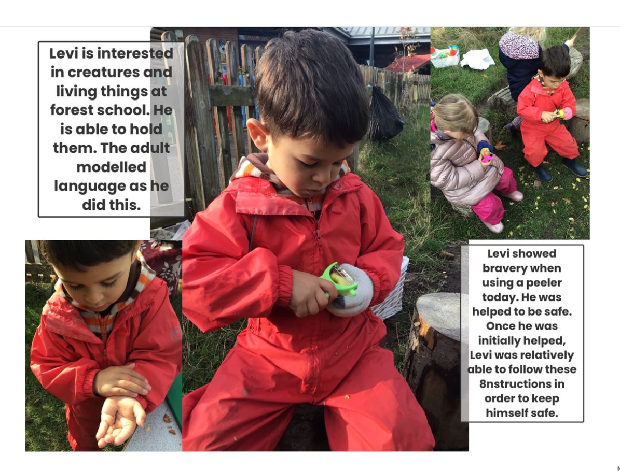
Evidence of children’s learning
The EYFS Statutory Framework highlights that there is no need for formal recording of children’s learning in the EYFS, especially as this can detract from teaching and high quality interactions.
Adult’s record significant moments on some occasions. Adult’s ensure they know their children well and can talk about what they do and say.
Adult’s know the curriculum is being implemented as they hear children using the target language and children show their knowledge through play.
Some evidence will be recorded on Seesaw, as follows.
The DT Co-ordinator will see small group, whole class and playful discussions taking place.

Learning DT in the EYFS can be through adult modelling and teaching techniques. It can be through being creative and exploring their own ideas in Adventure time. Or it can be through planned projects.
DT projects follows the sequence of:
To appraise and evaluate existing designs | To explore techniques | To design and make their own design  Sometimes to record their design | To evaluate their design
Explore edible seeds; how do they look? How do they smell? How do they taste?  Look at ready-made flapjacks. What is your opinion? What shapes do they come in? Do they look the same? Compare them. Which flapjacks are healthier than the others? Which should be eaten as a treat?  Vocabulary: sweet, oats, crunchy, salty, chewy, pointy, striped, sunflower, pumpkin, poppy, seed | Adult to teach children how to follow and make a simple flapjack recipe.  Children use tools, measuring tools.  Skills of measuring, stirring, combining | Children choose which seeds they will include in their flapjack, record this.  Follow the recipe again, adding their chosen seeds.  Children choose a shape tin. | Taste their flapjack.  What do you like about it?  How would you change it next time?
Explore buildings in the community.  Images/ maps/ photographs/ visit to the local area  Look at examples made by the adult/ previous cohort  What do you notice? Do you like this structure? Why? Why not? | Explore cutting and joining techniques; as per the Common Play Behaviours document.  How could you add windows to the church? | Children choose a building and make it using materials.  Record a map of the construction. | Talk about what you have made.  How did you make it? Draw out what techniques you have used.  Is there anything you could improve?  Peer evaluation.
Children taste purchased baby food.  What do you notice? Discuss texture, colour, smell. What does it remind you of?  Why is it this way? Links to consumer. | Explore pureeing techniques; boiling, mashing with a fork or potato masher, potato ricer.  Explore soft and hard fruits. How can you tell?  Skill; cutting, healthy eating, mashing, pureeing. | Children choose ingredients as a group to design and make a baby food. | Test it out; feed a baby!  Was it successful or unsuccessful?  Why? What could we do next time?
Look at existing Christmas decorations.  What do you notice? Discuss patterns, shapes, materials, features – how do they hang? What colours have been chosen? Why do you think this is?  Compare them – do they both use string to hang the decoration? | Explore patterning; through direct teaching/ painting, printing, peg boards, maths resources.  Explore malleable materials; how to shape.  Explore patterning in malleable materials using sequins, printing/ pressing. | Design and make a salt dough decoration. Choose which way you will decorate it? | Is it patterned?  Is it attractive?  Doe it work? Does it hang from a tree?  How could you improve it?

How does our curriculum prepare children for future learning?
The planned DT opportunities and directed challenges link explicitly to the lessons in Y1. The core areas of cooking, structures and mechanisms are addressed in the EYFS curriculum.
- Children in the EYFS learn the basic skills of cutting and fixing which support them to make a moving slider in Y1.
- Children in the EYFS cut and stew fruits and vegetables which lays foundational knowledge for making healthy smoothies more independently in Y1.
- Children in the EYFS learn how to build, join and fix buildings which supports them to create a free-standing windmill in Y1.

