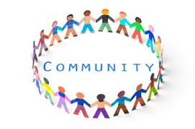
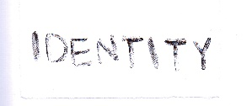
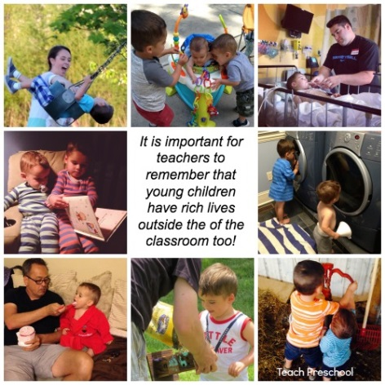
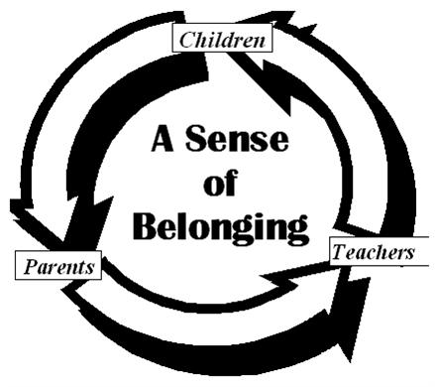
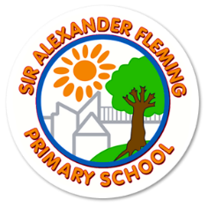
Early Years Foundation Stage
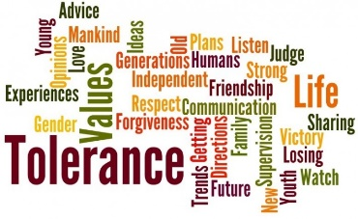
Curriculum Overview
Autumn 1
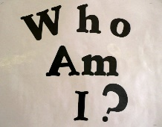
U is for Unique
Hypothesis
As a school, it is our priority to build positive relationships with children and their families. Bruce believes that when children feel secure that they perform better. Young children are ego-centric (Pollard) and therefore are interested in matters which relate to their own lives. What matters to children is themselves! Practitioners have chosen this project as all children can relate to it and have experiences of the key themes such as faces and homes. This is also important to our school, due to the limited life experiences some of the children may have had. Practitioners feel that this project is relatable and accessible to all parents, thereby further strengthening parental partnerships, which will ultimately improve child outcomes. This project will develop children’s sense of belonging within the setting as well as developing an understanding and respect for other’s lives. The professionals in the Foundation Stage have also reflected on their practice and recognise a need to provide children with opportunities in which they are exposed to a variety of people, cultures and ways of life. This project will allow this.
Provocation
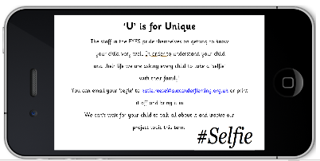
Every child and their family were set a ‘Holiday Challenge’ in which they were asked to take a family ‘selfie’. Children will be encouraged to discuss their photographs to enhance their speaking and listening skills and talk about their lives. This will also give practitioners an insight into the child’s experiences and interests and act as a vehicle towards building strong relationships between them.

Strengthening Parent Partnership
Expressing to parents that we are interested in the whole child. Most of a child’s important experiences happen at home. Celebrating and discussing these experiences.
Rites of passage.
Being honest and open about what children can do. Building on their previous knowledge and utilising their strengths and interests.
Being aware of each child’s home traditions and cultures. Enriching other children’s experiences by sharing what is important to each of us.
Recognising similarities and differences. Understanding others and being understood.
Using Seesaw to enhance the ways we communicate with children and their families.

Sense of belonging
To develop self-confidence/ security to show adults and children what they are capable of.
To be in a secure environment in which they know that they are safe and valued.
A learning community/ community learning contract. Children learn from other children. Children are not empty vessels!
Knowing their place in the world. Being ambitious.
Showing tolerance and understanding regarding others’ and their culture.
Change and growth exploration.
Philosophy for children; exploring what it might mean to be human.

Communication and language
Listening, attention and understanding
Children will know . . .  (Knowledge) | How we will deliver this . . .  (Pedagogy)
N  - Listen with interest to songs, rhymes and stories for a few minutes.  - Listen to others one to one.  R  - Sit quietly when appropriate.  - Join in with repeated refrains in stories.  - Respond to what they’ve heard through words or actions.  Y1  - Make comments about what they have heard and ask questions to clarify understanding. | - Nursery rhyme time every registration  - Weekly song focus  - Story time daily  - Theatre role-play in CP  - All adults engaging in high quality interactions at all time.  - Forest school to develop curiosity.  - Music area

Speaking
Children will know . . . | Children will say . . . | How we will deliver this . . .
N  - Use simple sentences.  - Begin to learn new words rapidly.  R  - Use more complex sentences.  - Use words to connect ideas, when prompted.  Y1  - Express ideas and feelings using full sentences.  - Offer explanations about why things may happen. | Nouns  But, and  (Adjective)  Maybe, perhaps, what about, I think | - High quality interactions; all staff  - Helicopter stories (at least once a week for all children  - A weekly nursery rhyme  - Story time daily  - Stories used in numbers and patterns sessions  - Environment considerations; high quality role-play, small world and construction areas  - Home challenge; to inspire talking about what they know  - Neli (R), Talk Boost (N) starting Sept 2022

Physical Development
Gross-motor
Children will know . . . | Children will say . . . | How we will deliver this . . .
N  - Tries to stand on one foot.  - Imitates simple movements.  - Catch a balloon.  - Pedals a tricycle.  - Kicks a ball.  R  - Jumps in place with two feet together.  - Balance and hop on one foot.  - Catch a big ball.  Y1  - To balance along a beam.  - Catch a small ball.  - To kick ball forwards. | Kick, catch, throw, ball, bike, foot.  Balance, jump, hop, swing, hang.  Beam, alternative, forwards. | - Access to a planned physical development activity outdoors daily.  - Weekly PE for Reception  - Healthy Movers activities 2 x a week  - Squiggle while you wiggle

Fine-motor
Children will know . . . | Children will say . . . | How we will deliver this . . .
N  - Copy a circle and line.  - Roll a sausage of dough.  - Balance a tower of blocks.  - To put pieces into an inset jigsaw.  - Begins to use a knife to cut soft, long foods which can be easily steadied.  R  - Use a dominant hand.  - Snips paper using scissors.  - Writes their name and tries to copy letters.  - Use a rolling pin to flatten dough.  - Build a simple model out of Duplo.  - Join together pieces in a jigsaw.  - Uses a knife to chop soft materials with safety and control..  Y1  - Build a simple model out of Lego  - Cutting out simple shapes.  - Colour within the lines.  - Form all letters of the alphabet (lower case).  - Use a pincer grip. | Draw, colour, block, marks, writing, playdough, roll, jigsaw, cut, scissors  Use the handwriting patter.  Name, rolling pin, dough, build, circle  Model, 2D shapes x 5 – triangle, square, circle, rectangle, diamond, letter names | - Malleable area provision  - A writing area in every class base  - Access to the Art Studio daily  - Expressive Art and Design Project – Paul Klee Faces

Personal, Social and Emotional Development
Self-regulation
Children will know . . . | Children will say . . . | How we will deliver this . . .
N  - To identify two basic emotions; happy and not happy (sad).  - To regulate their self to sit for a few minutes in a place the adult asks them to.  - To follow a simple adult request, with modelling and a reminder.  R  - To join in with the routine of the day, with prompts to support them.  - To identify 4 emotions; happy, sad, hungry, angry.  - To follow a simple adult request.  Y1  - To identify emotions in themselves and others and regulate their behaviour accordingly.  - To immediately follow a direct adult request, and understand the reasons for the request, for example safety.  - To set and work towards simple goals.  - To wait their turn for equipment, resources or within a game. | Happy, not happy, sad, listen  Angry, hungry, feeling, safe, my turn  Taking turns, patient, persevere | - Daily small group sessions in N  - Carpet sessions  - Adults supporting behaviour during open door sessions – encouraging children to play together, take turns, make choices  - Stories about diversity to support understanding of respect –  - Home challenge – to listen to others and their experiences  - Emotions in fairytales – The three little pigs, the Gingerbread man

Managing self
Children will know . . . | Children will say . . . | How we will deliver this . . .
N  - To know what the toilet is used for.  - Help by attempting to pull up their clothing when getting changed.  - Pull the zip on their coat up or down.  R  - Use the toilet independently.  - Put their coat on and make good attempts at doing up their zip.  - Attempt to put their arms into an apron.  - Sustain their interest in an activity of their own choosing for ten minutes.  Y1  - To change their clothing independently. | Toilet, wee, pooh, zip, up, down  On my own, apron, on, coat, top, trousers | - Weekly PE sessions  - Access to Open Door – art studio, sports equipment ( See open door plan)  - Scheduled times to go to the toilet, adults supporting and removing support as necessary  - Daily shared snack in N, rolling snack in R, playtime snack Y1

Building Relationships
Children will know . . . | Children will say . . . | How we will deliver this . . .
N  - Be able to leave their caregiver with the support of a teacher.  - Play alongside others.  - Begin to take turns and share with adult support.  R  - To express their needs and wants to other children using words and actions.  - To have a significant friend.  - To take turns and share resources with another child.  Y1  - Show sensitivity to other’s feelings, needs and wants.  - To play reciprocally with another child.  - To engage in play with a group of others. | Mummy, daddy, nanny, Miss Reese, play, my turn  Your turn, share, Can I . . .? It’s my turn, friend  Kind, together | - Drawing their family  - Sharing and talking about their family – home challenge  - Open Door sessions  - N – Peace at last focus

Literacy
Comprehension
Children will know . . . | Children will say . . . | How we will deliver this . . .
N  - How to turn pages in a book.  - To join in with some repeated words in rhymes, songs and simple stories.  R  - To talk about significant events in stories they know well.  - To recall key parts of a story.  Y1  - Retell stories and narratives using their own words and those that they have recently been taught.  - Know a greater number of stories.  - Anticipate what may happen in a story. | Book, story, incy wincy (words)  Once upon a time, next  One day, night | - Focus stories – Peace at last  - Focus rhymes – Incey Wincey  - Role-play; books  - Small world  - A weekly story at forest school  - Helicopter stories (once a week)  - Small group story focus weekly  - Rainbow readers in R and Y1

Word Reading
Children will know . . . | Children will say . . . | How we will deliver this . . .
N  - To begin to know that print gives meaning.  R  - To hear and identify initial sounds in words.  - To orally blend a CVC word.  - To read words using the GPCs taught (single letters).  Y1  - To read words and sentences using the GPCs taught (including at least ten digraphs) |  | - Phase 1 teaching in N  - Jolly Phonics scheme, discrete teaching daily  - Independent readers  - Home reading focus - seesaw  - Reading application at forest school  - Rainbow reading in Y1/ decodable book

Writing
Children will know . . . | Children will say . . . | How we will deliver this . . .
N  - That they can create marks using a variety of media.  R  - They can write their name.  - They can form the single letters they have been taught.  - They begin to write CVC words using the GPCs taught.  Y1  - They can write phonetically decodable sentences using the GPCS taught, including ten digraphs. |  | - Jolly Phonic scheme; discrete teaching daily  - Forest School diary in Writing journal (R)  - English lessons (Y1)  - An adult allocated task in open door each week  - Writing resource area in all classrooms and outdoors

Mathematics
Number
Children will know . . . | Children will say . . . | How we will deliver this . . .
N  - When there are lots or not lots of objects.  - To say some number names in order forwards and backwards.  - To know a number can represent a quantity.  - To copy a pattern of actions.  R  - Numbers and place value to 5.  - Comparing groups.  - Addition and subtraction – one more, one less.  Y1  - Numbers and place value to 10.  - Addition – number bonds to ten. | Lots, one, not lots, how many, more.  One, two, three, four, five, most, few, one more, one less, forwards, backwards.  Add, equation, equals. | - Number songs and rhyme (1 x focus a week, at least)  - Discrete teaching in Numbers and Patterns (White Rose  - An adult allocated to outdoor maths each week.  - Number resource area in all classrooms and outdoors

Numerical patterns
Children will know . . . | Children will say . . . | How we will deliver this . . .
N  - To copy a repeated pattern of actions.  R  - Continue a repeated pattern using a range of media.  Y1  - Create a pattern and increasingly complex core.  - Creating a 4 characteristic pattern. | Clap, pat, stamp, then, next.  Repeat, again.  Double, characteristic, core, same, different. | - Art work-printing, cross-curricular.  - Songs – Hokey Cokey, Clap your Hands and Stamp your feet.

Understanding the World
People and Communities
Children will know . . . | Children will say . . . | How we will deliver this . . .
N  - People in their family and people who are not.  - The names of some of their care givers, teachers and a significant friends name.  - They have a place they live in.  - The names of two rooms in a house/ nursery.  R  - Most of the children’s names and all the teachers who support them in their class.  - That they are part of at least two communities; home and school.  - Some of the features of their home.  Y1 Geography, RE, PSHE  - They belong to a class and that it is apart of a wider School community.  - Other people have feelings and how to work well within a school community.  - Land use around the school. | Mummy, daddy, nanny, Miss Reese, a child’s name, house, windows, roof, door, two rooms for example, bedroom, kitchen.  Different types of home for example a flat, bungalow.  Kitchen and associated features such as fridge, oven, sink.  Bathroom – toilet, sink.  Bedroom – bed, wardrobe.  Fish and chip shop, job, road, church, community centre, forest, path, bridge, traffic, office staff, headteacher, senior leaders, caretaker, responsibility, roles, allotment, playground. | - Books: Peace at last, Not Now Bernard.  - Nursery Rhymes and Songs: Wind the bobbin up, Going to build a house, Head, shoulders, knees and toes.  - Small world houses and homes.  - A nurturing home corner, which reflects some of the items in their homes.  - Home challenge – to bring in a photograph of their family in their home.  - See sequence of lessons for Autumn 1.

The Natural World
Children will know . . . | Children will say . . . | How we will deliver this . . .
N  - Where leaves come from.  - Notice what is happening to leaves in Autumn.  - The 4 basic features of a face.  - 4 Basic parts of the outside of a house  - 3 room names in a house  R  - Describe the changes that are happening in Autumn.  - More detailed features of their face.  - That homes can have similarities and differences.  - Conceptual knowledge of shelter and warmth.  - 3 different types of homes  Y1  - The difference between deciduous and evergreen trees.  - To name the 5 human senses. | Leaf, grass, tree, weather, rain, wind, falling, snow.  Nose, mouth, ears, eyes.  House, wall, roof, windows, door, kitchen, bathroom, bedroom, bed, oven, fridge, washing machine  Autumn, tree, twigs, logs, changing.  Eyebrows, eyelashes, cheek, chin.  Caravan, flat, same, different  Branch, trunk, deciduous, evergreen, dying, oak tree, acorn, pine-cone, fog, ice, frost, mist, sleet, hail, seasons, storm, thunder, lightening.  Look, touch, feel, smell, taste. | - Forest School Sessions.  - Art opportunities – collecting leaves, drawing leaves, mixing and exploring colour.  - Art Project – Faces.  - Books – information  - Videos  - Walk around local area

Past and Present
Enquiry Question: Were we always this way?
Children will know . . . | Children will say . . . | How we will deliver this . . .
N  - What babies are and what they need.  - That they were a baby.  R  - The difference between a baby and a child.  - That babies grow into children.  Y1  - How to sequence the lifecycle of a human. | Long ago, now, baby, cot, bottle.  Then, old, today, when  In the past, present, already happened, remember, different, before, earlier, older, foetus, toddler, adolescent, OAP. | - See Past and Present sequence of lessons.  - Real life experience – have a baby visit the setting. Primary evidence and some historical interpretation.  - Book – Information book; Now and then. My History. Primary evidence.  - Talking bags – baby objects/ sorting baby and child objects and comparing them. Primary evidence.  - Babies and themed resources in the home corner.  - Children to bring in photographs of them as babies/ artefacts such as baby clothing/ toys. Primary evidence.  - To mark-make what I have learnt – a baby in a cot with a nappy on etc. To talk about reasons for wearing a nappy etc.  - Create representations of me in the past and me now (the chronology of my life.)  - To test and make baby food.

People and Communities
Enquiry Question: What are the occasions people celebrate and why?

Children will know . . . | Children will say . . . | How we will deliver this . . .
N  - To recall some parts of a religious story.  - To talk about ways they celebrate with their family, with reference to a photograph.  - To join in with celebrations in school (where appropriate)  R  - To know the main parts in at least two religious stories related to Christianity and Hinduism.  - To talk about religious artefacts they can see.  - To recognise that different people celebrate in different ways.  Y  - To make simple comparisons between two religious stories.  - To retell the Nativity story in detail. | Christmas, Jesus, Angel, Three Kings, party  Joseph, Mary, Son of God, Shepherds, King Herod, hallelujah  Christian, Bible, celebrate | - Small world play  - Story books  - Videos  - Powerpoints – layering knowledge  - Information books  - Craft activities  - Talk bag of objects  - Home challenge – showing things they celebrate at home.

Computing
Children will know . . . | Children will say . . . | How we will deliver this . . .
N  - To use technology appropriately in play; press buttons, turn on and off, talk into a telephone.  - I can recognise some everyday examples of technology and know their uses.  - I know if a computer/ robot is on or off.  - I know I can press buttons to make something happen.  - Grown-ups must know when I am using a computer or tablet in order to keep me safe.  - I can make marks using digital drawing technology.  R  - I know that technology must be used safely.  - I know that a grown-up must know if I am using technology.  - I know I can communicate using technology.  - I can select tools in order to create a picture using drawing technology.  Y1  - I can explain what personal information is.  - I can explain what information should not be shared online.  - I can identify who are the adults I can trust.  - I can identify and follow the rules of using technology at home and at school. | N computer, tablet, phone, game, on, off, safe, button  R robot, press, grown-up/ adult, tools, instruction  Personal, information, share, online, password, safety. | - Project evolve  - Technology across areas; telephone, toys with buttons/ switches, torches, lights, lightboxes  - IWB

Expressive Arts and Design
Creating with Materials
Children will know . . . | Children will say . . . | How we will deliver this . . .
N  - Know that artwork isn’t always flat; To build with a variety of objects including shapes  - Describe the texture of materials in simplistic terms  - Place objects to create artwork. Begin to do this purposefully.  - Know the name of an artist.  - I can use two methods of joining materials such as glue and tape. I use these techniques with increasing accuracy.  - I can use spring scissors to cut strips off from paper.  - I can snip with regular scissors. I begin to cut food with a knife.  - I begin to create models with a purpose. I can talk about my design choices.  - I can do a simple fold using regular paper.  - I can use a rolling pin to roll out play dough for a purpose such as cutting out a flat shape.  - I can roll a sausage by pushing my hands forwards and backwards, on the table.  - I can roll a sausage in the palms of my hands.  R  - Use marks to create representations.  - Use lines and a variety of shapes to draw a detailed portrait.  - Know the name of two artists.  - I select a method based on the purpose/ properties of materials.  - I use tools to cut and shape foods with increasing independence.  Y1  - Name the primary colours  - Explore mixing of colours to identify secondary colours.  - Find collections of colours  - Applying colour with a range of tools  - Make as many tints of one colour as possible (adding white)  - Use colour to express feelings | Hard, soft, build, tall, up, put, Andy Goldsworthy, down, side, fix, tape, I have, fold, push, squeeze, roll, cut, chop, knife  Draw, pencil, pen, crayon, paper, line, curve, Paul Klee, Chuck Close, shapes-round, square  Paint, primary colour, mix, 2D, sketchbook, tints, colour names. | - Paul Klee/ portraits focus in the art studio  - Clay faces  - Malleable provision  - Autumn; natural objects at forest school – collage  - Construction  - Mark-making resources

Being Imaginative
Children will know . . . | Children will say . . . | How we will deliver this . . .
N  - Respond to an adult singing songs.  - Begin to use pretend objects as real ones (symbolic play).  R  - Join in with most of the words in a song they know.  - How to be able to take on a simple role such as a mother in the home corner.  - Begin to use objects to represent something else.  Y1  - Sing a range of songs and nursery rhymes.  - To add a narrative to their own role-play. | The repeated words in stories and songs. | Helicopter stories

