

N Bedroom, kitchen map, house, school, bridge, hut,

shed, grass, playground, sandpit, mud, grass, pond, go, rain, sun, snow, Sir Alexander Fleming Primary School, Africa, far away, hot, place, animals

R Flat, shop, church, next to, across the road,

path, come back, wind, fog UK, Telford, Ghana, in, flag, hotter, zebra, elephant, lion, rhino, hippo, giraffe

An EYFS Geographer will say . . .

An EYFS Geographer will know . . .

N Some of the rooms in a house

The human features of a place they know well; the Nursery Garden

The physical features of the Eco Garden.

That maps show places.

Some basic types of weather linked to seasons.

Africa is a place far away from the UK.

Africa is a hot place.

Some animals that live in Africa.

R Some places of significance in the Sutton Hill Community; shop, community centre, church.

To know what some people do in these places/ what these places are used for.

To know where these places are in relation to one another; next to, across the road.

That maps can be used to show routes.

More weather types linked to seasons.

Know that they live in the UK

Know school it is in Telford.

Ghana is in Africa.

Recognise the Ghanaian flag.

6 animals native to Africa.

Africa is hotter than the UK.



**Key Texts**

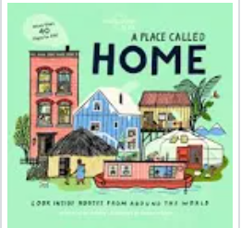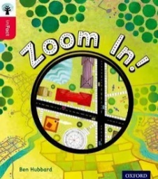

Displays/ folders - construction

What did we do last time?

Last term?

**Understanding the World**

**People, Culture and Communities**

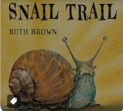

**EYFS geographers will take part in geography projects**

**Autumn Term Enquiry: Our Homes** *What are the features of a home?*

* Talk about and discuss homes using photographs and books
* Build homes in the construction area
* Role-play in the home corner/ small world homes

**Spring Term Enquiry Question: Our Community** *What helps keep us safe in our area?*

* Home challenge; to send in a photograph of a special place
* Visit to the local shops; later drawing the route on a map
* Building pathways using large and small scale construction
* Designing and making junk model buildings
* Building 3D maps of the community
* Drawing maps
* Using a map with Cubetto. Designing a map in order to move Cubetto.
* Using maps to locate places and objects at forest school.

**Summer Term Enquiry:** *What are the similarities and differences between where we live and Africa*

* Visit The Safari Park
* Small world animals and habitats
* Role-play; masks and African materials
* Videos/ photographs of a range of places in Africa

Routes on bikes

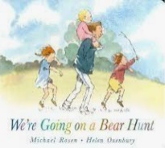

Globes, maps

**Geography opportunities**

**in our environment**

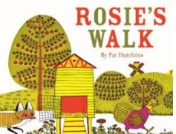

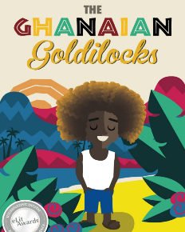

Small world places; buildings, roads, pathways

Book areas;

fiction and non-fiction

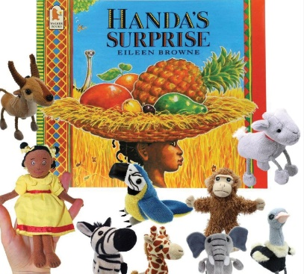

Forest school; places, weather

Weather depicted in yearly timeline

Story journeys

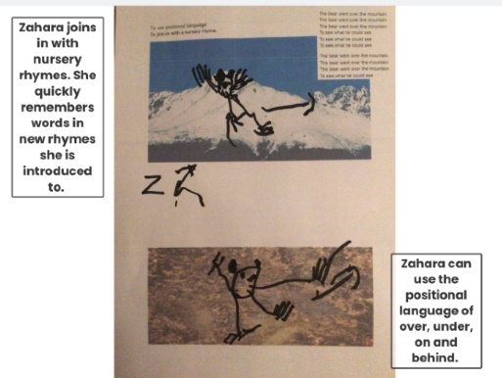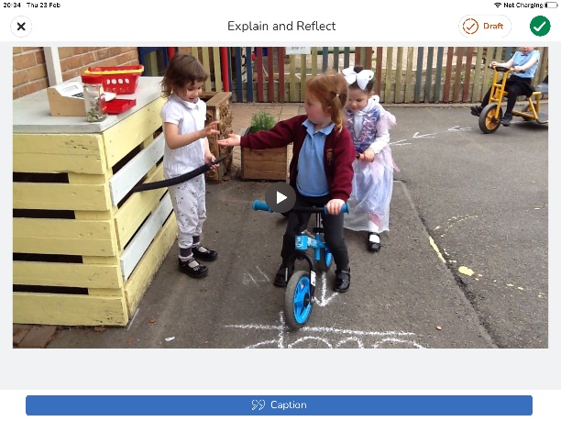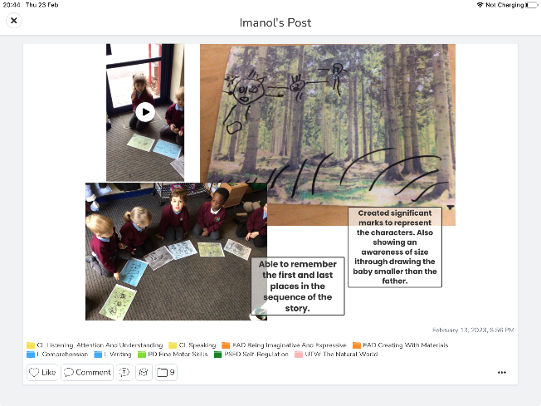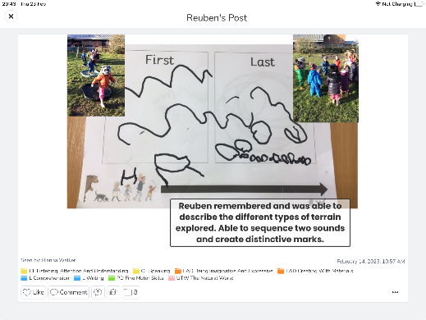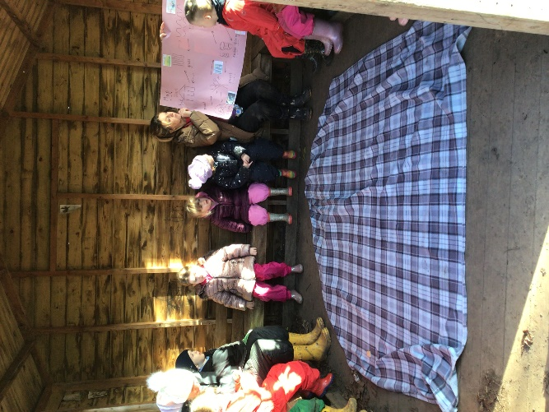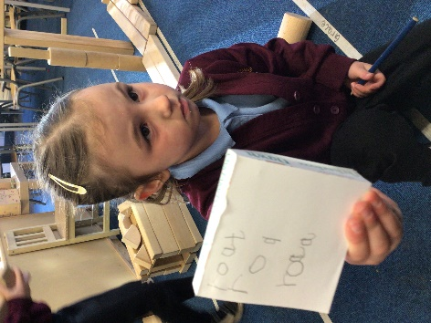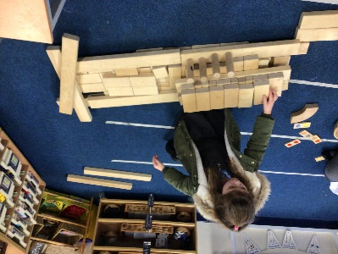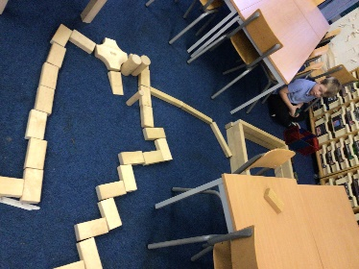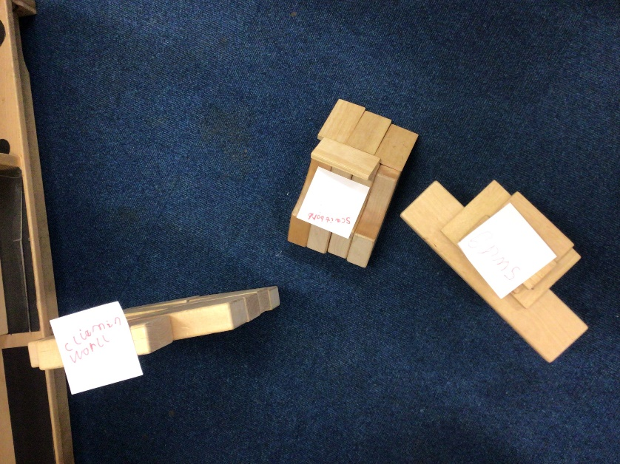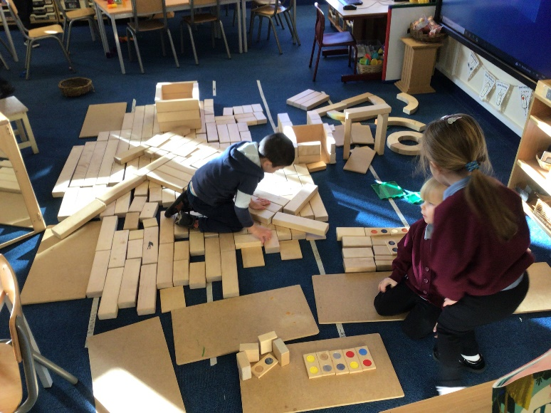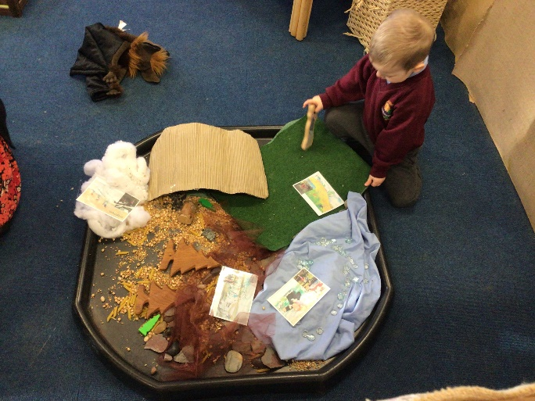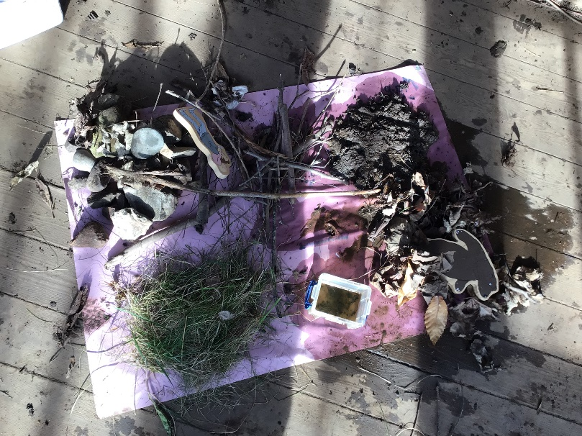

**Evidence of children’s learning**

The EYFS Statutory Framework highlights that there is no need for formal recording of children’s learning in the EYFS, especially as this can detract from teaching and high quality interactions.

Adult’s record significant moments on some occasions. Adult’s ensure they know their children well and can talk about what they do and say.

Adult’s know the curriculum is being implemented as they hear children using the target language and children show their knowledge through play.

Sometimes the sequence of learning is displayed on walls.

Some evidence will be recorded on Seesaw, as follows.

The Geography Co-ordinator will see small group,

whole class and playful discussions

taking place.