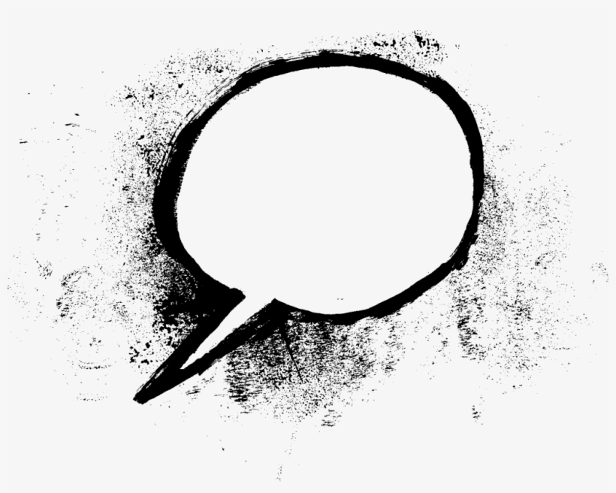

N Long ago, now, baby, cot, bottle, soon, poppy

R Then, old, today, when, next, grown-up, adult,

change, bigger, taller, remember, soldiers, die

**An EYFS Historian will know . . .**

N That they are a child.

That they will change over time.

What babies are and what they need.

That they were a baby.

That they have participated in events in the near past.

Recall some parts of stories set in the past.

R The difference between a baby and a child.

Their age and some significant ages of others.

The difference between a child and a grown-up.

The name of a significant historical figure and two key facts about their life.

How to talk about past, personal events.

Talk about some significant differences of the past, when studying stories set in the past.

An EYFS Historian will say . . .

Understanding the World

**Past and Present**

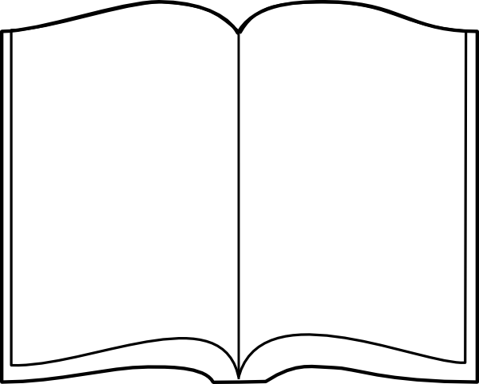

**Key Texts**

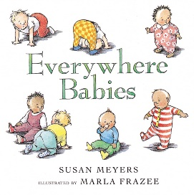

Displays/ floor books

What did we do last time?

Last term?

My History

(Non-fiction)

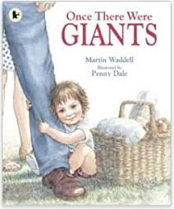

**EYFS historians will take part in history projects**

**Autumn Term Enquiry Question: Were we always this way?**

* Real life experience – have a baby visit the setting. *Primary evidence and some historical interpretation.*
* Book – Information book; Now and then. My History. *Primary evidence.*
* Talking bags – baby objects/ sorting baby and child objects and comparing them. *Primary evidence.*
* Children to bring in photographs of them as babies/ artefacts such as baby clothing/ toys. *Primary evidence.*
* To mark-make what I have learnt – a baby in a cot with a nappy on etc. To talk about reasons for wearing a nappy etc.
* Create representations of me in the past and me now (the chronology of my life.)

**Spring Term Enquiry Question: What were homes like in the past?**

* Images of children’s homes.
* Look at homes in stories and nursery rhymes; The House that Jack Built
* Artefacts from the past in the home corner
* Comparing items from the home from now and in the past. Have you ever seen one of these? What could this be?
* Blists Hill visit (R)

**Summer Term Enquiry Question: Who is the King of England?**

* Books about King Charles
* Thinking about his role.
* Knowing key facts about his family, place of residence.

Baby resources in the role-play area

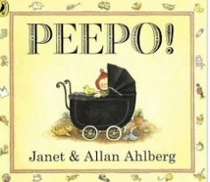

**History opportunities**

**in our environment**

Small world people of different ages

Past and present books;

fiction and non-fiction

A timeline of the year

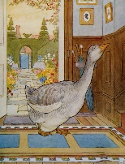

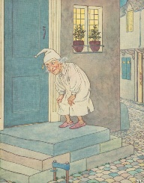

Nursery rhyme imagery

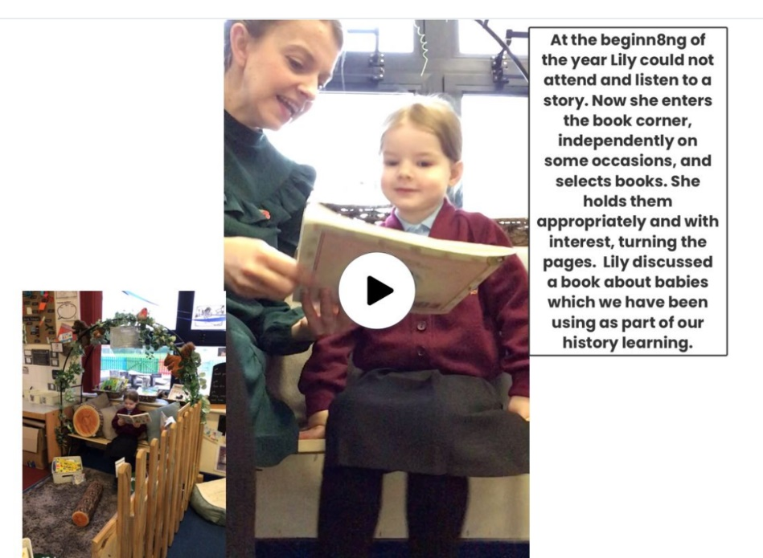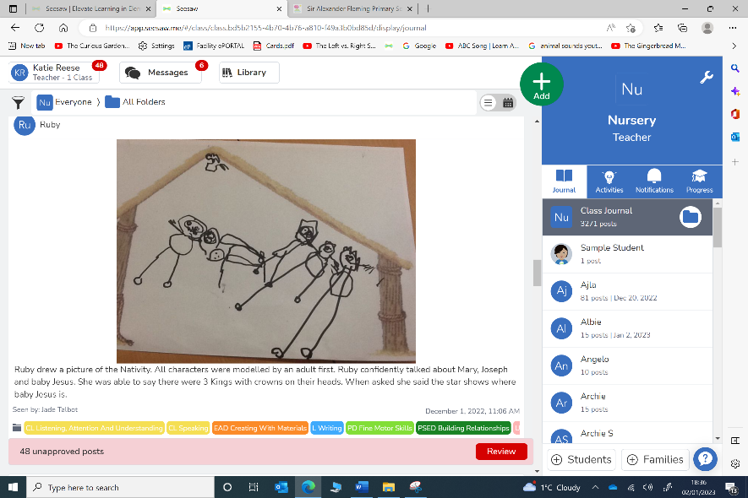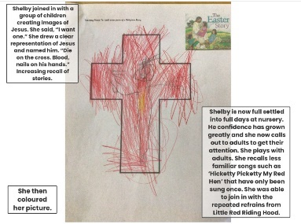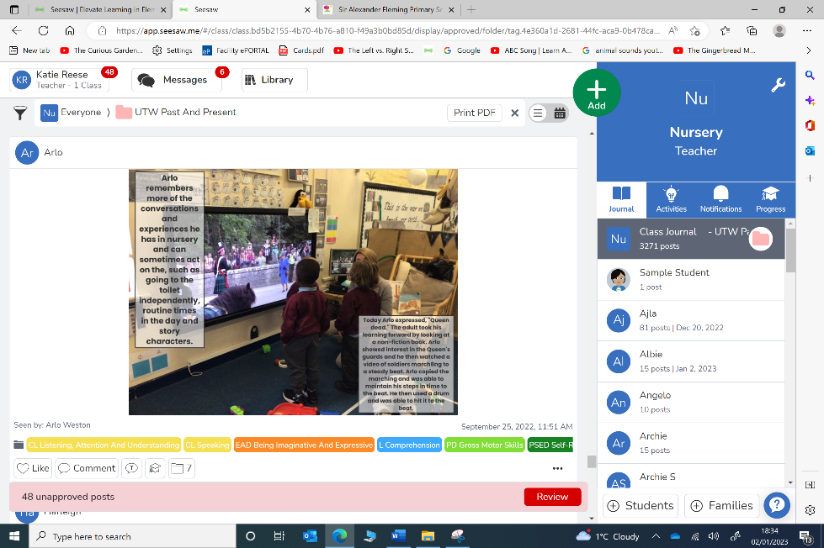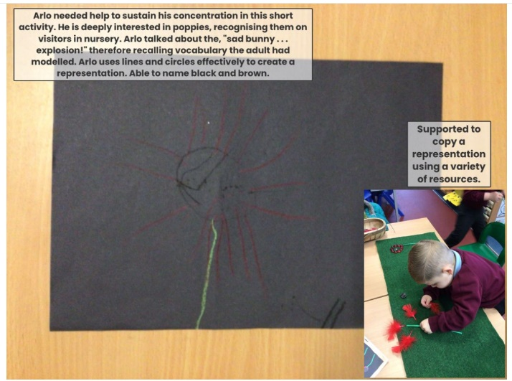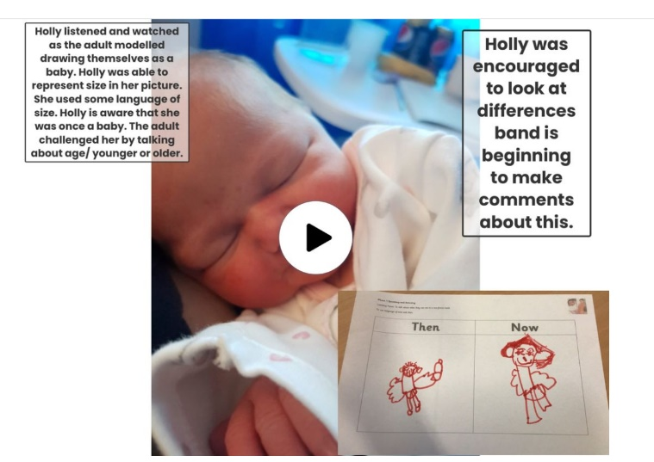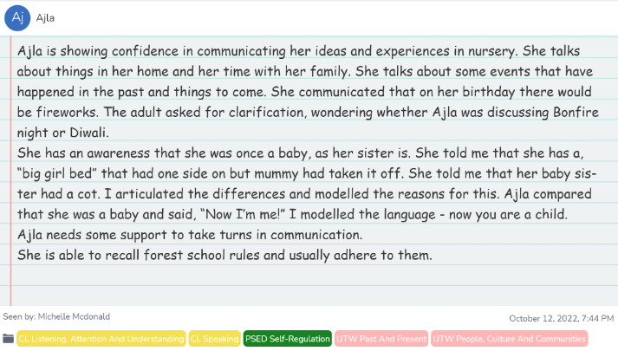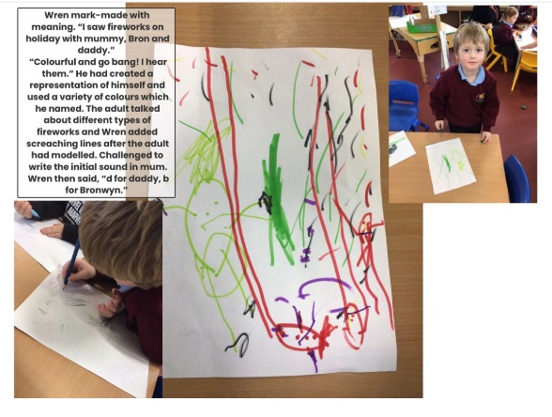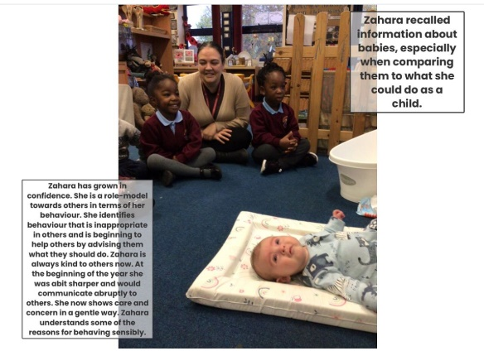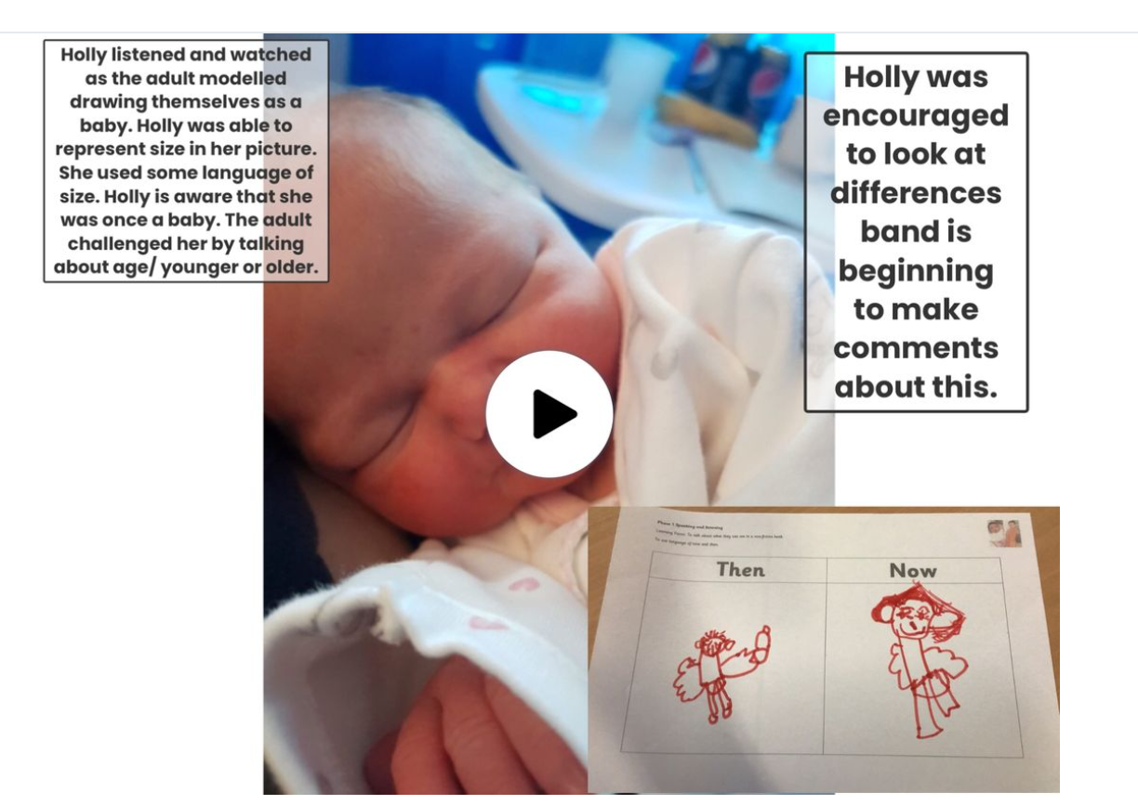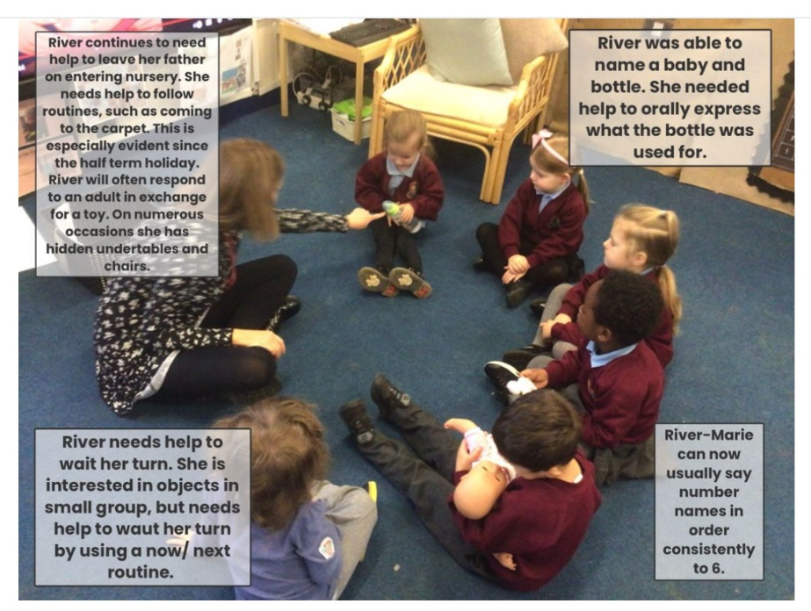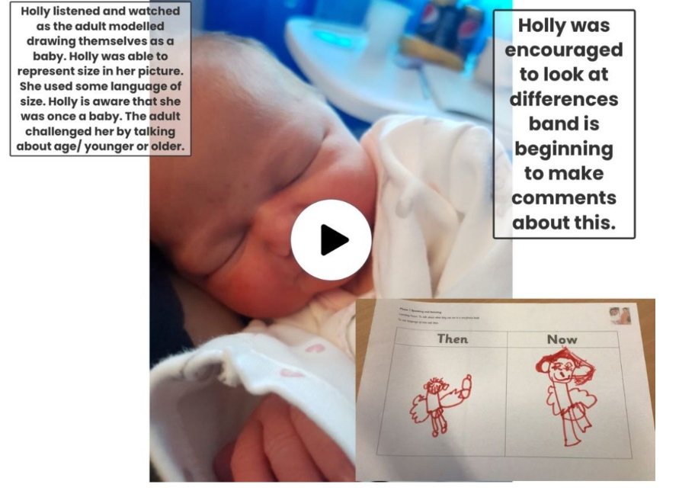

**Evidence of children’s learning**

The EYFS Statutory Framework highlights that there is no need for formal recording of children’s learning in the EYFS, especially as this can detract from teaching and high quality interactions.

Adult’s record significant moments on some occasions. Adult’s ensure they know their children well and can talk about what they do and say.

Adult’s know the curriculum is being implemented as they hear children using the target language and children show their knowledge through play.

Sometimes the sequence of learning is displayed on walls.

Some evidence will be recorded on Seesaw, as follows.

The History Co-ordinator will see small group,

Whole class and playful discussions taking place.