

N computer, tablet, phone, game, on, off, safe, button

R robot, press, grown-up/ adult, tools, instruction

An EYFS ICT technician will say . . .

**An EYFS ICT Technician will know . . .**

N I can recognise some everyday examples of technology and know their uses.

I know if a computer/ robot is on or off.

I know I can press buttons to make something happen.

Grown-ups must know when I am using a computer or tablet in order to keep me safe.

I can make marks using digital drawing technology.

R I know that technology must be used safely.

I know that a grown-up must know if I am using technology.

I know I can communicate using technology.

I can give an instruction to a robot and watch the outcome.

I can select tools in order to create a picture using drawing technology.

Understanding the World

**Computing and ICT**



**Key Texts**

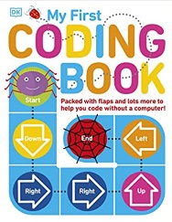

Displays/ floor books

What did we do last time?

Last term?

Technology in the role-play area; phone, shower, oven,

lamp

**EYFS ICT Technicians will take part in ICT projects**

**Autumn Term: U is for Unique**

* Technology in the environment
* Technology in our homes
* Ipad project; distorting images of our face
* E-safety; Project Evolve

**Spring Term: C is for Community**

* Cubetto Project
* E-safety; Project Evolve

**Summer Term: A is for Alive**

* E-safety; Project Evolve

**ICT opportunities**

**in our environment**

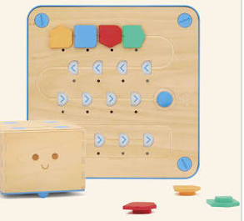

Books

Interactive

whiteboards;

access to online games,

digital drawing

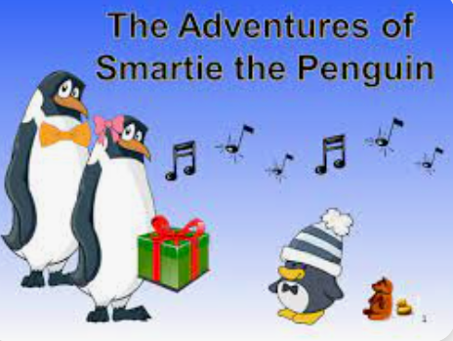

Electronic toys; torches, wind up toys, toys with buttons

Smartie the Penguin puppet; online safety

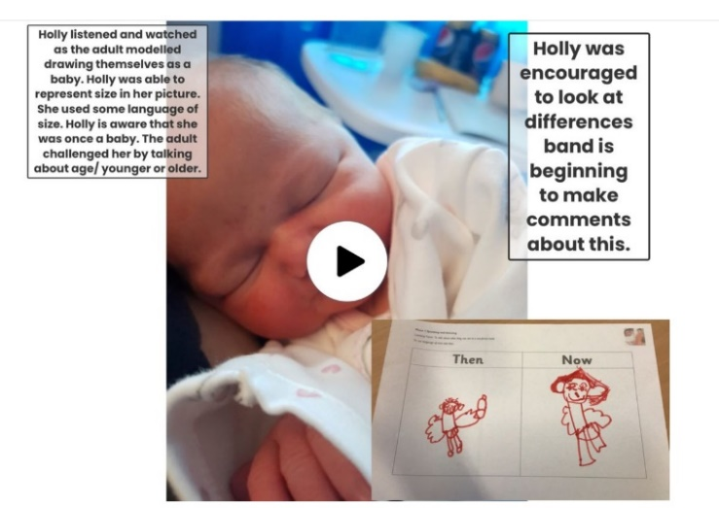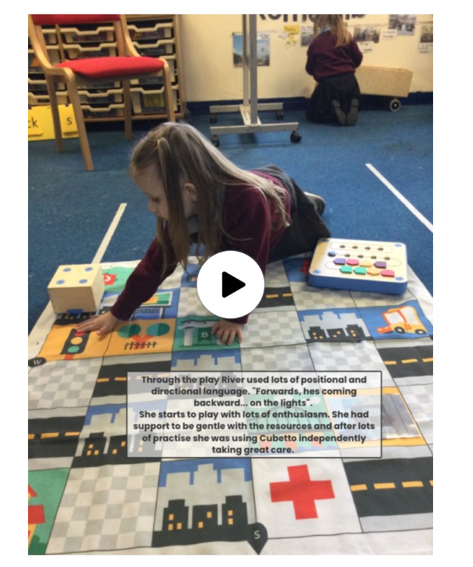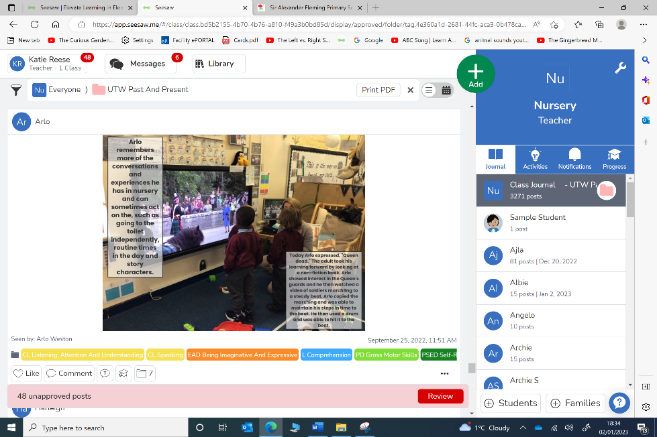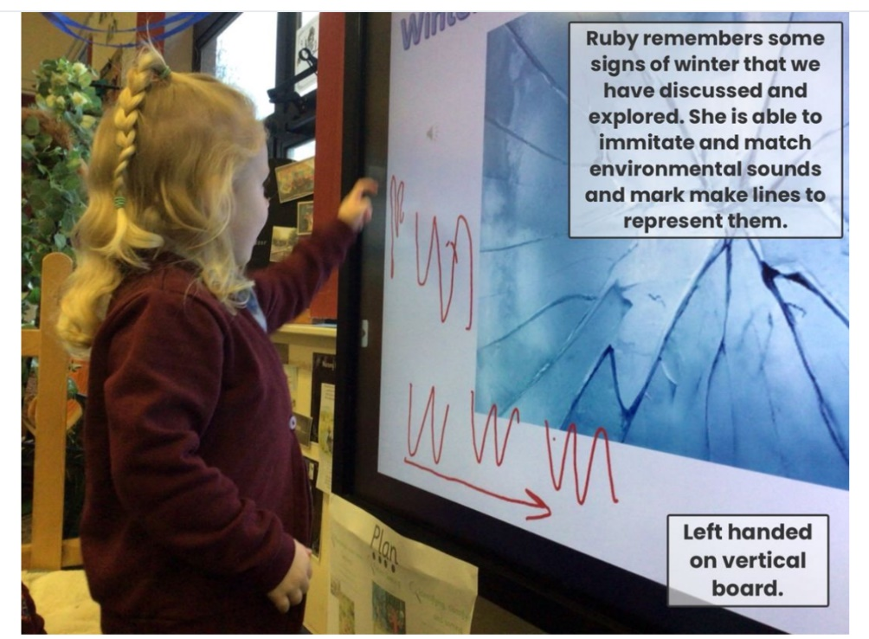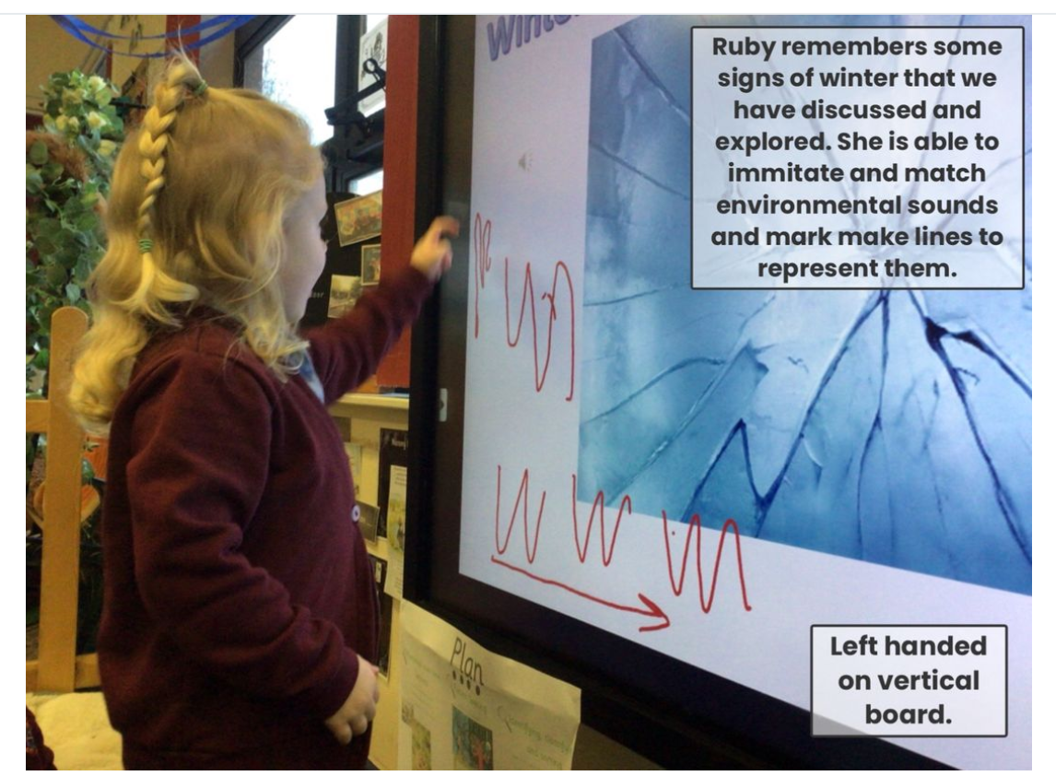

**Evidence of children’s learning**

The EYFS Statutory Framework highlights that there is no need for formal recording of children’s learning in the EYFS, especially as this can detract from teaching and high quality interactions.

Adult’s record significant moments on some occasions. Adult’s ensure they know their children well and can talk about what they do and say.

Adult’s know the curriculum is being implemented as they hear children using the target language and children show their knowledge through play.

Some evidence will be recorded on Seesaw, as follows.

The ICT Co-ordinator will see small group, whole class and playful discussions taking place.