

N nursery rhymes, instruments, share, listen, sing, play, learn, beat, loud, quiet, stop, move, hands, feet, shake, tap, hit

R action songs, respond, explore, pulse, rhythm, pitch, high, low, long, short, perform, share, actions, voice, big sounds, soft sounds, soft sounds, soft, medium, hard, solo, group, ring.

**An EYFS Musician will know . . .**

N To join in with words and actions in nursery rhymes and songs.

To know some nursery rhymes off by heart.

To enjoy moving to music.

To have an awareness of the pulse in songs and rhymes.

Have an awareness of volume.

R To know more nursery rhymes off by heart.

To know/ understand the stories behind the rhymes.

To match movements to types of songs and music.

To move with the pulse of music.

Have an awareness of pitch.

An EYFS Musician will say . . .

Understanding the World

**Being Imaginative and Expressive**

**Music**



**Key Texts**

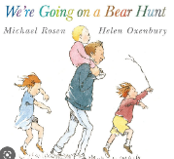

Displays/ floor books

What did we do last time?

Last term?

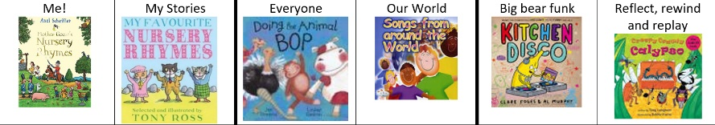

Theatre

Nursery Rhyme resources

CD player/ Alexa

Music Area;

indoor and outdoor

**EYFS Musicians will participate in . . .**

**All Year:**

* Small group (N) Phase 1 focussing of sounds, songs
* Daily Nursery Rhyme Time
* Weekly Charanga lesson (R)
* Weekly Squiggle While You Wiggle – moving to a range of songs
* Singing and chanting rhyming stories
* Poetry Basket- rhythm and pulse

**Music opportunities**

**in our environment**

Interactive

whiteboards;

music and dance to listen to

Music played at lunchtime

Cookery during Adventure Time

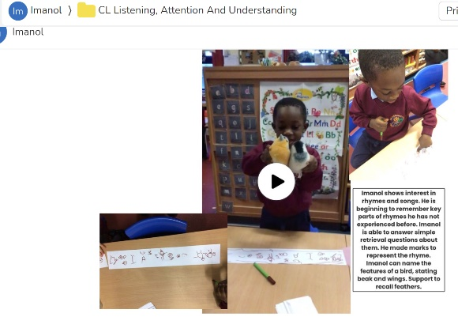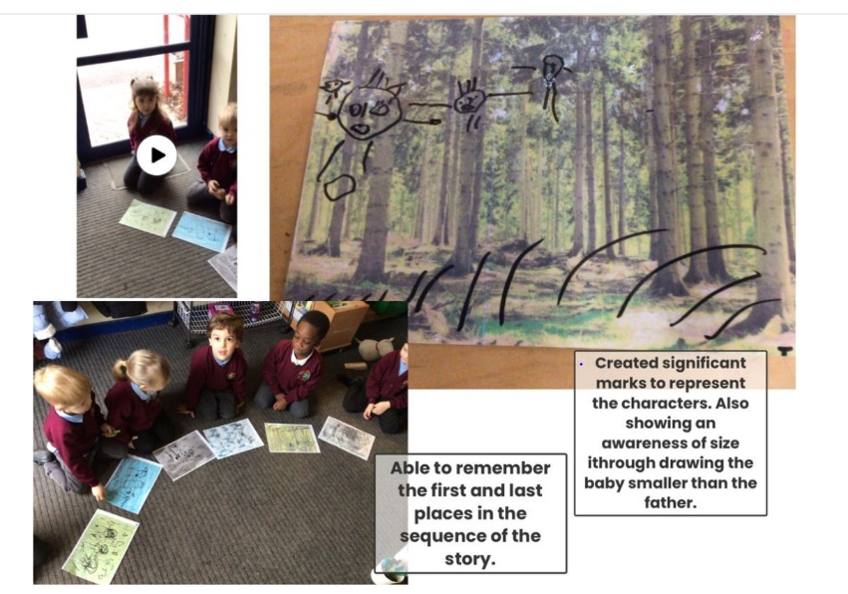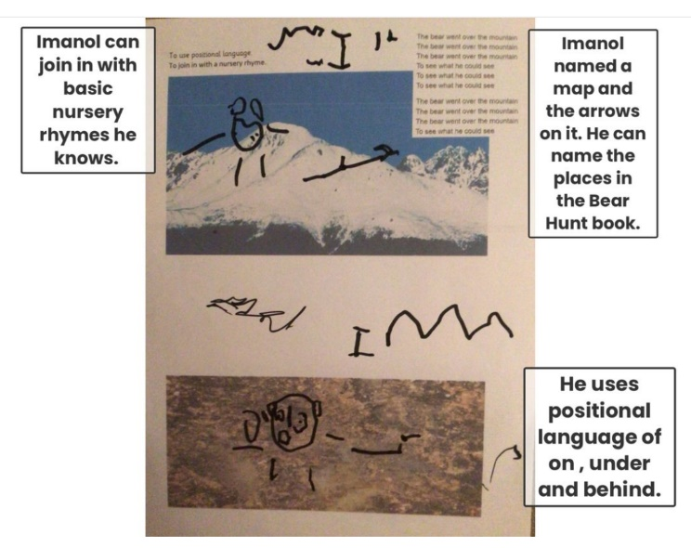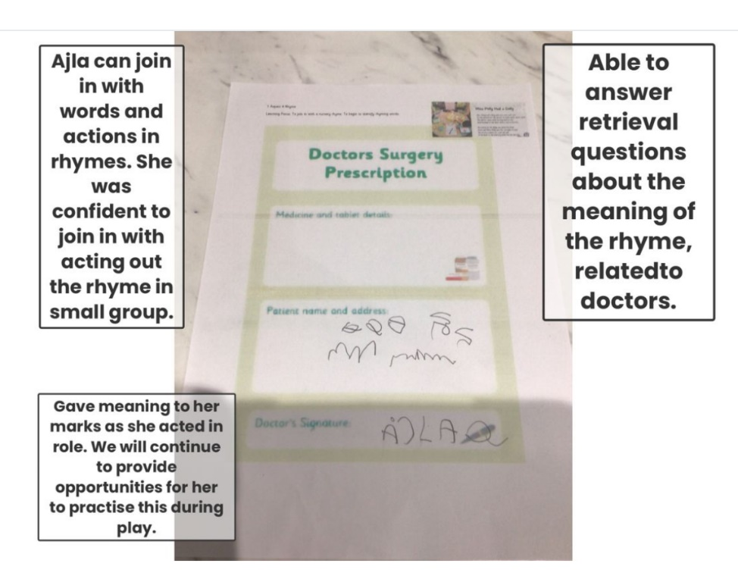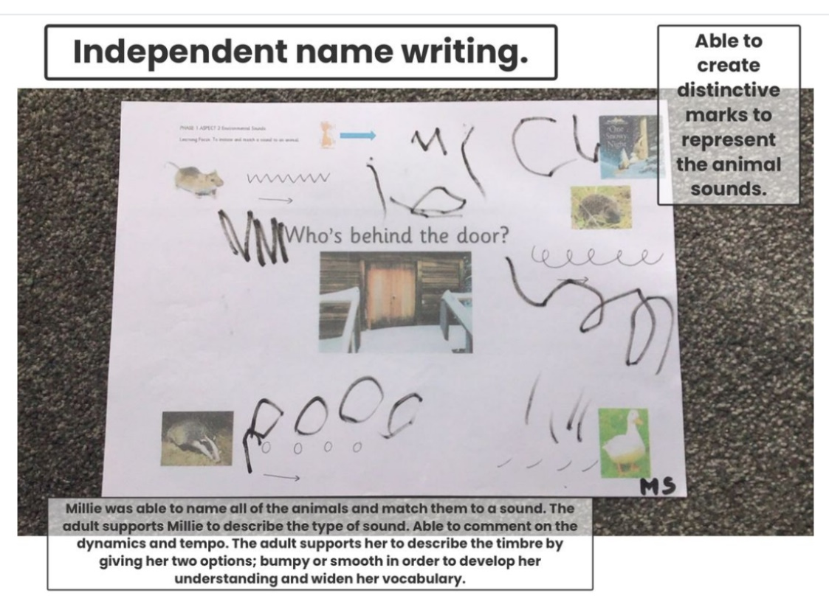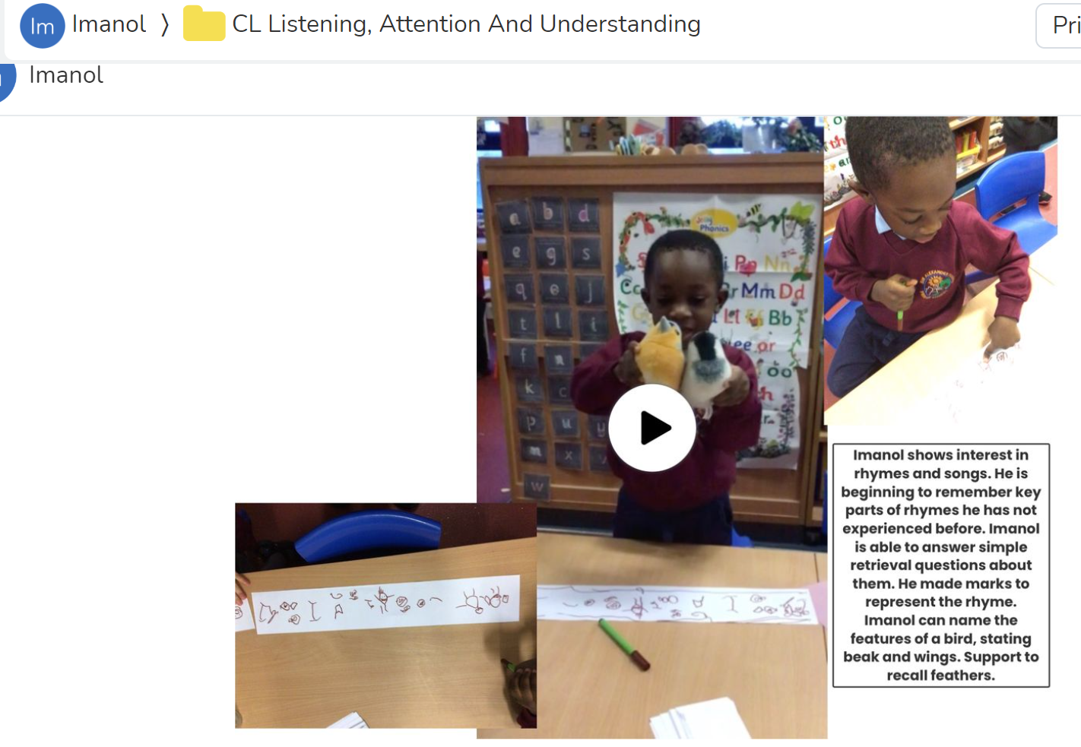

**Evidence of children’s learning**

The EYFS Statutory Framework highlights that there is no need for formal recording of children’s learning in the EYFS, especially as this can detract from teaching and high quality interactions.

Adult’s record significant moments on some occasions. Adult’s ensure they know their children well and can talk about what they do and say.

Adult’s know the curriculum is being implemented as they hear children using the target language and children show their knowledge through play.

Some evidence will be recorded on Seesaw, as follows.

The Music Co-ordinator will see small group, whole class and playful discussions taking place.