Geography Long Term Curriculum Overview
 | EYFS | Year 1 | Year 2 | Year 3 | Year 4 | Year 5 | Year 6
Autumn Term | U is for Unique  Our Homes  What are the features of a home?  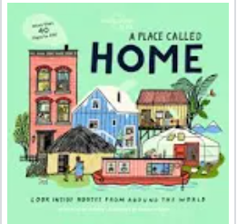 | Our school, our area (Telford)  Which parts of my local area could be improved?  OR  Do the school ground encourage wildlife?  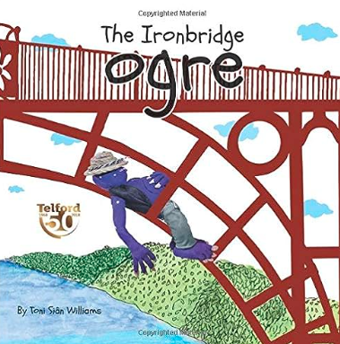 | Hot and cold countries  How does our climate compare to that of others? | Settlements  How and why have settlements changed over time?  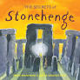 | European study: Greece  How does life in Greece compare to my own?  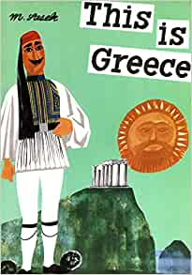 | Antarctica  ‘A runway is to be built in Antarctica for an aircraft to fly in researchers who are involved in conserving the whale population of the region.’  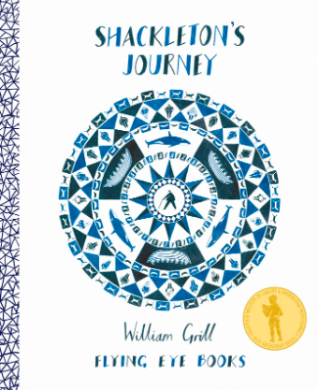 | Economic activity and distribution of natural materials  What impact does trade have on our area?
Spring Term | C is for Community  What helps keep us safe in our area?  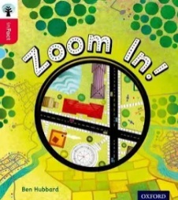 | Seasons and weather  How does the weather influence our lives?  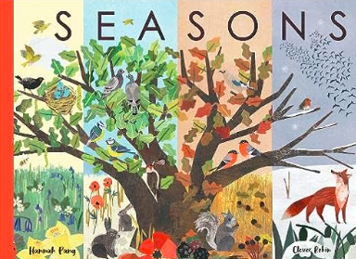  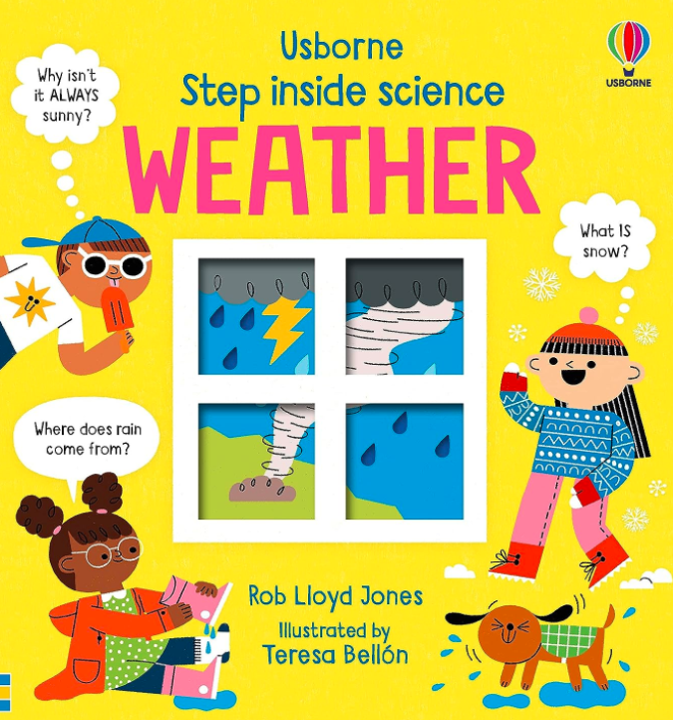 | Geographical skills and fieldwork  ‘The council would like to close our local high street to cars and only allow people to walk along it’.  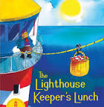 | Rainforests  How can we save the world’s lungs? | Earthquakes and volcanoes  What would happen is the same earthquake or volcano eruption was to happen here?  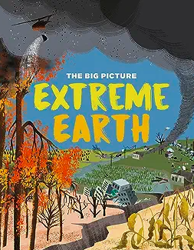 | North and South America  How does a region of North or South America compare to where I live? | European study: France  How does life and the environment in France compare to where I live?  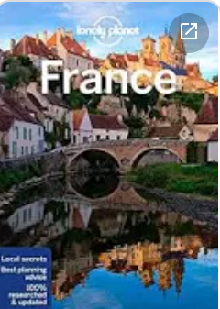
Summer Term | A is for Alive  African Animals  What are the similarities and differences between where we live and Africa? | Our place in the world  What are the human and physical features of the country we live in?  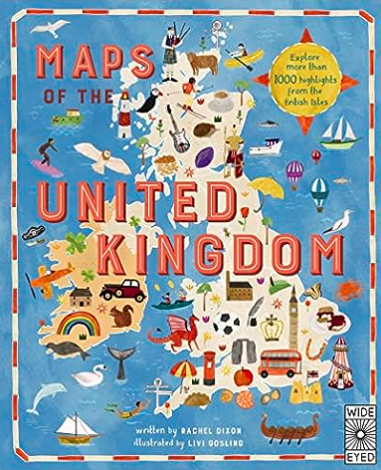 | Coasts  What features can be found along the coastline?  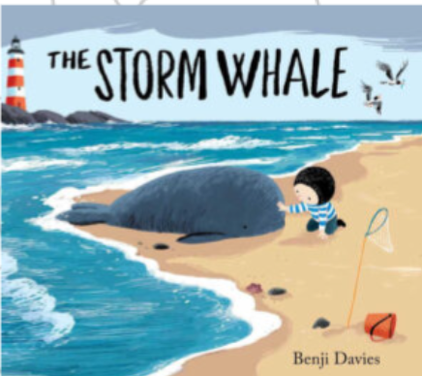 | Rivers  Why do people live in flood-prone areas?  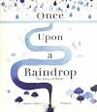 | Local study (Housing/  land use)  Where is the best place to build new houses?  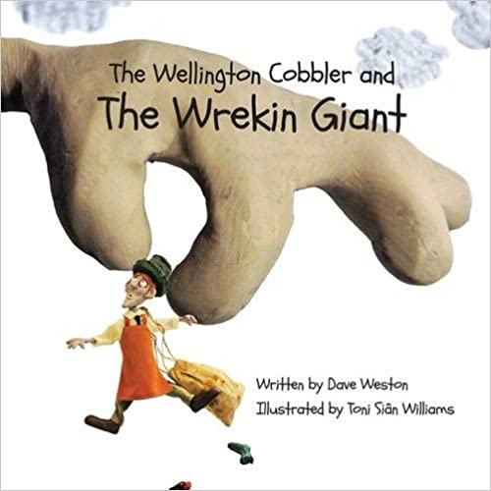 | UK Geography fieldwork – Rivers  What further action to mitigate flooding can be recommended?  OR  How does it change as it flows along?  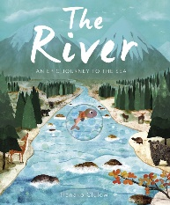 | Local study: Telford  Change and continuity  How and why has Telford changed over time?  